**Assignment 4.2**

Applying following Pig commands on the Student dataset as show in snapshots

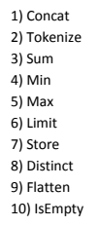

**1.CONCAT:**  For this I have created a table name Studentdetails.txt which contains studentname, age and gender . I have loaded this table into a as shown in grunt shell.

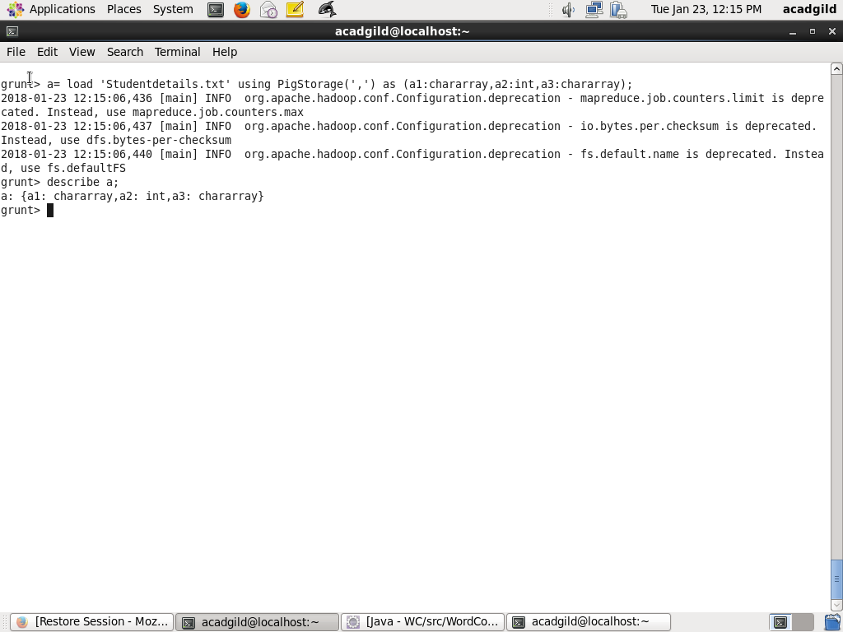

These are the table entries as shown below. 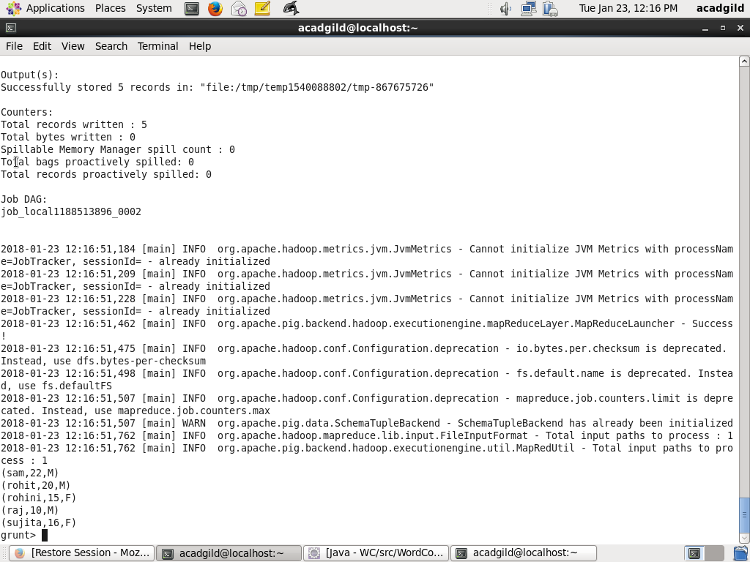

Now im applying CONCAT and merging the name and gender of students as shown below

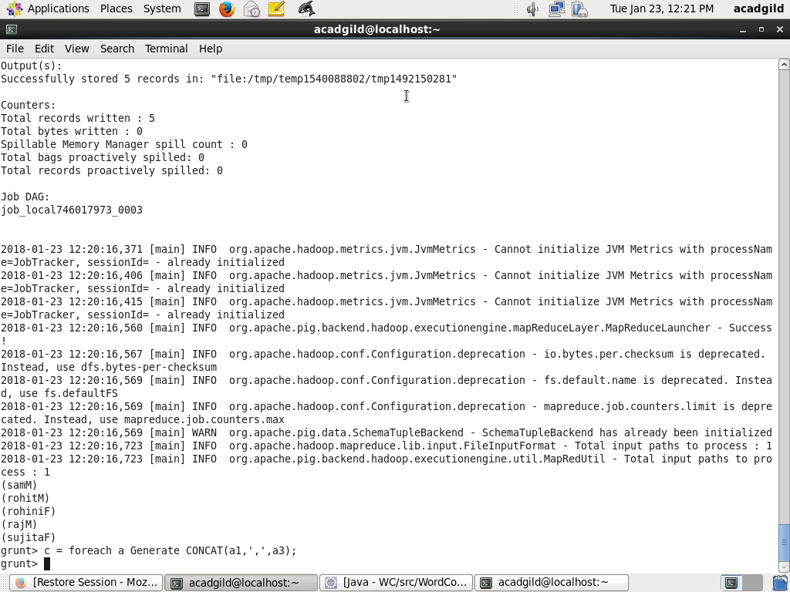

Here is the result

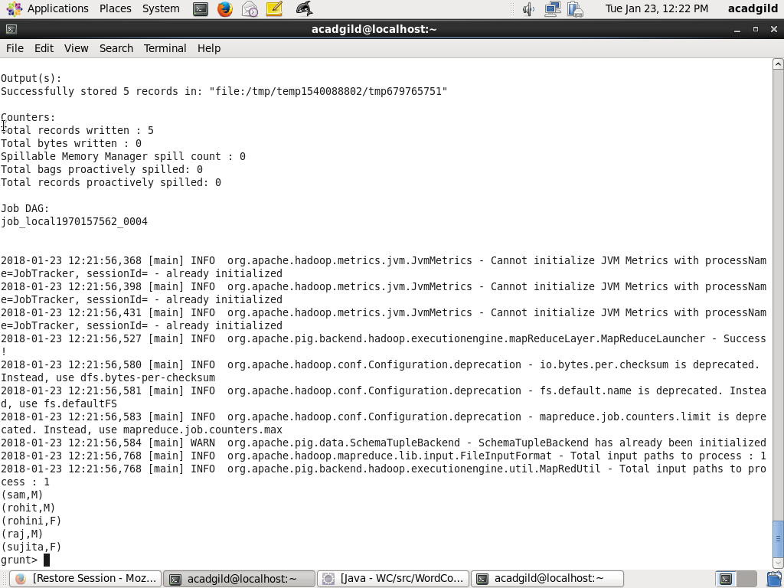

**2.TOKENIZE**

Here is the Studentdetails.txt table with

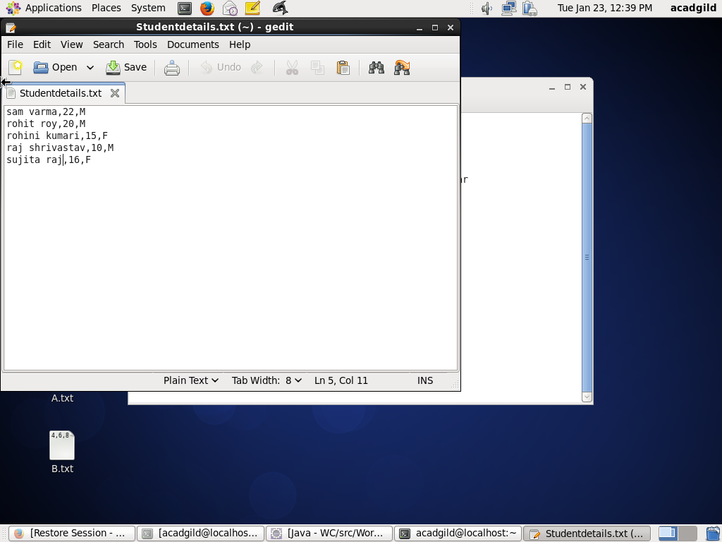.

Here im loading Studentdetails.txt into student_details inside the grunt shell.

Then im applying TOKENIZE to the names

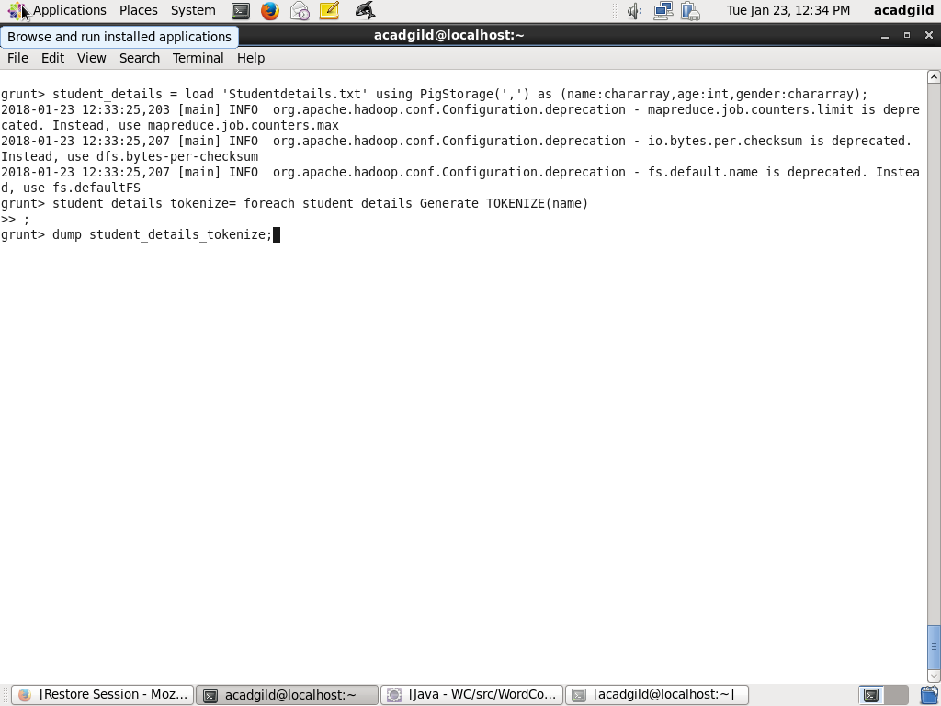

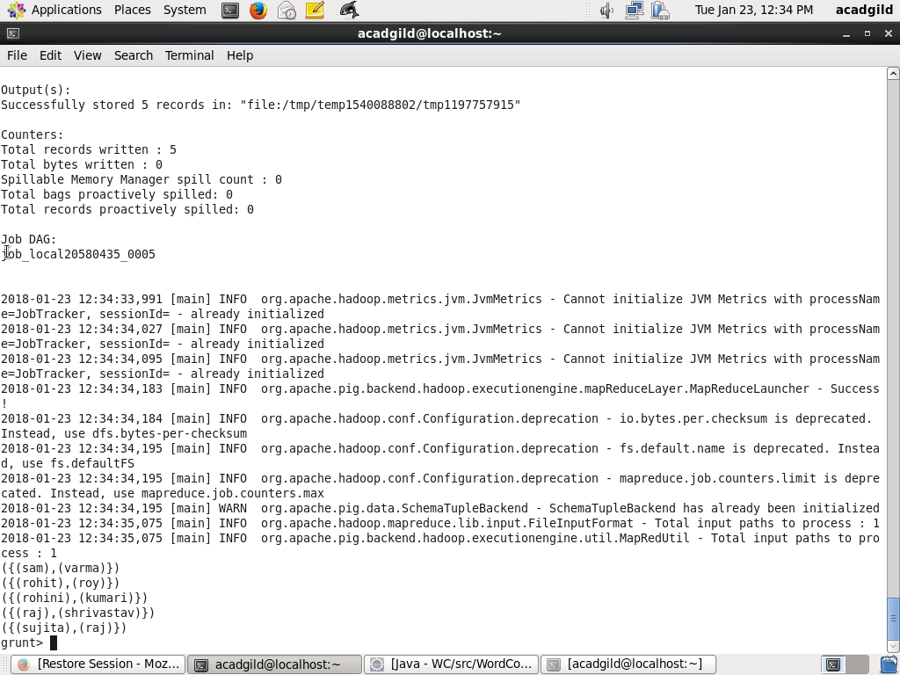

**3.SUM**

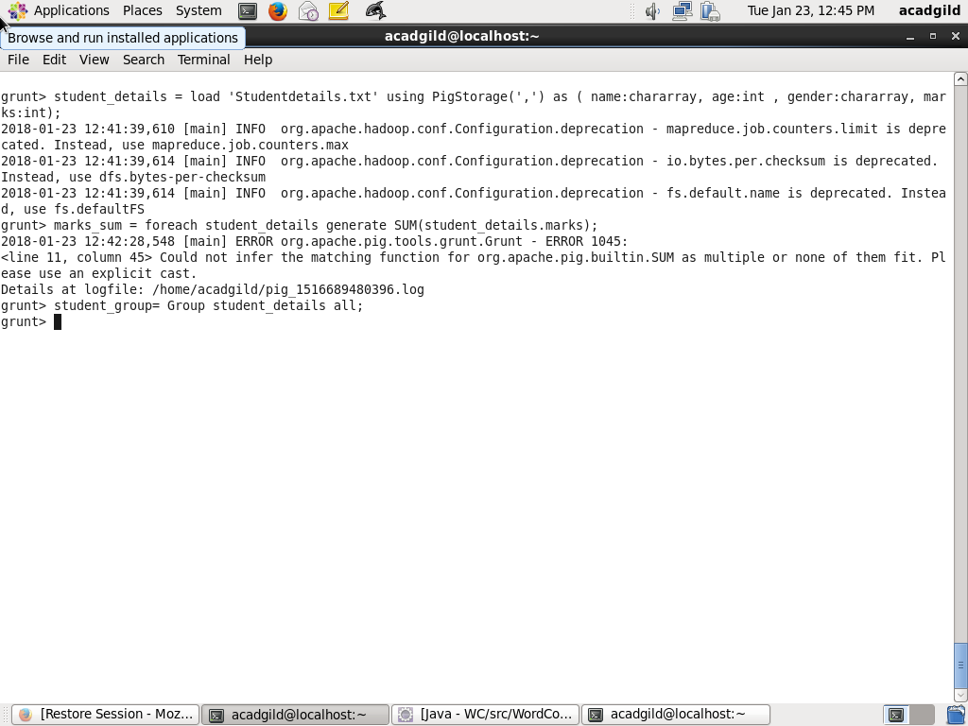For this first applying group to the student_details table

Dump student_group table result

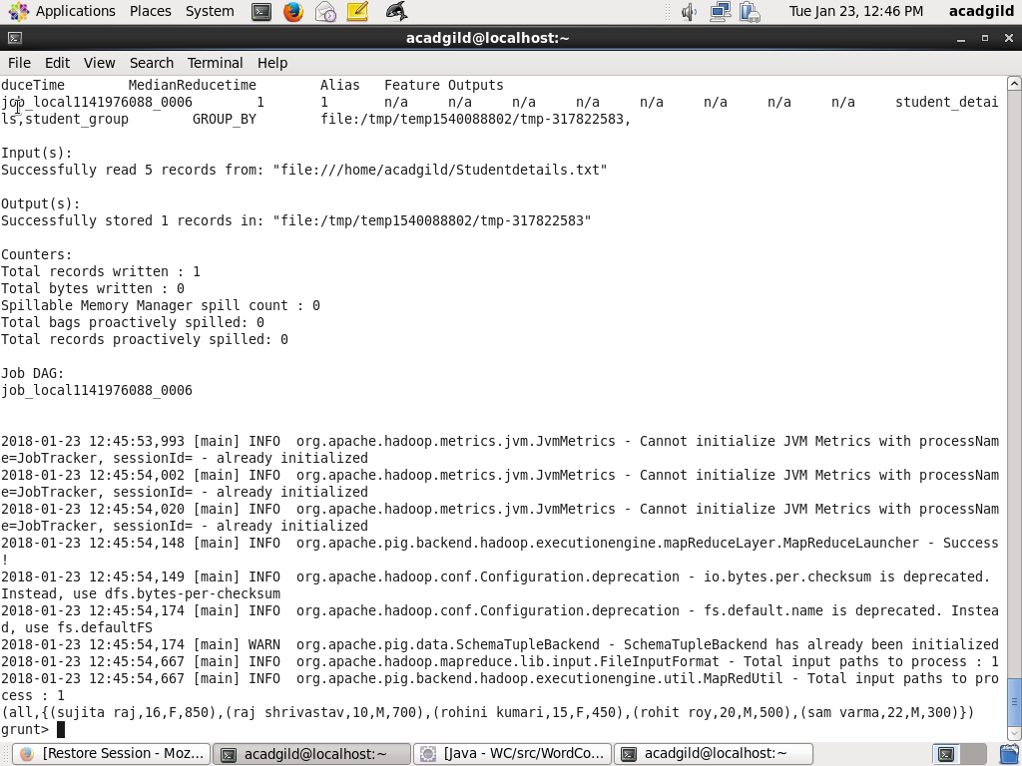

Then performing SUM function on marks of the student_group as shown below

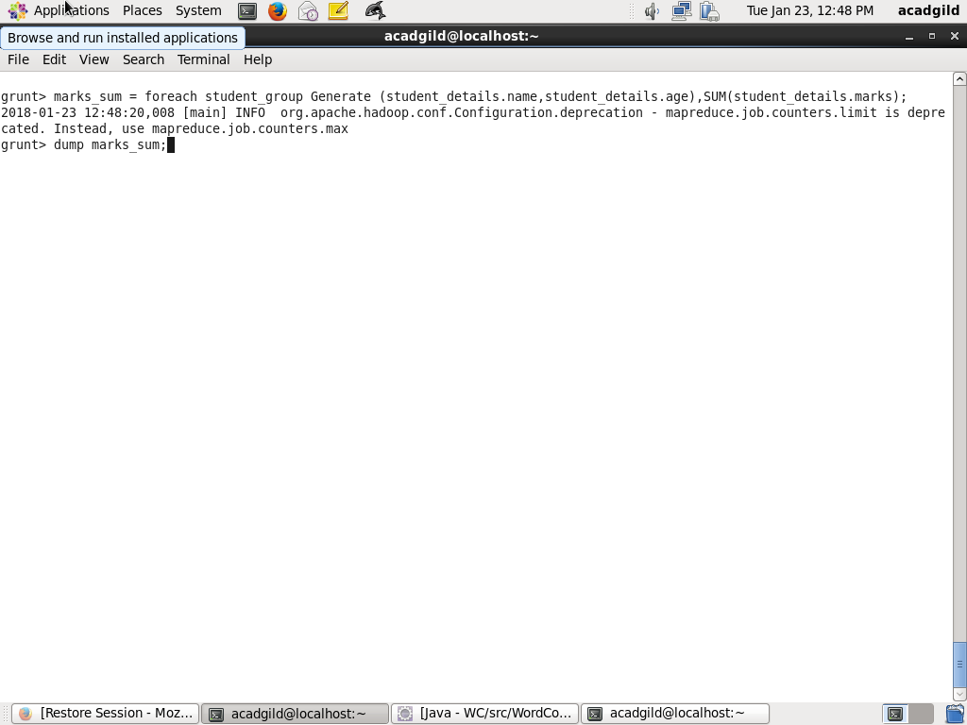

Dump mark_sum in the grunt shell. Following is the result.

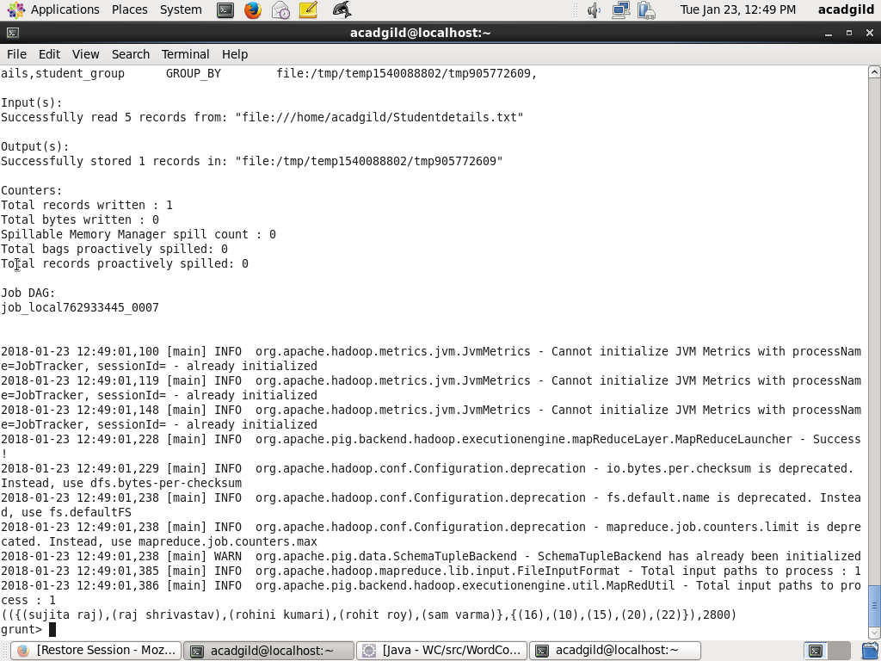

**4.MIN**

Now applying MIN to the student_group to get the minimum marks from that as shown below

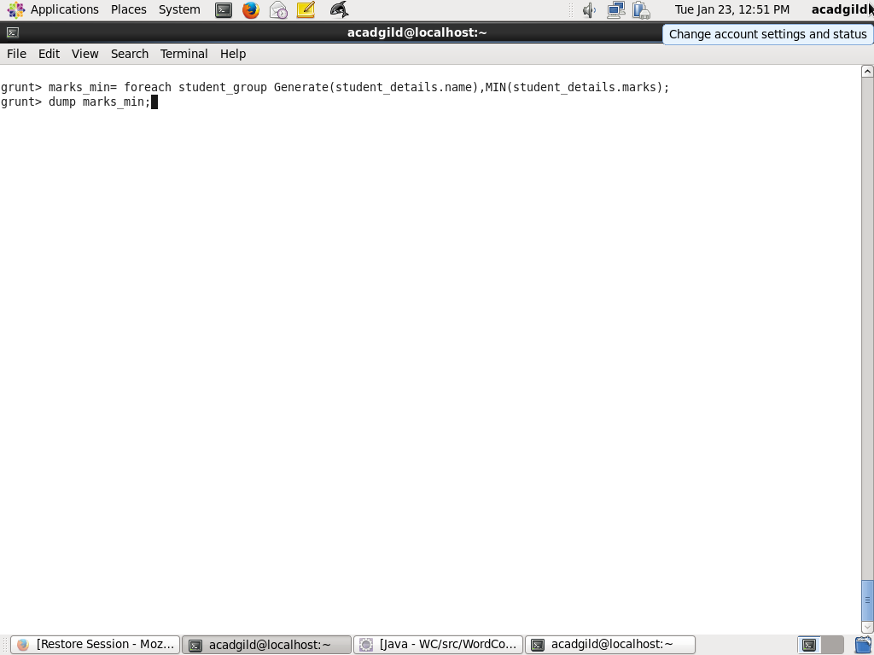

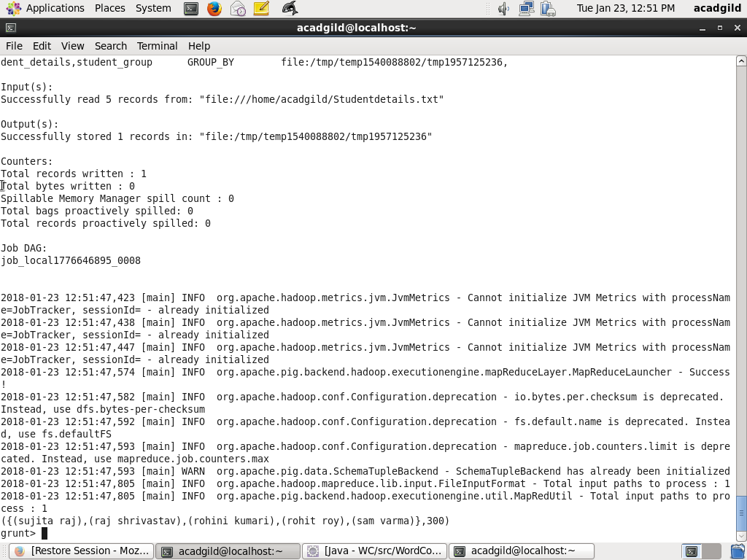

**5.MAX**

MAX is applied on student_group to get the maximum marks .

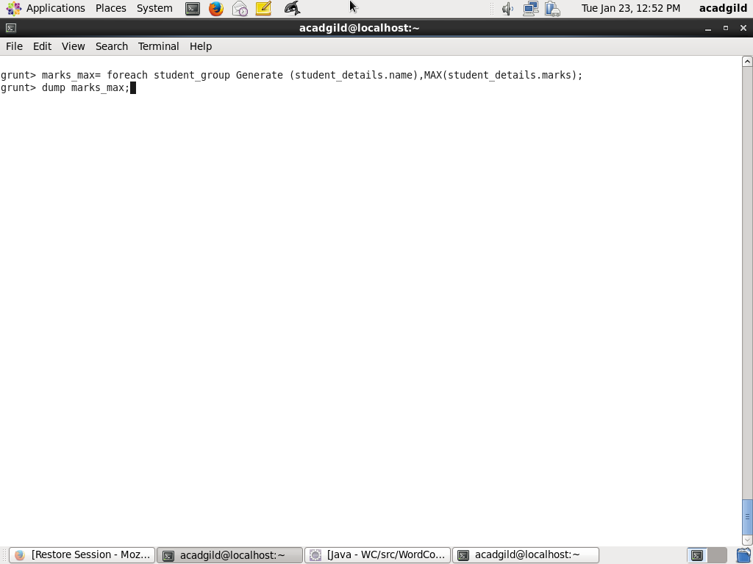

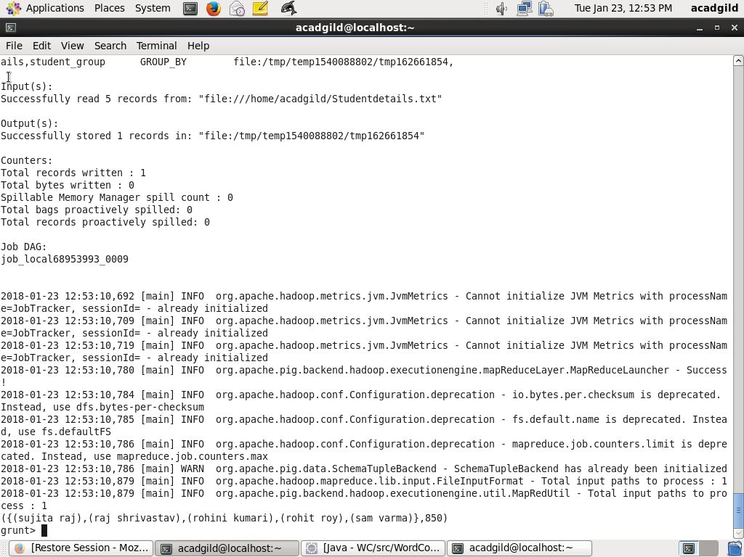

**6.LIMIT**

Applying LIMIT to the desired number of records from the table as shown below

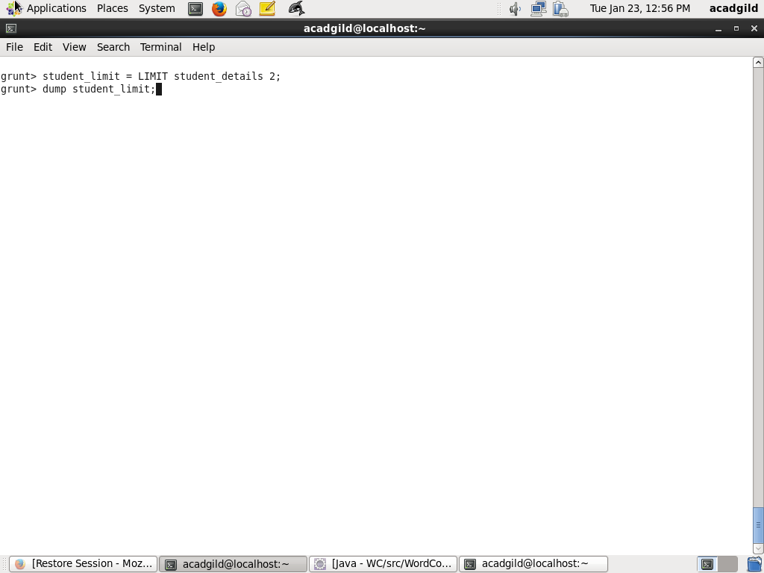

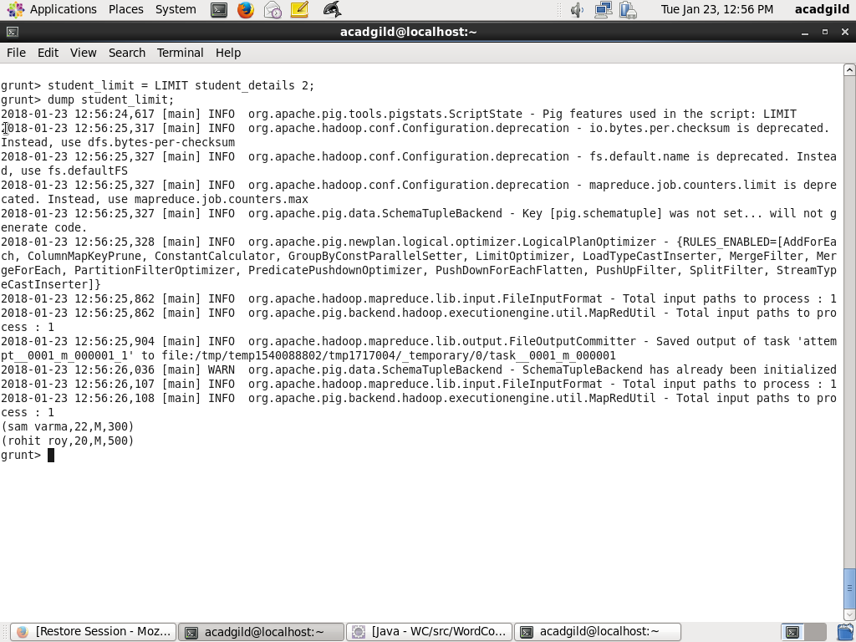

**7.STORE**

Im uing STORE command to store student details inside the hdfs directly as shown below

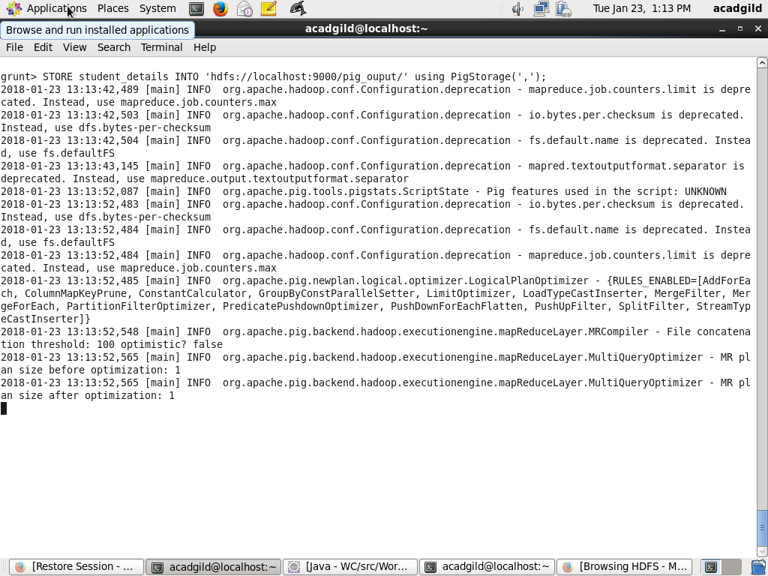

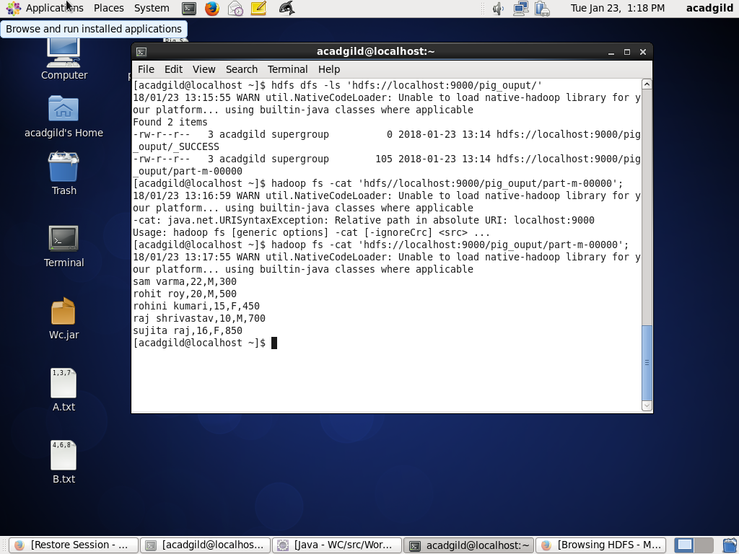

Now displaying record from hdfs using cat command



**8.DISTINCT**

Now getting the unique records from student_details as shown below by applying DISTINCT command

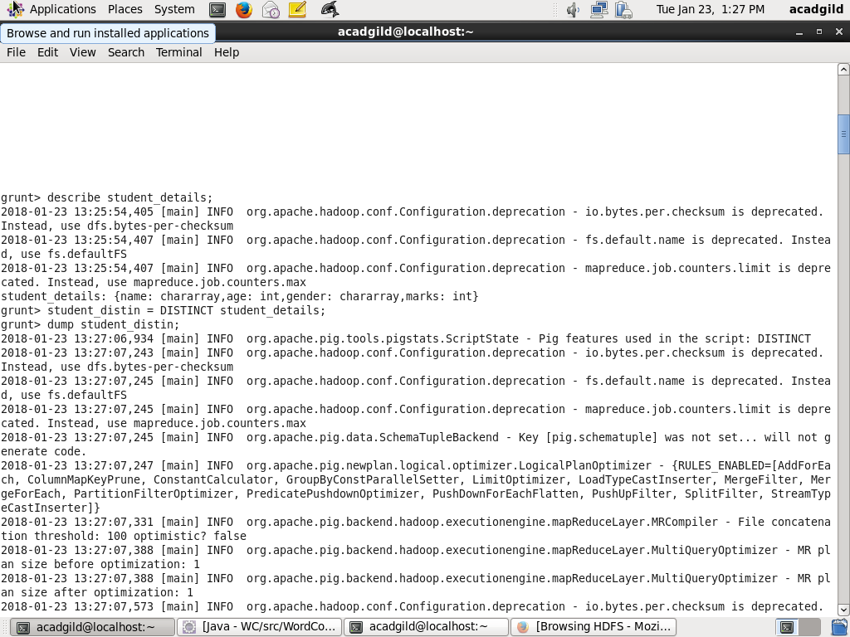

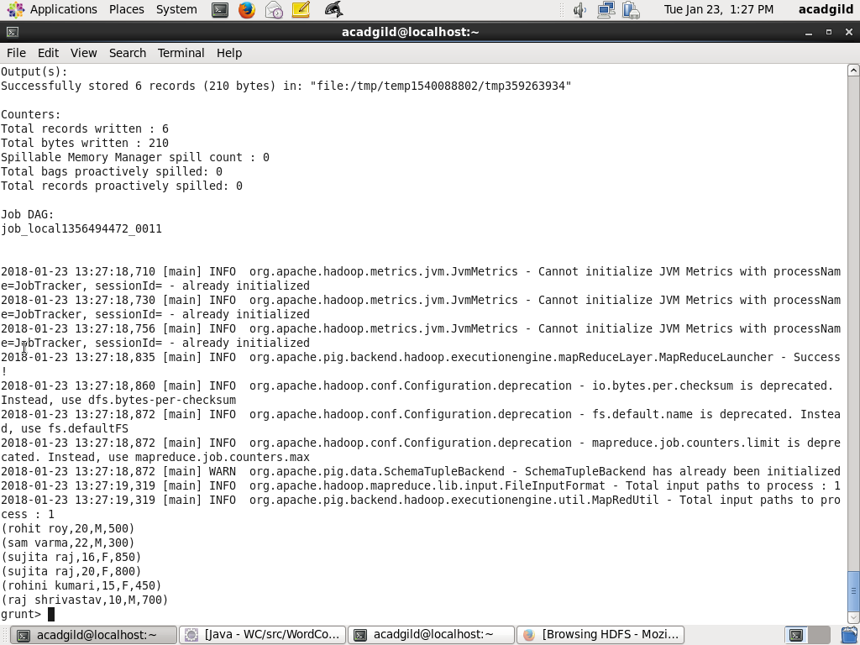

**9.FLATTEN**

Applying FLLATEN command on name of student_details.

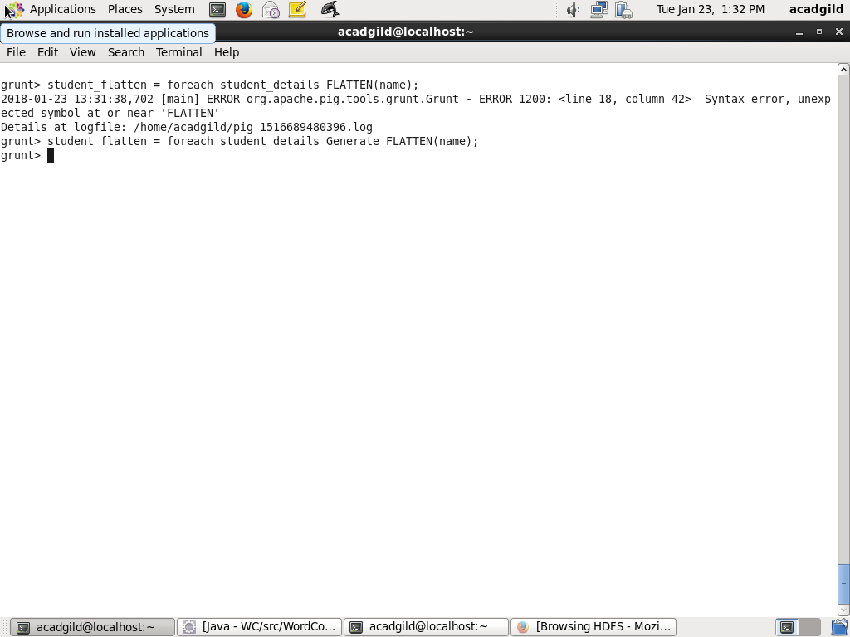

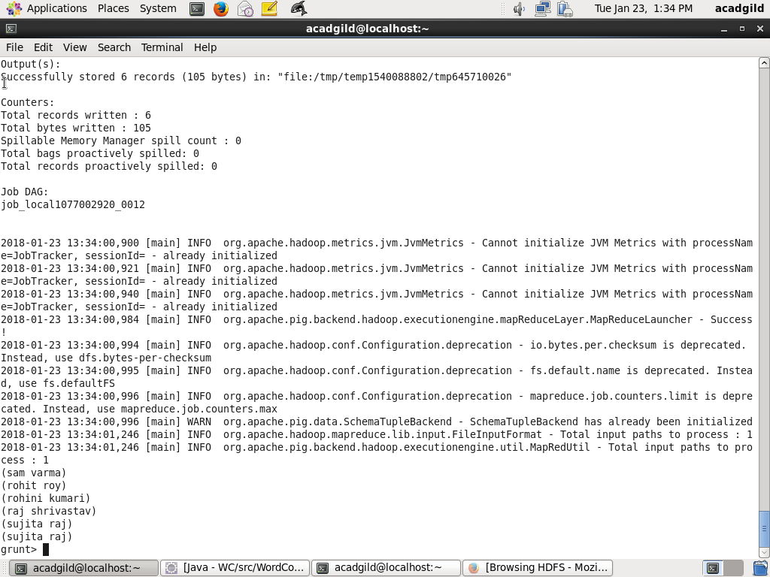

**10.IsEmpty**

Firstly inserting empty record in the studentdetails table as shown below

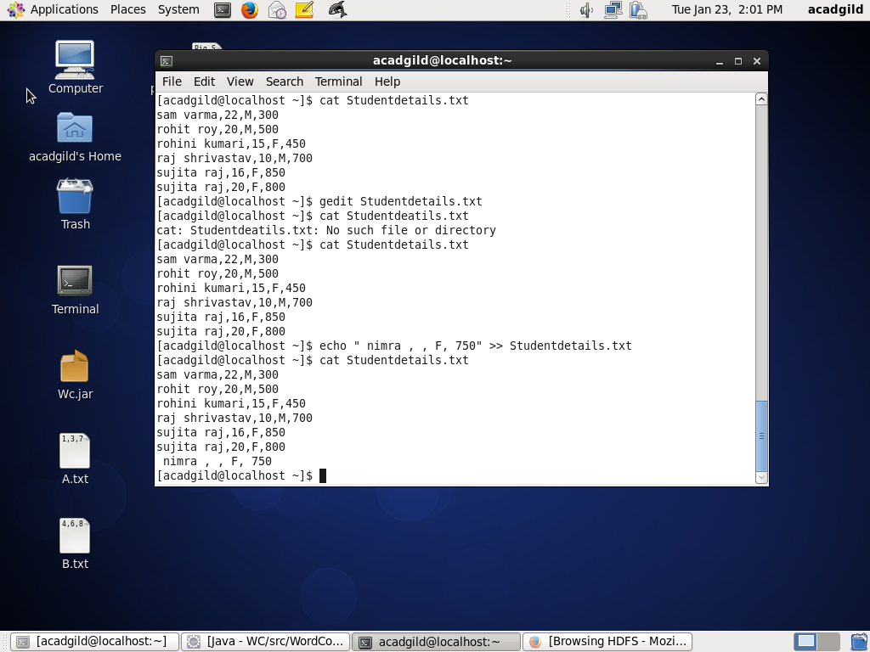

Applying group by $1 which is age as follows then applying IsEmpty command as follows

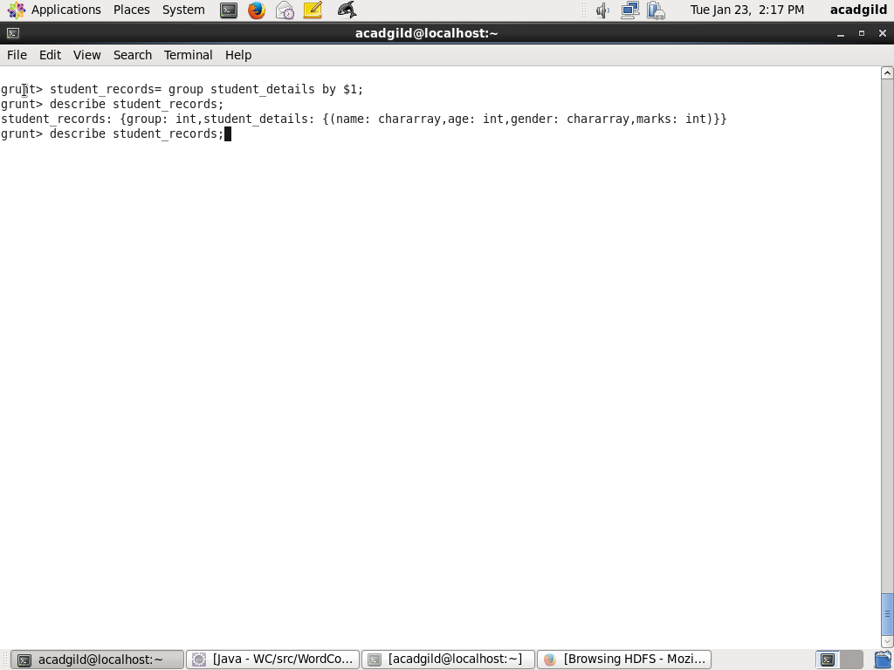  
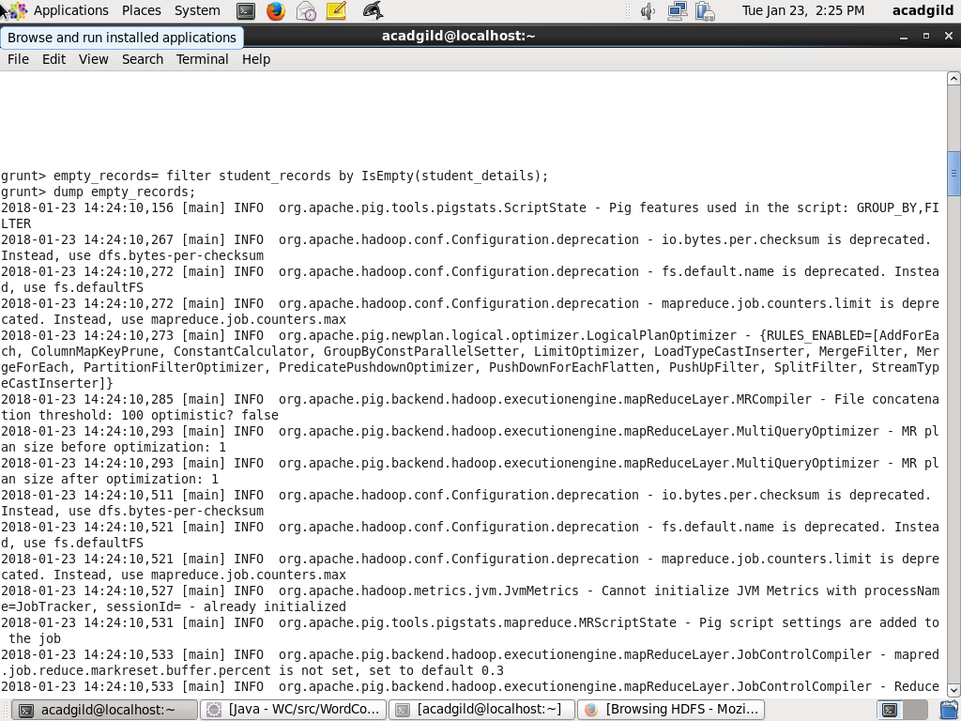**{(nimra, , F, 750)}**