**Assignment 4.1**

1.Java program to add two numbers provided .

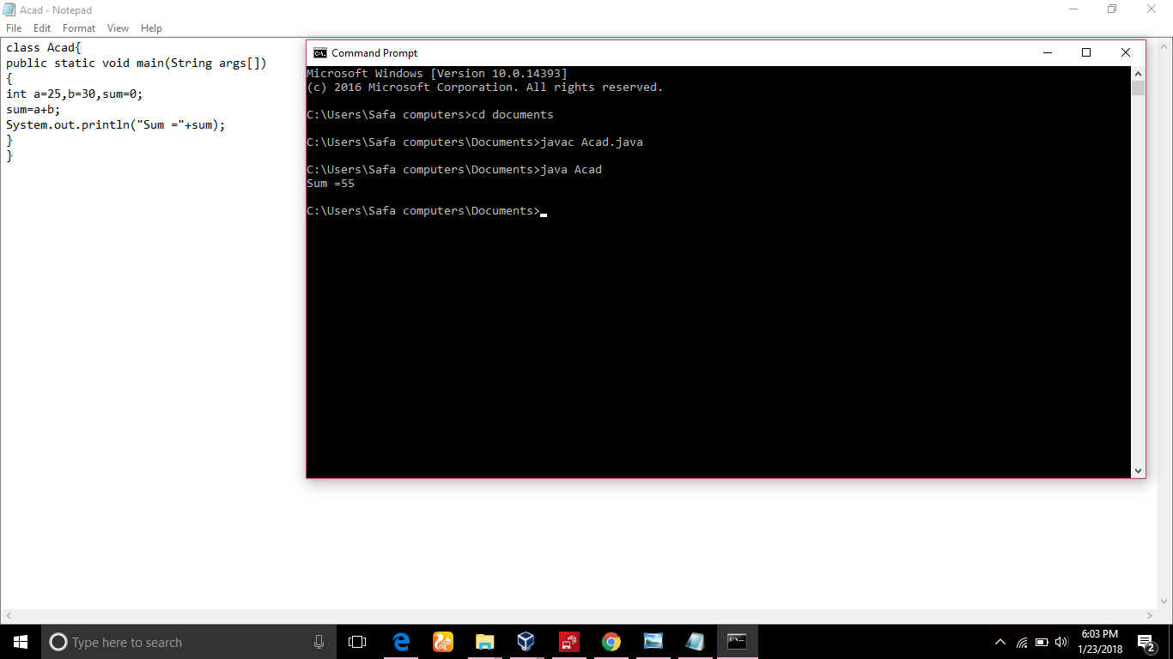  
2. Java program to add two numbers provided at runtime as shown in the screen shot.

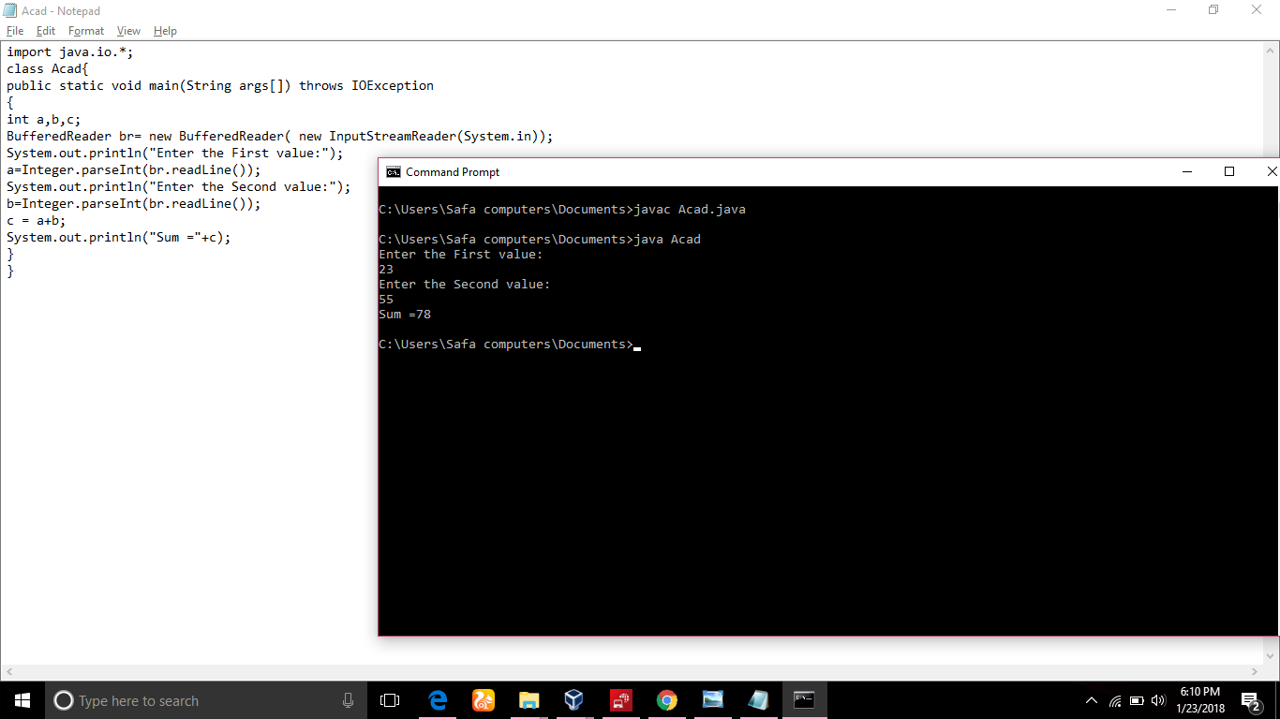

3.Java program to add two numbers by using sum method.

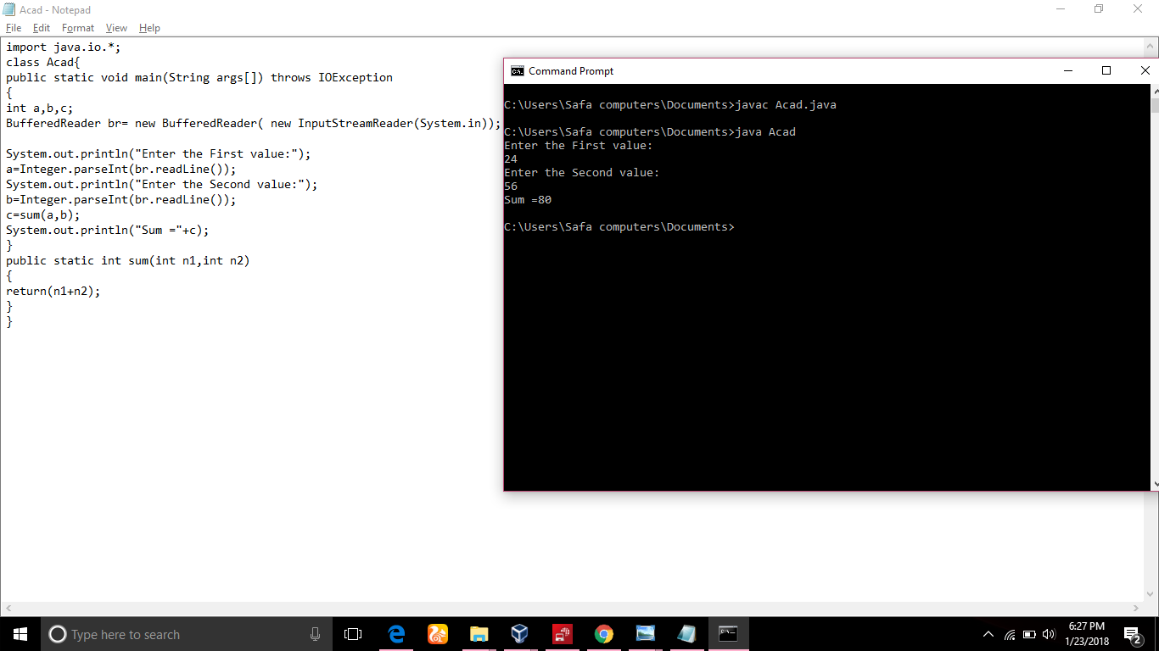

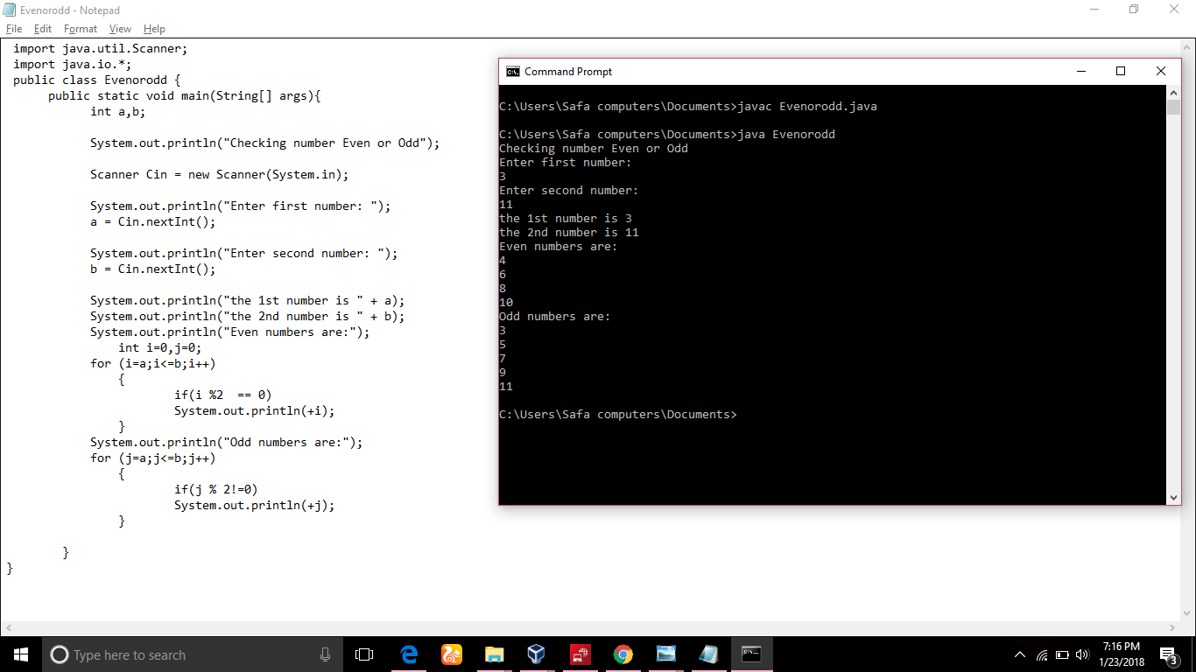4. Java program to display even and odd numbers between given two numbers

5.Java program to display first 10 multiples of 3.

