Assignment 5.1

**(A)TOP 5 employees(employee id and employee name) with high rating.(In case two employees have same rating, employee with name coming first in dictionary should get preference)**

1. I have loaded table employee_details as shown below



1. I have written and executed pig script in local mode using command as

$ pig –x local emp_top_5_hrating.pig as shown in below snapshot.And the is output is as follows.



dump emp_g;

**(B) TOP 3 employees (emloyeename,employeeid) with highest salary (employee names with dictionary preference)**

Below is the pig script executed in local mode as shown below in snapshot

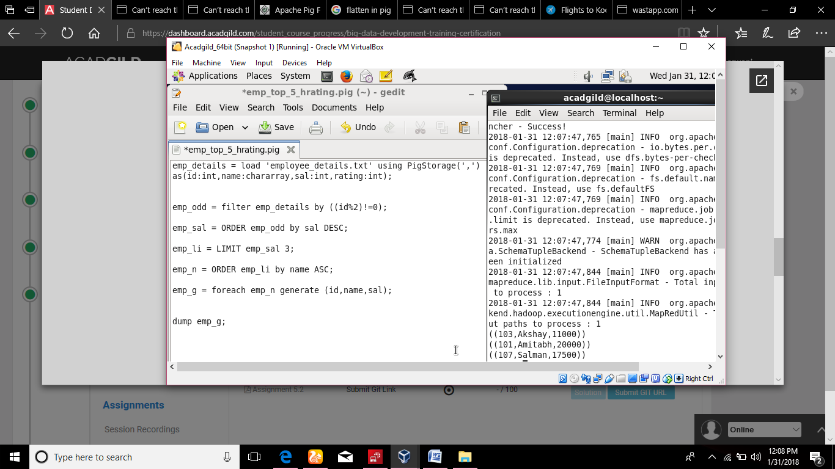

**(C) Employee id and name with the maximum expenses ( name should be in dictionary preference)**