**Project -1 Introduction To Scala - Session 1**

USA crime Analysis

1. Pig program USA crime Analysis Data calculate number of cases for each fbiCode.
2. Pig program USA crime Analysis Data calculate number of cases for ward = 32.
3. Pig program to calculate number of arrests in THEFT district wise.
4. Pig program to calculate number of arrests done between october 2014 and october 2015.
5. **Pig program USA crime Analysis Data calculate number of cases for each fbiCode.**

Firstly we have to

* Create a table in grunt shell with the name crimedata
* Load data into crimedata dataset which is already available in local file stystem as follows

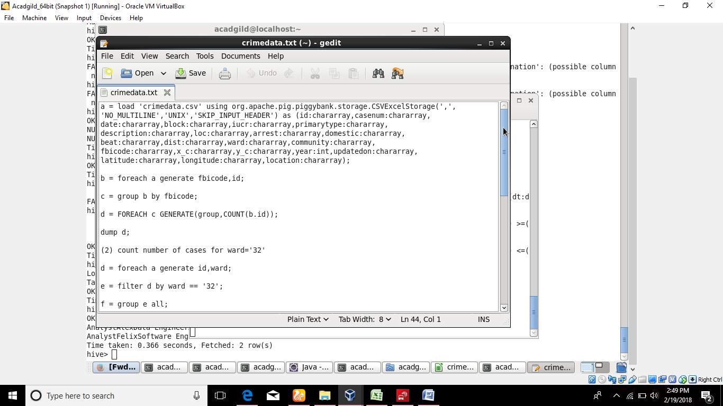

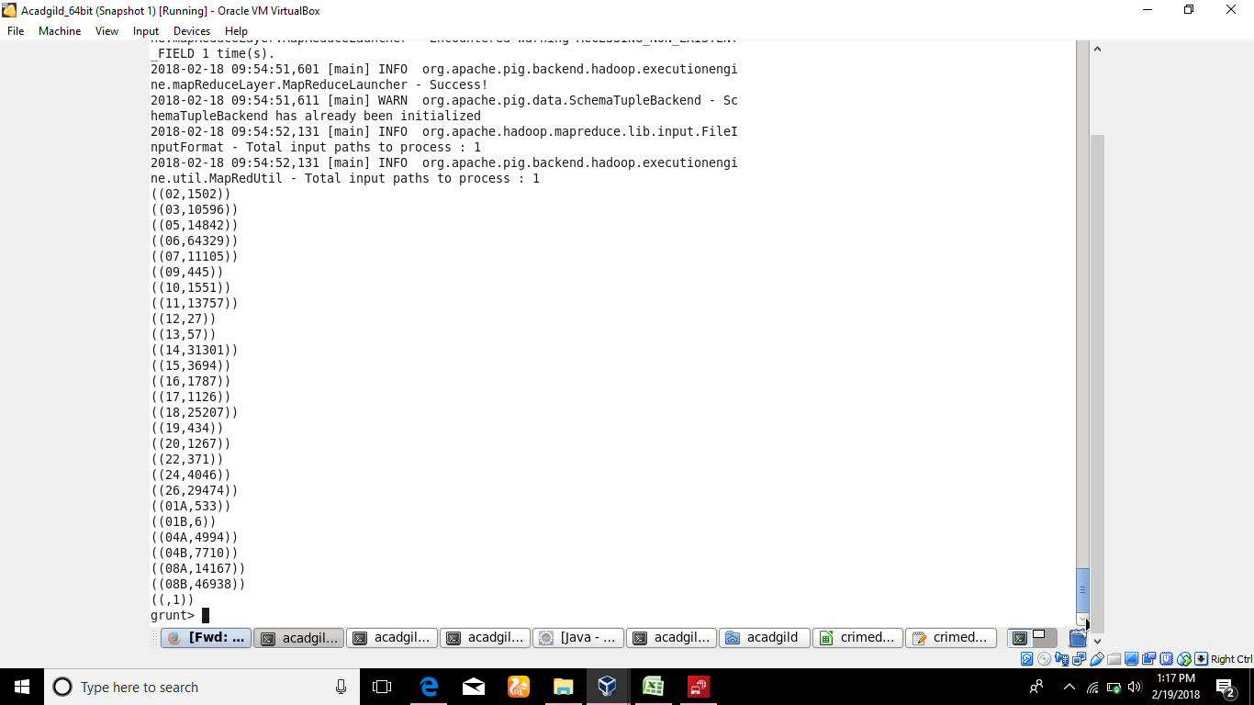

1. **Pig program USA crime Analysis Data calculate number of cases for ward = 32.**

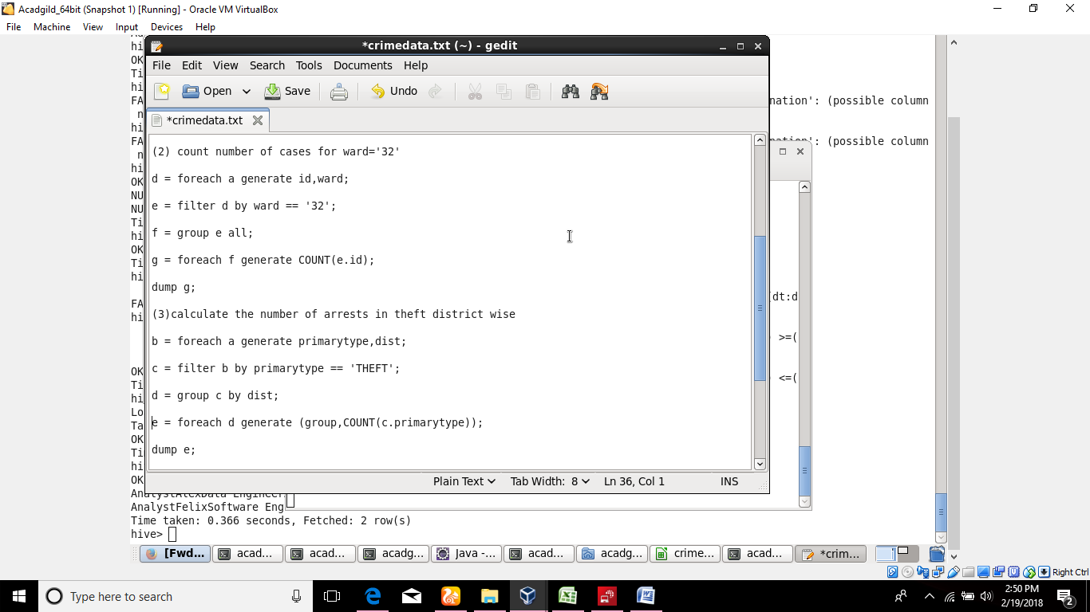

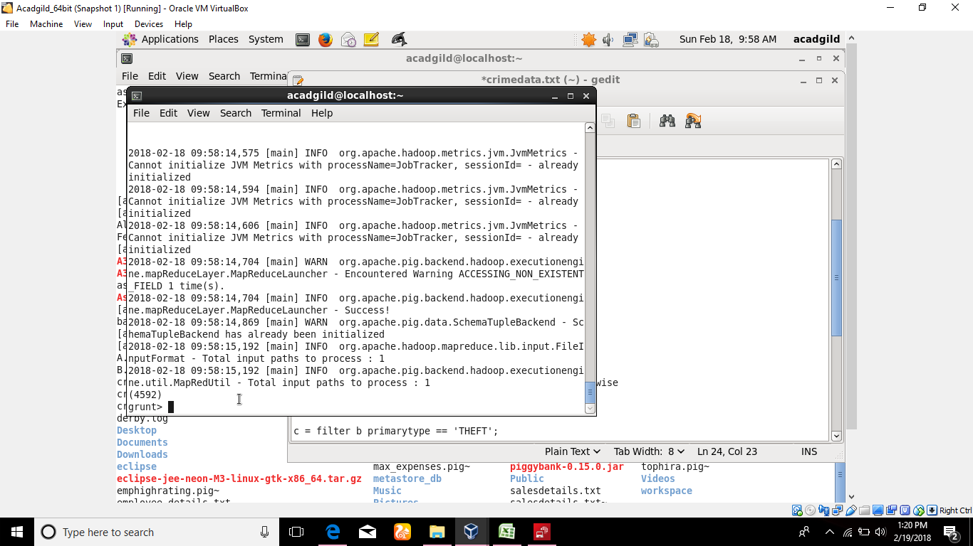

1. **Pig program to calculate number of arrests in THEFT district wise.**



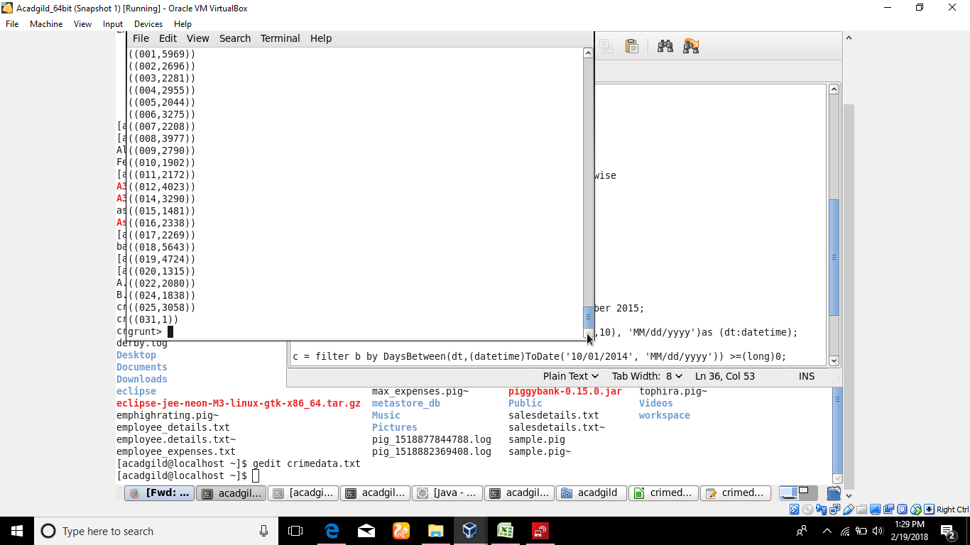

1. **Pig program to calculate number of arrests done between october 2014 and october 2015.**



