**Session2-Assignment-2**

**Aim:**

Creating max-temp.txt with 15 records in local file, putting that file in hdfs using hadoop commands.

1 .I have Created max-temp.txt using echo or gedit as shown in below snapshot

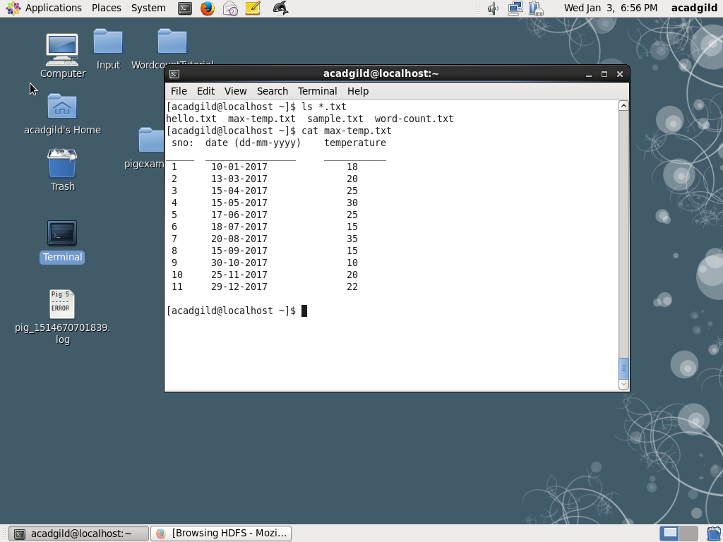

2. Placing max-temp.txt using “-put” command. As I have already put that file in’ /user/acadgild/hadoop’ as shown in below snapshot

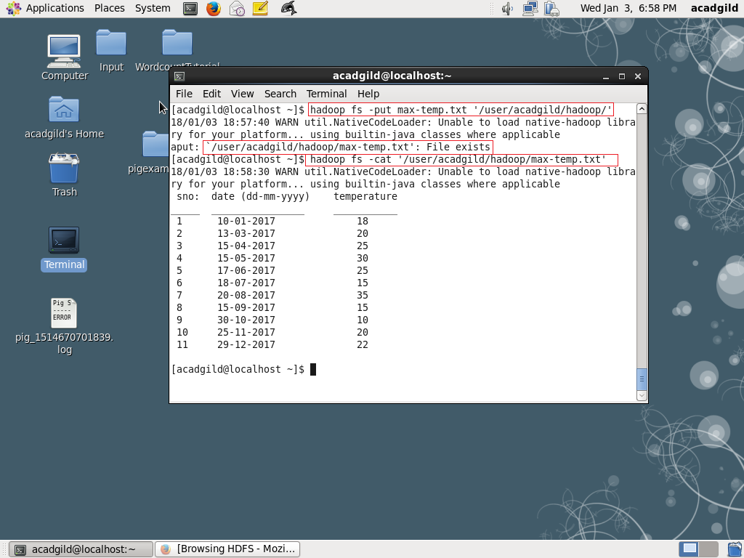

Finally I have seen the content of max-temp.txt using “-cat” command from “/user/acadgild/hadoop” present in hdfs.