**Session2 –Assignment 1:**

1. As I have already created “ hadoop “ directory using “mkdir” command . As shown in snapshot accessing to hadoop directory using “cd” command.

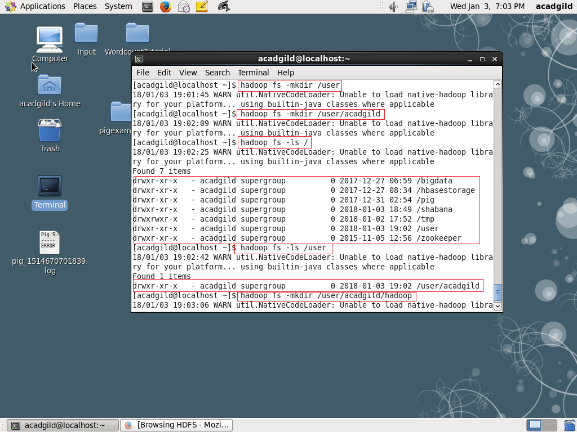

1. I have created “word-count.txt” file in hadoop folder using “echo” command as shown in snapshot.

