Projet Libre : Fleet Admiral

Savinien LAURENT

# Sommaire

Contents

Sommaire 2

Le Projet 3

Technologies 4

WBS 5

Dictionnaire 6

# Le Projet

Fleet Admiral est un jeu vidéo de tactique spatiale inspiré du jeu LOGH de 2008, dont les captures d’écran me servent de maquettes pour le visuel.

Il s’agit donc d’un jeu où le joueur est un Amiral de Flotte, et contrôle donc une flotte. Une flotte est composée de plusieurs Task Forces, qui sont un groupement d’escadrons, qui eux-mêmes sont un groupement de vaisseaux.

Le plus bas niveau de contrôle que le joueur a pendant une partie est sur une Task Force : il ne peut pas sélectionner un escadron ou un vaisseau pour lui donner des ordres. Il n’y a pas de création d’unités pendant une partie.

Le combat se fait principalement « automatiquement ». Les vaisseaux ont trois catégories majeures d’armement : les spinaux, les défenses de courte portée et les armements activés par le joueur (AAJ, ou PAA en anglais).

Les armements spinaux sont des canons qui font partie intégrante de la structure en longueur du vaisseau, et tirent donc vers l’avant du vaisseau, dans un arc très restreint, mais à longue portée. Le contrôle de ces armements est automatique, c’est-à-dire que le joueur n’a qu’à placer et orienter sa Task Force correctement pour que tous les vaisseaux de celle-ci tirent sur une cible devant eux et à portée.

Les armements de courte portée ont, comme leur nom l’indique, une portée restreinte par rapport à la puissance des canons spinaux ; mais ils sont montés sur tourelle et ont donc un arc de 360 degrés.

Enfin, les armements activés par le joueur sont les missiles, les escadrons de chasseurs, les senseurs, les capacités spéciales d’officiers, etc… Les missiles, dépendant de leurs types, ont une portée fixe à l’avant des vaisseaux, ou peuvent être tirés sur une cible choisie. Les chasseurs se divisent en chasseurs, bombardiers, et intercepteurs. Ces AAJ font l’objet d’une option dans l’UI lorsqu’une Task Force est sélectionnée.

Entre les missions, le joueur a la liberté de réorganiser sa flotte. Ici, il peut choisir quels vaisseaux forment un escadron, et quels escadrons forment une Task Force. Il peut assigner des Officiers supérieurs à une Task Force.

Le joueur suit donc une campagne, qui est composée de plusieurs arcs, nommés scénarios. Chaque scénario comporte plusieurs missions, dont une mission principale, quelques missions secondaires (3-5) et quelques missions optionnelles (1-3). Les missions principales sont celles qui, lorsqu’elles sont accomplies, font avancer le scénario vers le prochain arc. Les missions secondaires avancent les objectifs de la mission principale : par exemple si la mission principale est de détruire une base pirate, défendue par 200 vaisseaux ; les missions secondaires peuvent être, dans un premier temps, de trouver la base, puis d’intercepter certains de leurs vaisseaux afin de réduire la difficulté de la mission principale.

Les missions optionnelles sont des missions rapportant des ressources, sous la forme d’influence à l’amirauté (XP), de connaissances technologiques (améliorations de vaisseaux), ou monétaires.

# Technologies

Le projet est réalisé entièrement sous Unity, codé en C# (sous Visual Studio).

# Scope

Le scope de ce projet est de terminer la partie technique du projet de jeu vidéo. Le design des vaisseaux, le plot de la campagne, les dialogues, les équilibrages de statistiques, la liste exhaustive des modules de vaisseau, de traits des officiers, etc… ne sont pas prévus dans le scope, et j’utiliserai des placeholders ; car les tâches à réaliser faisaient monter le WBS à 96JH.

# WBS

# Dictionnaire

Temps total estimé : 48JH ou 384 heures. Cela ne comprend que le côté technique, pas les éléments de graphismes tels que les modèles de vaisseaux, ni le plot de la campagne ou ses dialogues, ni l’équilibrage des statistiques.

|  |  |  |  |  |
| --- | --- | --- | --- | --- |
|  | Tâche | Description | Temps Estimé (JH) | Complétion (%) |
| 1. | Main Menu | This is the first screen of the game. It allows the player to navigate through *Options*, *New Game*, *Continue Game*, *Load Game*, and *Skirmish* options. | 6 | 0 |
| 1.1 | Menu UI | This is the User Interface for the Menu, including the navigation options to the various game screens. | 1 | 0 |
| 1.2 | Background | This is an animated background that will change depending on the default loaded save file (the one used for the *Continue Game* option) | 1 | 0 |
| 1.3 | Options | The Options Menu, allowing the user to change settings, such as : | 3 | 0 |
| 1.3.1 | Graphics | * The graphics settings for the game (resolution, etc…) | 1 | 0 |
| 1.3.2 | Sound | * The sound options for the game (volume bars, etc...) | 1 | 0 |
| 1.3.3 | Language | * A language setting to change languages, using a language file. | 1 | 0 |
| 2. | Game Scene | This is the Game Scene, the main screen on which the gameplay takes place. It consists of a Map with elements on it such as planets, suns and asteroids (or clusters) ; a navigation mesh for the units to move upon, which is bidimensional, and the various components below. | 14 | 0 |
| 2.1 | Game UI | The User interface with which the player will interact to play the game, including minimap, mission progress bar, and the selected unit’s information and gameplay options (see **2.4.3 - Player Input Weaponry** for gameplay options examples) | 2 | 0 |
| 2.2 | Units | This is the mechanic related to the organisation of units. The term *Unit* refers to **2.2.2 - Task Forces**. | 3 | 0 |
| 2.2.1 | Ships | A ship is the minutest element in the organisation of the fleet. They are organised in squadrons. | 1 | 0 |
| 2.2.2 | Squadrons | A squadron consists of two ship classes, one head class and one escort class. This becomes clearer in the **3.3 - Fleet Management** section. In effect, there is, in a squadron, one or two head ships and one to ten escort ships (the smaller the class, the more ships in a squadron). The number of each has close to no impact on gameplay and is merely visual ; smaller ships will be more numerous in order to be seen and recognized as a squadron. | 1 | 0 |
| 2.2.3 | Task Forces | Squadrons are in turn organised in task forces, and this is the smallest unit the player will control (as in “give commands to”). Players will order movement and special armaments to the task force, which will react depending on its composition. Different ship classes will have different armaments (see **2.4.3 - Player Input Weaponry**), so your fleet composition will have an importance. | 1 | 0 |
| 2.3 | Movement | This part is related to Task Force - or unit - movement. | 4 | 0 |
| 2.3.1 | Unit Selection | This is the mechanic by which the player can select one of his units. This is by default on left click. | 1 | 0 |
| 2.3.2 | Ordered Movement | This type of movement keeps the orientation and organization of the formation intact ; ships will use their thrusters to circle laterally around a target for example. This movement is therefore slow. This is by default bound to right click. | 2 | 0 |
| 2.3.3 | Fast Movement | This type of movement prioritizes speed over organization : ships will break their formation and prioritize using their back engines to get to destination, and reorganizing once they arrived. This is by default bound to shift - right click. | 1 | 0 |
| 2.4 | Combat | Combat is the nerve of gameplay, it is the main resolution criterium of a given scenario. Combat is automatic as soon as an enemy unit is in range, without further input from the player. Targeting is squadron based. | 5 | 0 |
| 2.4.1 | Long range (Spinal) | The main armament of heavy ships is a spinal long-range weapon, which is most ship’s main source of damage. It being aligned with the ship, it requires the ship to be pointing at the enemies to be able to fire, hence the importance of formation and orientation of the Task Force. | 1 | 0 |
| 2.4.2 | Short Range (360°) | This armament is close range, but it is mounted on turrets, which allows it to fire in all directions. It is varied in type (also depending on ship class), but limited in firepower. | 1 | 0 |
| 2.4.3 | Player Input Weaponry | Those are the non automatic weapons, whose firing need to be ordered by the player. Those include Fire-and-Forget Missiles, flights (bombers, interceptors, fighters) ; but also support mechanics like scans, cloaking devices, etc... | 2 | 0 |
| 2.4.4 | Damage | When a squadron gets targeted and hit, the damage is applied directly to ships. When a ship is destroyed, it is removed from the squadron. When a squadron’s last ship is destroyed, it is removed from the task force. When a task force is destroyed, it is removed from the game. This can lead to a task force consisting of one squadron, consisting of one ship. | 1 | 0 |
| 3. | Campaign | The campaign elements of the game. | 19 | 0 |
| 3.1 | Story | This is the story for the campaign mode. | 1 | 0 |
| 3.1.1 | Dialogue UI | This is the dialogue interface with which the player will interact with the game. The choices will have short term consequences, like choosing an advantage for the next mission. | 1 | 0 |
| 3.2 | Missions | The campaign will be split into multiple scenarios, each scenario possibly comprising a small number of missions. | 8 | 0 |
| 3.2.1 | Mission Selection UI | This will be shown as a galactic map, and will allow the player to visually chose what his next step is. | 2 | 0 |
| 3.2.2 | Mission Types | There are multiple types of missions within one scenario arc : | 3 | 0 |
| 3.2.2.1 | Main Mission | This is the main objective of the scenario. It is usually a mission that is either hidden when the scenario starts, or too difficult to tackle right on. An example would be to destroy a pirate consortium’s space station, defended by 200 ships ; or whose position is unknown. | 1 | 0 |
| 3.2.2.2 | Secondary Mission | This is a complementary mission to the main one : it serves the scenario. Examples would include intelligence missions to locate the space station, or repression raids to thin out the defending fleet from 200 to about 120. There would be 3 to 5 secondary missions. | 1 | 0 |
| 3.2.2.3 | Optional Mission | An optional mission is a unrelated to the current scenario, but is available for the player to play. Those include resource gathering, technology research, and the like. | 1 | 0 |
| 3.2.3 | Mission Objectives | Mission objectives are the conditions at which the mission will be considered completed : target or fleet annihilation, area control, target control, escort, survive a set amount of time, etc... | 3 | 0 |
| 3.3 | Fleet Management | This is all related to the management of the player’s fleet. | 10 | 0 |
| 3.3.1 | Repair Ships | After each battle, the ships have sustained damage and have to be repaired, at a cost in resources and time. | 1 | 0 |
| 3.3.1.1 | Ship Status UI |  | 1 | 0 |
| 3.3.2 | New Ships | The player will have the possibility to use his newly acquired resources and/or technology in order to build more ships for his fleet. | 3 | 0 |
| 3.3.2.1 | Ship Creation UI | This screen allows to select a ship class, long range armament, short range armament, flight hangars, sensors, hull size, engine power, etc… | 2 | 0 |
| 3.3.2.2 | Ship Classes | Ships will be split into different classes, including Corvettes, Frigates, Destroyers, Light Cruisers, Heavy Cruisers, BattleCruisers, Dreadnoughts and SuperDreadnoughts. | 1 | 0 |
| 3.3.3 | Task Forces Management | The ships will then be organized in squadrons and task forces. | 3 | 0 |
| 3.3.3.1 | Task Force Management UI | Ships are not added individually in task forces ; instead, they are shown in the UI as ship cards, showing their statistics. | 1 | 0 |
| 3.3.3.2 | Task Force Creation | The cards are then selected in the following way :  First, the player selects the capital ship for the squadron, and then selects the escorts. Ships have different statistics depending on whether they are used as capital ship or escort, to reflect that there is only one capital ship and a range from 10 to 1 escorts, depending on the ship size (the bigger the ship, the less of it there will be in the squadron as escorts). Squadrons are then set in a Task Force ; a Task Force having at minimum 5 squadrons and at most 10. A Task Force’s first squadron’s capital ship is the Task Force’s Flagship. | 2 | 0 |
| 3.3.4 | Officers | Officers have special traits and can be assigned to Flagships for high ranking officers, or to capital ships for lower-ranking ones. These traits grant some bonuses or maluses. | 3 | 0 |
| 3.3.4.1 | Officers Affectations UI | This UI will allow drag and dropping of officers in the fleet’s squadrons. It is the same scene as the fleet management, but with a different tab. | 2 | 0 |
| 3.3.4.2 | Officers XP | Officers gain XP and traits as the player progresses with them. their bonuses range from flat stats to increases in the number of squadrons allowed in a Task Force for example. | 1 | 0 |
| 4. | AI | The algorithm determining the behaviour of enemies. It is called AI by language abuse from the videogame industry. | 10 | 0 |
| 4.1 | Officer traits | Officers will have traits from a random list that will alter their behaviour when played by the computer. | 2 | 0 |
| 4.2 | Ship traits | The computer will use different ship classes differently, heavier ships are not as mobile as lighter ships and that has to be taken into account for the AI’s behaviour. | 3 | 0 |
| 4.3 | Objectives | The AI will have to play the objectives during missions, so this has also to be taken into consideration for the behaviour. | 5 | 0 |

# Annexes : maquettes

Mission Selection UI concept.

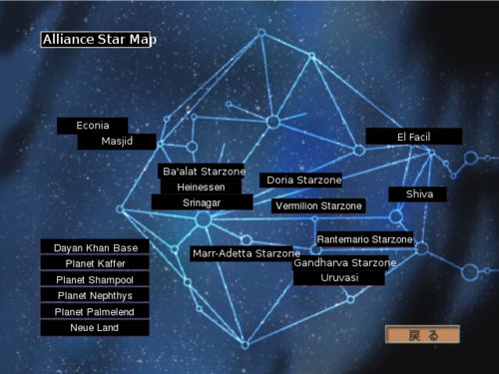

A Task Force with an assigned Officer. Each circle represents a squadron, composed of ships.

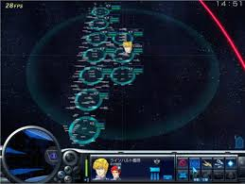

Concept de menu principal.

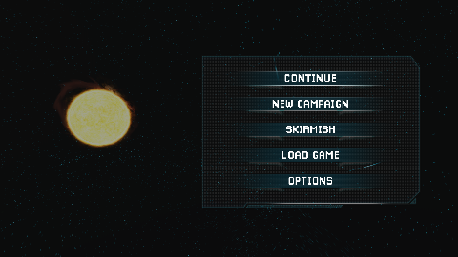

Task Force movement. This is an ordered movement, moving the Task Force to the indicated position with the indicated orientation. 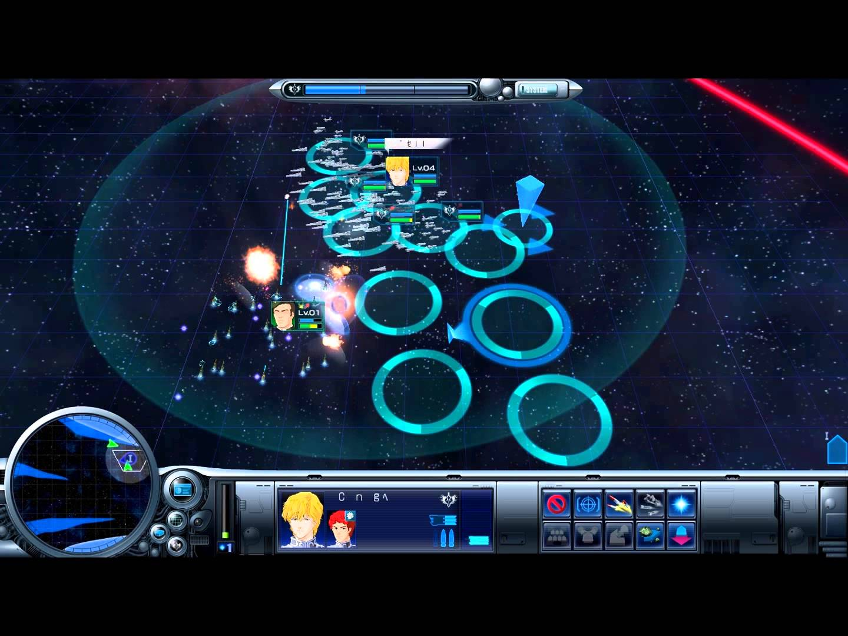

Combat :

Ici, on voit les armements spinaux tirer (lasers dans le cas présent).

Les cercles orange correspondent à l’indicateur de visée des missiles de la Task Force autour de laquelle il y a un cercle. Si le joueur décide de lancer les missiles, ils exploseront à la portée fixe définie par les cercles orange.

