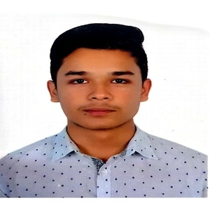
CURRICULUM VITAE

OF

MD. SARZIL SAFOAN

Mailing Address

Md. Sarzil Safoan
House-10, Road-7/C, Sector-3, Uttara, Dhaka-1230.
Contact No. 01630691153

Career Objective
Seeking a challenging position in a reputed organization will allow me to expand my knowledge, develop new skills, and maximize my strengths while also contributing to the organization's progress.

Self-Assessment
- Sincere, Punctual and dutiful to work.
- Able to motivate and convince people.
- Working under pressure and achieving the target goal.

Educational Details

Bachelor of Computer Science (Hon’s)
University : North South University
Passing Year
(expected) : 2027

Higher Secondary Certificate (H.S.C.)
Board : Dhaka
College : Milestone School and College.
Group : Science
Passing Year : 2021
Result : 4.85

Secondary School Certificate (S.S.C)
Board : Dhaka
School : Trust School and College.
Group : Science
Passing Year : 2019
Result : 4.39

Language Proficiency
- Bangla
- Proficient in English

Computer Skills
- Proficient with Microsoft Word, Excel and PowerPoint
- Proficient with programming languages like C, C++, Java.
- Web development skill in HTML, CSS, Javascript, Bootstrap.

Extra-curricular Activities
- Music.

Personal Information:
Father’s Name : Md. Abdus Samad Miah
Mother’s Name : Nargis Parven
Permanent Address : House-10, Road-7/C, Sector-3, Uttara, Dhaka-1230.

Date of Birth : 02/01/2003
Religion : Islam
Marital Status : Unmarried
Blood Group : O+
National ID No. : 8266420028

References
⬥

Robert McKelvey  Vice-President,  Jade Marketing Group Ltd.  Uttara Head Office, Dhaka-1230.  Cell: +88016166666  Email: robertm@jmgbd.com | Mohammad Al Jayed Merchandiser,  Jade Marketing Group Ltd.  Uttara Head Office, Dhaka-1230.  Cell: +8801743432416  Email: jayed@jmgbd.com

I, the undersigned, certify that the information contained in this resume is accurate and true to the best of my knowledge.

Signature



(Md. Sarzil Safoan)
Date : ......................

