Version overview

Date | Version | Author | Comment
29.10.2021 | V0 | Sas Miresan Andrei & Alexandru Pop | First version

System requirements for BussTrack

1 Introduction 2
2 General view of actors and use cases 2
3 Detailed description of actors and use cases 3
3.1 Actors 3
3.1.1 Administrator 3
3.1.2 Driver 3
3.1.3 User 4
3.2 Use cases 4
3.2.1 Use Case for Administrator 4
3.2.2 Use Case for Driver 4
3.2.3 Use Case for User 5

Introduction

The average person using the bus spends on average 5 minutes in the buss stop. It might not sound that bad, but in winter you sure will be freezing by the time you get on the bus. By using the BussTrack application the user is prompted when it needs to leave home to reach the bus with no waiting time. The app is map based so you can see all busses going through your city live. You can also check for routes in case you don’t know which bus to get.

General view of actors and use cases

Actor | Type | Description
Administrator | Human
Driver | Human
User | Human

Here is an example of a table containing use cases along with their general description

Use case | Actor | General description
Administrator log-in | Administrator | The Administrator logs in into the Administrator Account.
Administrator log-out | Administrator | The Administrator logs out from the Administrator Account.
Create routes | Administrator | The Administrator creates new routes for busses.
Create driver accounts | Administrator | The Administrator opens new Driver Accounts.
Driver log-in | Driver | The Driver logs in into the Driver Account.
Driver log-out | Driver | The Driver logs out from the account.
Buss page | Driver | The Driver is given a page to set the buss he is driving.
Driver  status update | Driver | The Driver updates when the bus is on break.
User sign-up | User | The User creates an account on the app.
User log-in | User | The User logs in into the app.
User log-out | User | The User logs out from the app.
User checks the bus stop | User | The User clicks on a bus stop on the map and sees the next busses to arrive and the time.
User checks the route | User | The User selects a bus line to see the route it goes.

Detailed description of actors and use cases

Actors

Administrator
Type: human
Detailed description:
This actor is the person who administrates the backend data of the app and the accounts of the other user types.

Where is used:
This actor is used in the:
- “Administrator Log-in “use case.
- “Administrator Log-out” use case.
- “Create routes” use case.
- “Create Driver accounts” use case.

Driver

Type: human
Detailed description:
This actor is the person who drives one of the busses. The Driver is the one responsible to set the line it drives every day and to update the status of the buss. The Driver is used to determine the location of the buss also.

Where is used:
This actor is used in the:
- “Driver Log-in “use case.
- “Driver Log-out” use case.
- “Buss page” use case.
- “Driver status update” use case.

User
Type: human

Detailed description:
This actor is the person who mainly uses the app with personal intentions.

Where is used:
This actor is used in the:
- “User sign-up” use case.
- “User log-in” use case.
- “User log-out” use case.
- “User checks the bus stop” use case.
- “User checks the route” use case.

Use cases
This sub-chapter should describe how each actor would interact with the system. If the actor is a human, then describe typical ways he will use the system. System requirements captured in this way are called use cases.

Use Case for Administrator
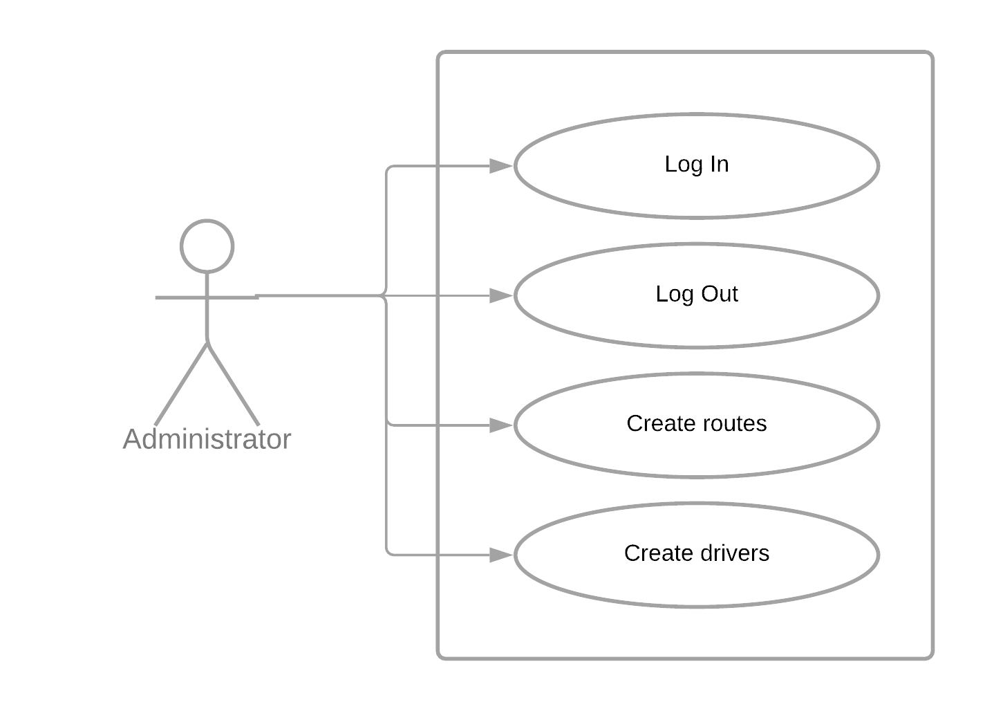
Description:
Actor: ……………..
Precondition: -
Postcondition: …………………..
Behavior: ………………………………

Use Case for Driver
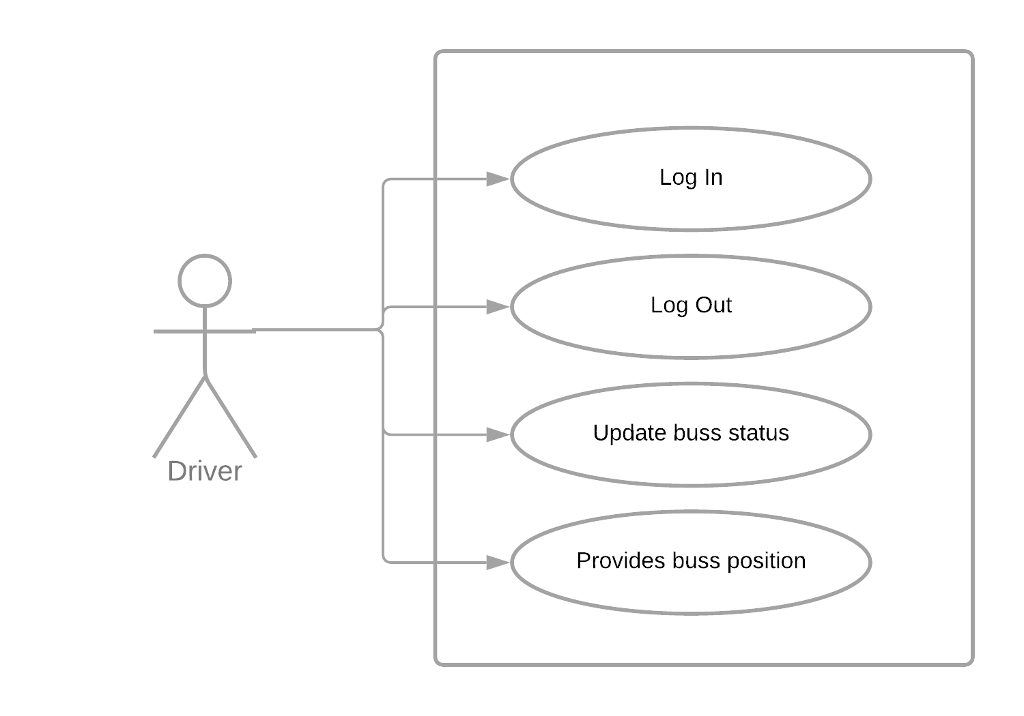
Description:
Actor: ……………..
Precondition: -
Postcondition: …………………..
Behavior: ………………………………

Use Case for User

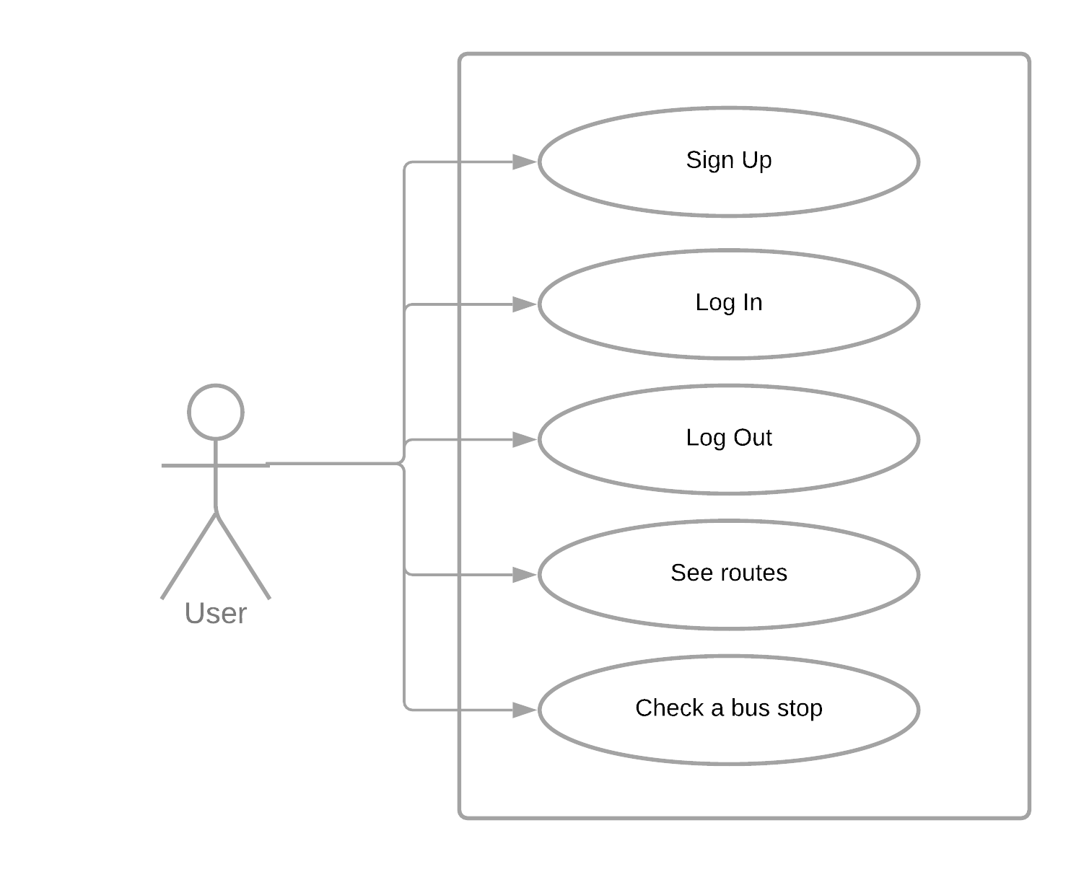
Description:
Actor: ……………..
Precondition: -
Postcondition: …………………..
Behavior: ………………………………

………………………………

