Versions:

Date | Version | Author | Comments
7 Nov. 2021 | V0.0 | Alexandru Pop & Sas-Miresan Andrei | First Version
12 Nov. 2021 | V0.1 | Alexandru Pop & Sas-Miresan Andrei | Added actors
12 Nov. 2021 | V0.2 | Alexandru Pop & Sas-Miresan Andrei | Theoretical Fundamentals

Analisys&Design for BussTrack

Content:
- General Presentation

- Theoretical Fundamentals

- IT Technology (which will be implemented)

- Functionalities

- Actors and related access rights

- Use Case Diagrams

- System Architecture

- Design (UML Diagrams)

- Operation Mode (Operation Guide, including screen-shots)

- Portability

- Competing Softwares

1. General Presentation

The average person using the bus spends on average 5 minutes in the buss stop. It might not sound that bad, but in winter you sure will be freezing by the time you get on the bus. By using the BussTrack application the user is prompted when it needs to leave home to reach the bus with no waiting time. The app is map based so you can see all busses going through your city live. You can also check for routes in case you don’t know which bus to get.

- Theoretical Fundamentals

We plan to use the support APIs for the Google Maps provided by Google through the APIs supported by the Android studio app to determine the location of the user and the locations of the other drivers.

We will take the map provided by Google and we will edit it changing the markers for buss stations and the user to make it easier for the user to use the app. Also using a server we will add the information gathered from all the users to find the best average of the duration of the busses.

Combined with the data base that keeps track of the busses and routes the bus drivers are going on the app will determine the duration to the station the user is waiting at.

- IT Technology

The app will be run on a server hosted by Firebase connecting all the devices of all the users collecting the location data and broadcasting the proper information back to all the users.
The routes taken by the busses and the static location of the bus stations along with the data of the busses ids and users account data are stored in a MySQL based database.
Also the Firebase functionalities are used to encode the database informations, especially the login data to protect the accounts.
The app also uses the provided APIs from google to generate the map and to project the location of the user and the busses on the map.

- Functionalities
App functionalities:
- Standard User can check routes
- Standard User can see busses on map
- Standard User can check bus stop information
- Admin can create a standard user account
- Admin can create a driver account
- Admin can add, edit buss stops, routes and busses
- Driver can set up the buss for the day
- Driver can passively pass data related to the buss

- Actors and related access rights

The application needs permission to access the location of your phone.
There are 3 types of actors:

Bus Driver
  - Helps us keep track of existing bussed and their position

Normal User (the one benefitting from the application)
  - Gets help in taking the buss he/she needs
Administrator
  - Manages tracks, busses and driver accounts

- Use Case Diagrams

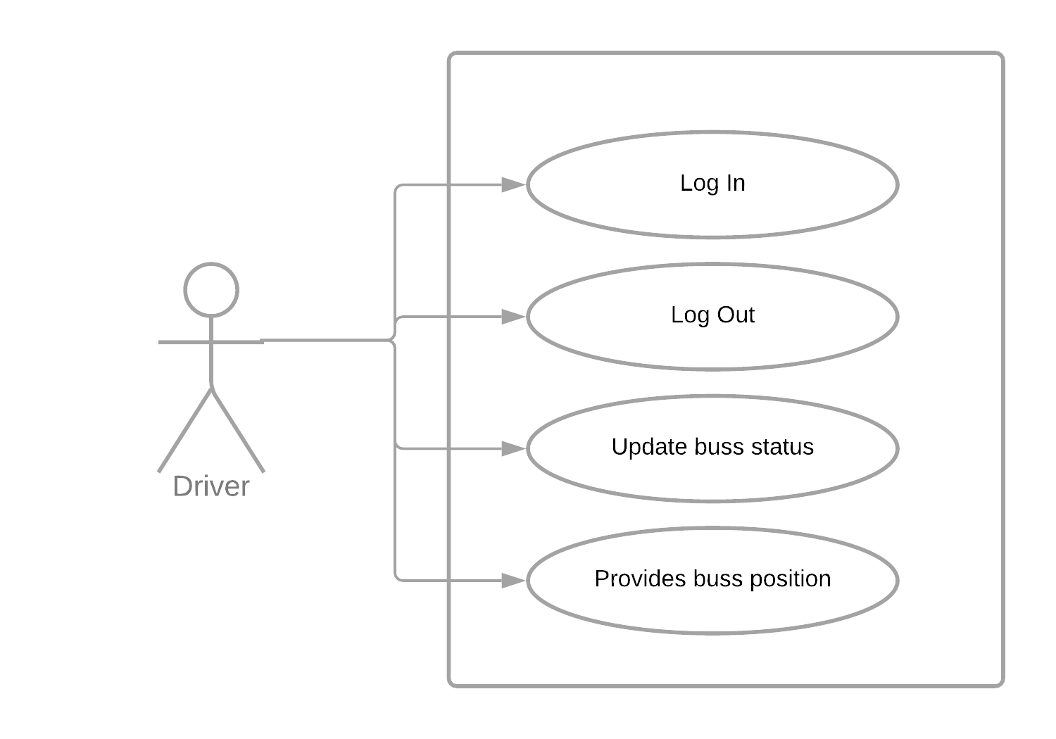

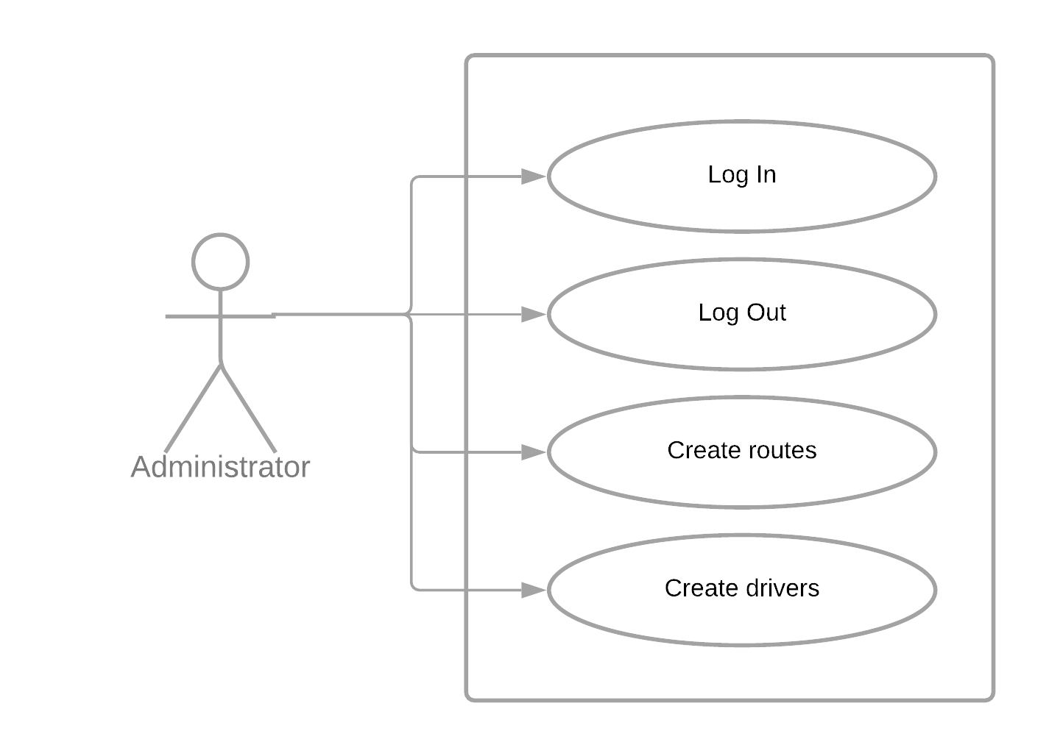

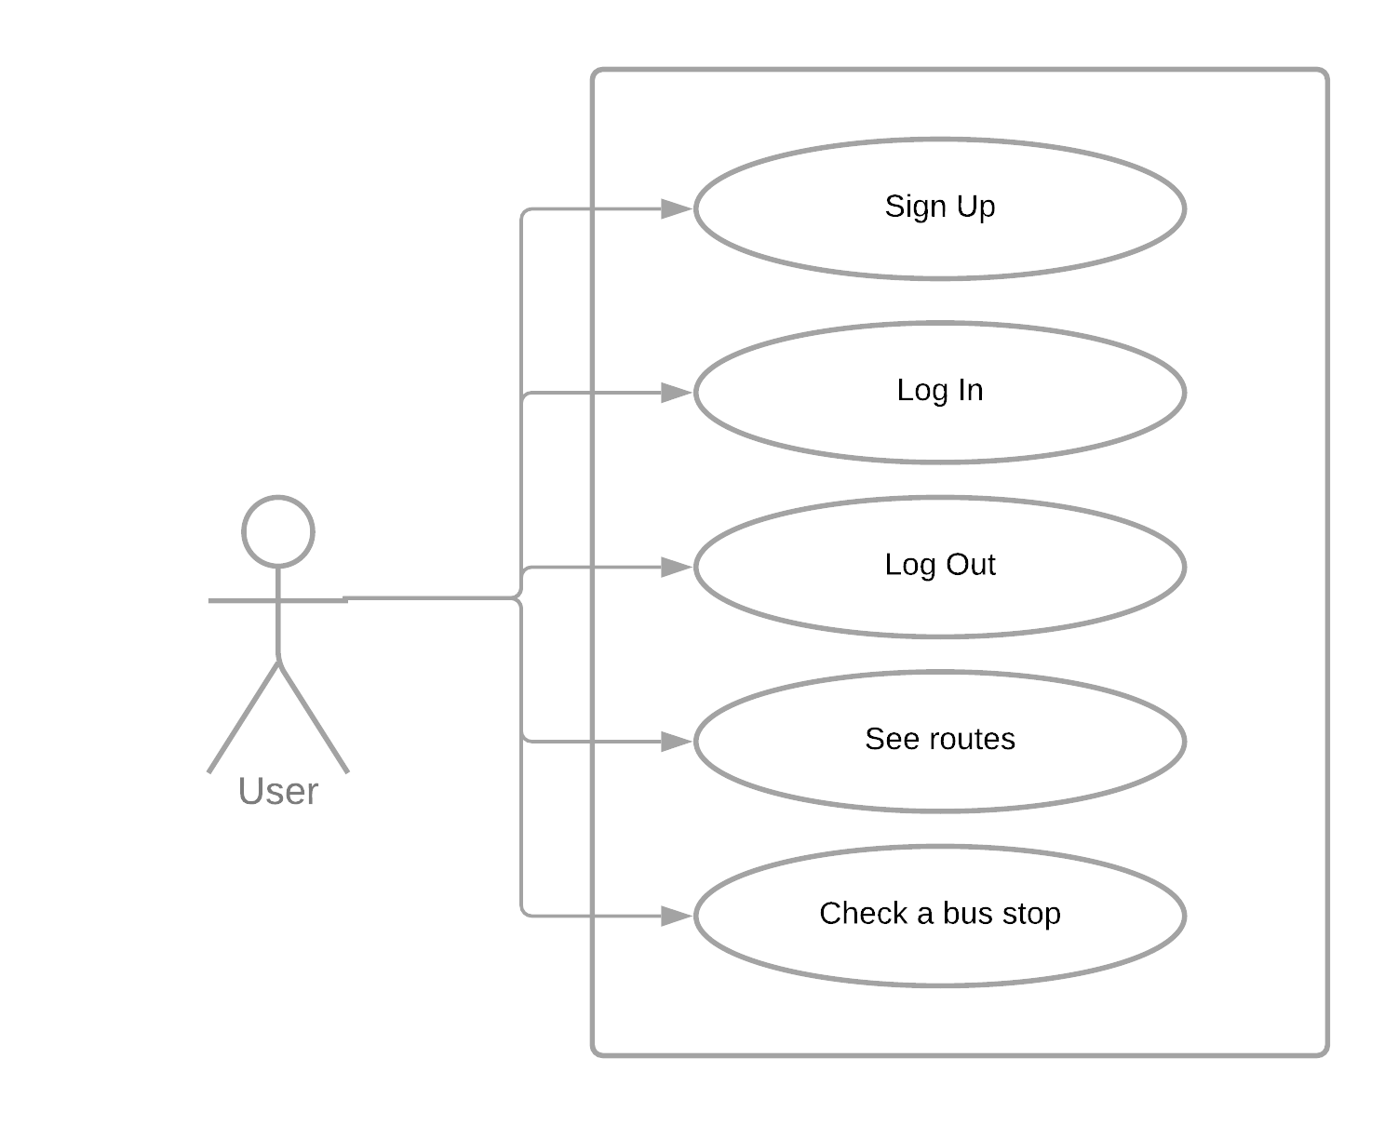

- System Architecture

- Design (aprox 12 UML Diagrams!!!)

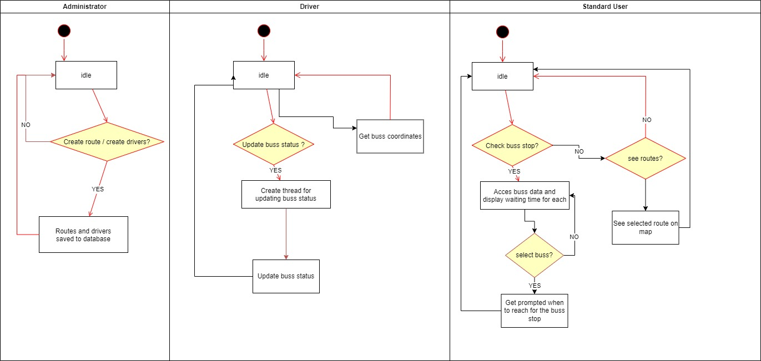
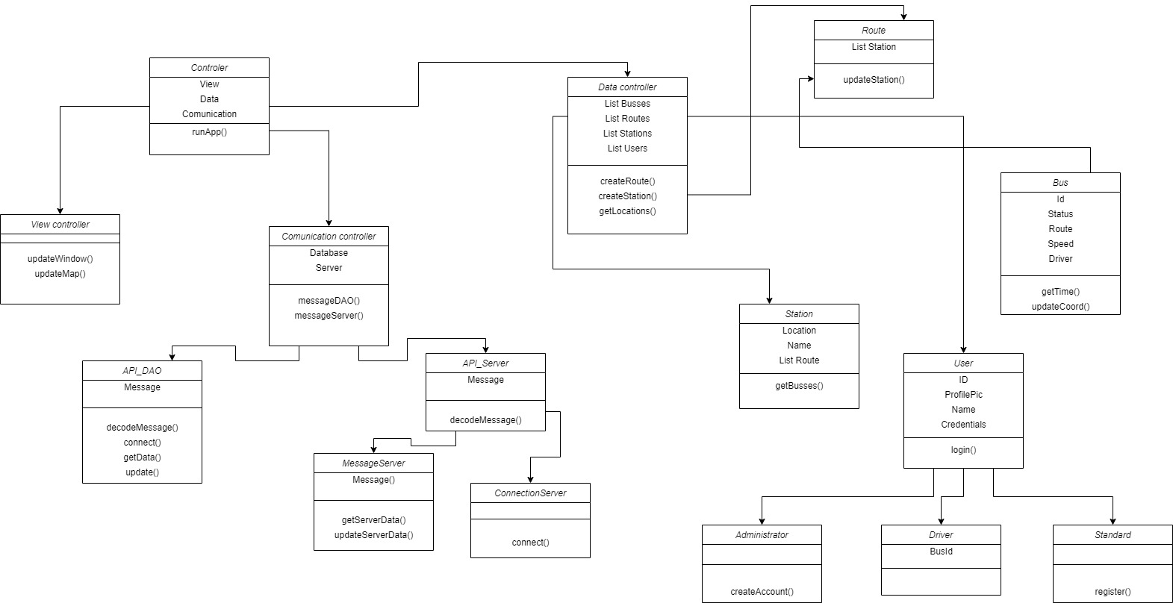
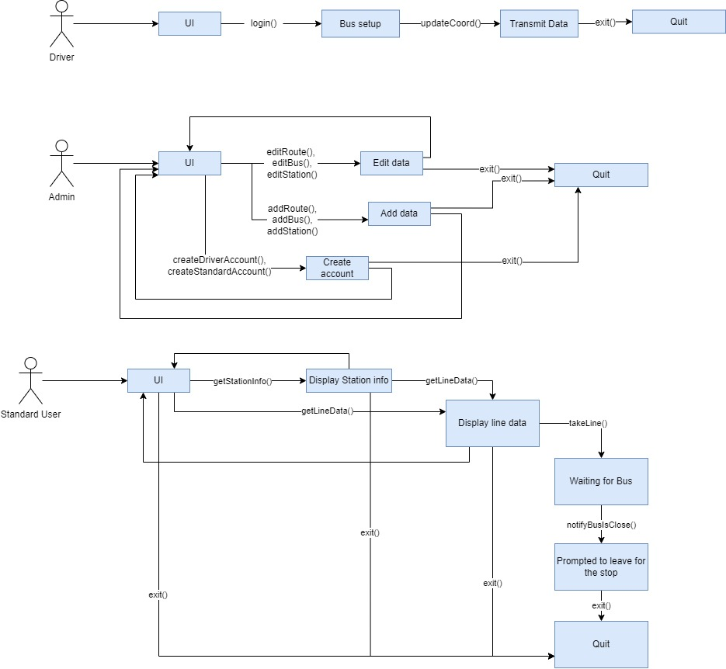
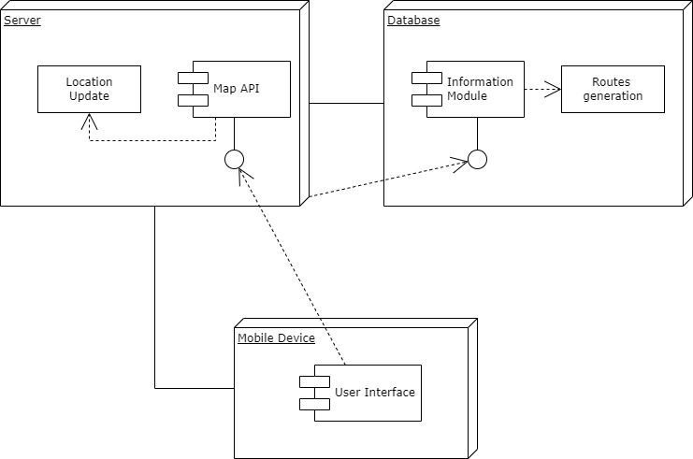
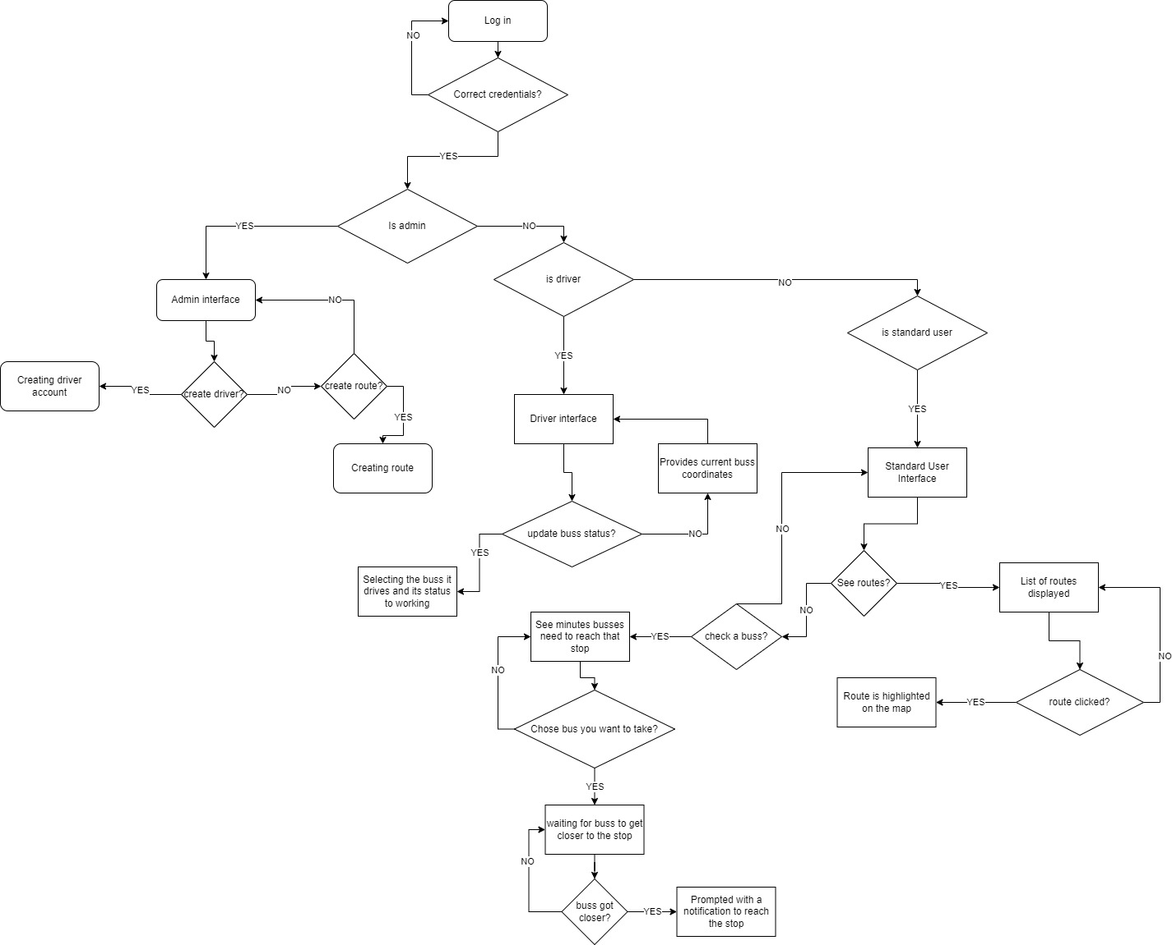
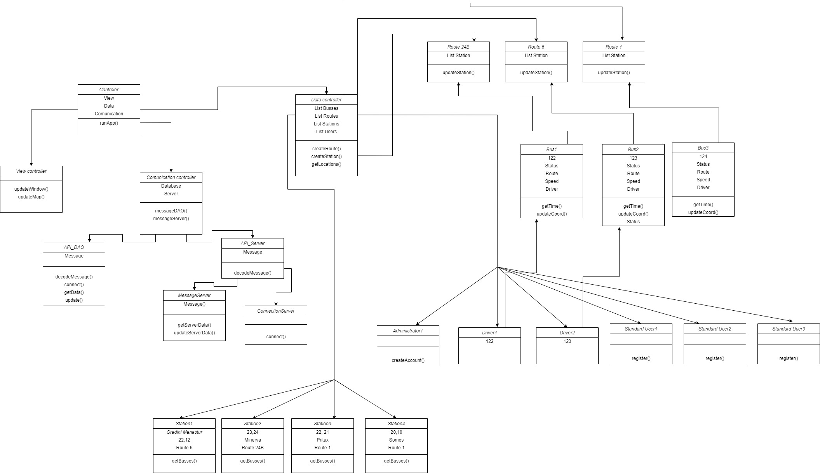
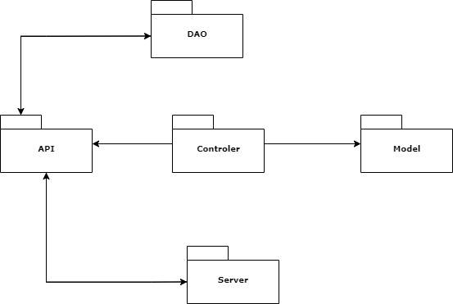
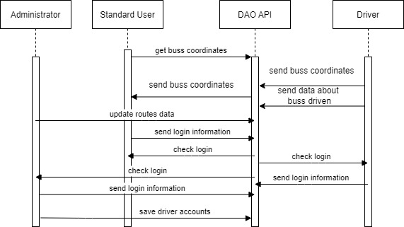
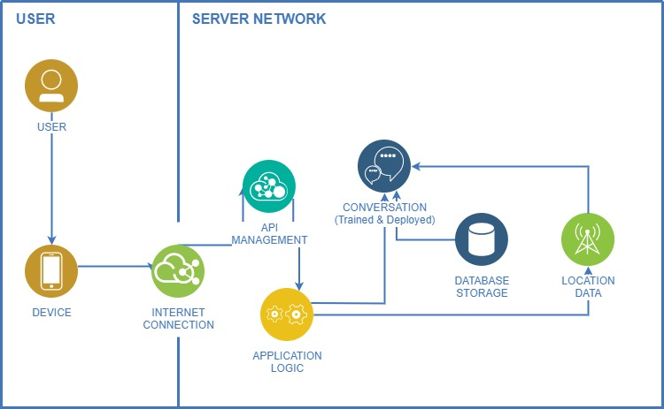
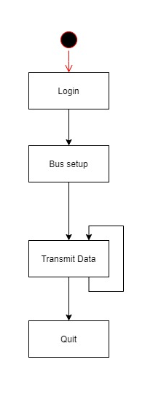
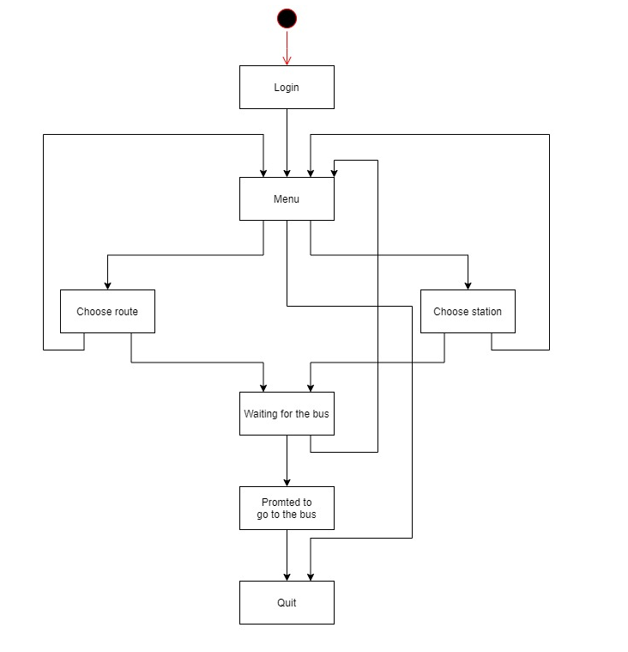
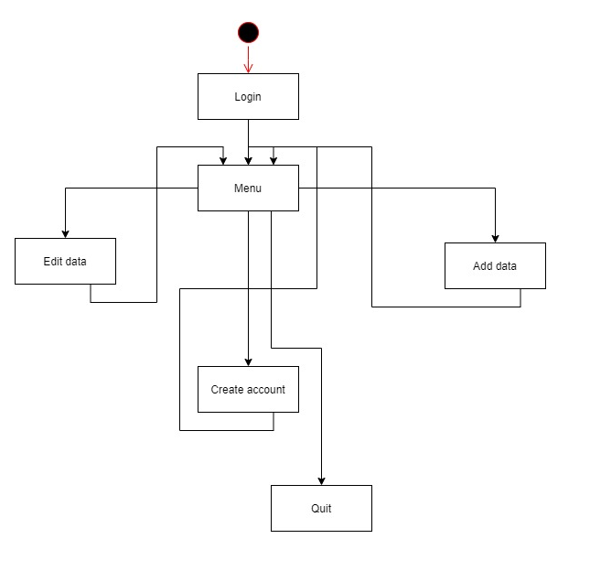

- Operation Mode (Interactivity presentation) + screen shots (UI design)

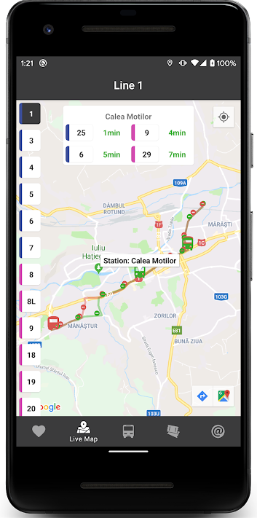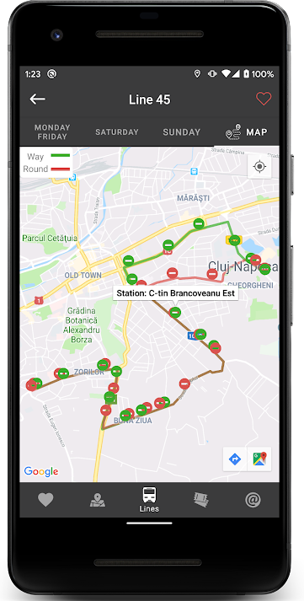

- Portability

Our BussTrack application is portable. It is a mobile application which currently runs on all android devices, whether it’s a phone, tablet or virtual machine.
All data is hosted on 24/7 running servers and so its always accessible from any device.
We are looking to expand our application for iOS lovers in the future but it will not be so soon as we focus on delivering quality first and then go wide.

- Competing software
The only competing software on the market is Bus Cluj-Napoca found in the Play Store, an app which crashes and it is out of service since 31th of October.

