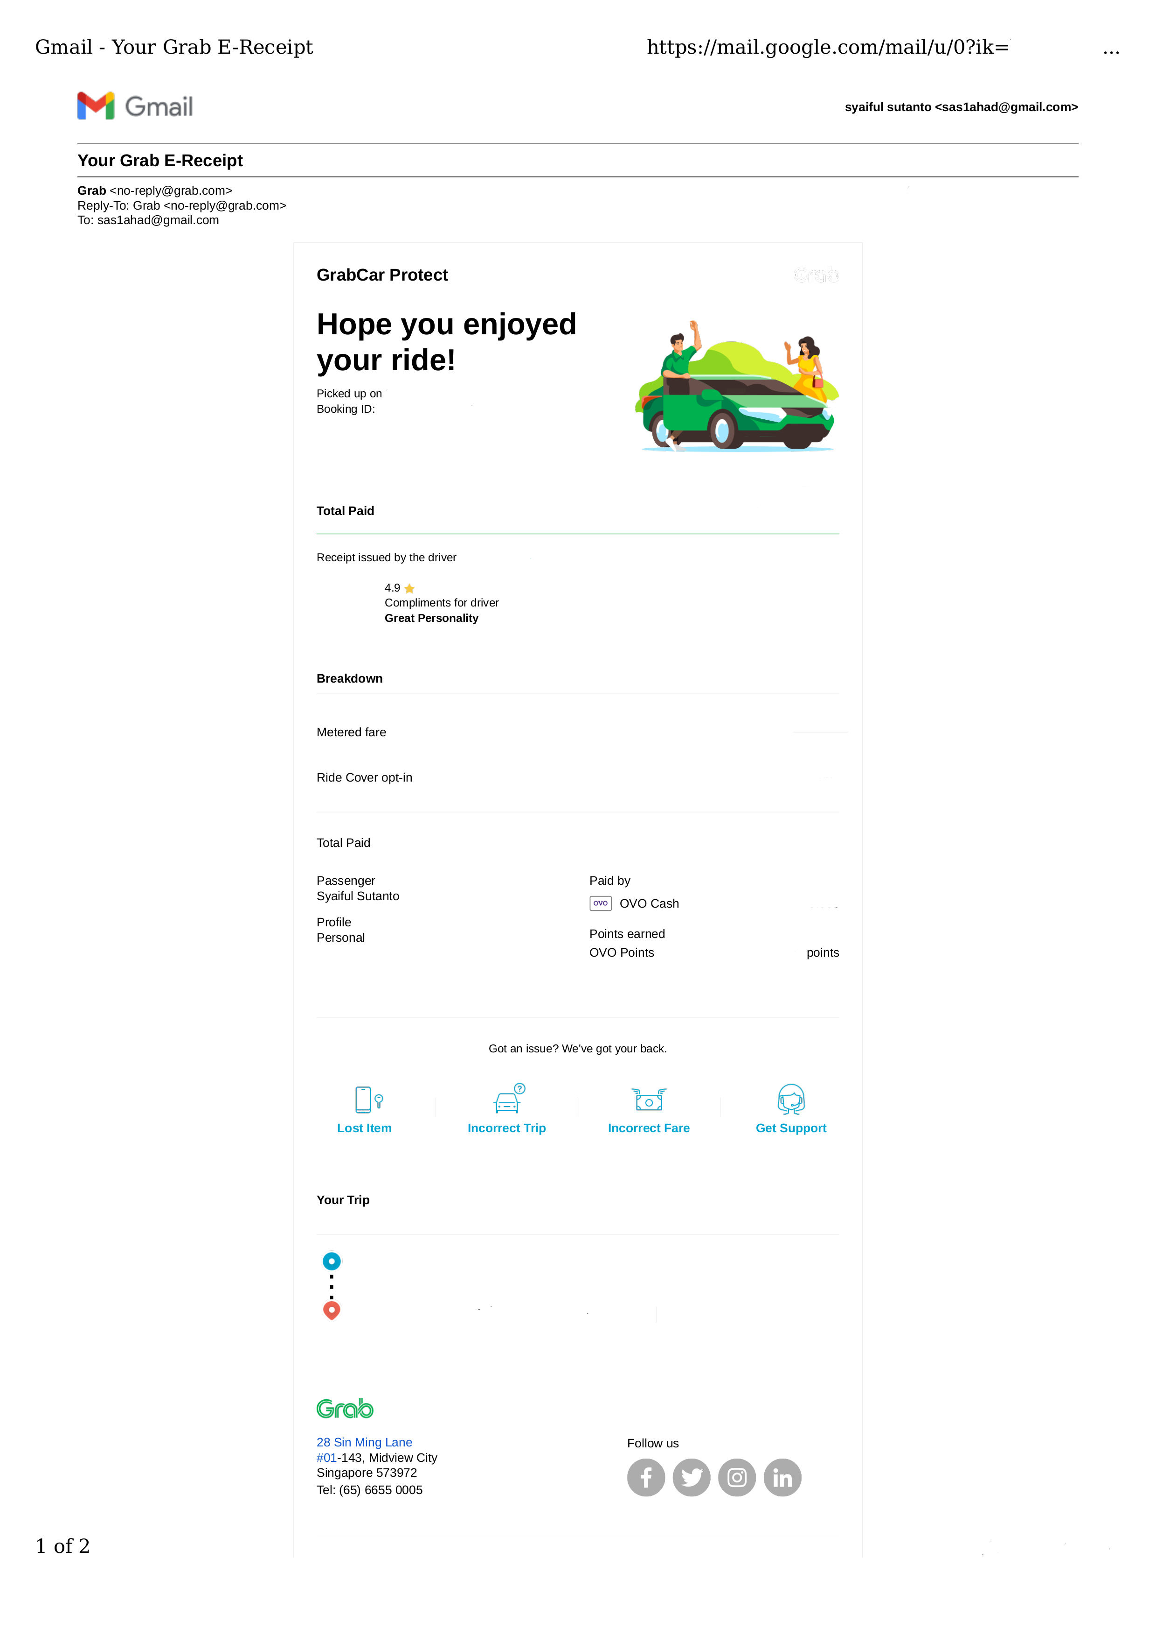

{{ tgl }}

{{ book }}

{{ pick }}

{{ takh }}

{{ tawl }}

{{ awal }}

{{ akhir }}

**{{ paid }}**

{{ ovo }}

{{ point }}

{{ fare }}

{{ trip }}

{{ t_fare }}

{{ opt }}