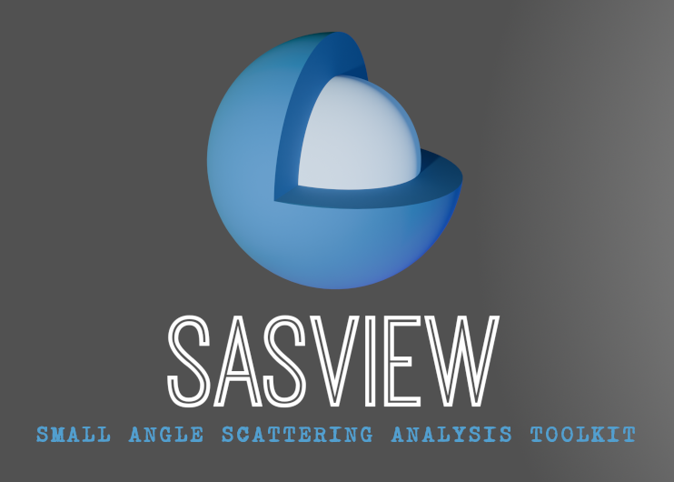
±3
+3
−3
+1
−1
Ri
Ri

SasView Tutorials

Modifying Weights
in SasView Version 6

www.sasview.org

Preamble

SasView was originally developed by the University of Tennessee as part of the Distributed Data Analysis of Neutron Scattering Experiments (DANSE) project funded by the US National Science Foundation (NSF), but is currently being developed as an Open Source project hosted on GitHub and managed by a consortium of scattering facilities. Participating facilities include (in alphabetical order): the Australian National Science & Technology Centre for Neutron Scattering, the Diamond Light Source, the European Spallation Source, the Federal Institute for Materials Research and Testing, the Institut Laue Langevin, the ISIS Pulsed Neutron & Muon Source, the National Institute of Standards & Technology Center for Neutron Research, the Oak Ridge National Laboratory Neutron Sciences Directorate, and the Technical University Delft Reactor Institute.

SasView is distributed under a 'Three-clause' BSD licence which you may read here:
https://github.com/SasView/sasview/blob/master/LICENSE.TXT

SasView is free to download and use, including for commercial purposes.

© 2009-2024 UMD, UTK, NIST, ORNL, ISIS, ESS, ANSTO, ILL, TUD, DLS, BAM

If you make use of SasView

If you use SasView to do productive scientific research that leads to a publication, we ask that you acknowledge use of the program with the following text:

This work benefited from the use of the SasView application, originally developed under NSF Award DMR-0520547. SasView also contains code developed with funding from the EU Horizon 2020 programme under the SINE2020 project Grant No 654000.

Contributors to this Tutorial

Miguel Gonzalez (gonzalezm@ill.fr)
Steve King (stephen.king@stfc.ac.uk)

Last revised: 22 August 2024

Acknowledgements

The option to modify the weights of each data set was originally coded by Iestyn Cadwallader-Jones, during an internship at the ILL in 2021. Useful discussions about the limitations and the dangers of this approach with Paul Kienzle, Lionel Porcar, Paul Butler, Wojciech Potrzebowski, Stephen King, Najet Mahmoudi, Sylvain Prevost, and Tim Snow are gratefully acknowledged.
As a pre-requisite to this tutorial is is assumed that the reader is familiar with using SasView to simultaneously fit datasets as covered in the tutorial simultaneous_1d_fitting_in_sasview.

The program interface shown in this tutorial is a pre-release development version of SasView Version 6.0.0 running on a Windows platform but, apart from a few small differences in look and functionality, this tutorial is generally applicable to any version of SasView Version 6.x on any platform.

The functionality described in this tutorial is not available in earlier versions of SasView.

