
±3
+3
−3
+1
−1
Ri
Ri

SasView Tutorials

Correlation Function Analysis
in SasView Version 6

www.sasview.org

Preamble

SasView was originally developed by the University of Tennessee as part of the Distributed Data Analysis of Neutron Scattering Experiments (DANSE) project funded by the US National Science Foundation (NSF), but is currently being developed as an Open Source project hosted on GitHub and managed by a consortium of scattering facilities. Participating facilities include (in alphabetical order): the Australian National Science & Technology Centre for Neutron Scattering, the Diamond Light Source, the European Spallation Source, the Federal Institute for Materials Research and Testing, the Institut Laue Langevin, the ISIS Pulsed Neutron & Muon Source, the National Institute of Standards & Technology Center for Neutron Research, the Oak Ridge National Laboratory Neutron Sciences Directorate, and the Technical University Delft Reactor Institute.

SasView is distributed under a 'Three-clause' BSD licence which you may read here:
https://github.com/SasView/sasview/blob/master/LICENSE.TXT

SasView is free to download and use, including for commercial purposes.

© 2009-2025 UMD, UTK, NIST, ORNL, ISIS, ESS, ANSTO, ILL, TUD, DLS, BAM

If you make use of SasView

If you use SasView to do productive scientific research that leads to a publication, we ask that you acknowledge use of the program with the following text:

This work benefited from the use of the SasView application, originally developed under NSF Award DMR-0520547. SasView also contains code developed with funding from the EU Horizon 2020 programme under the SINE2020 project Grant No 654000.

Contributors to this Tutorial

Steve King (stephen.king@stfc.ac.uk)
Piotr Rozyczko (piotr.rozyczko@esss.se)
Wojciech Potrzebowski (wojciech.potrzebowski@esss.se)

Revisions

Last revised: 27 May 2025

Acknowledgements

The correlation function analysis used in earlier versions of SasView was originally coded by Adam Washington at Sheffield University, UK and released on GitHub under an MIT License (https://github.com/rprospero/corfunc-py). It was incorporated into SasView by ISIS Summer Student Lewis O’Driscoll in 2016. However, the inspiration for that code lies in a much earlier piece of software, CORFUNC, developed by Tom Nye (then an undergraduate mathematician at Cambridge University, UK) in 1994 at the request of (now Prof) Tony Ryan (whilst seconded to the Daresbury SRS). CORFUNC was later released as part of the CCP13 software suite for Fibre & Polymer Diffraction. The source code for CORFUNC is available at https://github.com/scattering-central/CCP13.

In SasView 6.x the correlation function analysis has been completely refactored from first principles by Lucas Wilkins at ISIS. It may not, therefore, nor should it necessarily be expected to, exactly reproduce the output from the earlier codes.

SK would like to thank Elliot Gilbert (ANSTO) for prompting a more careful analysis of the data in Example 1.

Learning Objective

This tutorial will demonstrate how to perform correlation function analysis on 1D (‘intensity’ versus Q) datasets in SasView 6.x. This analysis was not available before Version 4.1.0.

It is assumed that the reader has some familiarity with the purpose and principles of correlation function analysis. If not, these references provide an overview:

- Ruland, W. Coll. Polym. Sci. (1977), 255, 417-427
- Strobl, G.R.; Schneider, M. J. Polym. Sci. (1980), 18, 1343-1359
- Koberstein, J.; Stein R. J. Polym. Sci. Phys. Ed. (1983), 21, 2181-2200
- Baltá Calleja, F.J.; Vonk, C.G. X-ray Scattering of Synthetic Poylmers, Elsevier. Amsterdam (1989), 247-270
- Göschel, U.; Urban, G. Polymer (1995), 36, 3633-3639
- Stribeck, N. X-ray Scattering of Soft Matter, Springer-Verlag. Berlin Heidelberg (2007), Section 8.5
- https://www.diamond.ac.uk/Instruments/Soft-Condensed-Matter/small-angle/SAXS-Software/CCP13/Fibre-Diffraction-Review.html (Issue 3)
- https://www.sasview.org/docs/user/qtgui/Perspectives/Corfunc/corfunc-theory.html

Also note that the integrals applied by the correlation function analysis in SasView (see page 15) assume that the data being transformed was either collected on a pinhole-collimated instrument or, if it was instead collected on a slit-collimated instrument, that it has been suitably Lorentz-corrected. Transforming slit-smeared data directly will generate invalid output.

The program interface shown in this tutorial is SasView Version 6.0.1 running on Windows 11 but, apart from a few small differences in look and functionality, this tutorial is generally applicable to SasView 6.x running on any platform. However, there are separate tutorials for using the old program interface released with SasView 4.x and SasView 5.x.

Glossary

a priori information | Known facts about the system/datasets being analysed.
Correlation function | A real-space function that describes spatial relations in the system whose datasets are being analysed. The greater the degree of structural order in the system, the more periodicity the correlation function will display. In essence, the correlation function is a density probability function.
Correlation length | A measure of the periodicity of a correlation function.
Extrapolation | A mathematical process for inferring unknown values, or extending a function beyond known limits, using trends in known data or established dependencies.
Fourier Transform | A mathematical ‘tool’ that decomposes a measured signal into a sum of sine or cosine functions.
Invariant | Also called the Porod Invariant, the Scattering Invariant, and the Total Scattering:
Inverse-space | See reciprocal-space
Long Period | In a lamellar system, the distance from one face of a lamellae to the same face of the adjacent lamellae.
Real-space | Real world coordinates. The opposite of inverse-space or reciprocal space.
Reciprocal-space | The Fourier Transform of real world coordinates. The opposite of real-space. In scattering measurements, Q is the reciprocal-space equivalent of a real world length scale.
SLD | Abbreviation for Scattering Length Density, a measure of the ability of a molecule to scatter. Strictly speaking, SLD is a SANS quantity, so if fitting SAXS data use electron density values in their place.  SLD values (neutron and X-ray) can be calculated with the SLD Calculator Tool in SasView.
Total Scattering | See Invariant
Transformation | A mathematical process for converting between real-space and inverse-space.
Uncertainties | Every experimental measurement, including the measurement of I(Q), is subject to some degree of error (which will, ideally, be included in the dataset). Similarly, the parameters returned by any analysis will have some associated range of uncertainty.  Parameters with uncertainties that are more than 95% of the parameter value should be viewed with deep suspicion.
Running SasView

Windows
Either select SasView from ‘Start’ > ‘All Programs’ (if using Windows 10), or click on the magnifying glass icon in the toolbar and type ‘SasView’ into the search box (if using Windows 11) or, if you asked the installer to create one, double-click on the SasView desktop icon.


Mac OS
Go in to your ‘Applications’ folder and select SasView.

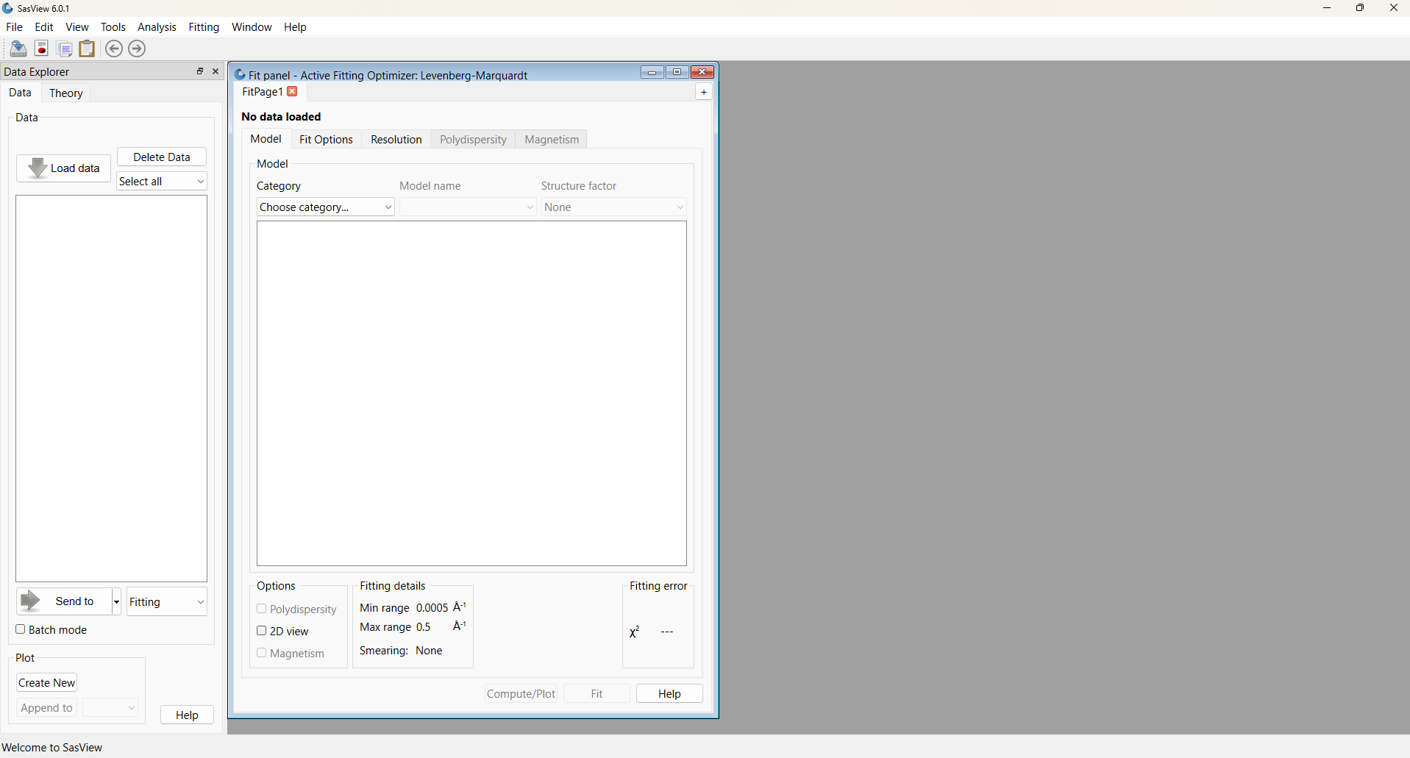

Example 1

This computes the correlation function from a quasi-lamellar system and then interprets that correlation function to extract parameters characterising the underlying nanostructure. This is a typical use case.

In the Data Explorer panel, click the Load Data button, and navigate to the \example_data\1d_data folder in the SasView installation directory.
Select the ISIS_98929.txt dataset and click the Open button.

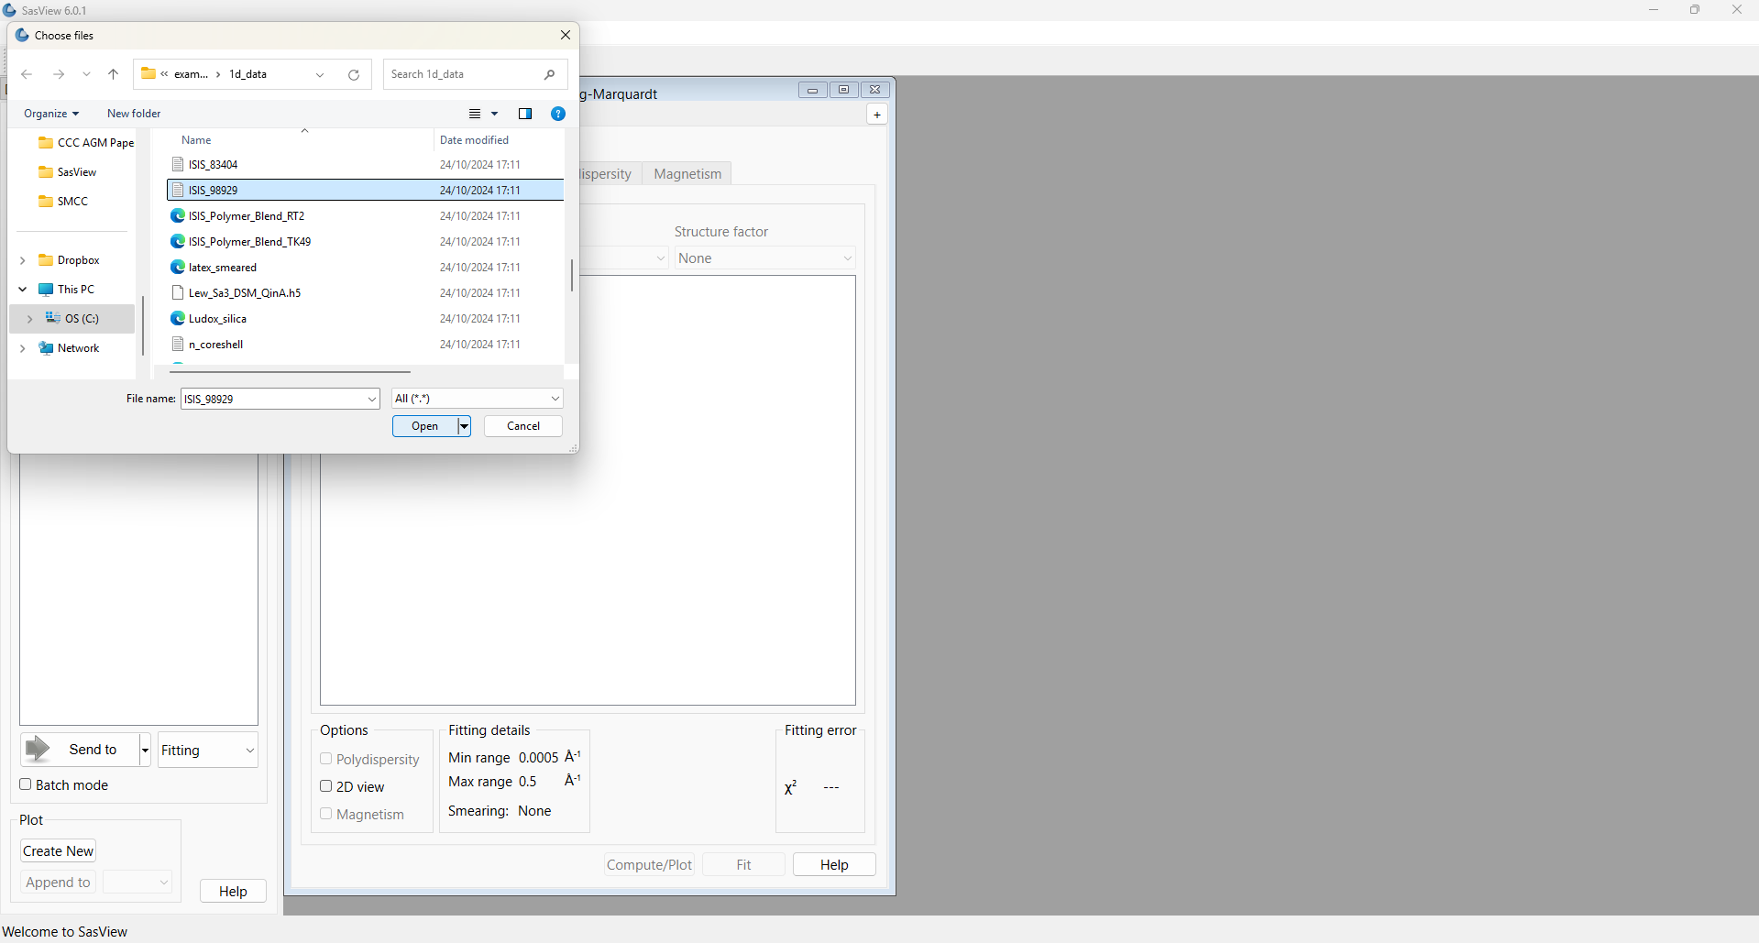
This dataset is the SANS from fibres of nylon-6 (polyamide-6) hydrated with heavy water. The fibres are aligned perpendicular to the neutron beam and parallel to the detector meridian.

Nylon is a semi-crystalline polymer, meaning it is composed of alternating regions of crystalline (more dense) and amorphous (less dense) polymer, giving it a quasi-lamellar microstructure. When hydrated, water molecules preferentially locate to the amorphous regions. If heavy water is used the SLD of the amorphous regions is enhanced relative to the SLD of the crystalline regions.

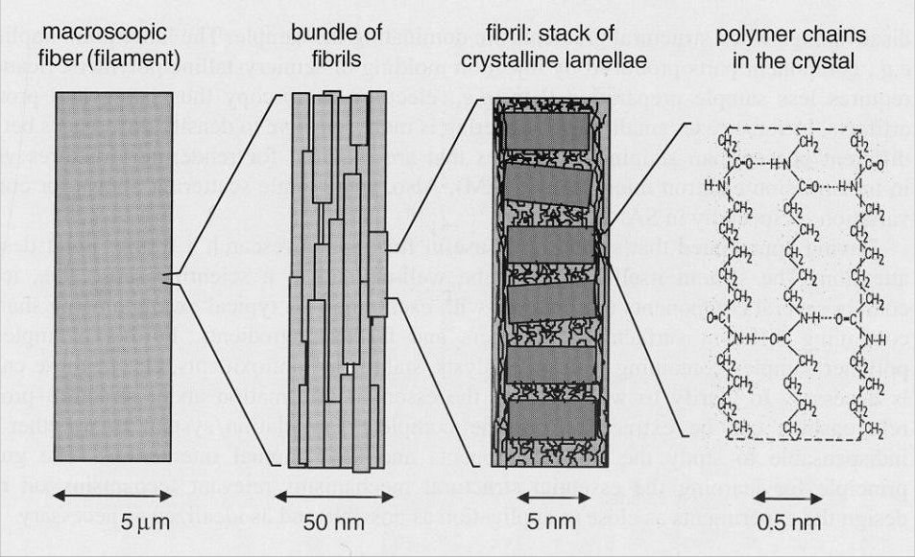
T
The hierarchical structure of nylon fibres. Figure reprinted from “Use of scattering methods in chemical
industry - SAXS and SANS from fibers and films”. Chapter 21, in “Neutrons, X-rays and Light:
Scattering Methods Applied to Soft Condensed Matter”. Lindner & Zemb (editors), North-Holland. 2002.

This periodicity in the nanostructure manifests itself as a peak in the scattering data.

At the bottom of the Data Explorer panel, click the drop-down that currently says ‘Fitting’ and select Corfunc. The Fit Panel transforms into a Corfunc Perspective page.

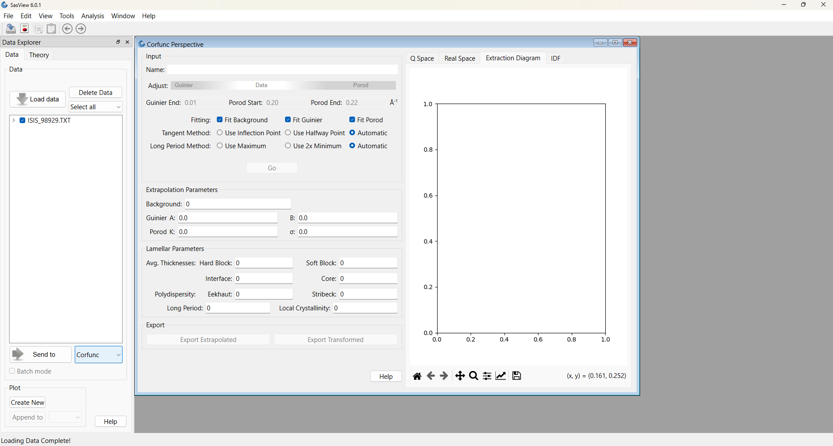
Then click the Send to button.

The measured data is displayed in the graph window along with three vertical bars.
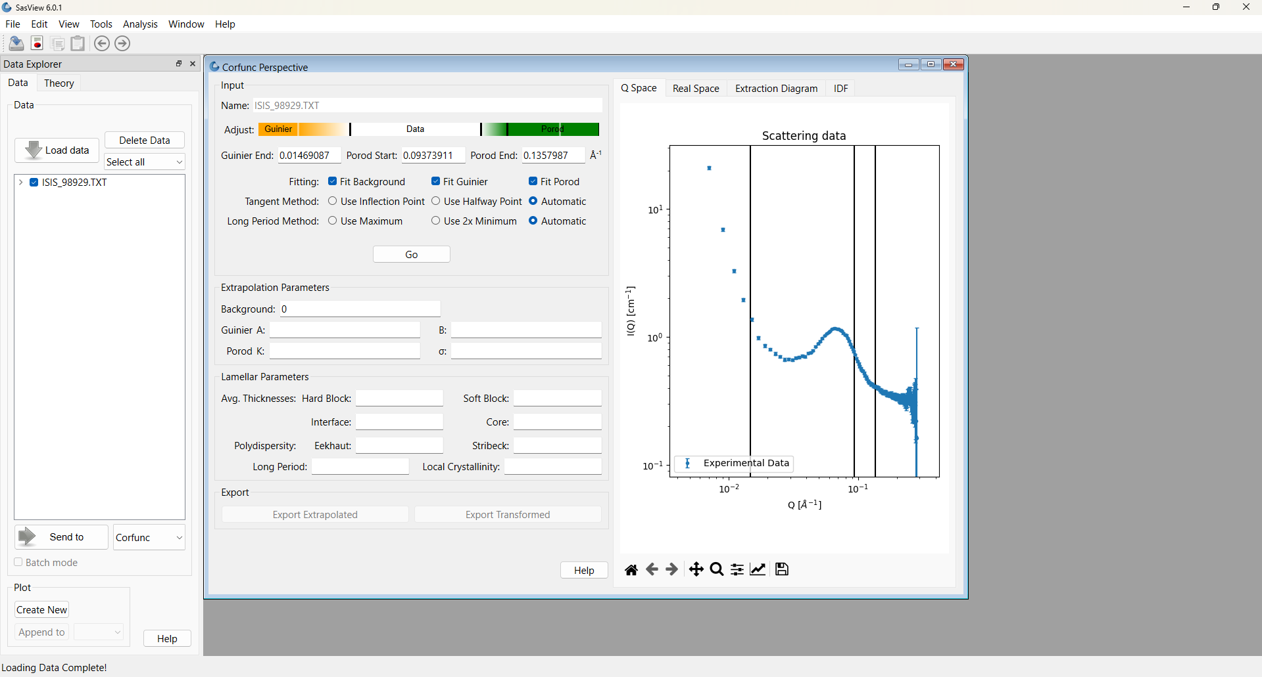

Tip: If you want to change the axis scales or to alter the appearance of the plot, click on the ‘rising arrow’ arrow icon (“Edit axis, curve and image parameters”) in the plot toolbar.

The correlation function is computed by taking the (cosine) Fourier Transform of the scattering data. However, this requires performing an integration between Q=0 and Q=∞, and quite clearly the measured data do not extend to those limits (and nor could they)! The prerequisite, therefore, is to extrapolate the measured data towards those limits.

The three vertical bars represent the limits of the measured data that will be used to construct the extrapolation functions. In the case of the low-Q extrapolation, all data to the left of the leftmost vertical bar is used. In the case of the high-Q extrapolation, data between the two rightmost vertical bars is used.

Aside: At the present time, SasView extrapolates the measured data with the following functions:

Low-Q | High-Q
Guinier function | Porod function

where B is proportional to a radius-of-gyration, σ is a measure of how abruptly the SLD changes between the quasi-lamellar regions (σ ≥ 0; 0 represents a step function), and Bg is a Q-independent background level. A and K are just scale factors with ln(A) = I(Q=0).

Though the Guinier function may be a dubious description of the low-angle scattering from some systems, because of the transformation from reciprocal-space to real-space any artefacts that the use of this function introduces only manifest themselves in the region of the correlation function where the density probability is close to zero anyhow.

Conversely, the quality of the high-Q extrapolation is much more important, so consider carefully which data points to include between the limit bars. Do not include any data points within the peak itself. In lieu of infinity, SasView computes the high-Q extrapolation out to 100 times the largest Q value in the measured dataset.

The default positions of the limit bars need adjustment. In particular, the high-Q limits span a break of slope which the Porod extrapolation procedure will struggle with.

Tip: You can change the default extrapolation ranges in the Corfunc Perspective page either by typing appropriate Q-values in the “Guinier End”, “Porod Start” and “Porod End” boxes, or by grabbing and moving the black bars in the multicolour “Adjust” tool (the grey bars represent the data limits).

You cannot grab and move the limit bars on the plot itself, but their positions will update on the plot in response to your inputs above.

For this example, first change the low-Q extrapolation limit to 0.011. This should give three data points for the Guinier fit.

Now make the upper limit for the high-Q extrapolation (the rightmost vertical bar) to be the penultimate data point (Q=0.283), as the last data point has a large uncertainty. In fact, if you try setting Q=0.285 the box will turn red as a warning it is the last data point!

The positioning of the lower limit for the high-Q extrapolation is more arbitrary but, as explained above, also more important. We need to encompass sufficient data points to give a good extrapolation but not so many that the extrapolation is impacted by the tail of the peak in the data. Try a lower limit of Q=0.128.

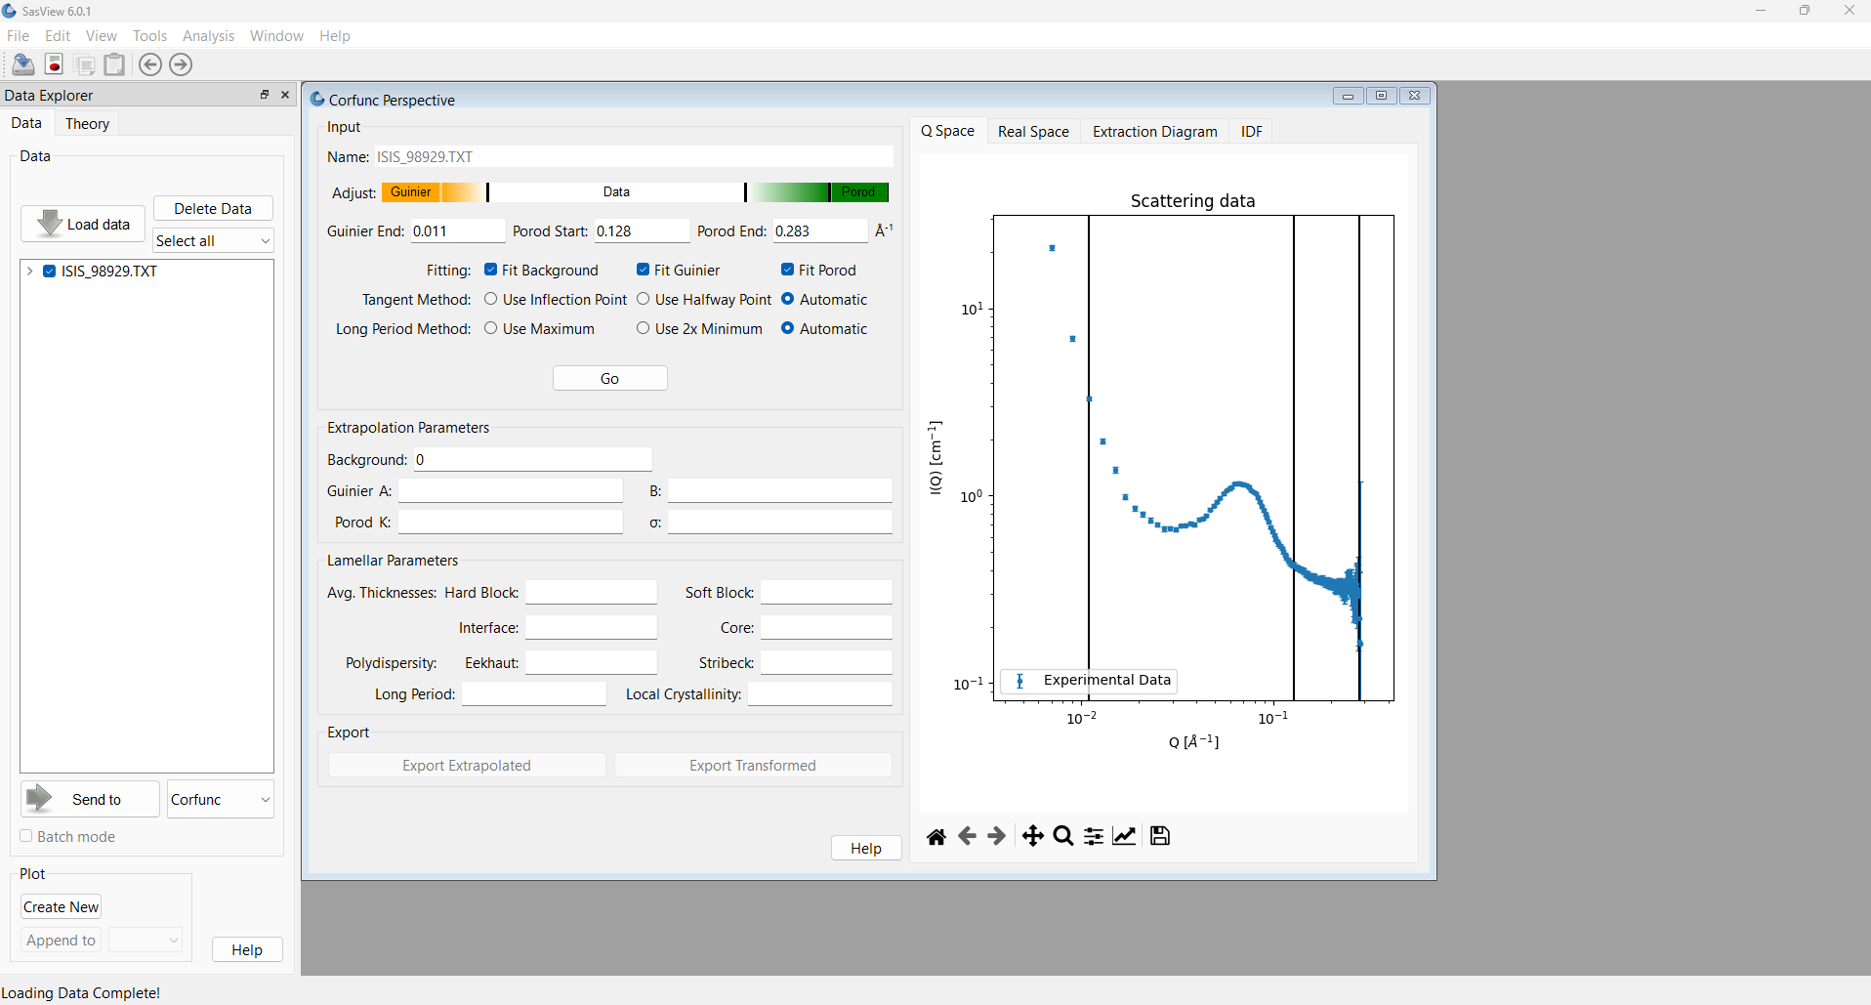
At this point, in SasView 4.x/5.x, you would now perform the low- and high-Q extrapolations, before transforming the extrapolated data. And then, should you wish, get SasView to derive information from the computed correlation function. But those operations are completed as three separate steps. In SasView 6.x the three operations (extrapolation > transformation > extraction) have been combined into one step!

Just like in SasView 4.x/5.x, SasView 6.x still allows you to choose whether to have it automatically determine the background level and fit parameters for the Guinier and Porod extrapolations. Automatic determinations are selected by default.

If you uncheck any of these boxes, you will need to supply the relevant information in the Extrapolation Parameters section of the Corfunc Perspective (see the previous Aside box).

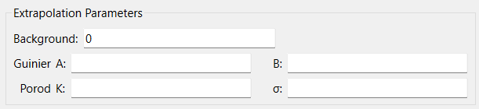

Aside: In SasView 4.x the program automatically subtracts the background level from the displayed data. In SasView 5.x and SasView 6.x the data are always displayed with the background still present.

Aside: Smoothing is applied to prevent the joins between the extrapolations and the measured dataset generating ‘ripples’ in the correlation function. At the same time it provides a means of giving the concatenated dataset equally spaced Q points which facilitates the Fourier Transform.

The algorithm used is described in more detail in the SasView documentation at: https://www.sasview.org/docs/user/qtgui/Perspectives/Corfunc/corfunc-technical.html#merging

Unlike SasView 4.x/5.x, SasView 6.x also gives additional control over how the correlation function is interpreted.

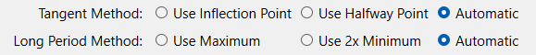

We will return to these options later. For now, leave both methods on the automatic setting.

We are now ready to compute the correlation function. So click the Go button.

After a few seconds, several things happen:

- SasView computes the low-Q and high-Q extrapolation functions; the values of A, B, K, σ, and Background are returned in the Extrapolation Parameters section of the Corfunc Perspective.

- The graph window updates to show an orange line; this is a smoothed concatenation of the low-Q extrapolation (from 0 ≤ Q < Q_{min}), the measured dataset (from Q_{min} ≤ Q ≤ Q_{max}), and the high-Q extrapolation (from Q_{max} < Q ≤ 100 x Q_{max}). Note that the full Q-range of the extrapolated data is not displayed for clarity!

- Unseen, correlation functions are computed from the extrapolated data.

- The correlation functions are interpreted assuming the presence of a quasi-lamellar structure and the resulting parameters are displayed in the Lamellar Parameters section of the Corfunc Perspective.

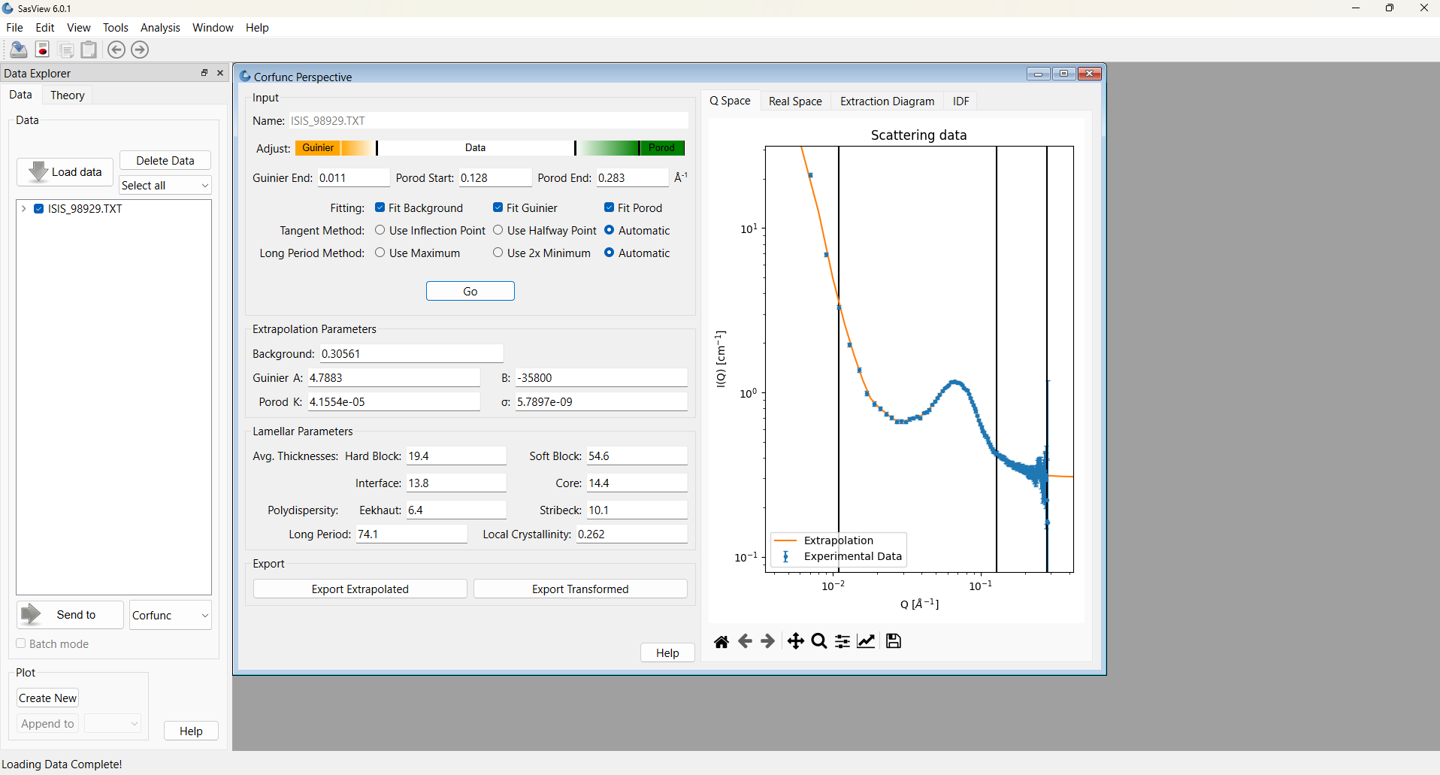

The essential outcome from extrapolation is that I(Q)_{extrapolation} is ~zero at high Q values. If this is not the case, manually adjust the Background and re-extrapolate. If the high-Q data are noisy then this may require several iterations.

The background value returned, 0.305, represents the background at 100 x Q_{max}. To check how well it represents the background level within the range of the experimental data, click on the magnifying glass icon at the bottom of the plot window and drag the cursor to expand just the high-Q region of the data.
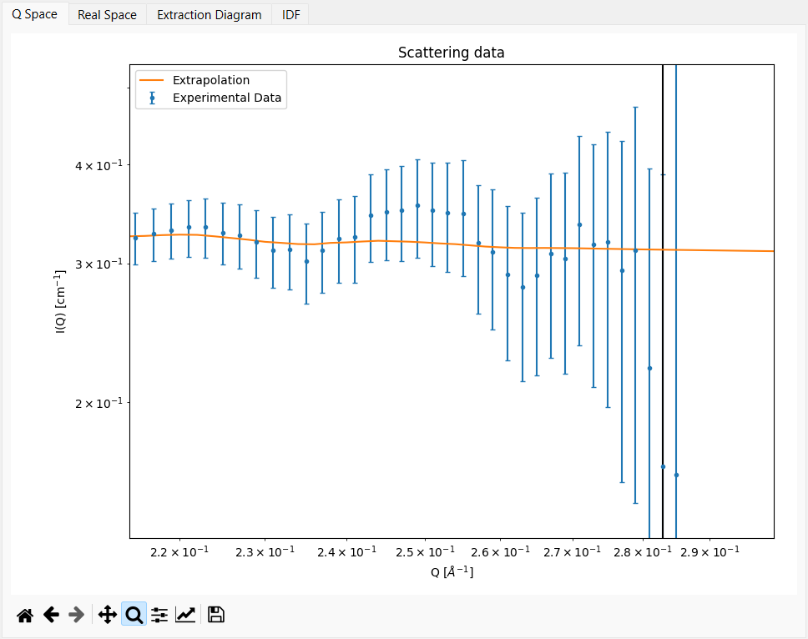

As can be seen above, it looks like it would be sensible to move the upper limit for the high-Q extrapolation in from Q=0.283 to Q=0.279.

Set this revised limit and click the Go button again. The background value increases slightly to 0.311.

Now click on the plot tab labelled ‘Real Space’. Two functions are displayed:

- Γ₁(z); the 1D Correlation Function
- Γ₃(z); the 3D-averaged (or ‘Radial’) Correlation Function
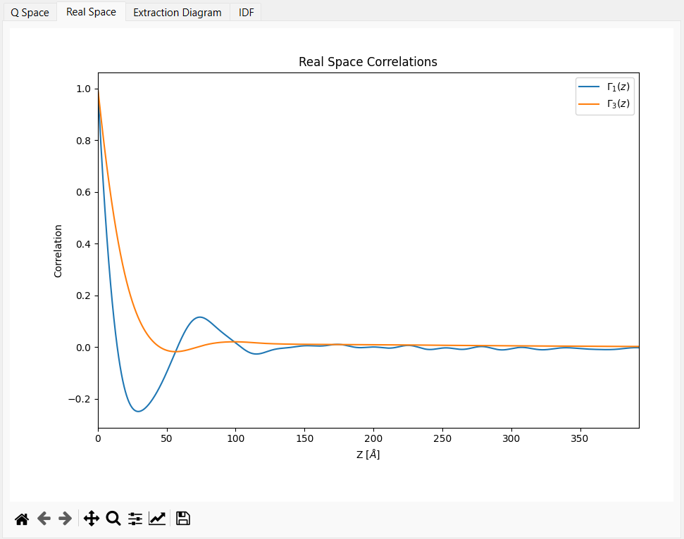

Both are damped oscillatory functions with the maxima denoting each new lamellar repeat. But notice that less structure is evident in Γ₃(z) because of the orientational averaging.

The reader may be familiar with pair distribution functions (usually abbreviated to PDF’s) from Total Scattering measurements. In the same way PDF’s describe the probability of finding two atoms separated by a given distance in a material, these correlation functions reflect the separation of similar SLD (and by inference, similar density).

Now click on the plot tab labelled ‘IDF’ to see the Interface Distribution Function, g₁(z).

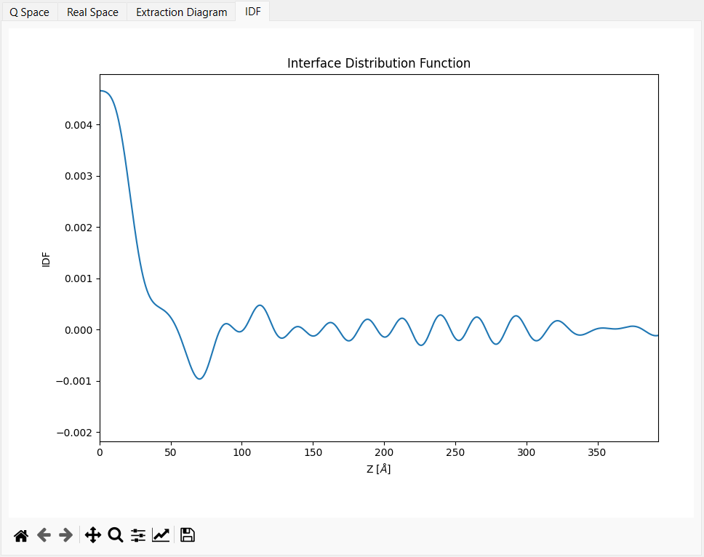
The IDF is a superposition of the thickness distributions from all the contributing lamellae.

Aside: The transforms that SasView computes are:

1D Correlation Function:

3D Correlation Function:

which is equivalent to computing:

Interface Distribution Function:

where Γ₁(0) = Γ₃(0) = 1, and g₁(0) ≥ 0.

The integral breadth of a correlation function is called the correlation length:

SasView has computed these transforms out to a real-space distance of, in this example, 1570 Å (given the input data were in Å⁻¹). But because the features of interest in the transforms are all at much smaller distances only a reduced range out to 390 Å is shown for clarity.

Having obtained the correlation functions it is always advisable to inspect them for artefacts from the Fourier Transform procedure:

- Do Γ₁(z) & Γ₃(z) smoothly curve into the ordinate at z=0? (sometimes overly small values of σ can cause the functions to meet the ordinate at a sharp angle)
  - This example: Yes
- Does Γ₁(0) = Γ₃(0) = 1?
  - This example: Yes
- Do Γ₁(z) & Γ₃(z) tend to 0 as z tends to ∞?
  - This example: Yes
- Are there ‘ripples’ in Γ₁(z) & Γ₃(z) with a period of? (ie, corresponding to the truncation point of the Fourier Transform)
  - This example: No (Q_{max} for this dataset was 0.285 Å⁻¹ so the period of these ripples would be ~0.2 Å)
- Are there ‘ripples’ in Γ₁(z) & Γ₃(z) with a period of? (ie, corresponding to the point at which the measured dataset was extrapolated to high-Q)
  - This example: Not obviously (Q_{max} for the extrapolation was 0.279 Å so the period of these ripples would be ~22 Å)
- Are there ‘ripples’ in Γ₁(z) & Γ₃(z) with a period of? (ie, corresponding to the point at which the measured dataset was extrapolated to low-Q)
  - This example: No (Q_{min} for this dataset was 0.007 Å so the period of these ripples would be ~900 Å)

and lastly:

- Do the principle peaks in Γ₁(z) & Γ₃(z) seem to correspond to expectations?!!!
  - This example: It is well-established that the quasi-lamellar repeat distance between the crystalline regions in hydrated nylon-6 is about 84±4 Å (see for example, King, S.M.; Bucknall, D.G. Polymer (2005), 46, 11424-11434). As can be seen the first prominent maximum in Γ₁(z) is around 74 Å, but the fact that it is not a sharp or symmetrical peak bears testament to an underlying distribution of imperfectly ordered spacings. So in general Γ₁(z) does seem believable. The maximum in Γ₃(z) is around 99 Å.

Tip: To save the data points for Γ₁(z), Γ₃(z) or g₁(z), simply click the Export Transformed button and they will be written to a text file. The format of this file is described in the Appendix. It is similarly possible to save the extrapolated dataset by clicking the Export Extrapolated button. A dialog window will appear requesting the Q-range and Q-interval, but note that this is pre-populated with the values from the loaded dataset (ie, without the extrapolations).

As we have the a priori information that this sample possesses a quasi-lamellar structure the final part of the analysis is to inspect the physical parameters SasView has derived from Γ₁(z). These are the values displayed in the Lamellar Parameters section of the Corfunc Perspective.

WARNING!
The Lamellar Parameters are garbage unless it is known that the scattering they are derived from is from a lamellar or quasi-lamellar nanostructure! So use them with caution!

Before we look at the values themselves it is first instructive to understand how they are derived.

Aside: Various procedures have been proposed to extract structural parameters from Γ₁(z). SasView uses the positions of the first local minima (with Γ₁(z) < 0) and local maxima (with Γ₁(z) > 0), along with the extrapolated intercept and gradient of the linear section between the ordinate at z=0 and the first local minima, as shown below. Note that in this figure x represents z.

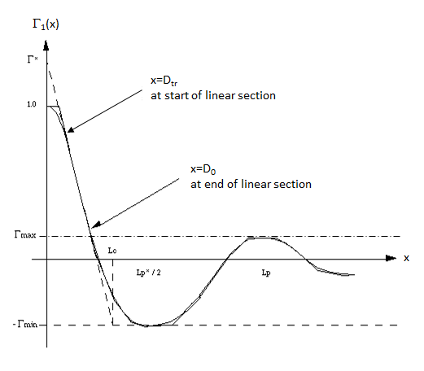
Schematic explanation of the extraction of ideal lamellar structural parameters from Γ₁(x).
Figure reprinted from “SAXS Correlation Function Analysis: Notes on the Software at Daresbury”. Nye. 1994.

From which:

Long Period L_{p}
Average Hard Block Thickness† L_{c}
Average Core Thickness D₀
Average Interface Thickness D_{tr}
Local Crystallinity L_{c} / L_{p} = Φ_{c}

Eeckhaut Polydispersity Γ_{min} / Γ_{max}
Stribeck Polydispersity L_{c} / ((L_{c} – L_{p}) Γ_{max})

and:

Average Soft Block Thickness† L_{p} – L_{c} = L_{a}
Average Chord Length ((1/L_{c}) + (1/L_{a}))⁻¹
Average Crystalline Chord Length ((1/L_{c}) + (1/L_{a}))⁻¹ / Φ_{c}
Non-Ideality (L_{p} – L_{p}*)² / L_{p}²

† “hard block” = crystalline, “soft block” = amorphous

For more information the reader is referred to the references provided at the start of this tutorial. But from the box above it should be clear that this is a semi-quantitative approach! The programmatic challenge then lies in devising robust algorithms to correctly identify the first local minima and maxima, D_{tr}, D₀ and L_{c}. Clearly, if Γ₁(z) exhibits too much noise/distortion incorrect interpretations will result.

To allow you gauge the confidence you can place in the lamellar parameters, SasView 6.x actually generates a plot of how it is interpreting Γ₁(z). To view it, click on the plot tab labelled ‘Extraction Diagram’.

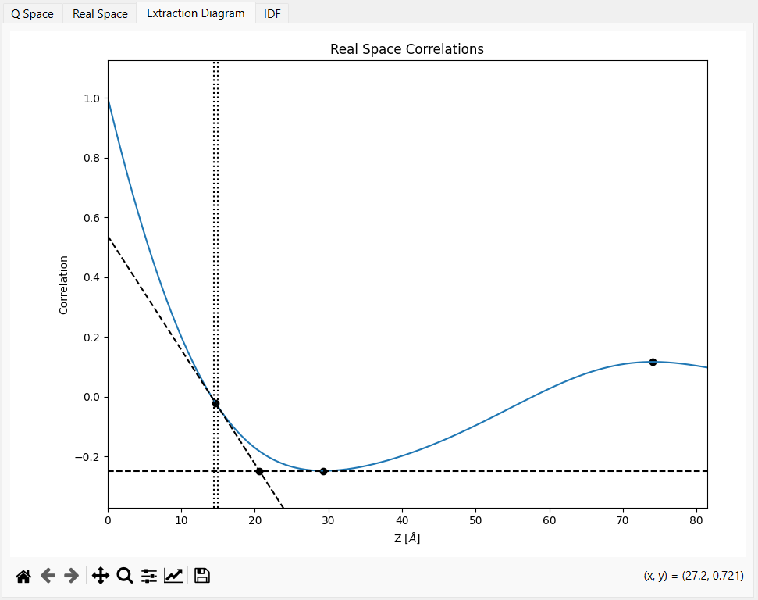
For this example SasView seems to have sensibly identified the key features. And the derived lamellar parameters are:
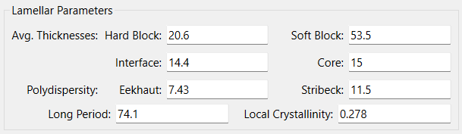

WARNING!
Although the Corfunc Perspective will ascribe values as representing the ‘hard’ (crystalline) or ‘soft’ (amorphous) regions of the nanostructure, because of Babinet’s Principle it actually has no way of knowing which is which! Responsibility for correctly reporting these parameters therefore lies with the user!

As mentioned at the start, for this particular example it is known that the peak in the SANS data, and therefore the peak in the correlation functions, comes from the ‘soft’ (amorphous) regions. This can be easily proven by hydrating the nylon fibres with a water mixture matched to the SLD of nylon; the peak then disappears!

In SasView 6.x two measures of the polydispersity are offered; one proposed by Guy Eeckhaut, the other proposed by Norbert Stribeck. Only the former value is reported by SasView 4.x/5.x.

It is then highly-recommended to conduct a ‘sensitivity check’ to see how Γ₁(z), Γ₃(z), g₁(z) and the extracted parameters change as the value of Bg is altered. To do this, simply untick Fit Background, change the value of the Background parameter, and then click Go.

Below we can see the effect of changing Bg from 0.31128 (the value above) to 0.3000 (ie, 3.6% less). Visually, only a very keen eye would spot the change in Γ₁(z) and Γ₃(z), but there is quite a dramatic change in g₁(z) around 45 Å.

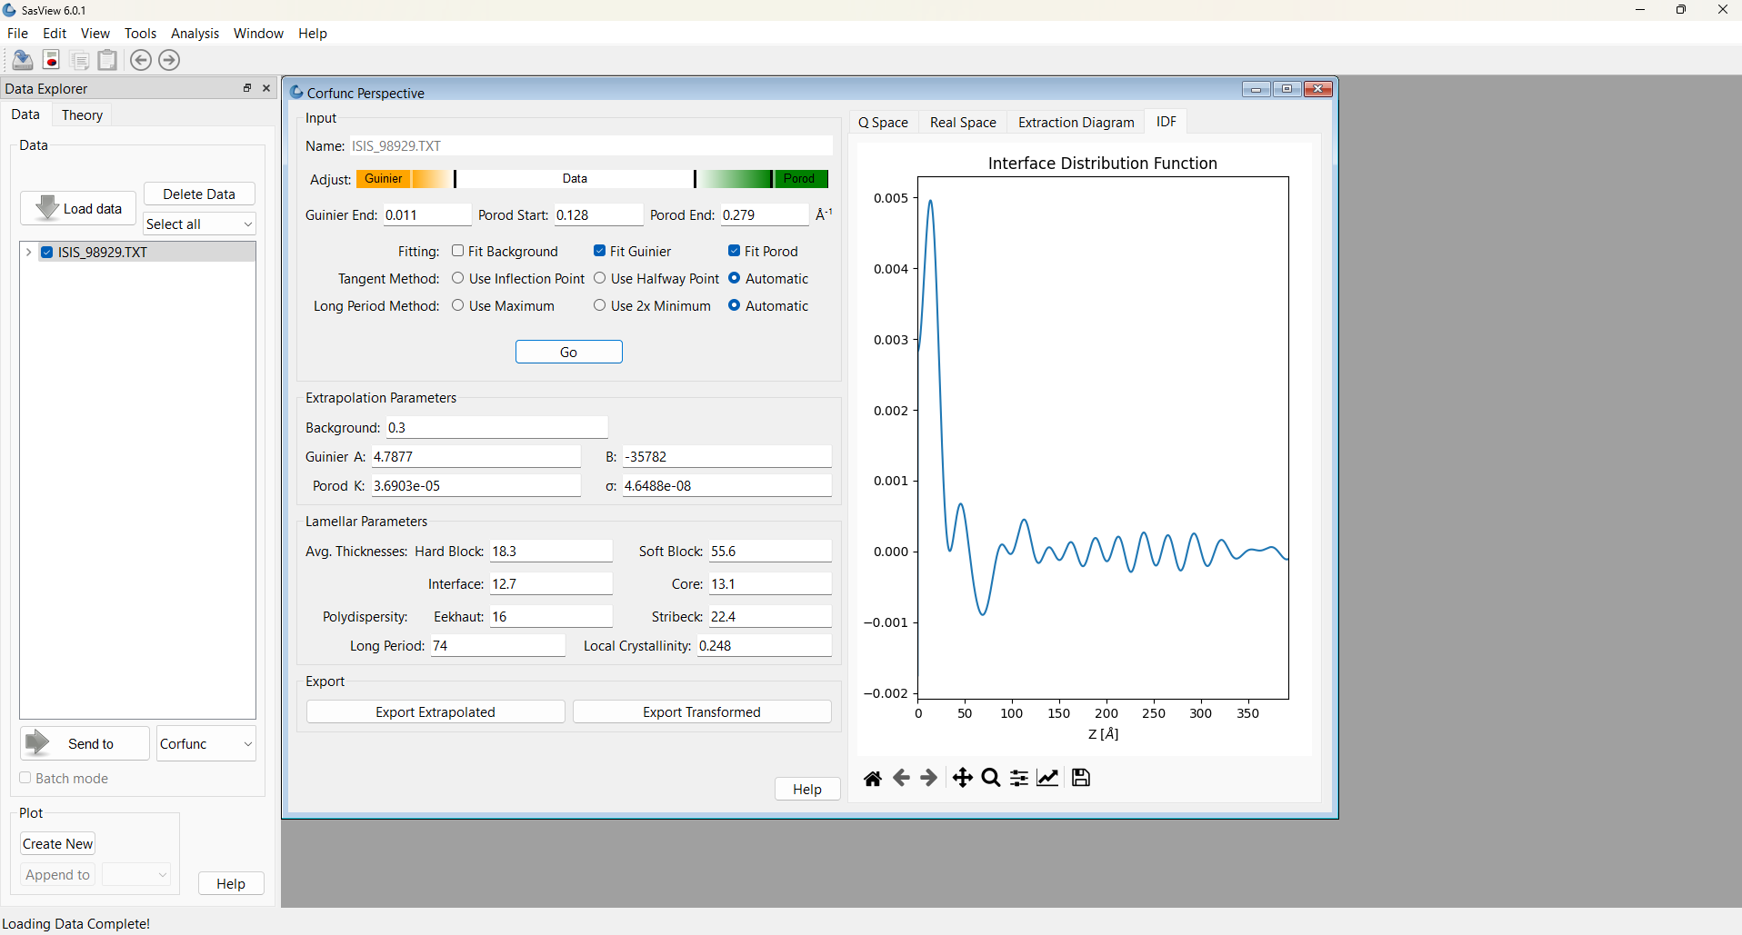
In terms of the extracted parameters:

- the Long Period is virtually unchanged (good!)
- the Soft Block Thickness has increased by ~4%
- the Hard Block Thickness, Interface Thickness, Core Thickness and Local Crystallinity have all decreased by ~11-12%
- but most significantly, both measures of Polydispersity have doubled!

This ‘sensitivity check’ therefore emphasises the importance of having good data in the high-Q region in order to allow a sensible background subtraction prior to calculating the correlation functions.

But in summary, we can see that the Correlation Function analysis suggests that most of the quasi-lamellar nanostructure in the nylon fibres is actually amorphous polymer (~28% crystallinity, soft block thickness of ~53 Å). And certainly nylon fibres are highly flexible and extensible.

As a further check, a SasView model-fit to the same dataset is shown below. The model used (lamellar_stack_paracrystal) describes a sandwich of regular repeating lamellae of infinite lateral dimensions where the lamellar repeat distance is subject to Gaussian polydispersity. The model fit also incorporates 10% instrumental resolution smearing (as the data were collected with pinhole collimation).

The SLD of the hard blocks has been fixed at the SLD for nylon, whilst the SLD of the matrix has been fixed at the SLD of heavy water.

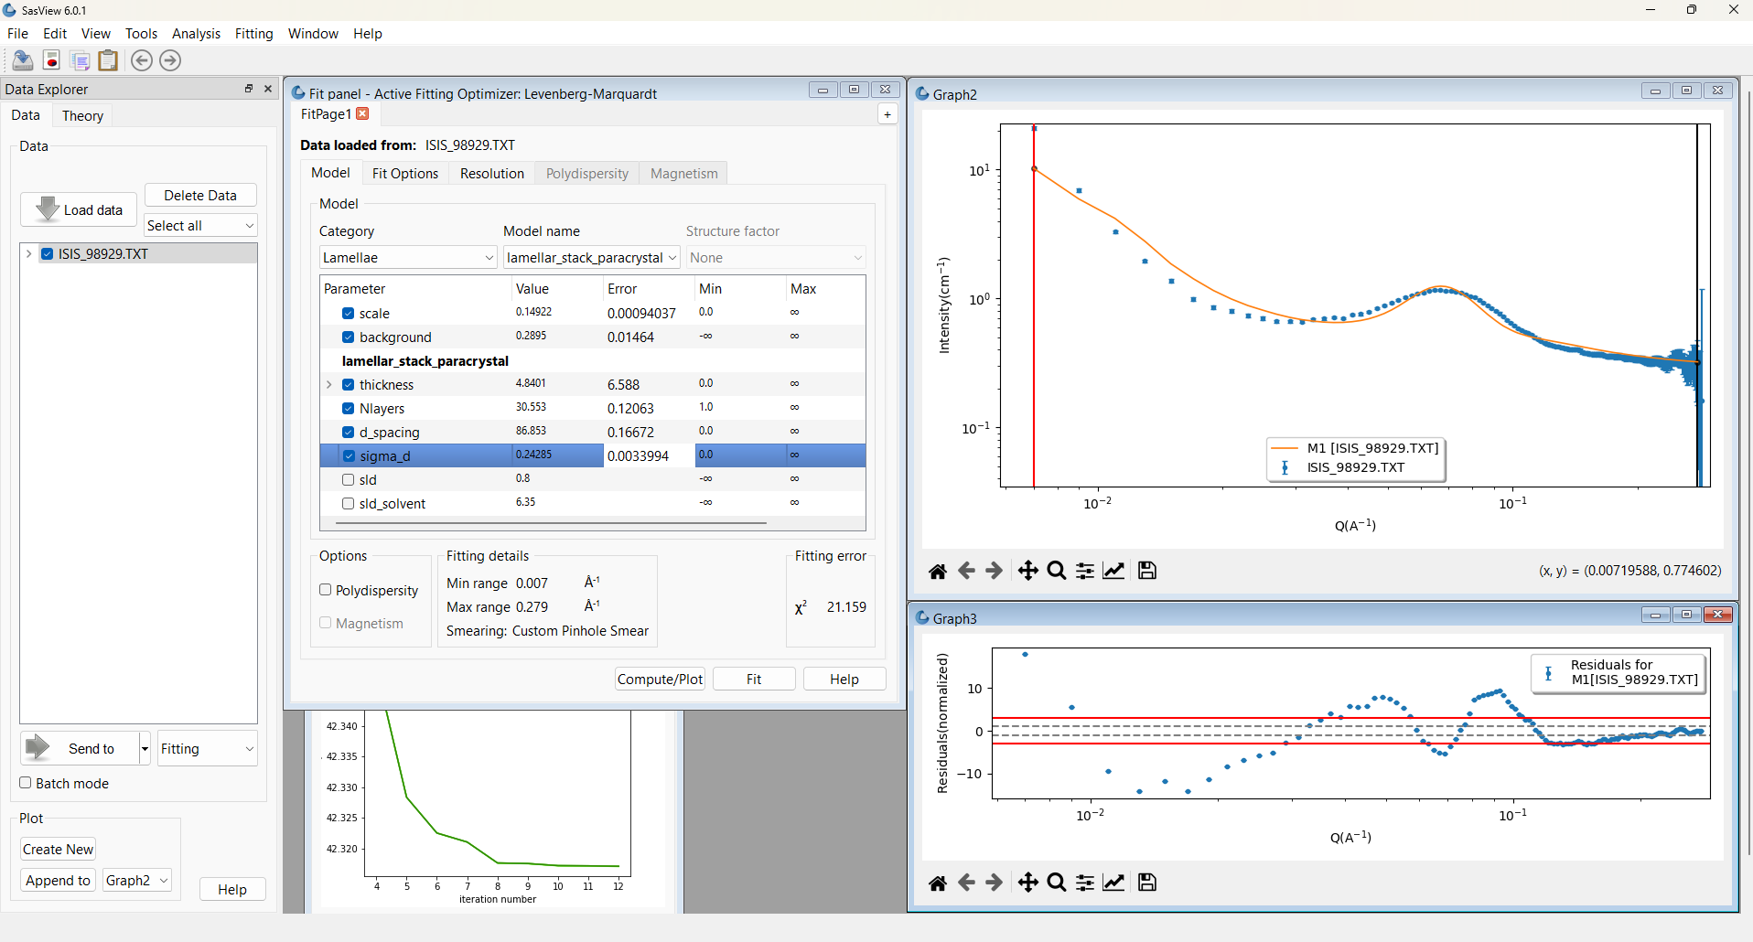
Although the fit is not very good, it nonetheless returns a lamellar repeat distance of ~87 Å with ~24% polydispersity (one standard deviation). The comparable values from the correlation function analysis were 74 Å and 7.5-11.5%, respectively. There is, however, quite a large discrepancy on the layer thickness. One additional piece of information the fit returns, that is not accessible by correlation function analysis, is the number of lamellae in each stack; here Nlayers: ~30.

So which analysis is more correct? That very much depends on the system being studied. In this example, the amorphous/crystalline regions in a nylon fibre are certainly not regular infinite lamellar sheets of uniform thickness. The fitting model is therefore describing a very idealised structure. In contrast, the correlation function analysis is completely model-independent as far as the computation of Γ₁(z), Γ₃(z), and g₁(z) are concerned, but the interpretation of those functions is then less precise. It also assumes that the water molecules are completely penetrating all of the amorphous regions.

Going Manual

The ‘Automatic’ settings will attempt to use the most appropriate of each of the two procedures shown, based on the quality of the computed correlation function.

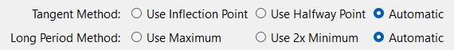
The first procedure shown for each method (ie, Use Inflection Point and Use Maximum) correspond to the procedures (but not necessarily the same algorithms) present in SasView 4.x/5.x and the original CORFUNC program. The alternatives are then:

- Tangent Method: in circumstances where the form of the initial decay of the correlation function makes it difficult to establish a true tangent, the midpoint of the initial decay can be used instead;

- Long Period Method: in circumstances where the computed correlation function exhibits oscillations between the first minimum and the subsequent true maximum, it may be more appropriate to compute the Long Period as twice the distance of the first minimum.

Optional

The dataset \example_data\1d_data\ISIS_83404.txt is SANS from the same fibres but after exposure to sulphuric acid, a reagent known to degrade the amide linkage. If you wish, use correlation function analysis to examine how this changes the nanostructure.

Example 2

This example is actually a demonstration of correlation function analysis from a nanostructure that does not exhibit lamellar order. It is included here to highlight the potential applications of correlation function analysis in other fields.

The data in question is from a parametric survey, using a variety of techniques but including SANS, of how different heat treatments affect the nanostructure of Fe-Cr binary alloys. The work is described in Xu et al, Acta Mat., (2017) available at https://doi.org/10.1016/j.actamat.2017.12.008. This material undergoes spinodal decomposition on thermal ageing, resulting in Fe-rich and Cr-rich domains and a characteristic ‘spinodal peak’ in the SANS.

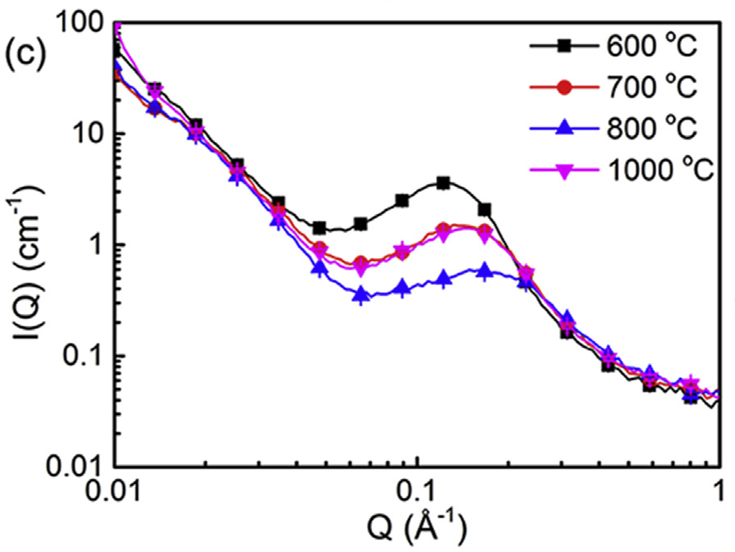
SANS data of alloy specimens treated at different temperatures and subsequently
aged at 475 C for 100 hours. Figure reproduced from Fig 6 in Xu et al, Acta Mat., (2017).

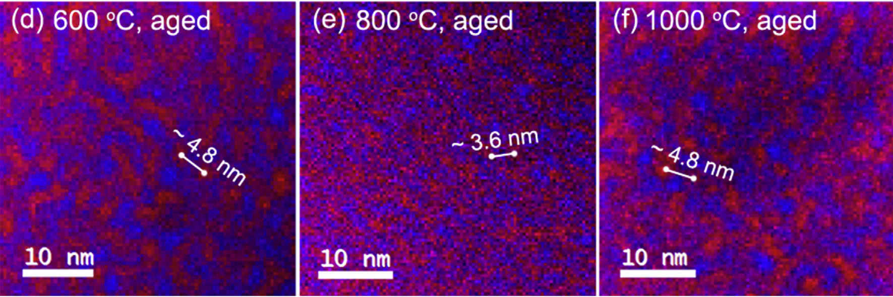
Ratio maps of the intensity of the Cr L3-edge (red) and Fe L3-edge (blue) from alloy specimens treated at different
temperatures and aged at 475 C for 100 hours. Figure reproduced from Fig 9 in Xu et al, Acta Mat., (2017).

Thin sections of the alloy specimens were examined by STEM-EELS and the resulting images processed to generate the 2D auto-correlation maps of the Fe/Cr distribution shown above. These maps were in turn radially-integrated to yield an averaged (auto)correlation function as shown below.

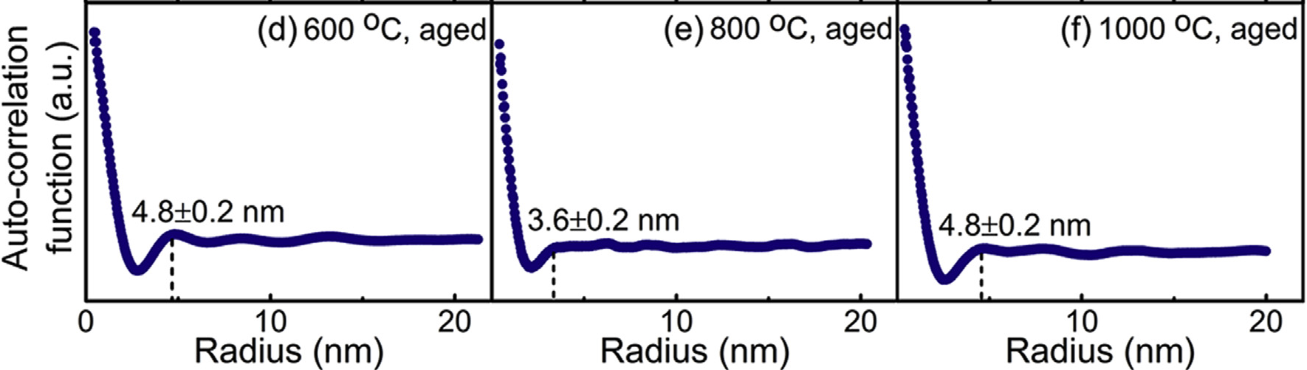
Azimuthally integrated and averaged profiles of the Cr/Fe L3-edge ratio maps from alloy specimens
aged at 475 C for 100 hours. Figure reproduced from Fig 10 in Xu et al, Acta Mat., (2017).

For comparison, here are the (replotted) correlation functions as computed using SasView 5.x:

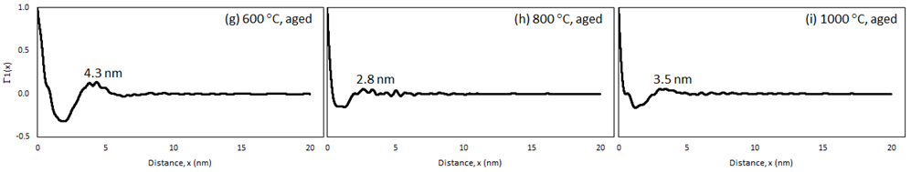
As can be seen, the agreement is actually quite reasonable! But the important point here is that the SANS-derived correlation functions are averaged over a far larger gauge volume (mm³) compared to that from the STEM-EELS measurements (nm³).

Further Information

For further information, please consult the

SasView Tutorial Series

or

http://www.sasview.org

or email

help@sasview.org

Appendix

Clicking the Export Transformed button in the Corfunc Perspective window writes a comma-separated text file with the extension .csv.

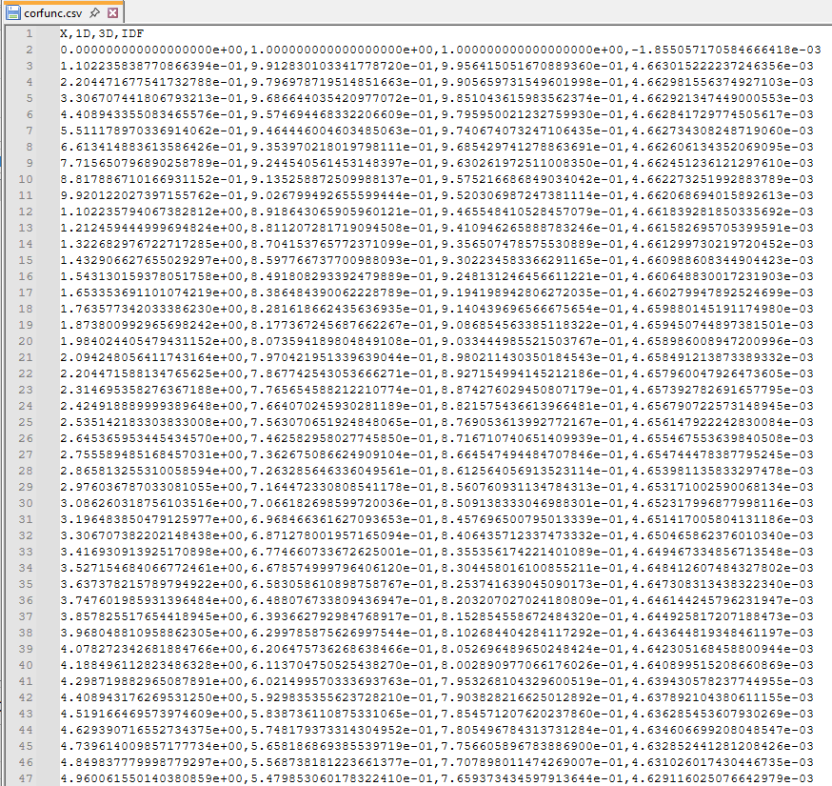
The columns in this file are, in order of occurrence:

- The real-space distance (in the inverse of the units of the input data)
- The value of Γ₁(z)
- The value of Γ₃(z)
- The value of g₁(z)

WARNING!
SasView will load this file but it will incorrectly interpret the second & third columns (because it will be expecting dI and dQ values, not Γ₃(z) and g₁(z) values)!

