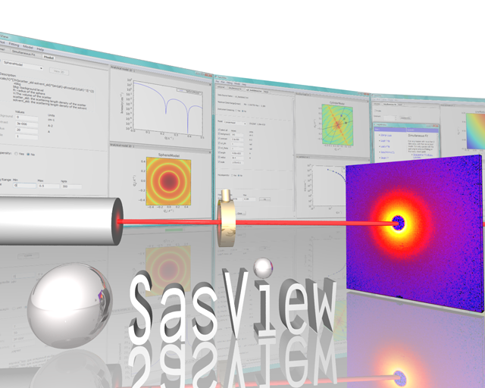

SasView Tutorials

Subtracting a Model Calculation from Experimental Data in SasView Version 4.x

www.sasview.org

Preamble

SasView was originally developed by the University of Tennessee as part of the Distributed Data Analysis of Neutron Scattering Experiments (DANSE) project funded by the US National Science Foundation (NSF), but is currently being developed as an Open Source project hosted on GitHub and managed by a consortium of scattering facilities. Participating facilities include (in alphabetical order): the Australian National Science & Technology Centre for Neutron Scattering, the Diamond Light Source, the European Spallation Source, Federal Institute for Materials Research and Testing, the Institut Laue Langevin, the ISIS Pulsed Neutron & Muon Source, the National Institute of Standards & Technology Center for Neutron Research, the Oak Ridge National Laboratory Neutron Sciences Directorate, and the Technical University Delft Reactor Institute.

SasView is distributed under a 'Three-clause' BSD licence which you may read here:
https://github.com/SasView/sasview/blob/master/LICENSE.TXT

SasView is free to download and use, including for commercial purposes.

© 2009-2020 UMD, UTK, NIST, ORNL, ISIS, ESS, ANSTO, ILL, TUD, DLS, BAM

If you make use of SasView

If you use SasView to do productive scientific research that leads to a publication, we ask that you acknowledge use of the program with the following text:

This work benefited from the use of the SasView application, originally developed under NSF Award DMR-0520547. SasView also contains code developed with funding from the EU Horizon 2020 programme under the SINE2020 project Grant No 654000.

Contributors to this Tutorial

Andrew Jackson (andrew.jackson@ess.eu)
Steve King (stephen.king@stfc.ac.uk)

Revisions
Last revised: 23 March 2020
Learning Objective

This tutorial will guide you through using the Data Operation tool in SasView to subtract an underlying function from experimental data. This type of operation is sometimes useful if the experimental data contains complex background contributions that hinder normal model-fitting.

The program interface shown in this tutorial is SasView Version 4.2.1 running on a Mac but, apart from a few small differences in look and functionality, this tutorial is generally applicable to SasView 4.x or 5.x running on any platform.

Running SasView

Windows
Either select SasView from ‘Start’ > ‘All Programs’ or, if you asked the installer to create one, double-click on the SasView desktop icon.


Mac OS
Go in to your ‘Applications’ folder and select SasView.

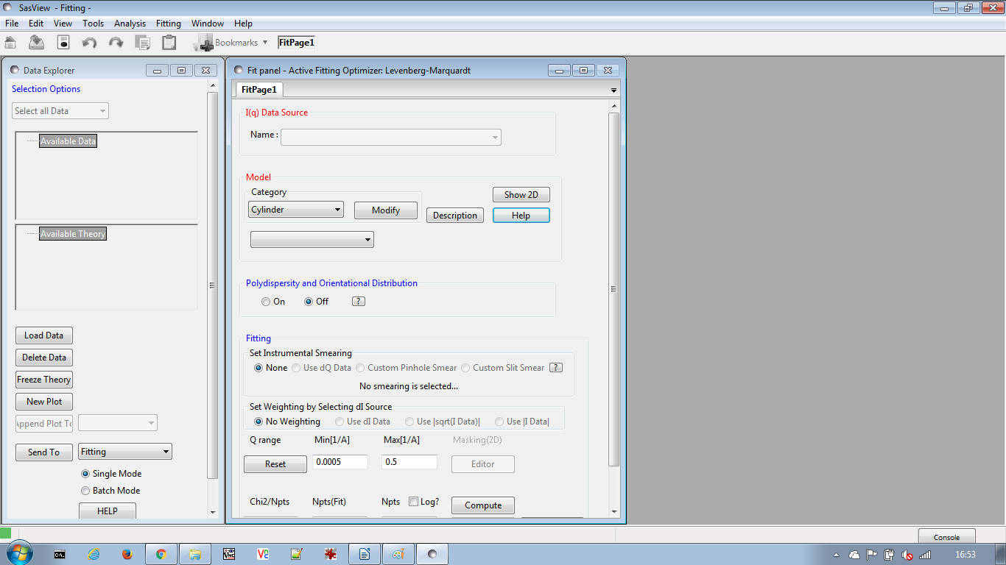
Example

The quasi-lamellar scattering from within a bundle of nylon-6 (polyamide-6) fibres is superimposed on top of the scattering from the surfaces of the fibres themselves. Subtracting this surface scattering highlights the scattering from the underlying morphology.

For more information on the morphology of nylon-6 see the tutorial ‘Correlation Function Analysis in SasView’.

(Technical note to experts in polymer science and fibre diffraction: the example data used represent nylon fibres that have been treated so as to modify the native morphology!)

In the Data Explorer panel, click the Load Data button, and navigate to the \test\1d_data folder in the SasView installation directory.

Select the ISIS_83404.txt dataset and click the Open button.

At the bottom of the Data Explorer panel, ensure the drop-down says Fitting. Then click the Send To button.

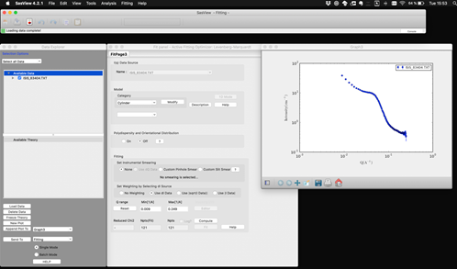
We now need to choose the form factor to subtract. Surface scattering can often be approximated by a power law dependence, so here we shall try to subtract a power law with background model from the data.

In the FitPage, go to the Category drop-down and select ‘Shape Independent’. And in the drop-down below that select the model ‘power_law’.
Now adjust the model parameters and use the Compute button (not the Fit button) until you are satisfied with the shape of the fit and the model parameters. In the screenshot below the parameters are:

scale | 0.007
background | 0.25
power | 1.8

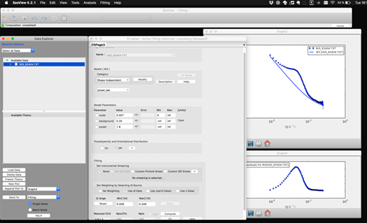
Then go to the Tools option on the Menu Bar and select Data Operation. The following window will appear:

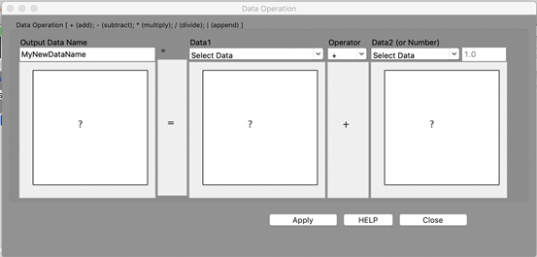
Set the ‘Output Data Name’ to whatever you you want the subtracted dataset to be called; here 83404_pl_sub. Then, use the ‘Data1’ drop-down to select the experimental dataset ISIS_83404.txt, set the operator to ‘-’ (minus), and use the ‘Data2’ drop-down to select the computed model (generically called M# [dataset name], where # is a program-generated reference number); here M3 [ISIS_83404.TXT].

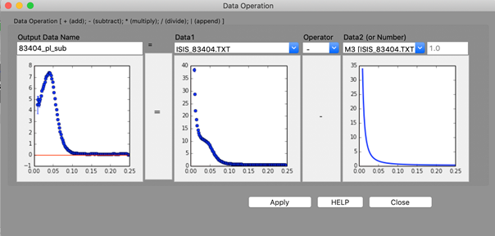
Finally, click Apply and Close. The subtracted dataset will appear in the Data Explorer...

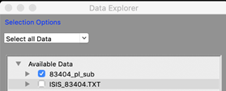
...from where it can be plotted, fitted, exported, or further manipulated.

Before | After
 | 