# Operating Safety Manual: Agipix - Autonomous Aerial Development platform

## System specifications

|  |  |
| --- | --- |
| Characteristic | Value |
| Weight | 1254 g |
| Peak Thrust | 37.6 N |
| Thrust to Weight | 2.98:1 |
| Max Payload | 1252 g |
| Dimensions | 348 x 306 x 142 mm |
| Low level controller | PX4 |
| High level computer | Nvidia Jetson Orin NX (Connect tech Hadron career) |
| CPU mark | 3170 on glmark2-es2 (100 TOPS (INT8)) |
| GPU | Yes |

## Isometric view

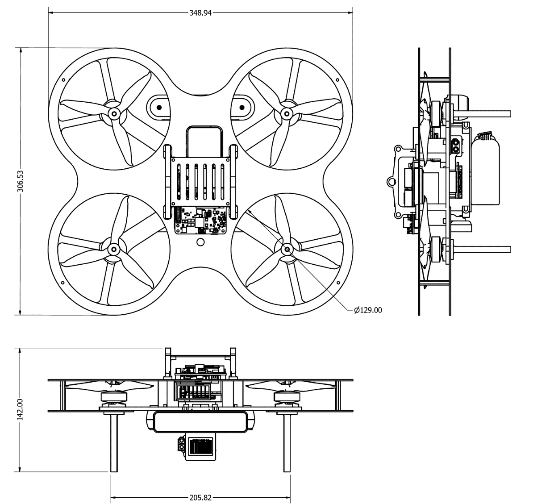

## Exploded view

Safety switch [1]

Jetson Orin NX

Landing gear

Lipo battery

ESC

RealSense D455

Propeller guards

Carbon fibre top plate

PX4

RealSense T265

Brushless motor

Arm/kill switch [2]

Live telemetry

Emergency Land [4]

Force Hover [5]

Offboard enable switch [3]

## Safety layers

### [HW] Hardware safety switch

This is the topmost layer and overrides all below. Motors can not be powered unless this is activates. A safety switch [1] is a control on the vehicle that must be engaged before the vehicle can be armed, and which may also prevent prearming (depending on the configuration).

### [SW] Prearm checks.

Low level controller runs pre-arm checks for sensor health, localisation accuracy, battery level etc. Vehicle can not be armed if the check fails.

### [HW] Remote Arm/Kill switch.

An arming switch [2] is a switch or button on an RC controller that can be used to arm the vehicle and start motors (provided arming is not prevented by a safety switch).

### [HW] Emergency Land/ Force hover switch

These switches in the RC controller ([4] and [5]) overrides offboard control at operators will.

### [HW] Remote Offboard enable switch.

This switch on the RC controller [3] has to be enabled to go to the software-controlled mode. All above must be satisfied for activation.

### [SW] System health monitor

A health monitor is implemented in the high-level controller that monitors live telemetry and disables offboard control and goes back to force hover if safety parameters fall below thresholds.

### [SW] ROS2 Heartbeat message

The above health monitor broadcasts a heartbeat at 5 Hz to the ROS 2 system. This informs the connectivity and health of the vehicle to the system wide safety measures.

### [SW] Teleoperator node Emergency Land/ Force hover option

The ROS2 teleoperator node also has Emergency Land/ Force hover options that can disable offboard control during teleoperation

## General Operation

1. Operator connects the battery to power the system.
2. Operator checks High level controller connection to the system after boot.
3. Operator initiates Visual odometry to the low-level controller.
4. Operator enables Safety switch [1] when prearm checks enable position control (Can be monitored in live odometry)
5. Operator initiates ROS2 teleoperation.
6. Operator toggles arm switch [2]
7. Operator toggles offboard switch [3]
8. Teleoperator now has control of the system.