# ASSIGNMENT 1 FRONT SHEET

|  |  |  |  |
| --- | --- | --- | --- |
| **Qualification** | **BTEC Level 5 HND Diploma in Computing** | | |
| **Unit number and title** | 10: Website Design & Development | | |
| **Submission date** |  | **Date Received 1st submission** |  |
| **Re-submission Date** |  | **Date Received 2nd submission** |  |
| **Student Name** | Nguyen Thai Duong | **Student ID** | GCD210524 |
| **Class** | GCD2501 | **Assessor name** | Phan Thanh Tra |
| **Student declaration**  I certify that the assignment submission is entirely my own work and I fully understand the consequences of plagiarism. I understand that making a false declaration is a form of malpractice. | | | |
|  | | **Student’s signature** |  |

**Grading grid**

|  |  |  |  |  |  |  |  |
| --- | --- | --- | --- | --- | --- | --- | --- |
| P1 | P2 | P3 | P4 | M1 | M2 | M3 | D1 |
|  |  |  |  |  |  |  |  |

|  |  |  |
| --- | --- | --- |
| * **Summative Feedback:** ❒**Resubmission Feedback:** | | |
| **Grade:** | **Assessor Signature:** | **Date:** |
| **Signature & Date:** | | |

**Student Assessment Submission and Declaration**

When submitting evidence for assessment, each student must sign a declaration confirming that the work is their own.

|  |  |  |  |
| --- | --- | --- | --- |
| Student name: Nguyen Thai Duong | | Assessor name: Phan Thanh Tra | |
| Issue date: 20/3 | Submission date: 31/3 | | Submitted on: CMS |
| Programme: BTEC | | | |
| Unit: Website Design & Development | | | |
| Assignment number and title: 1 | | | |

**Plagiarism**

Plagiarism is a particular form of cheating. Plagiarism must be avoided at all costs and students who break the rules, however innocently, may be penalised. It is your responsibility to ensure that you understand correct referencing practices. As a university level student, you are expected to use appropriate references throughout and keep carefully detailed notes of all your sources of materials for material you have used in your work, including any material downloaded from the Internet. Please consult the relevant unit lecturer or your course tutor if you need any further advice.

**Student Declaration**

|  |
| --- |
| **Student declaration**  I certify that the assignment submission is entirely my own work and I fully understand the consequences of plagiarism. I declare that the work submitted for assessment has been carried out without assistance other than that which is acceptable according to the rules of the specification. I certify I have clearly referenced any sources and any artificial intelligence (AI) tools used in the work. I understand that making a false declaration is a form of malpractice.  Student signature:  Date: |

Table of Contents

1. INTRODUCTION 5
2. SERVER TECHNOLOGIES AND MANAGEMENT SERVICES 6
   1. Domain name system 6
      1. Definition of DNS: 6
      2. Purpose of DNS: 7
      3. Type of DNS: 8
      4. How domain name is organized 10
   2. Explain the purpose and relationships between communication protocols, server hardware, operating systems and web server software with regards to designing, publishing and accessing a website:

12

* + 1. Communication protocols 12
    2. Server hardware 13
    3. Operating system 15
    4. Web server software 17
    5. Relationships between communication protocols, server hardware, operating systems and web server software 18

1. WEBSITE TECHNOLOGIES, TOOLS AND SOFTWARE 19
   1. Discuss the capabilities and relationships between front-end and back-end website technologies and explain how these relate to presentation and application layers.

19

* + 1. Front-end and Back-end 19
    2. Relationships between front-end and back-end website technologies 20
    3. Explain how these relate to presentation and application layers. 21
  1. Discuss the differences between online website creation tools and custom built sites with regards to design flexibility,performance, functionality, User Experience (UX) and User Interface (UI).

22

* + 1. Website builder 22
    2. Custom built sites 23
    3. User Experience 24
    4. User Interface 25
    5. The differences between online website creation tools and custom built sites with regards to design flexibility,performance, functionality, UX and UI

28

1. REFERENCES 29

## A. INTRODUCTION

* I presently work for a software training company that develops courses and topic presentations for existing businesses as well as fresh start-ups. MWS would like to develop a custom web-based e-commerce solution. As part of my responsibilities, I was asked to develop an engaging presentation to help inform and train staff members on the tools and techniques associated with front- and back-end development, as well as the technologies and services required to set up, host, and manage a typical commercial website. Further information may be found in the file MWS-CaseStudy.docx.
* In addition to my presentation, I will deliver a full report comprising a technical evaluation of the issues addressed in the presentation or an expanded handbook containing additional information for staff members.

## B. SERVER TECHNOLOGIES AND MANAGEMENT SERVICES

### Domain name system

* 1. Definition of DNS:

The Domain Name System (DNS) is the phonebook of the internet. It translates domain names, which are human-readable names of websites, into IP addresses, which are numerical addresses that computers use to communicate with each other.

Without DNS, we would have to remember and type the IP address of every website we want to access, which would be very difficult and inconvenient. DNS helps us access the internet easily by translating website names into addresses that computers can understand.

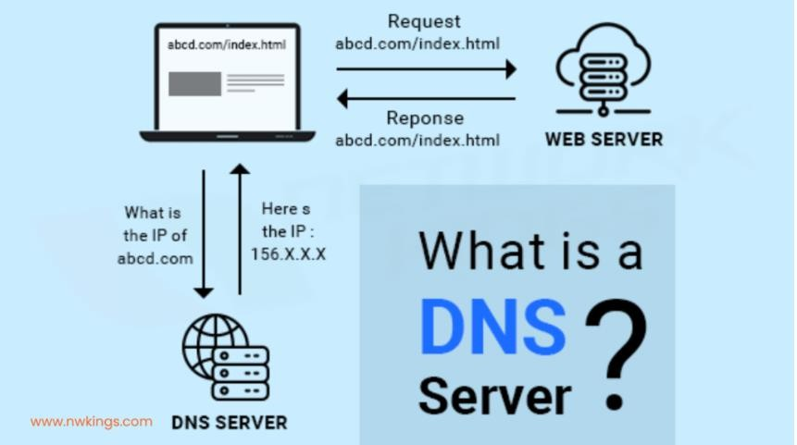

* 1. Purpose of DNS:

The primary purpose of DNS is to translate human-readable domain names into numerical IP addresses that computers can understand. This is essential for accessing the internet because computers only understand IP addresses, not domain names.

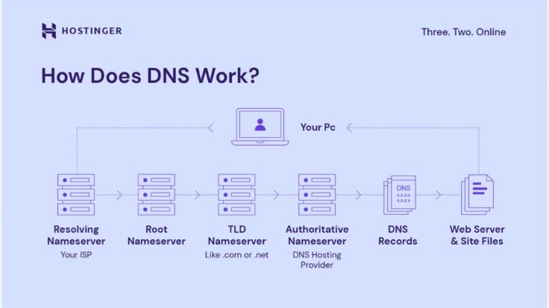

* 1. Type of DNS
     + Types of DNS server:

1. Root DNS servers:

-The root servers are the top level of the DNS hierarchy.

-There are 13 root servers around the world.

-They only know the location of the TLD name servers.

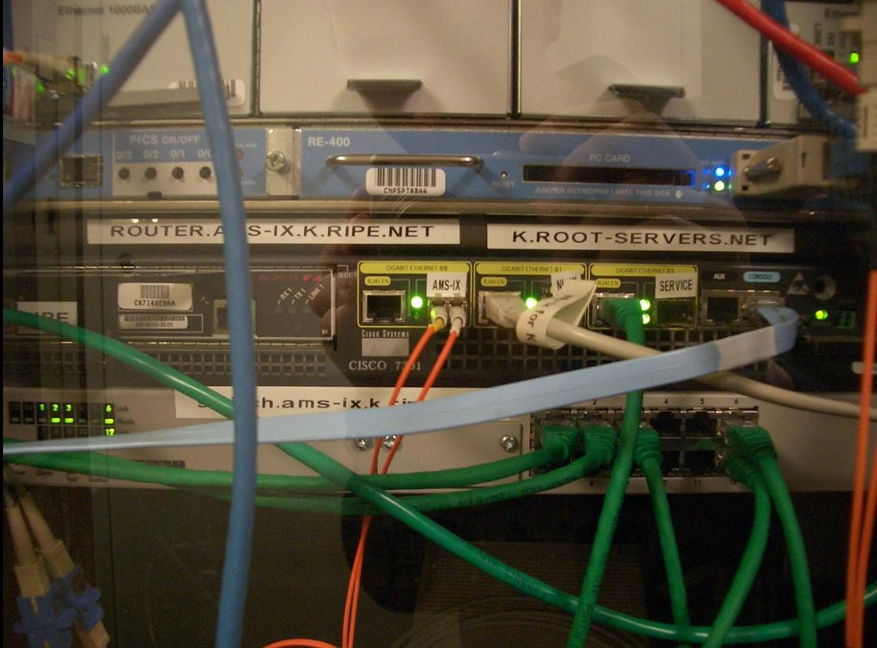

1. TLD (Top-Level Domain) name servers:

TLD name servers are responsible for a specific domain name extension, such as .com or .org. There are hundreds of TLD name servers around the world.

They know the location of the authoritative name servers for the domains under their control.

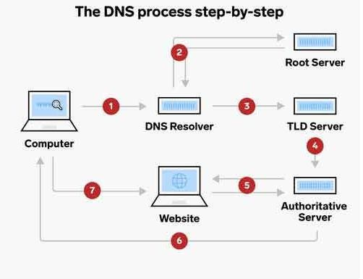

1. Authoritative name servers:

-Authoritative name servers are responsible for storing the IP addresses of specific domain names.

-They are typically located on the web server that hosts the website.

-They are the final stop in the DNS resolution process

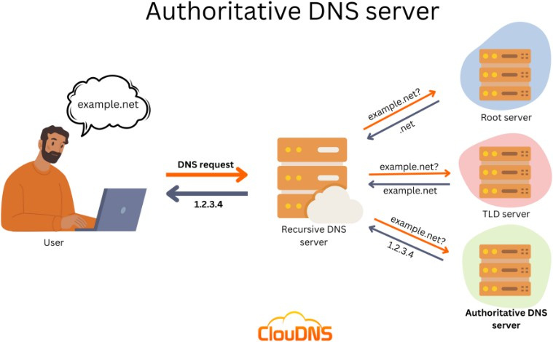

1. Recursive resolvers:

- Recursive resolvers are the servers that your computer or device queries when you type a domain name into your web browser.

-They are responsible for contacting the root and TLD name servers to find the IP address of the domain name you requested.

-There are many recursive resolvers around the world, and you can choose which one to use

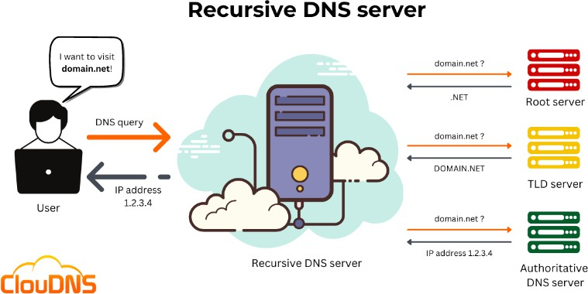

In addition to the four main types of DNS servers, there are several other types of DNS servers, such as:

* Caching-only servers: These servers store a copy of the DNS records they have recently looked up. This can help improve performance by reducing the number of times the resolver needs to contact the root nameserver and TLD.
* Relay servers: These servers forward DNS queries to other DNS servers. They are often used by organizations that want to control which DNS servers their users can access.
* Stub resolvers: These are lightweight DNS resolvers commonly used on embedded devices. They only know the location of a single recursive resolver.

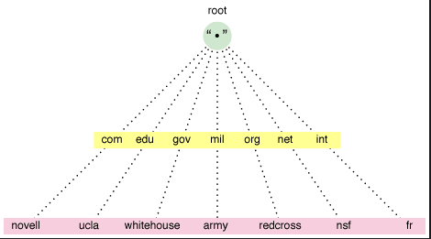

* 1. How domain name is organized

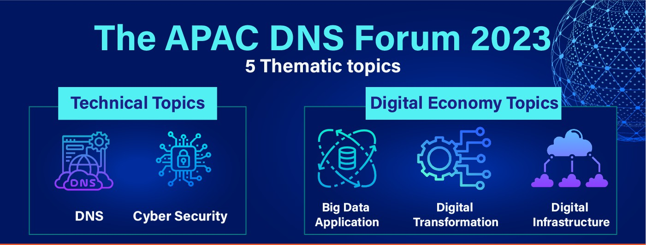

* + - How domain name is organized:
      * Subdomains are lower tiers of the Domain Name System parent domain that arrange domain names. Top-level domains (TLDs) are the first level of domain names and include generic top-level domains (gTLDs) like.com,.net, and.org, as well as country code top-level domains (ccTLDs). In the instances google.fr and google.com.au, the ccTLDs are indicated to the right of the dot, such as.fr or.au. Second and third-level domain names in the DNS system, such as DomainTools or Google, are classified as top-level domains. End users can often reserve these domains in order to host web pages, establish publicly accessible Internet resources, and link the Internet to local area networks. Second-level domains often convey the name of the organization and/or are descriptive of the service offered, whereas third-level domains are used to refer to a specific server inside an organization.

### Explain the purpose and relationships between communication protocols, server hardware, operating systems and web server software with regards to designing, publishing and accessing a website:

* 1. Communication protocols:
* Definition: Communication protocols are formal specifications of digital message formats and regulations. They are essential in telecommunications to exchange messages inside or between computing systems. Protocols for communication involve authentication, error detection and correction, and signaling. They can also explain analog and digital communication syntax, semantics, and synchronization. Hardware and software are used to implement communication protocols. There are dozens of communication protocols in use in analog and digital communications. Without them, computer networks would not exist.
* Purpose: Communication protocols enable various network devices to communicate with one another by sending analog signals, digital signals, various files, and data processing from one device to another. These protocols are used in telecommunications and computer networks where certain rules are followed to send data from source to destination. TCP (Transmission Control Protocol) and User Datagram Protocol (UDP) are the two most important protocols in networking
  1. Server hardware:



* Definition: A hardware-based server is a physical device that is linked to a computer network and hosts one or more software-based servers in addition to the operating system. A hardware-based server is sometimes known as a host. In theory, any machine with server software may act as a host.
* Three Types of Server Hardware
  + Tower servers:

A tower server is a self-contained computer cabinet with the size of a desktop tower PC. They are frequently used in enterprises and data centers since they take up less space and are more conveniently accessible than traditional servers.

Tower servers are servers that are built to be readily cooled. They frequently employ higher power density than blade or rack servers, which means they have fewer components per unit. As a result, they are larger and heavier than other types of servers. They may, however, be easier to operate and maintain.

* + Rack servers:

A rack server is a type of computer server intended to fit into a conventional 19-inch equipment rack. They are often employed in data centers and other large-scale computer settings. Rack servers provide more features and options than tower servers and are frequently more power-efficient and quieter.

Rack servers are servers with many mounting slots known as bays. They are typically standard in size and are intended to be stacked directly on top of one another. This makes them useful for data centers since they take up less space and consume less electricity.

Rack servers are data storage, management, and processing hardware devices. To prevent excessive heat buildup, which might harm the equipment, the racks require a particular cooling system.

Rack servers are a type of server that is designed to make cabling between network components easier. They are frequently utilized in data centers and for scalability. Rack servers often feature more than two hard drives and are available in a number of form factors.

* + Blade servers:

Blade servers are a form of server that is gaining popularity. They vary from rack servers in that they take up less space and are more efficient. They are usually more costly, however this depends on the manufacturer and model.

Blade servers are a type of server that offers several advantages to enterprises. These may be chosen according on the company's space, cooling, and financial requirements. For example, if a corporation is limited on space, it can choose for blade servers, which take up less physical space than standard servers. Moreover, blade servers require less cooling than conventional servers, saving the organization money on energy expenditures.

Blade servers are an increasingly common type of server for high-performance computing (HPC). This is due to their ability to respond quickly to requests from programs and users, making them suitable for usage in data centers. Moreover, blade servers use less electricity than conventional servers, making them more ecologically friendly.

Blade servers are hardware servers that house numerous blade servers in a single chassis. This enables the consolidation of several servers into a single device, which can result in cost savings and increased efficiency. This is becoming a more common alternative for larger enterprises.

* Purpose: Data, programs, and other resources are stored and managed on server hardware. It is an essential component of a network infrastructure because it provides the processing power, memory, and storage required to guarantee that applications and services function smoothly and reliably.
  1. Operating system:



* Resource Management:

- Security:

Memory Management: Allocates and manages memory for running applications. Process Management: Creates and manages processes (running programs).

Device Management: Controls and interactions with peripheral hardware devices. File Management: Organize and manage files and directories on storage devices.

-Networking:

Protects the system from unauthorized access and malicious attacks. Manages user accounts and permissions.

-User Interface:

Enables communication and resource sharing between computers on a network. Provides protocols for data transfer and communication.

Provides a graphical user interface (GUI) or command-line interface (CLI) for interacting with the system. Manages windows, menus, and other user interface elements.

-Application Execution:

Loads and executes application programs.

Provides services and resources needed by applications.

Here are some of the most popular operating systems:

-Desktop:

-Server:

Microsoft Windows Apple MACOS

Linux (various distributions) Mobile:

Google Android Apple IOS

Microsoft Windows Server Linux (various distributions)

The choice of an operating system depends on various factors, such as user needs, hardware compatibility, and application requirements.

* Purpose:

* The operating system will handle fundamental tasks including reading, writing, and maintaining data storage and file systems.
* Support for control as well as hardware management for maximum efficiency.
* Basic command mechanisms for operating machines are provided.
* Offers a fundamental interface system for applications and software.
* Make the computer system more user-friendly and efficient in its operation.
* Conceal hardware resource details from users.
* Give people with a more user-friendly interface system than the computer system.
* Serves as a bridge between the hardware and the user. It then makes it easier for consumers to access and utilise additional resources.
* Help with computer system resource management.
* Monitor who is utilizing resources and making requests, and arbitrate conflicts between programs and users.
* Distribute resources and distribute them effectively and equally among users and the program.
  1. Web server software:

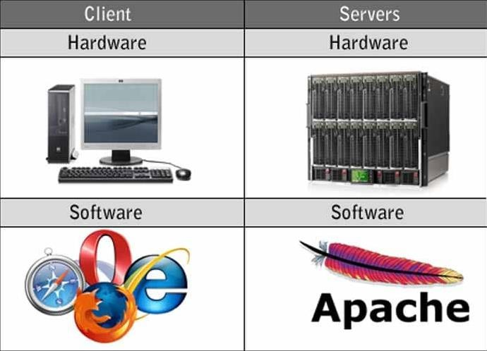

* A web server software package has numerous components that govern how web users access hosted content. This is, at the very least, an HTTP server. An HTTP server is software that recognizes URLs (web addresses) and HTTP requests (the protocol your browser uses to view webpages). An HTTP server is accessible via the domain names of the websites it hosts, and it serves the content of these hosted websites to the end user's device.

There are several popular web servers accessible, some of which are:

* Apache HTTP Server: Created by the Apache Software Foundation, it is a free and open source web server for Windows, Mac OS X, Unix, Linux, Solaris, and other operating systems; the Apache license is required.
* Microsoft Internet Information Services (IIS): A Microsoft product developed for Microsoft platforms; it is not open source but is extensively used.
* Nginx: A popular open source web server for administrators due to its low resource usage and scalability. Because of its event-driven architecture, it can accommodate several concurrent sessions. Nginx may also be used as a proxy server and load balancer.
* Lighttpd: The FreeBSD operating system has a free web server called Lighttpd. It is thought to be quick and secure, while using minimal CPU power.
* Sun Java System Web Server: Sun Microsystems' free web server that runs on Windows, Linux, and Unix. It is capable of handling medium to big websites.
* Server software is software that runs on server hardware and manages the server hardware's resources. It is in charge of granting other computers, applications, and services access to the server hardware's resources. It also has security, dependability, and scalability.
  1. Relationships between communication protocols, server hardware, operating systems and web server software:
* Communication protocol:

The protocol provides communication rules, syntax, semantics, synchronization, and error recovery mechanisms. Protocols can be implemented using either hardware or software, or a mix of the two.

* Server Hardware

Hardware is the tangible items that you can touch and see that are integrated and constructed into a single entity known as a Personal Computer (PC). In this situation, it may be a laptop or perhaps one of your smart gadgets.

* Operating System

The operating system (OS) runs on top of the hardware. The operating system (OS) is the software that provides the interface for communicating with the hardware. Of course, there's more to it than that. The operating system communicates with the kernel through device drivers, which deliver "commands" to the hardware to do the tasks that you specify.

* Webserver software

Web Server Software is also just a piece of software. It is installed and operated on a computer - the server acts as a Web Server, and users may access the Web site information from another computer on the network due to this application (Internet, intranet). Web servers may send Web clients through the Internet environment (or Internet) using the HTTP protocol.

**Conclusion:** For developing, publishing, and accessing a website, communication protocols, server hardware, operating systems, and web server software are all required. Protocols are in charge of facilitating communication between the server and the client. The physical hardware needed to store and run the website is referred to as server hardware. Operating systems are in charge of controlling hardware and running applications, whereas web server software is utilized to provide the website's data. To publish and visit a website, all of these pieces must operate together.

## C. WEBSITE TECHNOLOGIES, TOOLS AND SOFTWARE

### Discuss the capabilities and relationships between front-end and back-end website technologies and explain how these relate to presentation and application layers.

* 1. Front-end and Back-end

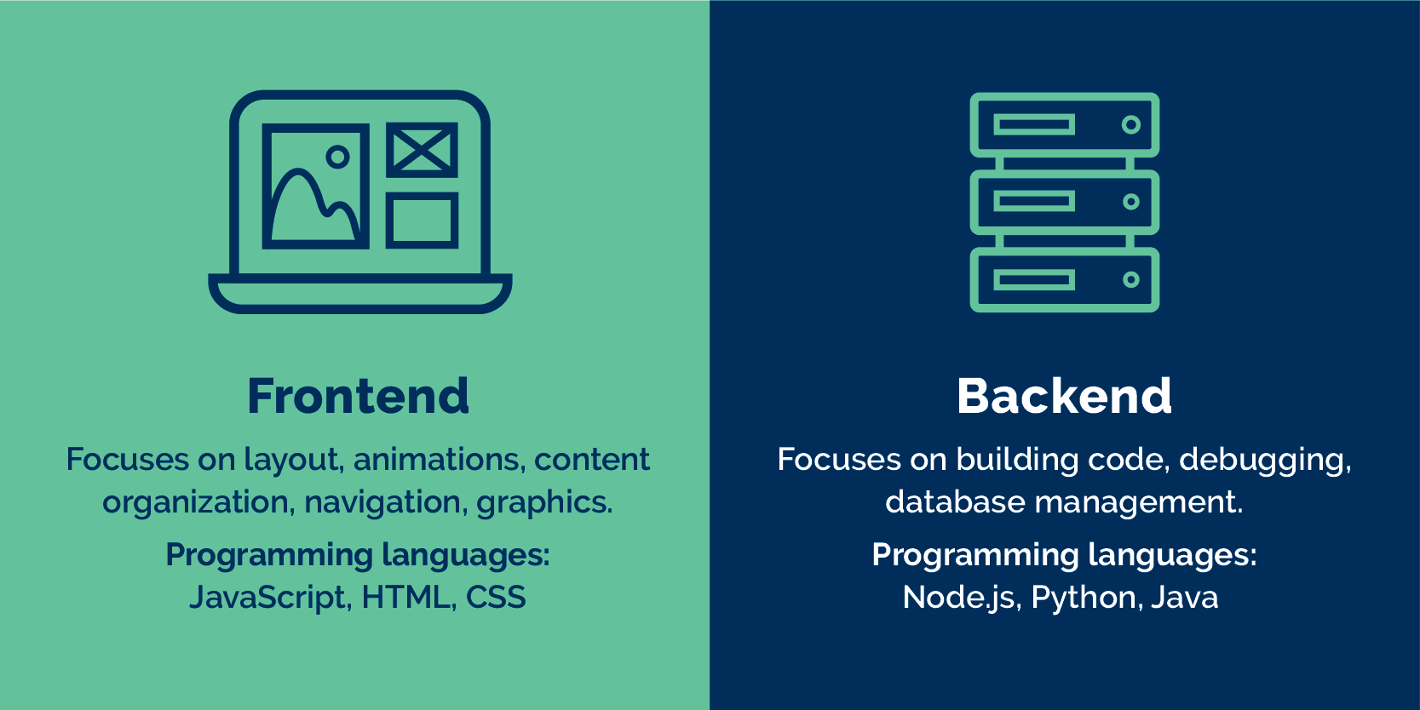

*Figure 10: Front-end and Back-end*

* + - Front- end: The front-end of a website is what interacts with the user. Everything you see when you explore the Internet, from fonts and colors to drop-down menus and sliders, is a mix of HTML, CSS, and JavaScript that the computer browser controls. your total.
      * HTML is an abbreviation for Hypertext Markup Language. It is a markup language that is used to create user interfaces.
      * CSS: The language that comes with HTML that sets a website's layout, color, and font components.
      * JavaScript: A programming language used to extend and enhance the functioning of a web page.
    - Back-end: It refers to the internals, which include the server, application, and database. Sample description: You need to book a flight, access a website, and interact with the frontend online. The program will then save the information you input in the database on the server. As a result, the server can more simply handle the BackEnds.
      * Backend technologies include Ruby, Python, PHP... and they are frequently augmented by frameworks such as Ruby on Rails, Cake PHP, and others to make the development process faster and simpler to collaborate.
      * Back End programming languages that are commonly used:
      * Java: The most popular programming language for websites and apps such as Netflix, Tinder, Google Earth, and Uber.
      * Ruby on Rails (RoR): This is the favored language among developers since it simplifies BackEnd programming.
      * Python is one of the most popular programming languages in the world. Python is used by the following websites and applications: Spotify, Google, Instagram, Reddit, and Dropbox.
      * PHP is a simple programming language to learn. It is also the programming language used by Facebook, Wikipedia, Tumblr, MailChimp, and Flickr.
  1. Relationships between front-end and back-end website technologies
     + HTML, CSS, and JavaScript are some of the front-end website technologies. These technologies are in charge of a website's presentation layer, with which the user interacts. Web servers, databases, and application programming interfaces are examples of backend technology (APIs). These technologies offer a website's application layer, which contains the logic and data processing. Front-end and back-end technology collaborate to deliver a seamless website experience.

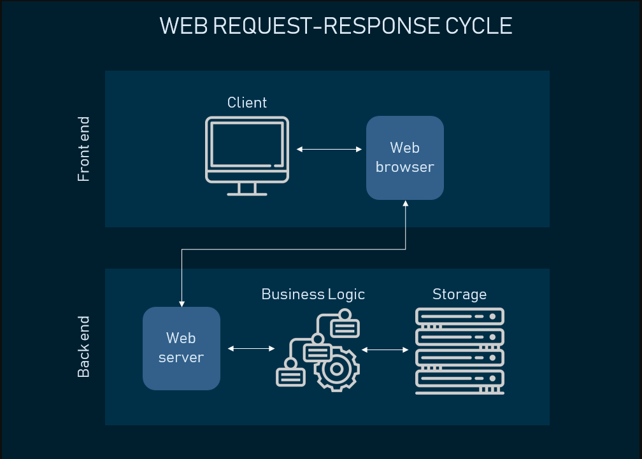

*Figure 11: Frontend and Backend*

* 1. Explain how these relate to presentation and application layers.
     + The presentation layer, also known as the front-end layer, consists of the user interface, which is a graphical user interface that can be accessed via a web browser or a web application that shows useful material and information to the end user. Similarly, this application layer is built with web technologies like as HTML, CSS, and JavaScript, as well as frameworks, and connects with other layers through API calls.
     + The presentation layer is typically delivered to desktops, tablets, and phones via a web browser or a web-based application hosted on a web server, whereas the application layer is typically hosted in the cloud or on a dedicated workstation, depending on the complexity and processing power requirements of the application. There are several advantages to employing three-layer architecture, including increased development speed, scalability, performance, and availability, as well as improved development efficiency by allowing teams to focus on their core skills.

### Discuss the differences between online website creation tools and custom built sites with regards to design flexibility,performance, functionality, User Experience (UX) and User Interface (UI).

* 1. Website builder:
     + A website builder is an online platform or tool that allows you to create a website without knowing how to code. It usually includes drag-and-drop software for customizing items on a page. Furthermore, many website builders contain a plethora of good pre-built page layouts and sections that you may begin modifying right away. The popularity of website building tools may be attributed to a number of factors. Even if you don't know how to code, you can use these tools to create a website. They are often provided as proprietary tools by website hosting firms. These tools include an editor, many themes, and the ability to design a site by dragging and dropping various items such as photographs, text, headers, and so on.



*Figure 12: Online website creation tools*

* + - Some online website builders include:
      * Weebly: Best overall
      * GoDaddy: Best for service providers
      * IONOS: Best for startups
      * Squarespace: Best for creatives
      * HostGator: Best for simplicity
      * Wix: Best for code-free customizations
      * Shopify: Best for dropshipping
      * Zyro: Best for affordability
      * WordPress.org: Best for versatility
      * Duda: Best for agencies
  1. Custom built sites:

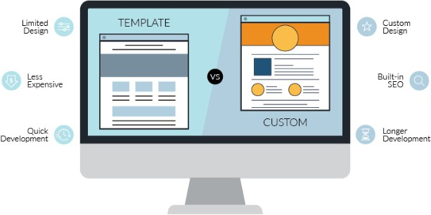

* + - A custom-built website is one that is created from the ground up. It is coded to meet the visual and functional requirements of your company. There is no template that will limit your demands; you may have everything you desire (or, should we say, whatever your developer is capable of generating!).
    - Custom-built websites are easy to maintain and will expand with your company. Personalized sites, as opposed to templated ones, are easier to edit and are more likely to survive a lifetime as new features are introduced.
    - Custom-built sites advantages:
      * Tailored to the needs of the company
      * Designs are limitless.
      * It is possible to alter it at any moment.
      * Improved SEO ranking
      * When a company expands, it must be adaptable.
      * Extremely responsive and mobile-friendly
    - Disadvantages of a Custom-Made Website
      * Expensive
      * Time-consuming
      * The website is depending on the developer's abilities.
  1. User Experience::
     + User Experience (UX) refers to the overall journey that people take when using a product. It includes their direct encounters with the product as well as how it fits into their broader job completion process.
     + Whether distinct components of the experience are directly controlled by the product or are simply connected with it, the whole experience is considered part of the UX from the user's perspective. The overall User Experience includes every interaction between the consumer and the firm.



* 1. User Interface:

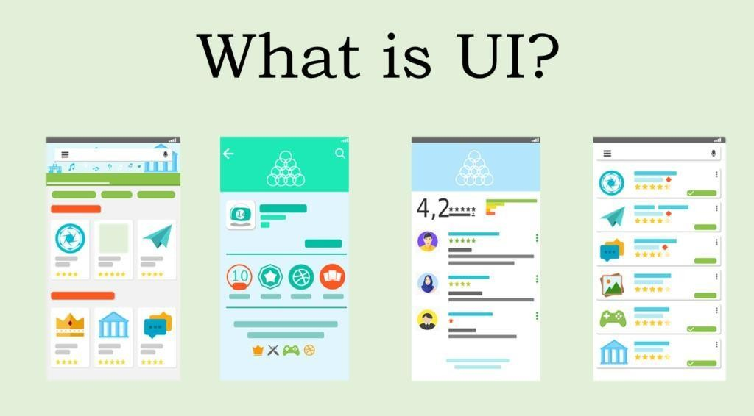

* + - The point of human-computer contact and communication in a device is the user interface (UI). Display displays, keyboards, mice, and the look of a desktop are examples of this. It is also how a person interacts with a program or a website.
    - Several organizations' increasing reliance on online and mobile apps has prompted many to prioritize UI in an effort to improve the entire user experience.
    - Types of UI:

The various types of user interfaces include:

* + - * graphical user interface ([GUI](https://www.techtarget.com/whatis/definition/GUI))
      * command line interface ([CLI](https://www.techtarget.com/searchwindowsserver/definition/command-line-interface-CLI))
      * menu-driven user interface
      * touch user interface
      * voice user interface ([VUI](https://www.techtarget.com/searcherp/definition/voice-user-interface-VUI))
      * form-based user interface
      * [natural language](https://www.techtarget.com/whatis/definition/natural-language) user interface

* The different of UI and UX:

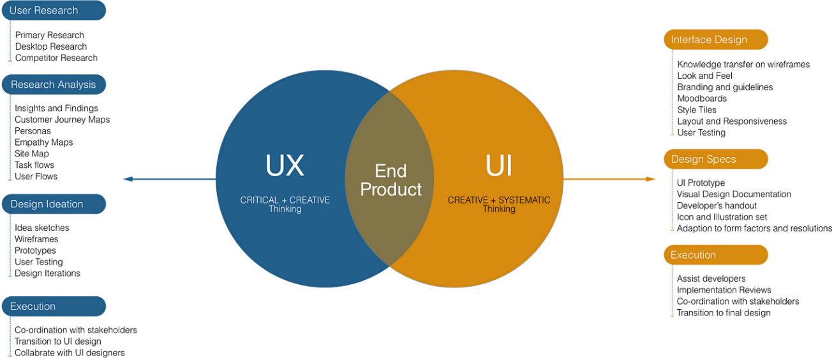

*Figure 16: UX and UI*

* Although the acronyms UI and UX are sometimes used interchangeably, the terms User Interface and User Experience are significantly distinct.
* The User Interface is what the user sees and interacts with within the product: the buttons, layout, navigation, form fields, and so on. It is what a user sees, touches, and clicks, much like the cockpit ofa plane or the buttons on a remote control. The term "UI" can also refer to a product's "look and feel."
* User Experience spans a far broader range of features than User Interface, while UI is clearly included inside this bigger definition. The User Experience encompasses everything an end-user performs with the product, including how it fits into their broader workflow and the actions before and after the product is used. Furthermore, the User Experience addresses how those encounters will vary over time as the customer's use changes and the product and organization improve.
  1. The differences between online website creation tools and custom built sites with regards to design flexibility,performance, functionality, UX and UI:

|  |  |  |
| --- | --- | --- |
|  | **ONLINE WEBSITE CREATION TOOLS** | **CUSTOM BUILT SITES** |
| Design flexibility | - The design is less scalable since it is built on pre-existing models that may not be compatible  with a wide range of various screen sizes. | * It has a higher level of flexibility since it can create its own style and concepts. * More enhanced features can be added. |
| Performance | * Poor performance due to browser limitations. * Poor security stability makes it tough to update and improve. | * Custom-built websites are easier to maintain. * Better search engine optimization |
| Functionality | You have limited visual design and navigation abilities.  Template sites may have restricted functionality. | Graphics and functionality are not restricted. You can't drag or drop anything.  Simply use an editor to create code and text.  E-commerce necessitates the use of custom-built websites. |
| User Experience (UX) | * Tools will be helpful in producing fantastic, valuable, and human-centered goods. * They are frequently less expensive and faster to construct than custom-built websites. | * A website is compatible with a wide range of devices. * SEO optimised and friendly, * Can support additional technology |
| User Interface (UI) | * Easy to customise * Tools have sample * By the way, if your design talents are lacking, the tools might assist you because they offer several functions. * Color, format, backdrop, and so forth are all limited. | * All features and selections are based on the user's notion. * It is suitable for business. * Everything on the internet may be downloaded and applied to your website. * There are no limitations, and you may include anything you want on your website. |

*Table 1: Compare*

# D. REFERENCES:

Heimdal Security Blog. (2022). *What Is a DNS Server? Definition, Purpose, Types of DNS Servers, and Their Safety*. [online] Available at: https://heimdalsecurity.com/blog/what-is-a-dns-server/.

Infoblox. (n.d.). *DNS - What is DNS? Learn How Domain Name System Works*. [online] Available at: https://[www.infoblox.com/glossary/domain-name-system-](http://www.infoblox.com/glossary/domain-name-system-dns/#%3A~%3Atext%3DThe%20purpose%20of%20DNS%20is) [dns/#:~:text=The%20purpose%20of%20DNS%20is.](http://www.infoblox.com/glossary/domain-name-system-dns/#%3A~%3Atext%3DThe%20purpose%20of%20DNS%20is) DomainTools | Start Here. Know Now. (n.d.). *What is a Domain Name and What Does it Do?* [online] Available at: https://[www.domaintools.com/support/what-is-a-domain-name-and-what-does-it-do/.](http://www.domaintools.com/support/what-is-a-domain-name-and-what-does-it-do/)

We Buy Used IT Equipment. (n.d.). *How is a Software Server different from a Hardware Server?* [online] Available at: https://webuyuseditequipment.net/how-is-a-software-server-different-from-a-hardware- server/.

Gillis, A.S. (2020). *What is a Web Server and How Does it Work?* [online] WhatIs.com. Available at: https://[www.techtarget.com/whatis/definition/Web-server.](http://www.techtarget.com/whatis/definition/Web-server)

Anon, (2021). *Tìm Hiểu Front End, Back End, Fullstack Là Gì? - Tmarketing*. [online] Available at: https://tmarketing.vn/front-end-back-end-fullstack-la-gi/ [Accessed 9 Apr. 2023].

Icecube Digital. (2020). *Advantages of Custom Built Sites vs Online Website Builder Tools*. [online] Available at: https://[www.icecubedigital.com/blog/advantages-of-custom-built-sites-vs-online-](http://www.icecubedigital.com/blog/advantages-of-custom-built-sites-vs-online-website-builder-tools/) [website-builder-tools/.](http://www.icecubedigital.com/blog/advantages-of-custom-built-sites-vs-online-website-builder-tools/)

Website Guides, Tips & Knowledge. (2022). *The Current State of Website Builders*. [online] Available at: https://[www.dreamhost.com/blog/state-of-website-](http://www.dreamhost.com/blog/state-of-website-builders/#%3A~%3Atext%3DA%20website%20builder%20is%20an) [builders/#:~:text=A%20website%20builder%20is%20an](http://www.dreamhost.com/blog/state-of-website-builders/#%3A~%3Atext%3DA%20website%20builder%20is%20an) [Accessed 9 Apr. 2023].

Smith, A.N. (2021). *Best Website Builder (Top 10 May 2022)*. [online] Forbes Advisor. Available at: https://[www.forbes.com/advisor/business/software/best-website-builders/.](http://www.forbes.com/advisor/business/software/best-website-builders/)

Hoory, L. (2023). *What Is A Website Builder? All You Need To Know*. [online] Forbes Advisor UK. Available at: https://[www.forbes.com/uk/advisor/business/software/what-is-a-website-](http://www.forbes.com/uk/advisor/business/software/what-is-a-website-) builder/#:~:text=A%20website%20builder%20is%20a [Accessed 9 Apr. 2023].

Churchville, F. (2021). *What is user interface (UI)? Definition from SearchAppArchitecture*. [online] SearchAppArchitecture. Available at: https:/[/www.techtarget.com/searchapparchitecture/definition/user-](http://www.techtarget.com/searchapparchitecture/definition/user-interface-) [interface-](http://www.techtarget.com/searchapparchitecture/definition/user-interface-) UI.

Norman, D. and Nielsen, J. (2021). *The Definition of User Experience (UX)*. [online] Nielsen Norman Group. Available at: https://[www.nngroup.com/articles/definition-user-experience/.](http://www.nngroup.com/articles/definition-user-experience/) nozakconsulting.com. (2022). *Custom Built Websites | Nozak Consulting*. [online]

Available at: https://nozakconsulting.com/custom-built-websites/ [Accessed 9 Apr. 2023].