Project Title: Online Examination System
Language: C++17
Platform: macOS (Apple Silicon)
Date: 21 February 2026
Build System: CMake 3.16+
GUI Framework: Qt 6.10.2 (Widgets)

Introduction
The Online Examination System is a modern desktop application developed using C++17 that provides a complete platform for conducting Multiple Choice Question (MCQ) based examinations.
The system is designed with a dual-interface approach, supporting both:
- A terminal-based console interface
- A modern native desktop GUI built using Qt 6 Widgets
A key distinguishing capability of the system is its AI-powered question generation, which integrates with:
- Google Gemini (primary)
- OpenAI GPT (fallback)
This allows examiners to dynamically generate topic-specific questions without maintaining a large static question bank. When AI services are unavailable, the system gracefully falls back to local file-based questions, ensuring reliability.
The project demonstrates strong software engineering principles including modular design, separation of concerns, asynchronous timing, and scalable architecture.

Objectives
The primary objectives of the Online Examination System are:
- To develop a configurable MCQ examination platform supporting timed tests and automatic submission.
- To integrate AI-powered question generation for dynamic exam creation.
- To provide dual user interfaces (Console + Qt GUI) powered by a shared core engine.
- To deliver instant evaluation and detailed answer review.
- To maintain clean, modular C++17 architecture following modern best practices.
- To support flexible exam configuration, including difficulty, duration, and passing criteria.

System Requirements
  - Hardware Requirements
Component | Minimum | Recommended
Processor | Intel i3 / Apple M1 | Intel i5+ / Apple M1+
RAM | 4 GB | 8 GB
Storage | 50 MB | 100 MB
Display | 1280×720 | 1440×900+
Network | Required for AI | Broadband

  - Software Requirements
- macOS 12.0 or later
- CMake 3.16+
- Clang/GCC with C++17 support
- Qt 6.x Widgets
- libcurl
- Homebrew package manager

System Architecture
- High-Level Architecture
.
├── ./onlineExam/ (3,526 total lines)
├── ./├── CMakeLists.txt 23
├── ./├── .env 4
├── ./├── main.cpp 543
├── ./├── data/
├── ./│ └── questions.txt 500
├── ./├── include/ (224 lines)
├── ./│ ├── APIQuestionGenerator.h 28
├── ./│ ├── ConsoleUI.h 14
├── ./│ ├── EnvLoader.h 11
├── ./│ ├── ExamConfig.h 61
├── ./│ ├── Question.h 30
├── ./│ ├── QuestionBank.h 17
├── ./│ ├── ResultAnalyzer.h 24
├── ./│ ├── Student.h 18
├── ./│ └── TimerManager.h 21
├── ./├── src/ (726 lines)
├── ./│ ├── APIQuestionGenerator.cpp 450
├── ./│ ├── ConsoleUI.cpp 44
├── ./│ ├── EnvLoader.cpp 56
├── ./│ ├── Question.cpp 47
├── ./│ ├── QuestionBank.cpp 60
├── ./│ ├── ResultAnalyzer.cpp 19
├── ./│ ├── Student.cpp 13
├── ./│ └── TimerManager.cpp 37
└── ./└── gui/ (1,506 lines)/
├── ./└── gui/ (1,506 lines)/├── guimain.cpp 355
├── ./└── gui/ (1,506 lines)/├── SetupWidget.h / .cpp 41 + 334
├── ./└── gui/ (1,506 lines)/├── ExamWidget.h / .cpp 67 + 283
├── ./└── gui/ (1,506 lines)/├── ResultWidget.h / .cpp 38 + 263
└── ./└── gui/ (1,506 lines)/└── MainWindow.h / .cpp 32 + 93

- Design Principles
- Separation of Concerns
Each layer has a clearly defined responsibility:
- UI handles presentation
- Core handles business logic
- API layer handles external services
- Data layer handles persistence
- Shared Core Engine
Both Console and Qt GUI reuse the same:
- Question model
- Timer
- Result analyzer
- Question generator
This ensures:
- code reuse
- easier testing
- consistent behavior
- Fault-Tolerant Question Loading
The system uses a cascading fallback strategy:
Gemini → OpenAI → Local File
This guarantees exam continuity even if APIs fail.

Module Description
- Question Module
Purpose: Represents a single MCQ.
Key Data:
- questionText
- options (vector of 4)
- correctIndex
- difficulty
- topic
Responsibilities:
- store question data
- provide getters
- support option shuffling
- QuestionBank
Purpose: Manages collection of questions.
Functions:
- load from file
- shuffle questions
- provide question list
Special Feature:
Uses std::set-based deduplication to avoid repeated questions.
- Student
Simple data holder for:
- student name
- student ID
- ExamConfig
Central configuration structure containing:
- question source
- topic
- difficulty
- number of questions
- exam duration
- passing percentage
This makes the system highly configurable.
- ResultAnalyzer
Responsible for:
- tracking correct/wrong/skipped
- computing score
- computing percentage
- pass/fail evaluation
- TimerManager
Implements asynchronous countdown using:
- std::thread
- std::atomic
Features:
- real-time countdown
- auto-submit on timeout
- thread-safe state
- APIQuestionGenerator
Handles AI integration.

Responsibilities:
- call Gemini API
- call OpenAI API
- parse JSON responses
- build Question objects
- manage fallback logic

- EnvLoader
Loads environment variables from .env file securely without hardcoding secrets.

Data Design
- Question File Format
Pipe-delimited format:
question|opt1|opt2|opt3|opt4|correct|difficulty|topic
Example:
What is the capital of France?|Berlin|Madrid|Paris|Rome|2|easy|geography
- Environment File
GEMINI_API_KEY=...
OPENAI_API_KEY=...
OPENAI_MODEL=gpt-3.5-turbo
OPENAI_TIMEOUT=30

User Interface Design
- GUI Flow
The Qt application follows a 3-screen wizard:
- Setup Screen
- Exam Screen
- Result Screen

- Setup Screen
Features:
- student info form
- source selection
- difficulty selector
- exam duration
- validation checks
- Exam Screen
Displays:
- live timer
- progress bar
- question text
- radio button options
- Next / Skip controls
Timer color states:
- Blue → normal
- Orange → warning
- Red → critical
- Result Screen
Shows:
- pass/fail badge
- score and percentage
- statistics summary
- detailed review table

Application Flow :

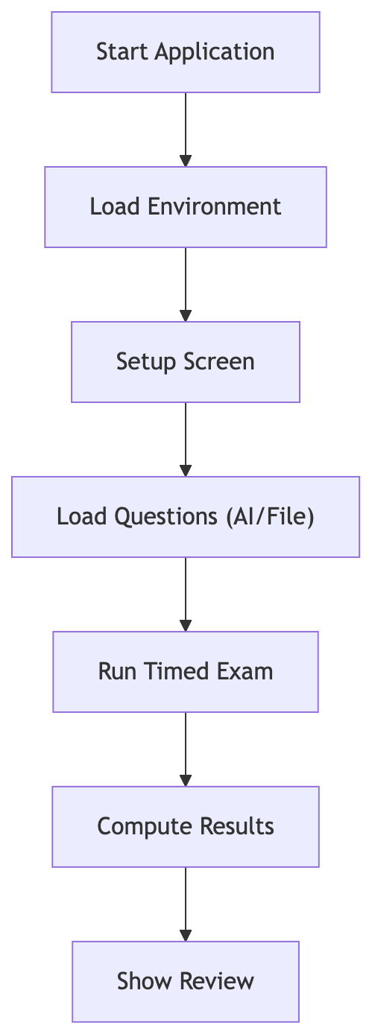

Key Features

Build and Installation
brew install qt
brew install cmake
mkdir build && cd build
cmake .. -DCMAKE_PREFIX_PATH=/opt/homebrew/opt/qt
cmake --build . -j10

Testing Strategy
The system was manually tested for:
- configuration validation
- API fallback
- timer expiration
- scoring accuracy
- GUI navigation
- console flow
- duplicate handling
All major functional paths were verified.

Limitations
- no database persistence
- no authentication system
- standalone desktop only
- limited local question diversity
- custom JSON parser (not fully robust)
- API rate limits

Future Scope
High-value upgrades include:
- SQLite integration
- PDF result export
- question editor GUI
- user authentication
- multi-topic exams
- cross-platform builds
- analytics dashboard
- network-based exams

Conclusion
The Online Examination System successfully demonstrates a robust, modular, and extensible platform for conducting MCQ-based examinations.
The project highlights strong competencies in:
- Modern C++17 development
- Qt GUI engineering
- API integration
- modular software architecture
- asynchronous programming
- scalable system design
With further enhancements such as database storage and analytics, the system can evolve into a full-scale production examination platform.

