SearchCraft
SearchCraft is a C++ autocomplete engine that combines: - Prefix search using binary search - Substring fallback search - Fuzzy matching with edit distance - Frequency-based ranking of suggestions

Project Structure
- app.cpp: Main source code
- data.txt: Query and frequency dataset
- output.png: Screenshot of sample output

Features
- Case-insensitive query handling
- Clean terminal output with highlighted match sections
- Top suggestions ranked by frequency
- Typo-tolerant fallback when no exact/prefix match is found

Build and Run
g++ -std=c++17 app.cpp -o app
./app

Usage
- Run the executable.
- Enter a search query.
- View top suggestions.
- Type exit, quit, or q to close.

Complexity Summary
- Prefix phase: Time O(log n + k + k log k), Space O(k)
- Substring phase: Time O(n * m + k log k), Space O(k)
- Fuzzy phase: Time O(n * m^2 + k log k), Space O(m^2 + k)
Where: - n = number of stored queries - m = query length - k = number of returned suggestions (TOP_K)

Screenshot
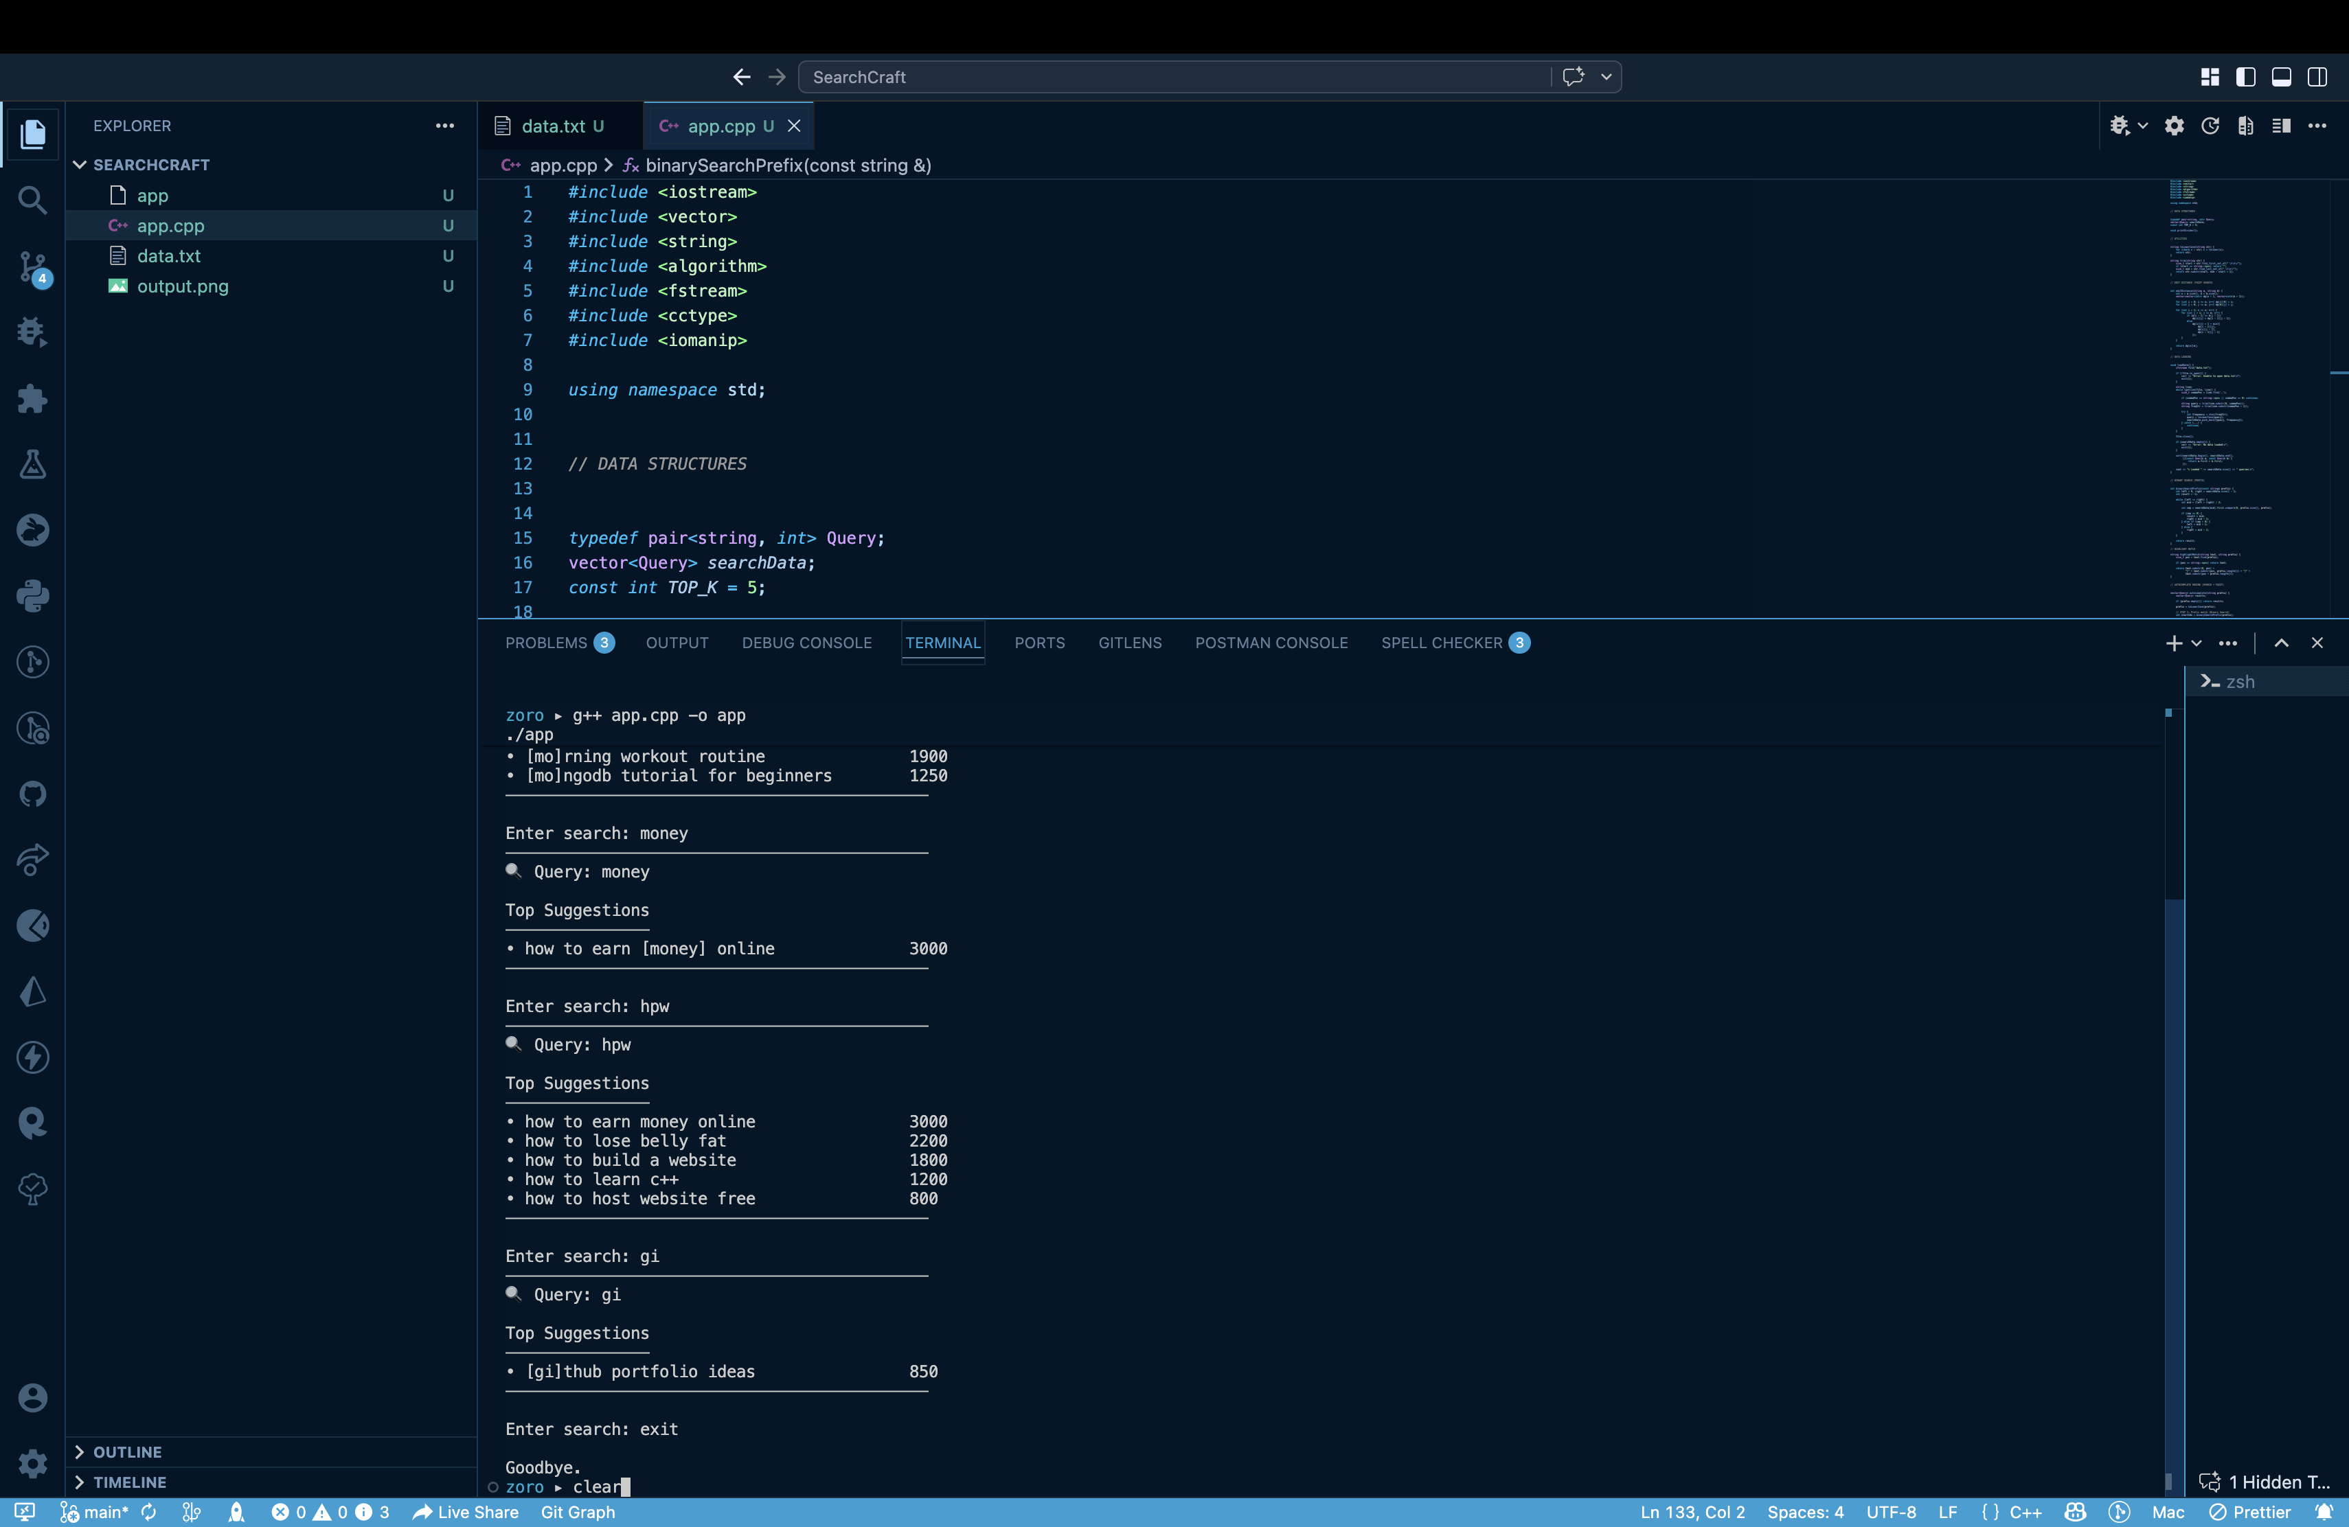
SearchCraft Output

