

School of Future Tech

Case Study Report

on

Scholarship Management System - 72

by

Sasanka Sekhar Kundu

150096725118

Table of Contents
INTRODUCTION TO THE CASE STUDY 3
PROBLEM STATEMENT / CASE BACKGROUND (ABSTRACT) 3
CASE STUDY DESIGN 4
METHODS & ALGORITHMS 7
Advantages: 12
Disadvantages: 12
Conclusion 13
References 13
Technology Documentation 13
Design Patterns & Architecture 13
Data Persistence 13
Project Requirements & Standards 13
Source Code & Implementation 14
Technologies & Tools 14
Academic & Industry Standards 14

INTRODUCTION TO THE CASE STUDY
The Scholarship Management System is a professional-grade desktop application representing a complete solution to automate and streamline scholarship administration in educational institutions. This case study documents the design, implementation, and technical architecture of a 1,500+ line C++17 application built with Qt Widgets framework.
Purpose of the Case Study
This project demonstrates:
- Real-world problem solving through software engineering
- Professional architecture patterns (3-tier layered design)
- Complete lifecycle development from requirements to production
- Clean code practices with SOLID principles
- Cross-platform application development using modern C++
Academic & Industry Significance
Educational institutions face critical challenges in managing scholarship programs manually:
- Time-consuming manual application reviews
- Error-prone eligibility assessments
- Lack of transparency in application tracking
- No audit trail for decision accountability
- Difficult scalability as student numbers grow
This system addresses all these challenges through automation and intelligent design

PROBLEM STATEMENT / CASE BACKGROUND (ABSTRACT)
Abstract
The Scholarship Management System (SMS) is a comprehensive solution developed to address the operational inefficiencies in scholarship distribution and application processing. Current manual systems require extensive administrative effort, lead to delays in applicant notifications, and provide limited transparency to students regarding application status.
Problem Statement
Primary Problem:
Educational institutions need an efficient, transparent, and automated system to manage scholarship applications from thousands of students while ensuring fair eligibility assessment based on objective criteria (marks and income).
Sub-Problems Identified:
Problem | Impact | Solution Provided
Manual Application Processing | 40% administrative time, prone to errors | Automated digital form submission
Inconsistent Eligibility Checking | Unfair decisions, complaints | Algorithm-based automated checking
No Application Tracking | Student anxiety, repeated inquiries | Real-time status tracking dashboard
Data Management | Scattered records, data loss risk | Centralized persistent storage
Limited Accessibility | Limited to office hours | 24/7 accessible desktop application
No Audit Trail | Accountability issues, disputes | Complete transaction logging
System Scalability | Cannot handle growth | Efficient file-based architecture

CASE STUDY DESIGN
System Design Overview
The Scholarship Management System uses a Three-Tier Layered Architecture following industry best practices:
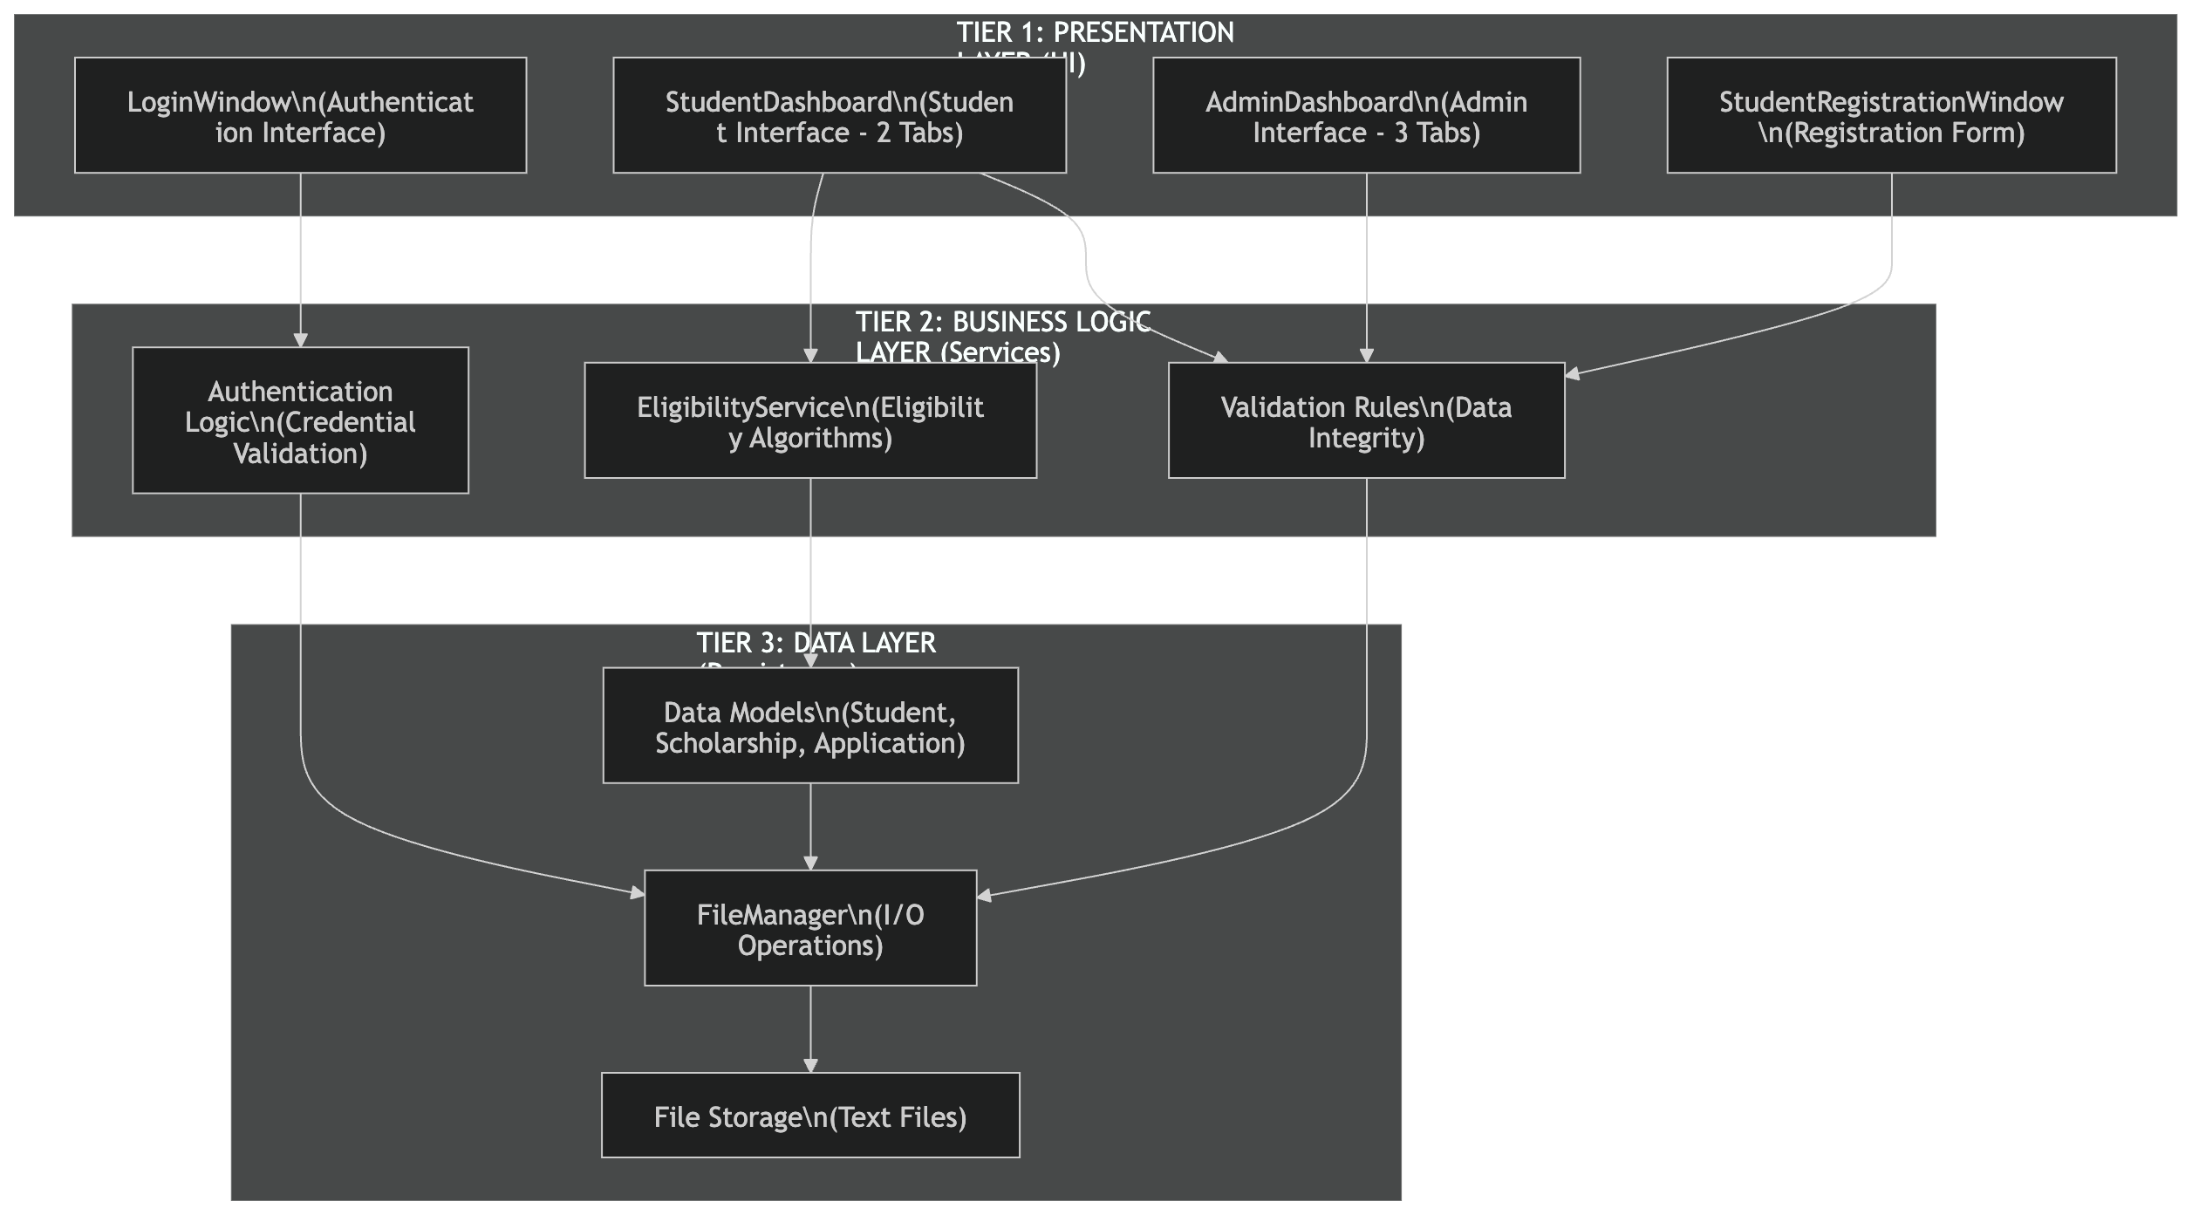

Component Design
Each tier has distinct responsibilities:
Presentation Tier (850 lines)
- Responsibility: User interaction and visual feedback
- Components: 4 window classes (LoginWindow, StudentDashboard, AdminDashboard, StudentRegistrationWindow)
- Pattern: Qt MVC with signals/slots
- UI Elements: Tables, buttons, forms, dialogs
Business Logic Tier (310 lines)
- Responsibility: Core algorithms and validation
- Components: EligibilityService, Authentication logic
- Operations: Eligibility checking, password validation, data validation
- Independence: Not dependent on UI specifics
Data Tier (300 lines + FileManager 200 lines)
- Responsibility: Data representation and persistence
- Components: Student, Scholarship, Application models
- Operations: Serialization/deserialization, CRUD operations
- Storage: File-based with pipe-delimited format
User Roles & Use Cases
Two Primary User Roles:
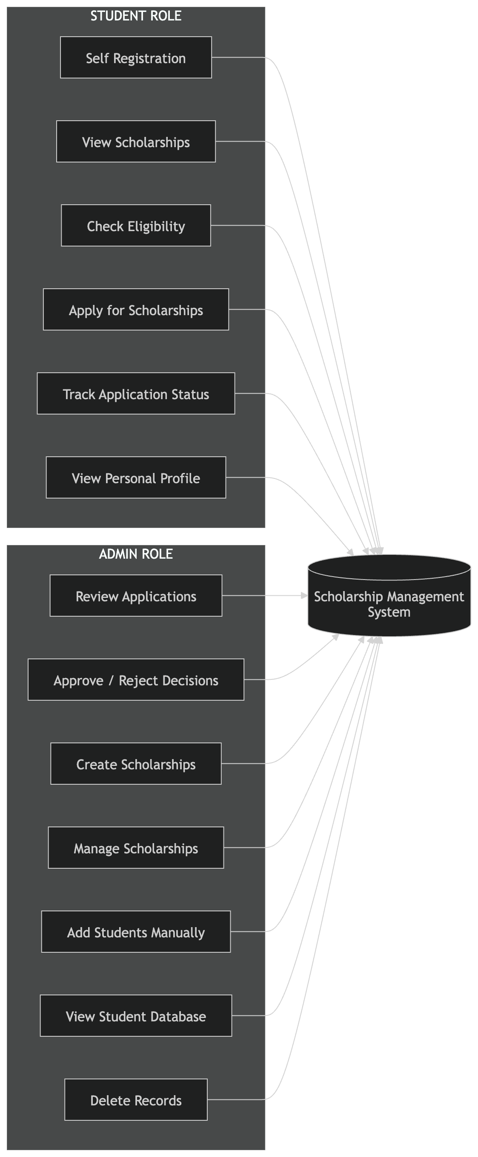
Data Model Design
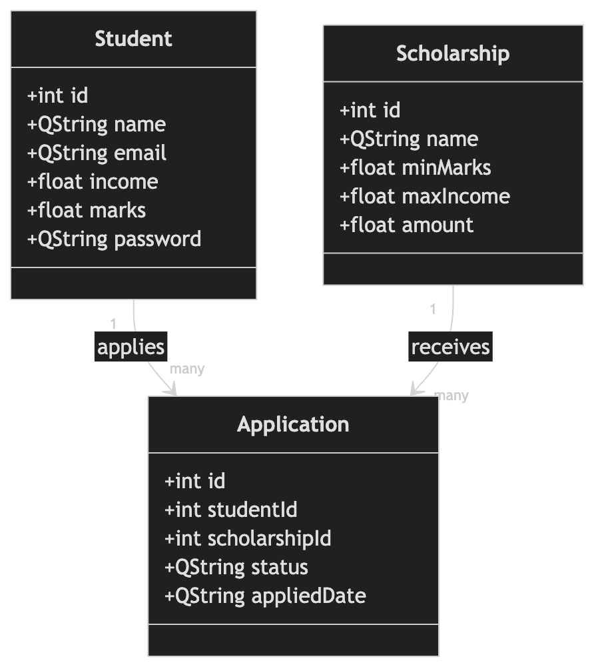
METHODS & ALGORITHMS
Core Algorithm: Eligibility Checking
Algorithm Name: Two-Criteria Eligibility Verification
Input Parameters:
- studentMarks: Student's academic performance (0-100)
- studentIncome: Student's family income (₹)
- scholarshipMinMarks: Scholarship minimum requirement
- scholarshipMaxIncome: Scholarship maximum income
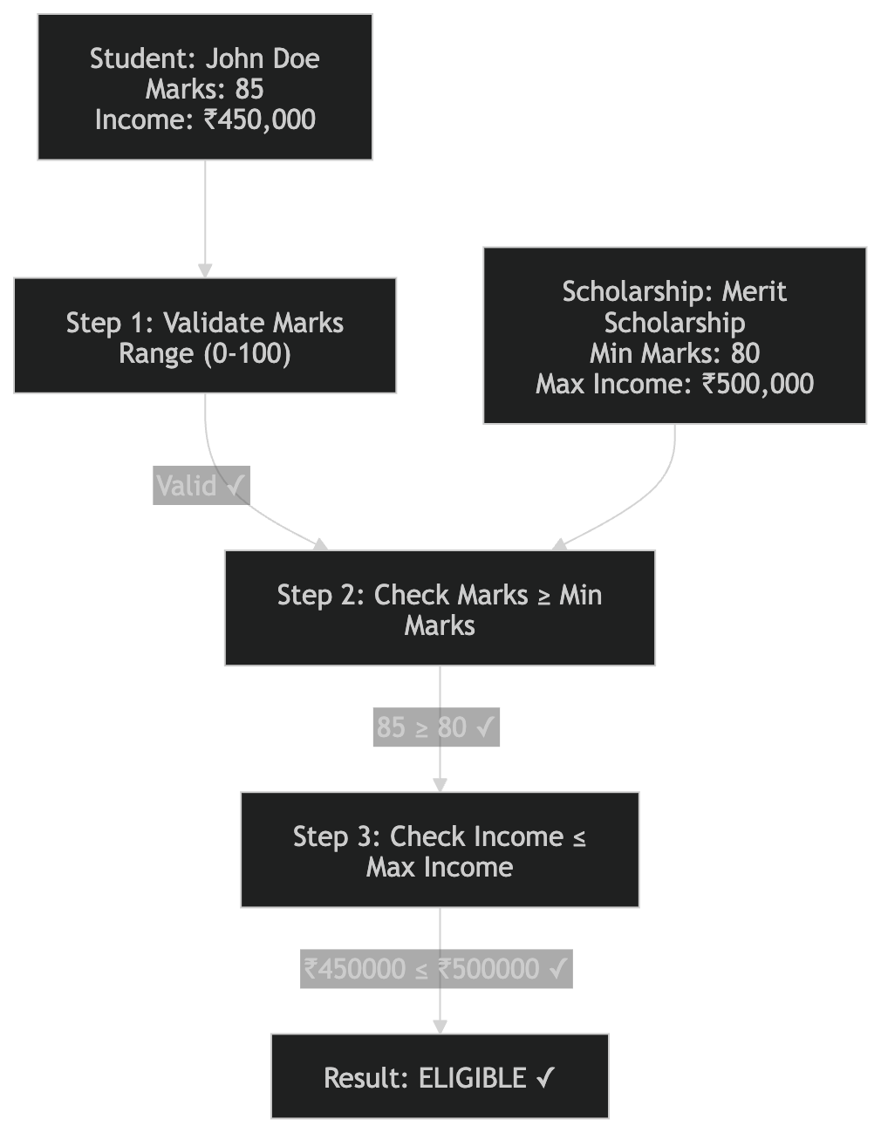

Time Complexity: O(1) - Constant time, only 2 comparisons
Space Complexity: O(1) - No additional data structures

Function IsEligible(student, scholarship):
STEP 1: Validate inputs
IF student.marks < 0 OR student.marks > 100 THEN
RETURN false
END IF
STEP 2: Check minimum marks requirement
IF student.marks < scholarship.minMarks THEN
RETURN false (Student marks too low)
END IF

STEP 3: Check maximum income requirement
IF student.income > scholarship.maxIncome THEN
RETURN false (Student income too high)
END IF

STEP 4: Both criteria satisfied
RETURN true (Student is eligible)

End Function
Authentication Algorithm
Algorithm Name: Credential Verification System
Input: email, password (user input)
Output: Student object (if valid) OR invalid student object
Function AuthenticateStudent(email, password):

STEP 1: Load all students from persistent storage
students = FileManager.LoadStudents()

STEP 2: Iterate through all students
FOR EACH student IN students:

STEP 3: Check email match
IF student.email == email THEN

STEP 4: Check password match
IF student.password == password THEN
RETURN student (Authentication successful)
END IF

END IF

END FOR

STEP 5: No match found
RETURN InvalidStudent() (Authentication failed)

End Function
Time Complexity: O(n) - Linear search through n students
Space Complexity: O(n) - Stores all students in memory

Registration & Validation Algorithm
Algorithm Name: Student Registration with Multi-Level Validation
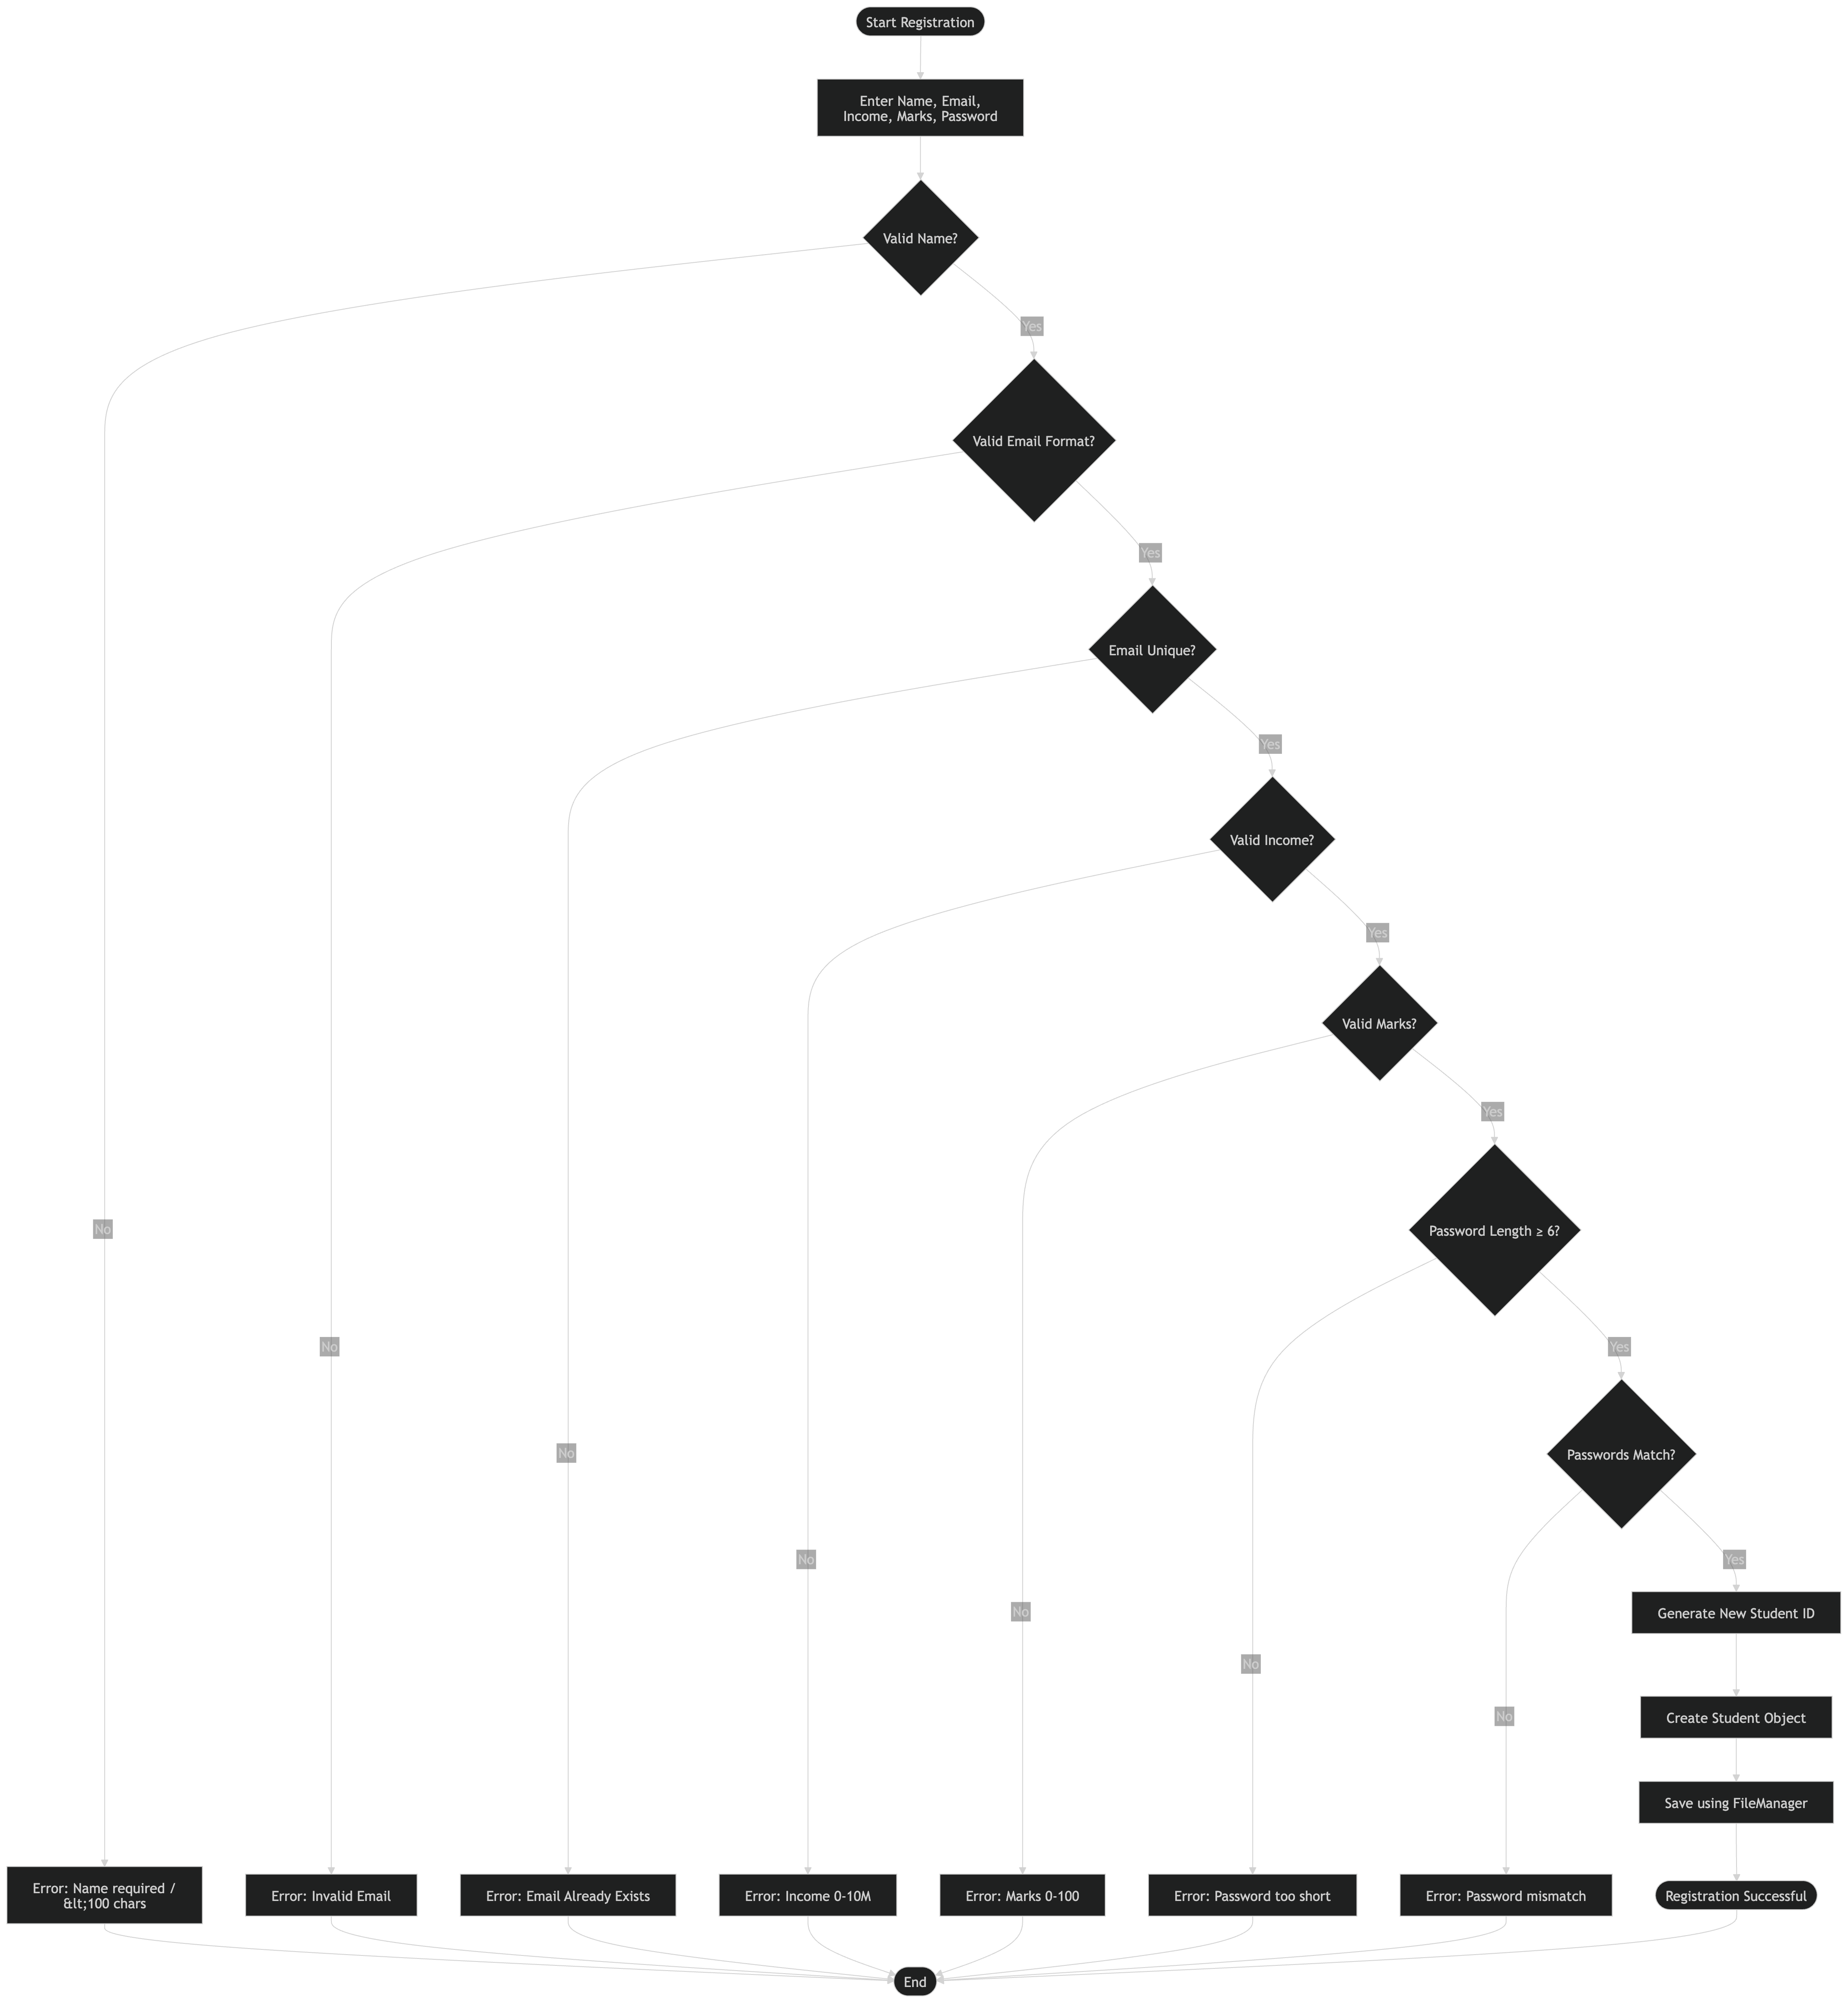

Deserialization (String to Object):
Technology Stack
Function StringToStudent(line):

STEP 1: Split by pipe delimiter
parts = line.split("|")

STEP 2: Validate field count (must be exactly 6)
IF parts.length < 6 THEN
RETURN InvalidStudent()
END IF

STEP 3: Parse and create student
id = parseInt(parts[0])
name = parts[1]
email = parts[2]
income = parseFloat(parts[3])
marks = parseFloat(parts[4])
password = parts[5]

STEP 4: Create object
RETURN Student(id, name, email, income, marks, password)

End Function
Category | Technology / Tool | Purpose / Usage
Programming Language | C++17 | Core application development with high performance and OOP support
Framework | Qt (5.15+ / 6.0+) | GUI development and event-driven architecture
Core Library | Qt Core | Provides QString, QVector, QFile, QTextStream
GUI Library | Qt Widgets | UI components like buttons, tables, input fields
Build Tool | qmake | Default Qt build system
Build Tool | CMake (3.16+) | Cross-platform build configuration
Compiler | GCC / Clang / MSVC | Compiles C++ code into executable
IDE | Qt Creator / VS Code | Development and debugging environment
Data Storage | Text Files (.txt) | File-based persistence system
Data Format | Pipe-delimited (` | `)
Version Control | Git | Source code management and tracking
Operating System | Windows / Linux / macOS | Cross-platform support

Some Advantages and disadvantages:

Advantages:
- Human readable (can open in text editor)
- Simple to parse (split by "|")
- No special libraries needed
- Complete control over format
- Easy version migration

Disadvantages:
- No indexing (linear search)
- Manual locking (no concurrency)
- No query language (manual filtering)
- Manual integrity (no constraints)

Conclusion
The Scholarship Management System represents a comprehensive and well-engineered solution to modernize and streamline the scholarship process within educational institutions. By integrating a robust three-tier architecture with C++ and Qt, the system effectively automates student registration, eligibility verification, application management, and administrative decision-making. It demonstrates strong adherence to software engineering principles such as modular design, data validation, and separation of concerns, resulting in a scalable, maintainable, and high-performance application. The system not only reduces administrative overhead and enhances transparency but also empowers students with a seamless, self-service experience. With its cross-platform capability, efficient file-based persistence, and intuitive user interface, the project stands as a practical and extensible foundation that can be further evolved into a full-scale enterprise or web-based solution.

References

Technology Documentation
- C++ Standards Committee. (2017). ISO/IEC 14882:2017 Programming Language C++.
- Qt Project. (2024). Qt 6 Official Documentation. Retrieved from https://doc.qt.io/
- Qt Project. (2024). Qt 5.15 LTS Documentation. Retrieved from https://doc.qt.io/qt-5/

Design Patterns & Architecture
- Gamma, E., Helm, R., Johnson, R., & Vlissides, J. (1994). Design Patterns: Elements of Reusable Object-Oriented Software. Addison-Wesley.
- Freeman, E., & Freeman, E. (2004). Head First Design Patterns. O’Reilly Media.
- Martin, R. C. (2008). Clean Code: A Handbook of Agile Software Craftsmanship. Prentice Hall.
- Newman, S. (2015). Building Microservices: Designing Fine-Grained Systems. O’Reilly Media.

Data Persistence
- Codd, E. F. (1970). A Relational Model of Data for Large Shared Data Banks. Communications of the ACM, 13(6), 377–387.
- Delimiter-Separated Values. Retrieved from https://en.wikipedia.org/wiki/Delimiter-separated_values

Project Requirements & Standards
- UNESCO. (2019). Guidelines for Scholarship Program Management. UNESCO Publishing.
- NACAC. (2023). Best Practices in College Admissions & Scholarship Award Decisions.

Source Code & Implementation
- Sasanka Sekhar kundu (2026). Scholarship Management System (SMS). GitHub Repository.
Retrieved from: https://github.com/Sasanka14/SMS--Scholorship-Managemnt-System
  - Language: C++17
  - Build System: qmake, CMake
  - License: Open Source

Technologies & Tools
- GCC / Clang Compilers – C++17 Support
- CMake (3.16+) – Build Automation
- qmake – Qt Build System
- Qt Creator – Integrated Development Environment
- Git & GitHub – Version Control and Repository Hosting

Academic & Industry Standards
- ISO/IEC 25227:2022 – Source Code Metrics
- Google C++ Style Guide
- Qt Coding Conventions
- SOLID Principles (Object-Oriented Design Best Practices)

