Super Mario Motion – Help Page

Welcome to the help page for Super Mario Motion.
Quick Navigation
The user interface 2
User data and settings 3
Location 3
Launch RetroArch from within the application 3
Train and use your own model 4
Setting up a custom control scheme and game 4
Modes explained 5
Simple Mode 5
Full-body Mode 6
Collect Mode 7
Frequently Asked Questions 8

The user interface
The UI is the main way the user interacts with the application. Here is an overview of each UI-element what what it does.
1. Preview Image: Shows a preview of your webcam.
2. Action Buttons: Clicking the launch game button, will start the selected game, for more information, see the chapter “Launch RetroArch from within the application”.
The Help button will lead you to this document.
3. Dropdown menus: Use the first menu to change the display of the preview image (1). Use the second dropdown menu to select the mode, for more information on what each mode does, see the chapter “Modes explained”. The third dropdown menu allows you to set which version of the game you want to play. Controls will also change accordingly.
4. Checkboxes: The first one enables debug information when checked, the second checkbox enables the application to simulate button presses to control the game.
5. Virtual Gamepad & Pose Indicator: This panel displays a virtual gamepad that shows in real time which buttons are pressed. Next to it is an icon indicating the current pose.
6. Pose label: Displays the current pose as raw text.
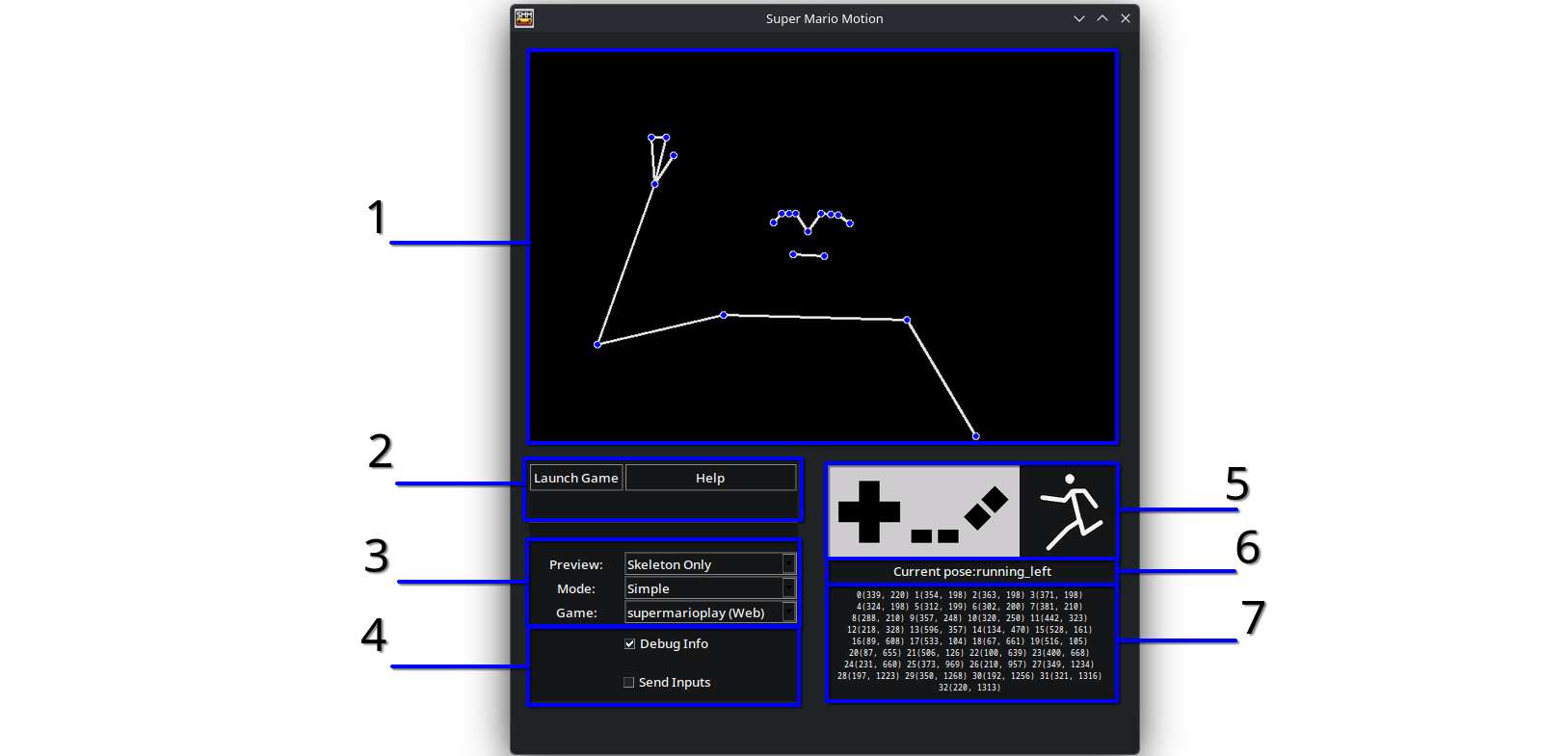
7. Debug Information: This only gets displayed when the “Debug Info” checkbox (4) is checked.

User data and settings

Location
A directory containing user data and settings gets created when you launch the application for the first time, only if it doesn’t already exist.
The folder can be found in the following location:
Windows | %appdata%/SuperMarioMotion
MacOS | ~/Library/Application Support/SuperMarioMotion
Linux | ~/.local/share/supermariomotion

Inside you will find a folder called config containing the config.json file. You can edit this file with a text editor of your choice. The values inside of the config will be loaded when the program starts. If you make changes while the program is running, you need to restart it.

Launch RetroArch from within the application
This guide will show you how to setup RetroArch paths, so that you can start it up by pressing the “Launch Game” button from within the application.
By default the config file looks like this:
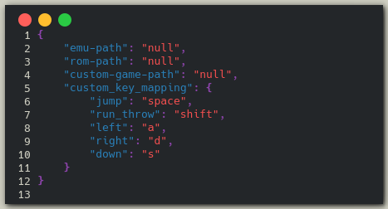
RetroArch can either be installed through Steam or as a standalone application.
Here are a few paths where RetroArch could be located by default:
Windows via Steam | C:\Program Files (x86)\Steam\steamapps\RetroArch
MacOS via Steam | ~/Library/Application Support/Steam/steamapps/RetroArch
Linux via Steam | ~/.steam/root/steamapps/common/RetroArch/

If you are sure that RetroArch is installed in that folder, you can copy the path and write it to the config on the "emu-path"-section. Replace the "null" with your valid path.
Next you need to find the location of your ROM. Make sure you include in your path not the to the directory where the file is, but also include the file with file extension.
Example: "C:\Users\<username>\Documents\game.nes"
You should know where your file is if you have one. We do not give instructions where to get it from. Each user should use their own legally obtained ROM.

Train and use your own model
After starting, the application it looks for a file called pose_model.joblib inside of the user data folder. If this file is not found, a default internal joblib file will be loaded.
Right now it is only possible to collect training data in the form of .csv files and there is no way to train the model using that data from within the application.
If you want to train your own model, you will need to clone the GitHub repository and run train.py. It should append all of your .csv files into a single file and create a .joblib file out of it. Depending on the size of your training data this could take a few minutes.
You can now delete the .csv files, if you no longer need them.

Setting up a custom control scheme and game
Open up the config.json, located inside of the config folder within the user data folder. In the config is a section called custom_key_mapping. Edit the values to the right of each action.
You can see the list of valid buttons here: https://pyautogui.readthedocs.io/en/latest/keyboard.html#keyboard-keys
To link to a custom game, you can specifiy the file path to the executable of the game.
Example: "C:\Users\<username>\Documents\games\my-cool-game.exe"
The Application supports three modes, that can be selected via the dropdown menu called "Mode:"

Modes explained

Simple Mode
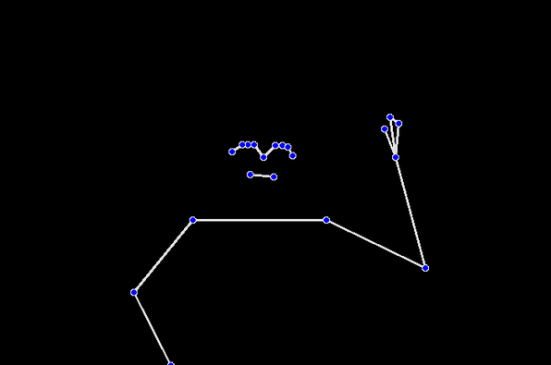
This mode is desinged to be used while sitting in front of your PC. You can control the game with the following arm gestures:
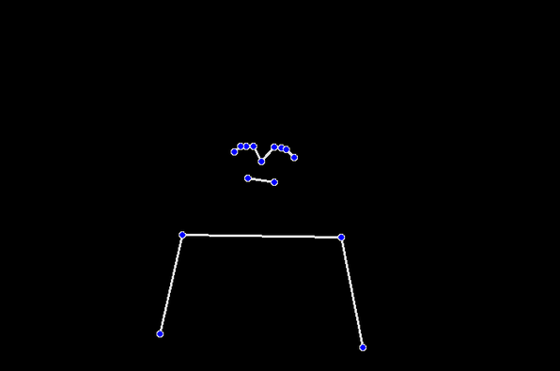 | Standing  You can stand still by keeping both arms in a neutral position.
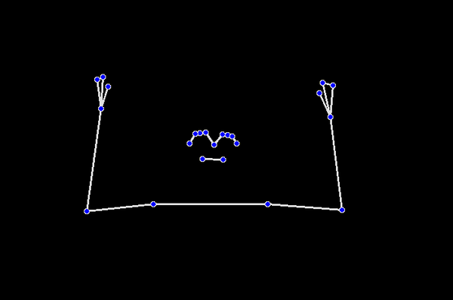 | Walking  You can walk to the left or right by raising the corresponding hand. The position of the wrist should be higher than your shoulders and lower than the eyes.
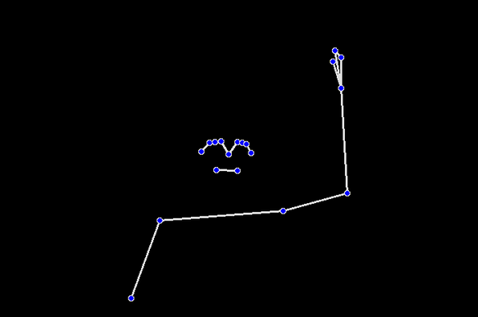 | Running  You can run to the left or right by raising your arm that corresponds to that direction.  The wrist should be above the height of your eyes.
Jumping
You are able to jump by holding up both of your hands. The wrists should be at least above your shoulders.
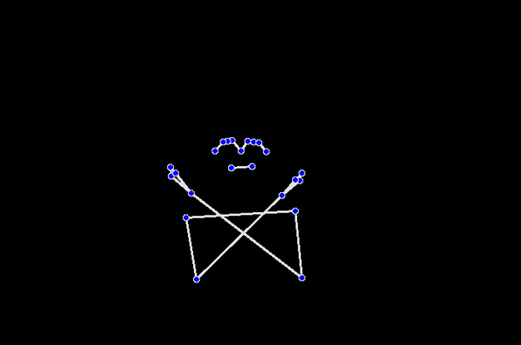 | Swimming  You can swim by crossing your arms.
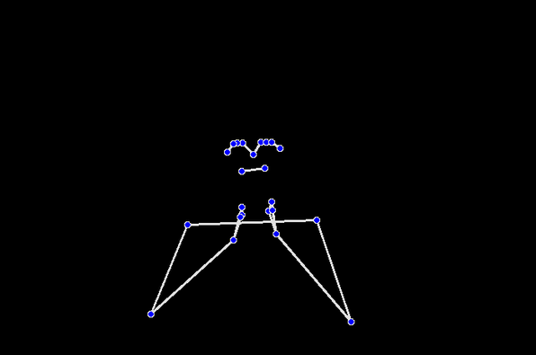 | Crouching  You can crouch by putting both of your hands together. The wrists need to be below your eyes.
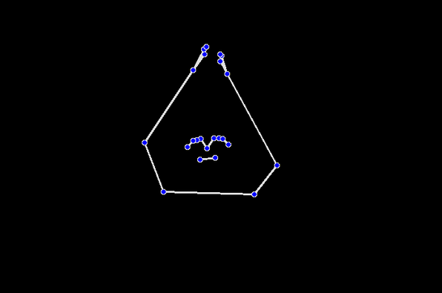 | Throwing  You can throw a fireball by putting both of your hands together above your head.

Full-body Mode
This mode is desinged to be used to play the game with full body motions. This means your entire body should be visible within the camera’s view.

A machine-learning model in form of a .joblib file is required to use this mode. The default installation includes a pre-trained model that is ready to use.

The available poses you can perform are as follows:

Standing
You stand still by having your body in a resting, neutral position.
Walking
You can walk to either side (left or right) by walking small relaxed steps, but remain in the same spot.
Running
You can run to either side (left or right) by making an exaggerated, fast running motion in the desired direction, while remaining on the same spot.
Jumping
You can jump in-game by holding your right fist up while jumping.
Swimming
You can swim while looking towards the camera and making a breaststroke motion with your arms.
Crouching
You can crouch by facing towards the camera lowering yourself onto your knees. Make sure that your hands are positioned toward the ground.
Throwing
You can throw a fireball by making a throwing motion with your left hand.

Collect Mode
Note: This mode is not designed for players that just want to play the game with motion controls.
Once you select this mode, you will notice that the UI now takes up the whole screen and a new button has appeared.

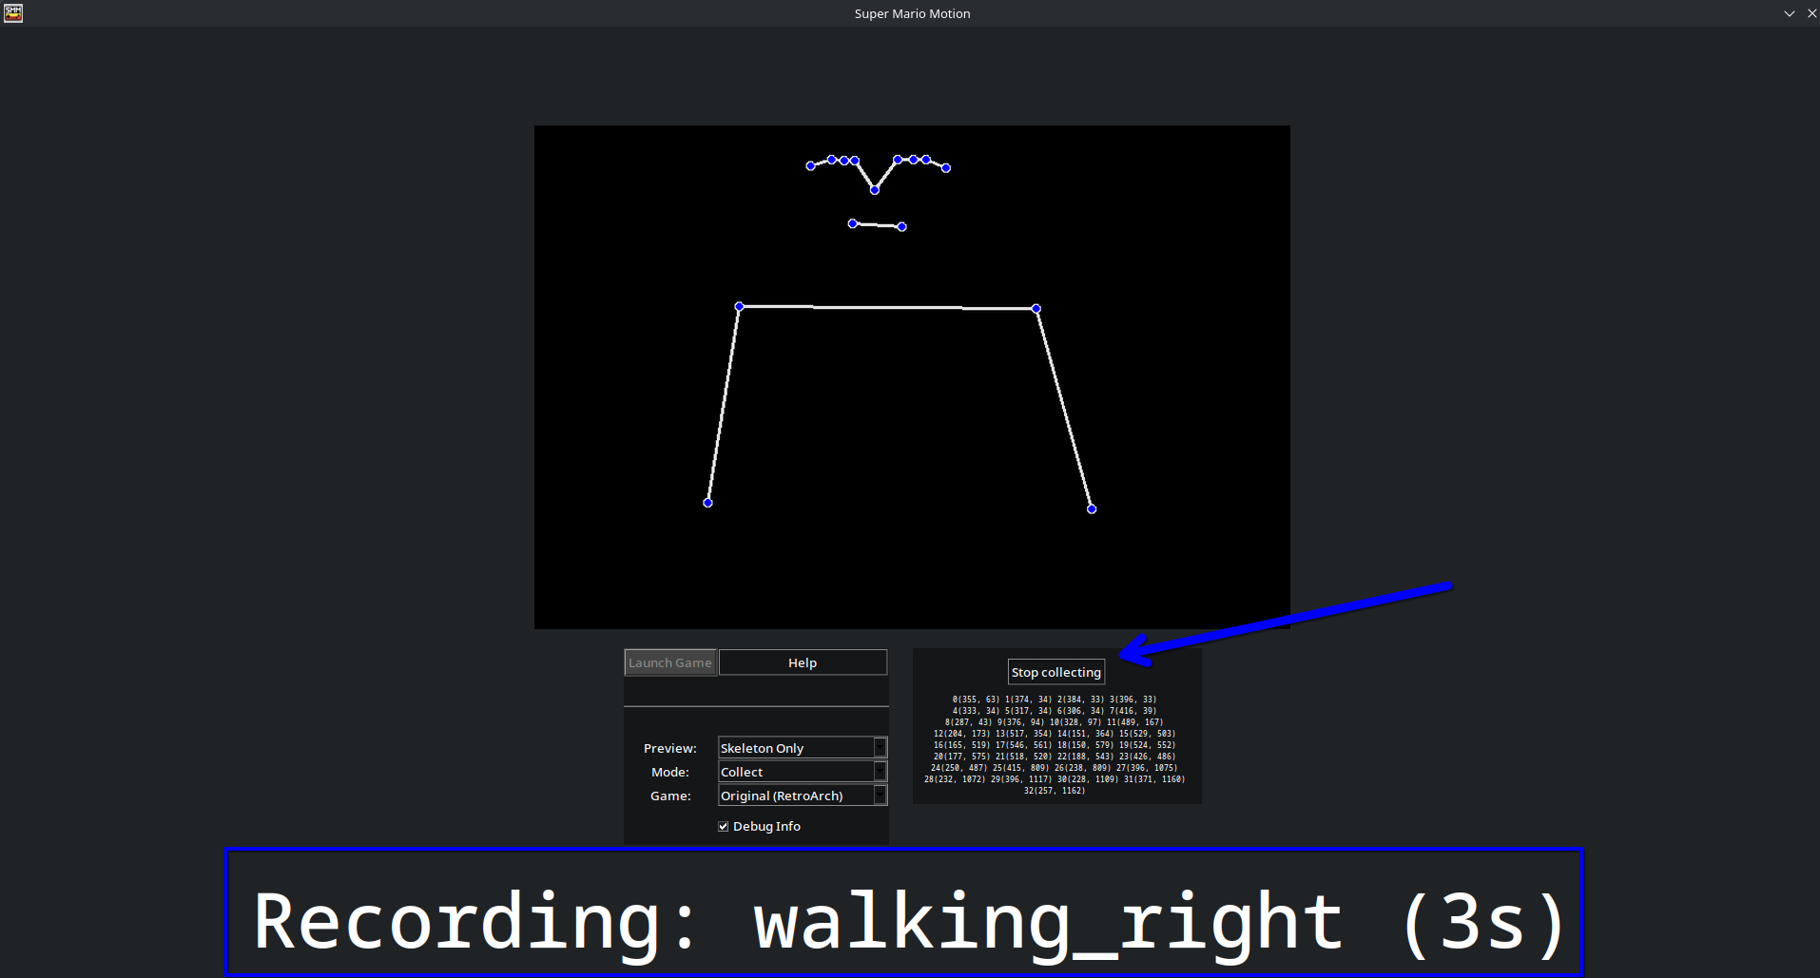
In this mode, you can collect samples of you doing poses, that can be used as training data to train and refine the full body pose recognition model.

You start the collection by pressing the new button on the right. On screen you will be informed on what kind of pose you should perform and for how long. By pressing the button again while collecting, you can preemptively stop the collection process.

Make sure that your whole body is visibile while recoding, otherwise you might collect bad data.

You can find your collected data in the data folder as .csv files.
If you are unsure where the data folder is on your system, see chapter “User data and settings”.

Frequently Asked Questions
“The program instantly closes upon startup”
→ This application needs a connected webcam to start up. Make sure your webcam is correctly plugged in and not occupied by other programs.

“The poses are being recognized but there arent any inputs sent to the game and the controller is also not displaying anything.”
→ Make sure that the Send Inputs checkbox is checked, otherwise the program will not send any inputs.

“I feel a big delay in Simple Mode, especially when jumping”
→ It takes a moment for your arms to get recognized when they’ve been out of view.
To reduce delay, we suggest going a bit further away from the camera, so that your arms are always in view.

“The Launch Game button is gray and is not pressable”
→ When the button is gray, that means that either RetroArch or the ROM-file could not be found in the specified path in the config. Please make sure that the paths are correct. See chapter “Launch RetroArch from within the application”

