**The Mathinator Software Requirements Specification For The Android Application**

**Version 1.2**

**Revision History**

|  |  |  |  |
| --- | --- | --- | --- |
| **Date** | **Version** | **Description** | **Author** |
| 23/10/16 | 1.0 | Initial Description | Hug, Lamm, Saupp |
| 1/11/16 | 1.1 | Use Cases added | Hug, Lamm, Saupp |
| 26/11/16 | 1.2 | Redefined Scope, Added UCs | Hug, Lamm, Saupp |
|  |  |  |  |

**Table of Contents**

1. Introduction...........................................................................................................................................................4

1.1 Purpose.........................................................................................................................................................4

1.2 Scope ............................................................................................................................................................4

1.3 Definitions, Acronyms, and Abbreviations ..................................................................................................4

1.4 References ....................................................................................................................................................5

1.5 Overview ......................................................................................................................................................5

2. Overall Description .............................................................................................................................................5

2.1 Vision ...........................................................................................................................................................5

2.2 Use Case Diagram........................................................................................................................................6

3. Specific Requirements ........................................................................................................................................7

3.1 Functionality - Android App ........................................................................................................................7

3.1.1 Take a Picture ......................................................................................................................................7

3.1.3 Go through History..............................................................................................................................7

3.2 Usability .......................................................................................................................................................7

3.3 Reliability.....................................................................................................................................................7

3.4 Performance .................................................................................................................................................7

3.5 Supportability...............................................................................................................................................7

3.5.1 Languages and platforms.....................................................................................................................7

3.6 Design Constraints .......................................................................................................................................8

3.6.1 Backend in Java ...................................................................................................................................8

3.7 Online User Documentation and Help System Requirements......................................................................8

3.8 Purchased Components ................................................................................................................................8

3.9 Interfaces ......................................................................................................................................................8

3.9.1 User Interfaces.....................................................................................................................................8

3.9.2 Hardware Interfaces ............................................................................................................................8

3.9.3 Software Interfaces ..............................................................................................................................8

3.9.4 Communications Interfaces .................................................................................................................8

3.10 Licensing Requirements ...............................................................................................................................8

3.11 Legal, Copyright, and Other Notices............................................................................................................8

3.12 Applicable Standards ...................................................................................................................................8

4. Supporting Information .....................................................................................................................................9

**Software** Requirements **Specification**

**1.** Introduction

This document describes the Software Requirements Specifications (SRS) for the Application

“The Mathinator”.

**1.1** Purpose

The purpose of this document is to give a detailed description of the requirements for the application “The Mathinator”. It will cover the features in full detail. Furthermore important characteristics of this project will be specified.

This includes design and architectural decisions.

**1.2** Scope

“The Mathinator” is an Android application designed to learn your handwriting via character

recognition based on an Artificial Intelligence (AI) and providing the user with the solution.

**1.3** Definitions, Acronyms, and Abbreviations

● **AI** - Artificial intelligence

● **Android** - A mobile operating system used primarily for smartphones and tablets

**1.4** References

|  |  |
| --- | --- |
| **Document** | **Where to find?** |
| Blog | [https://mathinator.tobiaslamm.de](https://mathinator.tobiaslamm.de/) |
| Github | <https://github.com/SaschaHug/Mathinator> |
| Use Case 1 “take a picture” | <https://github.com/SaschaHug/Mathinator/blob/master/1_UC_Mathinator_Take_A_Picture.pdf> |
| Use Case 2 “view history” | <https://github.com/SaschaHug/Mathinator/blob/master/2_UC_Mathinator_View_History.pdf> |
| Use Case 3 “show tour on first start” | <https://github.com/SaschaHug/Mathinator/blob/master/3_UC_Mathinator_Delete_Entry.pdf> |
| Use Case 4 “enable user to delete entries” | <https://github.com/SaschaHug/Mathinator/blob/master/4_UC_Mathinator_Use_Manual_Calculator.pdf> |
| Use Case 5 “do manual calculations” | <https://github.com/SaschaHug/Mathinator/blob/master/5_UC_Mathinator_Show_tour.pdf> |

**1.5** Overview

The rest of the document is separated into 3 different chapters.

Chapter 2 will cover our vision and Chapter 3 will cover the specific requirements needed to get there. Chapter 4 will provide additional Information.

**2.** Overall Description

**2.1** Vision

Studying mathematics can be a frustrating endeavour at times. Our application aims to aid the user in these troubled situations by providing solutions to certain problems, so the user can check whether they correctly solved the given equation. People using our app can take pictures of equations and are provided with a solution.

**2.2** Use Case Diagram

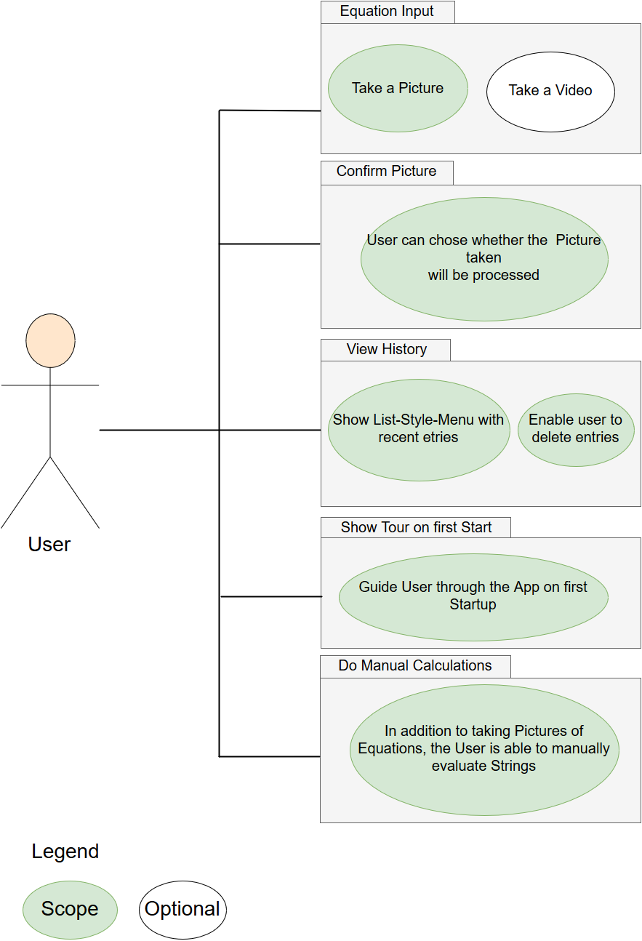

**3**. Specific Requirements

**3.1** Functionality - Android App

**3.1.1** Take a Picture

The User is able to take a picture with the smartphone camera.

**3.1.2** Solve Math Equation

The app provides the solution of the the mathematical equation on the screen after a picture was taken.

**3.1.3** Go through History

The user is able to go through previously taken pictures and review the results.

**3.2** Usability

We assume that the user is capable of installing an app via the official Play Store provided by

Google. We will additionally provide an installation guide.

The app itself is self-explanatory, though the user will be guided by popups which explain the apps functions the first time the app is used.

**3.3** Reliability

*To be determined.*

**3.4** Performance

*To be determined.*

**3.5** Supportability

**3.5.1** Languages and platforms

We will use the following languages and platforms, which will also be supported in future versions:

● Java EE 8

● Android Version 6.0 (Marshmallow)

**3.6** Design Constraints

All information about the architectural design of our application can be found in our software architecture document (Yet to be done).

In the following chapter you can read about general decisions.

**3.6.1** Backend in Java

The Backend of this application is written in Java. It consists of 2 elementary parts: The AI that recognizes input and the calculation unit that processes the aforementioned input.

**3.7** Online User Documentation and Help System Requirements

The app itself is designed to be intuitive. Additional help prompts are implemented to guide the user on first startup. Should there still be questions about the use of the app, users can contact us on our blog.

**3.8** Purchased Components

*None*

**3.9** Interfaces

3.9.1 User Interfaces

*To Be Determined*

3.9.2 Hardware Interfaces

*N/A*

3.9.3 Software Interfaces

*To Be Determined*

3.9.4 Communications Interfaces

*N/A*

**3.10** Licensing Requirements

*To be Determined*

3.11 Legal, Copyright, and Other Notices

*To be Determined*

3.12 Applicable Standards

*To be Determined*

**4.** Supporting Information

Visit our github for more information ([https://github.com/SaschaHug/Mathinator)](https://github.com/SaschaHug/Mathinator) and our

blog for the current status of the project ([https://mathinator.tobiaslamm.de).](https://mathinator.tobiaslamm.de/)