Intuition and accessibility in VR

Exemplified by a custom made VR-Minigame

Sascha Lucas Kufahl

Vincent Holtorf

31.05.2018

Table of Contents

Abstract 2

Motivation 2

State of the Art 2

Impact 2

Related Work 3

Concept 3

Implementation 3

Contribution 4

Future Work 4

# Abstract

A vr-mini-game developed with instant accessibility and playability in mind, by maximizing intuitive game design concepts. This was realized by breaking down all game mechanics and user interactions into their respective core elements.

# Motivation

General virtual reality (vr) applications, as well as vr-games or other vr-entertainment media, can still be considered to be an unconventional form of user technology. Even with the accelerating speed of development and improvements by the day, hardly any type of conventions in this media exist, compared to more established industries, such as film and traditional 2d desktop computer applications. This project tried to tackle the issue by researching and using known techniques as well as crystalizing ideas and concepts of directing user attention into 3d virtual space.

This game was instantiated as part of an university project and inspired by the desire to make vr-technology more accessible to the casual user. Further, it is intended to improve the understanding and establishment of conventions for the vr-media development.

Additional inspiration was drawn in by real world applications such as high tech drones and their simplification to the degree of modern toys. This process, of simplification of high end technologies into a digestible and accessible form, greatly influenced this project.

# State of the Art

Current vr-technology is considerably new and hardly available to the standard pc user. Therefore very few user experiences and issues are known, to provide a guideline for future vr-software development. Many of the existing vr-software is intended as a demonstration or an experimental vr-experience. Hardly, if any, “triple A” titles exist and even multimillion dollar companies are still in the development or research stages for this platform.

Further, no single application has yet reached global recognition. This could be, because of the platforms poor accessibility due to high hardware costs, or the software not being advanced enough.

These reasons could explain the need for staff and the required guidance at media conventions and vr-exhibitions.

# Impact

Our work can be considered as an example and an experience for vr-user interaction design and its implementation. Certain aspects, such as minimization in vr-space of 3d components in appearance and number, or the gradual introduction of interaction elements, were essential to our project.

# Related Work

*The Lab* (Valve Corporation) is a collection of mini-games to showcase possibilities in vr. It does so in a minimalistic setting and with a comical approach. The already established and fairly successful “Portal”-universe is used as the world setting.

*Oculus First Contact* (Oculus) is a short vr-experience, which introduces basic controls and the oculus touch controller to the user. It is presented in a semi game way.

*Metroid Prime Hunter* (Nintendo) is a first-person action-adventure. As one of the earlier complex games it gradually introduces game mechanics and controls to the user.

Modern drones and their origin as highly sophisticated and complex technology, also served as inspiration. Breaking down this advanced hardware, scale it down and make accessibly priced toys from technology that once was the pinnacle of military and state technology.

# Concept

Our concept was to create a highly accessible mini-game, by reducing interaction complexity to the bare minimum, while also trying to keep the game fun. We want to introduce new users to the general concept of vr-interaction and therefore require the polishing of the limited user interactions to enable a fluid and intuitive experience. Introducing every interaction gradually, while refraining from the use of text or speech, was also intended.

# Implementation

The project was developed using Unity and Blender. The “OVR” Framework was essential to enable the use of the Oculus Rift.

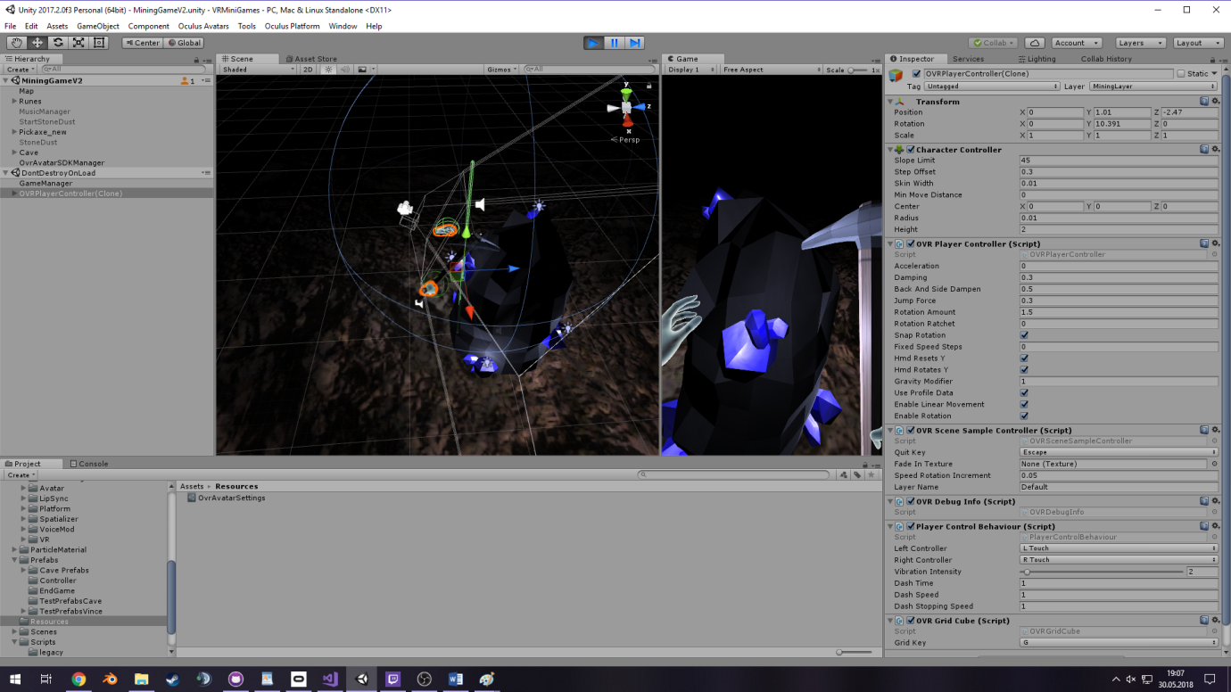

1 Unity Implementation; by Sascha Lucas Kufahl

# Contribution

Our project was meant to improve vr-userinteraction design and to further understand what intuition in vr means. Proven methods of directing user attention from other forms of media are not always applicable and therefore require redefinition or reconsideration for future vr-software development. Most of the already existing vr-software not consistent in their approach of handling users and user interaction.

The issue of movement in vr is still topic of discussions and the way it was handled in our project, by blinking the user from one place to the next, is but one approach of many. Acceleration can cause motion sickness for the player and was consequently avoided. The problem of communicating the time and direction of the blink was handled by signals and arrows, which were highlighted through lights and particle effects.

Overall through various efforts and playtests it became clear that intuition in vr can have many form and shapes and is heavily affected by the polishing process.

# Future Work

For future work, we would like to expand the repertoire of possible user interactions as well as developing additional game mechanics. This would further answer the question at what point the use of text or speech for the explanation of the software becomes a necessity. It would further deepen the understanding of intuitive vr-software design.

Also we would like to further polish existing elements of the game, such as the current dash mechanic. One possibility would be to add a little more time to the dash as well as animations.