SPOTIFY ETL & SNOWFLAKE ANALYTICS PIPELINE
Project Documentation

Overview
An end-to-end, event-driven data pipeline that extracts music catalog data from the Spotify Web API, transforms it using serverless AWS Lambda functions, and loads it into Snowflake for analytics. The pipeline runs fully automated from source to warehouse, with no manual intervention required between stages.

Architecture
The pipeline follows a serverless, event-driven Extract → Transform → Load pattern, structured as a data lake (raw vs. transformed zones in S3) with an automated ingestion layer into a Snowflake warehouse.

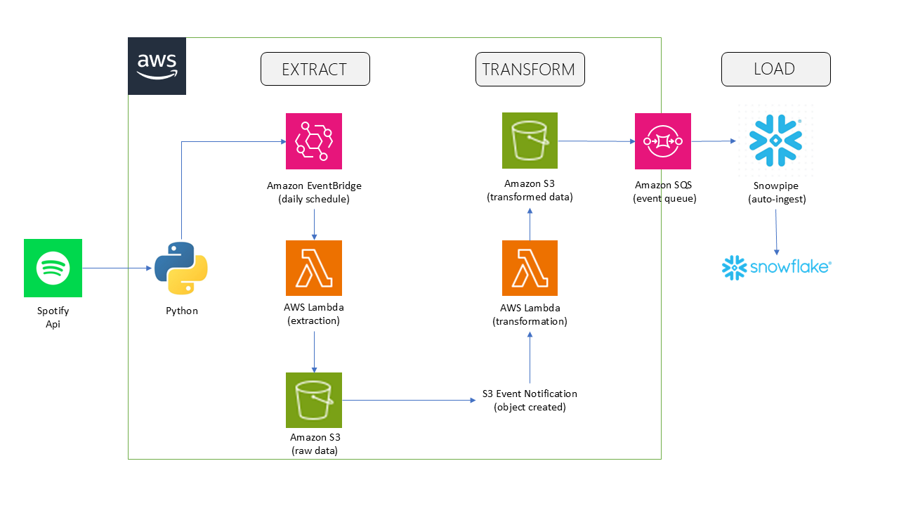

Spotify Web API → Python → Amazon EventBridge (daily schedule) → AWS Lambda (extraction) → Amazon S3 (raw data) → AWS Lambda (transformation) → Amazon S3 (transformed data) → Amazon SQS (event queue) → Snowpipe (auto-ingest) → Snowflake (MUSIC_CATALOG).

Technology Stack
Layer | Tool | Purpose
Extraction | Python, spotipy | Pulls artist/album/track metadata via Spotify Web API (Client Credentials Flow)
Compute | AWS Lambda | Two serverless functions — extraction and transformation
Scheduling | Amazon EventBridge | Triggers extraction on a daily schedule
Storage | Amazon S3 | Data lake — raw and transformed zones
Transformation | pandas | Cleans, flattens, and deduplicates raw JSON into structured CSVs
Event routing | S3 Event Notifications, SQS | Chains extraction to transformation and notifies Snowflake of new files
Warehouse | Snowflake | Stores curated, queryable tables
Ingestion | Snowpipe | Auto-loads new S3 files into Snowflake continuously
Access control | AWS IAM | Scoped, credential-based access from Snowflake to S3

Snowflake Objects
Object | Name
Database | MUSIC_CATALOG
Schema | CATALOG_DATA
Tables | ARTISTS, ALBUMS, TRACKS
Warehouse | COMPUTE_WH (X-Small, auto-suspend)
File Format | CSV_FORMAT
Stages | ARTISTS_STAGE, ALBUMS_STAGE, TRACKS_STAGE
Pipes | ARTISTS_PIPE, ALBUMS_PIPE, TRACKS_PIPE

Design Decisions & Challenges

Credential-based stage over Storage Integration
The Snowflake account is hosted in an AWS opt-in region, which caused a persistent sts:AssumeRole failure when setting up a Storage Integration — the trust relationship could not be established without Snowflake-side support for that region. Rather than block the project on a support ticket, the pipeline uses a credential-based external stage (an IAM access key/secret scoped to a single S3 bucket) instead. The tradeoff is manual key rotation in place of Snowflake-managed trust.

Least-privilege IAM
The IAM user used by Snowflake is scoped to read-only access on a single S3 bucket rather than broad or administrative permissions, following the same least-privilege principle learned earlier in the project when a Lambda execution role initially lacked s3:PutObject and had to be explicitly granted.

No automatic deduplication (known limitation)
COPY INTO and Snowpipe track which files have been loaded, not which rows. If the same artist or track appears across multiple extraction runs, it can be inserted more than once, since Snowflake does not enforce the PRIMARY KEY constraint declared on these tables. Duplicates were identified and removed with a ROW_NUMBER() deduplication pass. A production version of this pipeline would land data in a staging table and use MERGE (upsert) logic instead of COPY INTO directly into the final tables.

Setup Steps
- Create a Spotify Developer app (Client Credentials Flow — no user login required)
- Deploy the two Lambda functions, with an EventBridge rule for daily scheduling and an S3 event
trigger chaining extraction to transformation
- Run the Snowflake setup and load SQL scripts in order, using your own IAM credentials in place
of the placeholders
- Configure S3 Event Notifications on each transformed_data subfolder, pointing at the
corresponding Snowpipe's SQS notification channel
- Run the validation SQL to confirm the load

Future Improvements
- Replace COPY INTO plus manual dedup with a staging table and MERGE upsert pattern
- Migrate from EventBridge's simple scheduling to Airflow for orchestration
- Add SCD (slowly changing dimension) tracking for artist/track metadata changes over time
- Add data freshness and SLA monitoring

