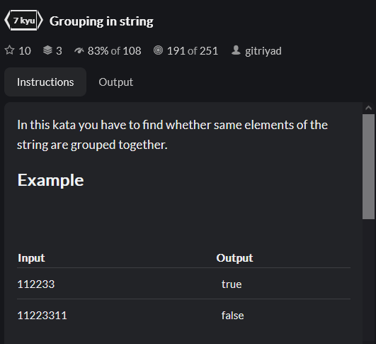

Returns false if we encounter a letter that we already saw and is not the letter before this one i.e. since if it is then it is consecutive.



