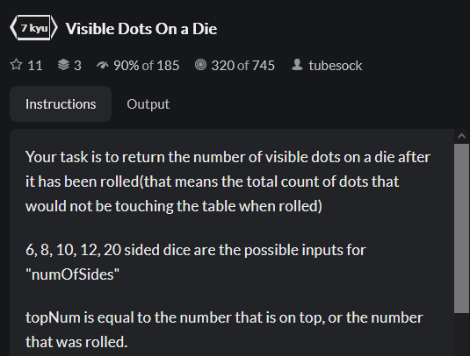

JS:

TS:

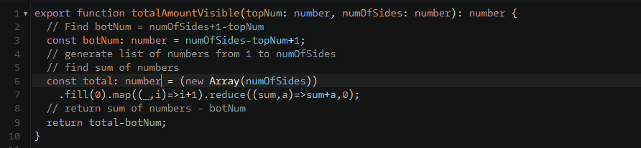

Python:

