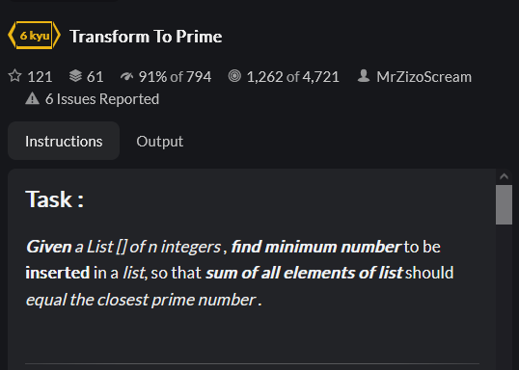

JS:



Python:

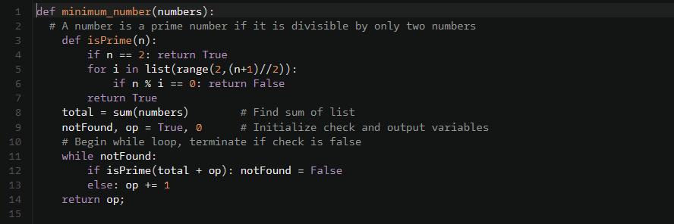

C#:  
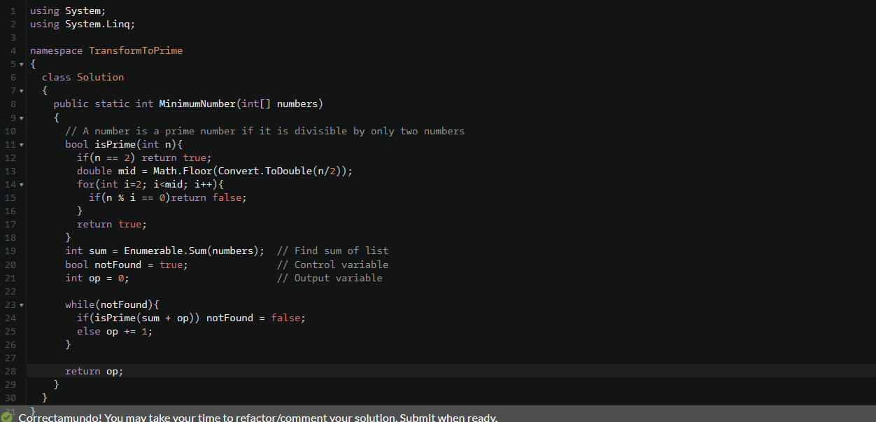

Best solutions JS:

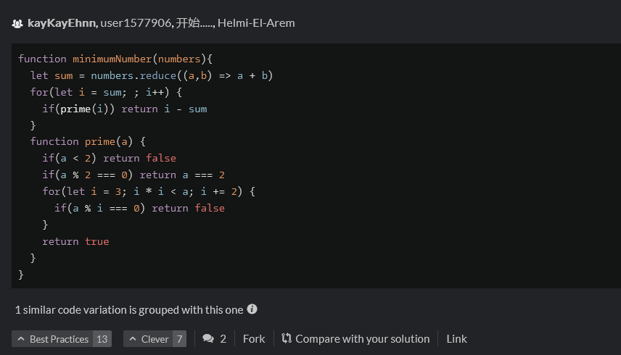

Python:

C#:

