Attempt:

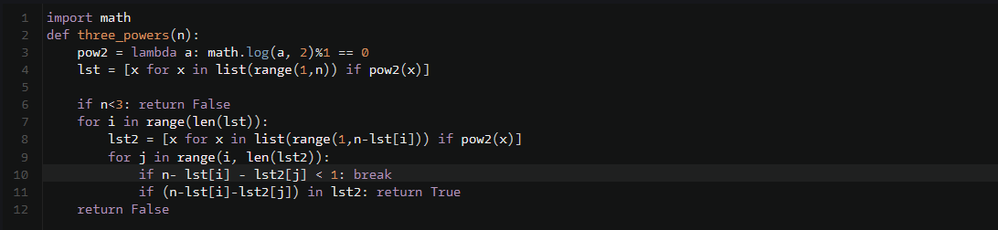

Solution:





