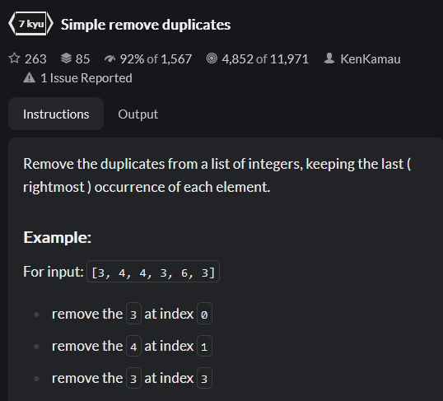





PHP:



