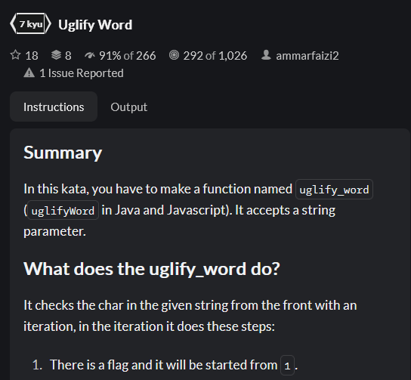



PHP:

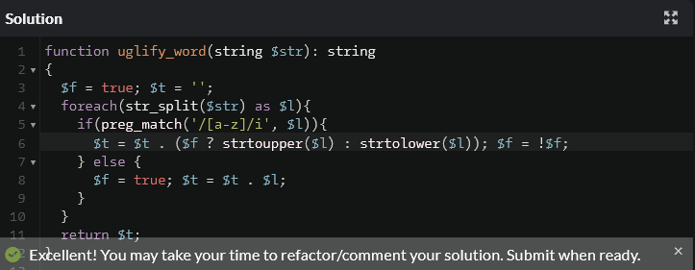

Python:



