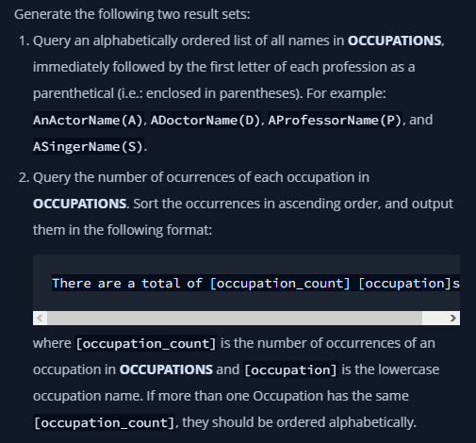

My Solution – MySQL and MS SQL Server:

