Guide to set up environment for running the program.

1. Install Python

* Python-2.7.10

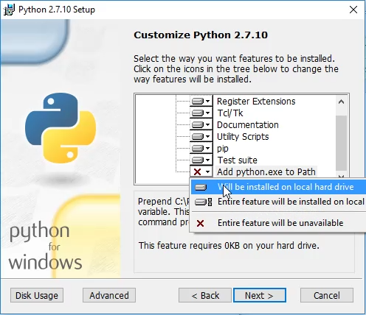

* Confirm the system path-variable is correctly set for python.

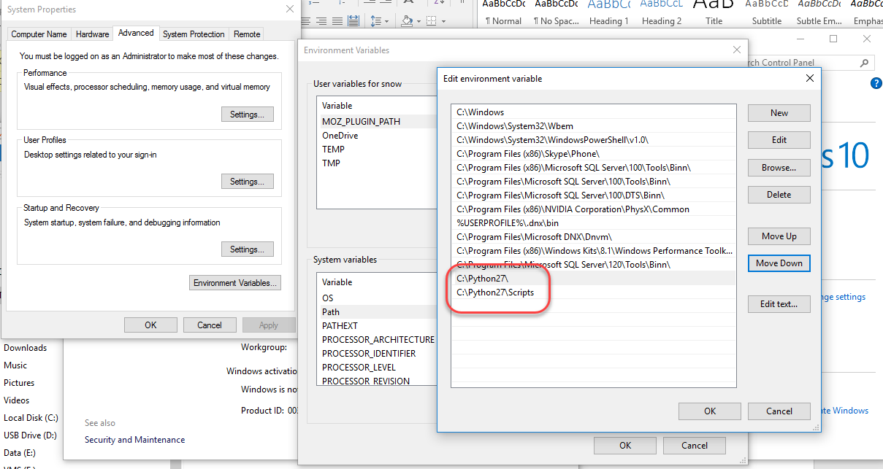

* Install the NumPy, Matpoltlib and somethings like below.

(In command prompt)

* > Pip install numpy
* > Pip install matplotlib
* > Pip install BeautifulSoup
* > Pip install beautifulsoup4
* > Pip install wheel
* > Pip install requests

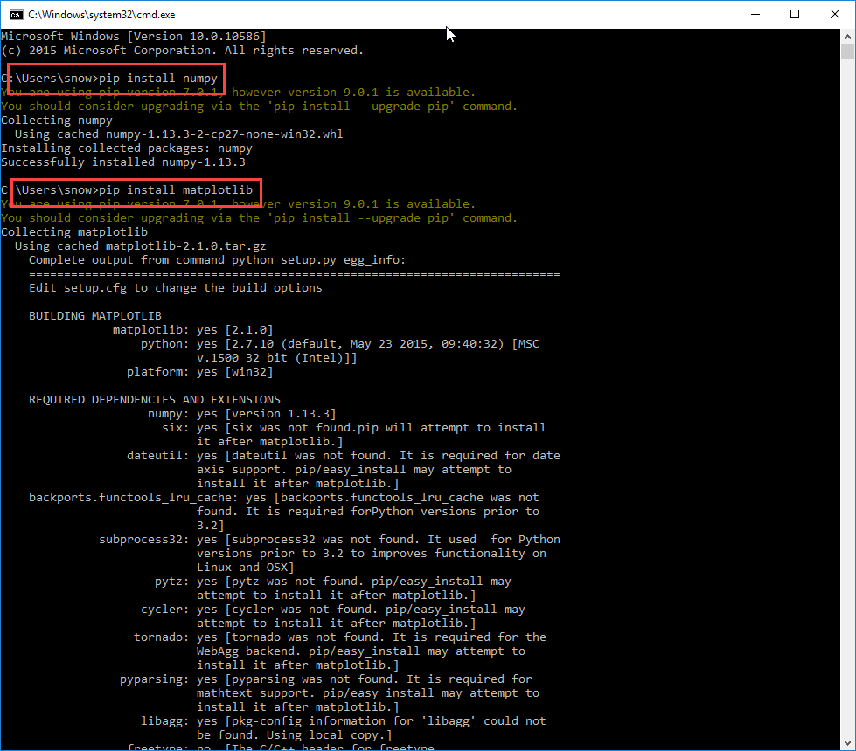

1. Install Mysql-python.

* Install VCForPython27.msi.
* Install MySQL_python-1.2.5-cp27-none-win32.whl.
* Pip install MySQL_python-1.2.5-cp27-none-win32
* Install mysql.
* Pip install mysql

1. Install OpenCV.

* Install Opencv 3.3.1.
* Copy the “cv2.pyd” file which is in the opencv’s installed folder (for example, c:\opencv-3.3.1\build\python\2.7\x86\cv2.pyd) to Python’s installed “site-packages” sub folder (for example, C:\python27\Lib\site-packages).
* Check to see if the python can load the opencv libraries successfully.
* > python
* > import cv2
* > print cv2.__version__

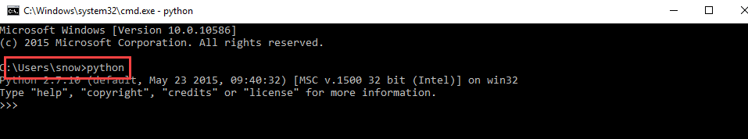

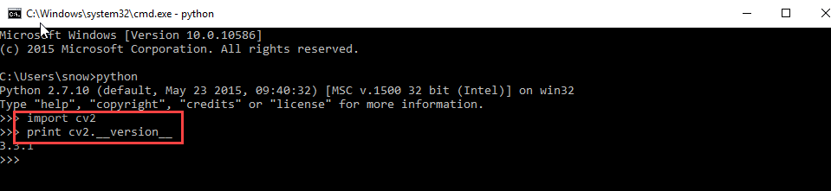

It must have output regarding that opencv’s version is 3.3.1.

* Copy the “opencv_ffmpeg331.dll” file in opencv’s “build/bin” sub folder to python’s “lib/site-packages” sub folder.

1. Dlib setup

* Install dlib-18.17.100-cp27-none-win32.whl.

Pip install dlib-18.17.100-cp27-none-win32.whl

1. Database setup

* Install mysql. (for example, install xampp.)
* Create database named as “facedb”.
* Create tables.(event_table, people_table)
* -- ----------------------------
* -- Table structure for `event_table`
* -- ----------------------------
* DROP TABLE IF EXISTS `event_table`;
* CREATE TABLE `event_table` (
* `id` tinyint(4) NOT NULL AUTO_INCREMENT,
* `date` char(20) COLLATE utf8_unicode_ci DEFAULT NULL,
* `image_path` char(255) COLLATE utf8_unicode_ci DEFAULT NULL,
* `name_id` char(255) COLLATE utf8_unicode_ci DEFAULT NULL,
* PRIMARY KEY (`id`)
* ) ENGINE=InnoDB AUTO_INCREMENT=6 DEFAULT CHARSET=utf8 COLLATE=utf8_unicode_ci;
* -- ----------------------------
* -- Table structure for `people_table`
* -- ----------------------------
* DROP TABLE IF EXISTS `people_table`;
* CREATE TABLE `people_table` (
* `id` int(11) NOT NULL AUTO_INCREMENT,
* `first_name` char(20) DEFAULT NULL,
* `last_name` char(20) DEFAULT NULL,
* `first_date` char(20) DEFAULT NULL,
* `last_sight` char(20) DEFAULT NULL,
* `url1` varchar(1000) DEFAULT NULL,
* `url2` varchar(1000) DEFAULT NULL,
* `url3` varchar(1000) DEFAULT NULL,
* `url4` varchar(1000) DEFAULT NULL,
* `url5` varchar(1000) DEFAULT NULL,
* `url6` varchar(1000) DEFAULT NULL,
* `url7` varchar(1000) DEFAULT NULL,
* `url8` varchar(1000) DEFAULT NULL,
* `url9` varchar(1000) DEFAULT NULL,
* `url10` varchar(1000) DEFAULT NULL,
* PRIMARY KEY (`id`)
* ) ENGINE=InnoDB AUTO_INCREMENT=33 DEFAULT CHARSET=utf8;

1. Run

* Set up webcam in your host computer.
* Run the “face_recog.py” in delivery folder which must be current directory via “cd” command.
* > python face_recog.py
* Then, you could see your face and others to spotted in the program window and you can check to see if search-results are recorded into tables using some tools like “Navicat for MySQL”.

(So, that’s all, thanks.)