ЛАБОРАТОРНА РОБОТА № 10
Серіалізація. Логування. Документування коду. XML та JSON парсери.
Мета: практика роботи з XML та JSON парсерами, використання серіалізації, логування та докусентування коду.
Хід роботи:
Завдання 1. Створити maven Java проект java_lab_10 з пакетом com.education.ztu. Додати в проект код з лабораторної роботи №3 з пакету game. Для реалізації завдань додати необхідні залежності в файл pom.xml.
Завдання 2. Серіалізація: • Додати до сутностей в пакеті game serialVersionUID (згенерувати за допомогою Inteliij IDEA) • Виключити деякі поля з серіалізації на власний розсуд (використати ключове слово transient) • Серіалізувати та десеріалізувати сутності.
Завдання 3. Логування: • Додати логування до коду в пакеті game. Використати бібліотеки Log4J, SLF4J. • Вивести логи в консоль та в файл. • Використати різні рівні логування (trace, debug, info, warn, error, fatal)
Завдання 4. Документування коду: • Додати документаційні коментарі до коду в пакеті game • Згенерувати документацію (щоб згенерувати JavaDoc у Inteliij IDEA необхідно натиснути Tools –> Generate JavaDoc –> вказати шлях, куди зберегти документацію)
Завдання 5. XML парсери: • Реалізувати читання та збереження XML файлу використовуючи DOM парсер. • XML файл використати будь який за бажанням.
Завдання 6. JSON парсер: • Провести перетворення сутностей з Java в JSON і навпаки з JSON в Java (використайте бібліотеки Gson або Jackson) Сутності для перетворень виберіть на власний розсуд.

Лістинг програми:
XMLReader.java:
package com.education.ztu.Classes;
import org.w3c.dom.*;
import javax.xml.parsers.*;
import javax.xml.transform.*;
import javax.xml.transform.dom.*;
import javax.xml.transform.stream.*;
import java.io.*;
import com.education.ztu.game.Student;
public class XMLWriter {
public static void writeStudents(String filePath, Student[] students) {
try {
DocumentBuilderFactory factory = DocumentBuilderFactory.newInstance();
DocumentBuilder builder = factory.newDocumentBuilder();
Document doc = builder.newDocument();
Element rootElement = doc.createElement("students");
doc.appendChild(rootElement);
for (Student student : students) {
Element studentElement = doc.createElement("student");
rootElement.appendChild(studentElement);
Element name = doc.createElement("name");
name.appendChild(doc.createTextNode(student.getName()));
studentElement.appendChild(name);
Element age = doc.createElement("age");
age.appendChild(doc.createTextNode(String.valueOf(student.getAge())));
studentElement.appendChild(age);
}
TransformerFactory transformerFactory = TransformerFactory.newInstance();
Transformer transformer = transformerFactory.newTransformer();
transformer.setOutputProperty(OutputKeys.INDENT, "yes");
DOMSource source = new DOMSource(doc);
File dir = new File("data");
if (!dir.exists()) {
dir.mkdir();
}
StreamResult result = new StreamResult(new File(filePath));
transformer.transform(source, result);
System.out.println("XML файл успішно збережено в папку 'data'!");
} catch (Exception e) {
e.printStackTrace();
}
}
}

XMLWriter.java:
package com.education.ztu.Classes;
import org.w3c.dom.*;
import javax.xml.parsers.*;
import javax.xml.transform.*;
import javax.xml.transform.dom.*;
import javax.xml.transform.stream.*;
import java.io.*;
import com.education.ztu.game.Student;
public class XMLWriter {
public static void writeStudents(String filePath, Student[] students) {
try {
DocumentBuilderFactory factory = DocumentBuilderFactory.newInstance();
DocumentBuilder builder = factory.newDocumentBuilder();
Document doc = builder.newDocument();
Element rootElement = doc.createElement("students");
doc.appendChild(rootElement);
for (Student student : students) {
Element studentElement = doc.createElement("student");
rootElement.appendChild(studentElement);
Element name = doc.createElement("name");
name.appendChild(doc.createTextNode(student.getName()));
studentElement.appendChild(name);
Element age = doc.createElement("age");
age.appendChild(doc.createTextNode(String.valueOf(student.getAge())));
studentElement.appendChild(age);
}
TransformerFactory transformerFactory = TransformerFactory.newInstance();
Transformer transformer = transformerFactory.newTransformer();
transformer.setOutputProperty(OutputKeys.INDENT, "yes");
DOMSource source = new DOMSource(doc);
File dir = new File("data");
if (!dir.exists()) {
dir.mkdir();
}
StreamResult result = new StreamResult(new File(filePath));
transformer.transform(source, result);
System.out.println("XML файл успішно збережено в папку 'data'!");
} catch (Exception e) {
e.printStackTrace();
}
}
}
AgeComparator.java:
/**
* A comparator implementation for comparing two Participant objects by their age.
* This class can be used to sort Participant objects in ascending order of age.
*/
package com.education.ztu.game;
import java.util.Comparator;
public class AgeComparator implements Comparator<Participant> {
/**
* Compares two Participant objects based on their age.
*
* @param p1 the first Participant object to compare
* @param p2 the second Participant object to compare
* @return a negative integer, zero, or a positive integer as the first argument
* is less than, equal to, or greater than the second.
*/
@Override
public int compare(Participant p1, Participant p2) {
return Integer.compare(p1.getAge(), p2.getAge());
}
}
Employee.java:
/**
* Represents an Employee who is also a Participant in the game.
* This class extends the Participant class, inheriting its properties and behavior.
*/
package com.education.ztu.game;
public class Employee extends Participant {
/**
* Constructs an Employee object with a specified name and age.
*
* @param name the name of the employee
* @param age the age of the employee
*/
public Employee(String name, int age) {
super(name, age);
}
}
Game.java:
/**
* Demonstrates the creation and management of teams in a game,
* with participants categorized as Scholars, Students, or Employees.
* This program showcases how teams can be created, participants added, and competitions held.
*/
package com.education.ztu.game;
public class Game {
/**
* The entry point of the application.
*
* @param args command-line arguments (not used in this application)
*/
public static void main(String[] args) {
// Creating Scholar participants
Schoolar schoolar1 = new Schoolar("Ivan", 13);
Schoolar schoolar2 = new Schoolar("Mariya", 15);
// Creating Student participants
Student student1 = new Student("Mykola", 20);
Student student2 = new Student("Viktoria", 21);
// Creating Employee participants
Employee employee1 = new Employee("Andriy", 28);
Employee employee2 = new Employee("Oksana", 25);
// Creating and populating a team of Scholars
Team<Schoolar> scollarTeam = new Team<>("Dragon");
scollarTeam.addNewParticipant(schoolar1);
scollarTeam.addNewParticipant(schoolar2);
// Creating and populating a team of Students
Team<Student> studentTeam = new Team<>("Vpered");
studentTeam.addNewParticipant(student1);
studentTeam.addNewParticipant(student2);
// Creating and populating a team of Employees
Team<Employee> employeeTeam = new Team<>("Robotyagi");
employeeTeam.addNewParticipant(employee1);
employeeTeam.addNewParticipant(employee2);
// Creating a second team of Scholars and adding participants
Team<Schoolar> scollarTeam2 = new Team<>("Rozumnyky");
Schoolar schoolar3 = new Schoolar("Sergey", 12);
Schoolar schoolar4 = new Schoolar("Olga", 14);
scollarTeam2.addNewParticipant(schoolar3);
scollarTeam2.addNewParticipant(schoolar4);
// Initiating a competition between two teams of Scholars
scollarTeam.playWith(scollarTeam2);
}
}
GameEntity.java:
/**
* Represents a game entity with attributes such as name, level, health, and weapon.
* Implements the Serializable interface to allow the object to be serialized,
* while excluding the health attribute from serialization using the transient keyword.
*/
package com.education.ztu.game;
import java.io.Serializable;
public class GameEntity implements Serializable {
private static final long serialVersionUID = 1L; // Ensures compatibility during serialization
private String name; // Name of the game entity
private int level; // Level of the game entity
private transient int health; // Health of the game entity (not serialized)
private String weapon; // Weapon used by the game entity
/**
* Constructs a GameEntity object with the specified attributes.
*
* @param name the name of the entity
* @param level the level of the entity
* @param health the health of the entity (not serialized)
* @param weapon the weapon of the entity
*/
public GameEntity(String name, int level, int health, String weapon) {
this.name = name;
this.level = level;
this.health = health;
this.weapon = weapon;
}
/**
* Returns a string representation of the GameEntity object.
*
* @return a string containing the entity's attributes
*/
@Override
public String toString() {
return "GameEntity{" +
"name='" + name + '\'' +
", level=" + level +
", health=" + health +
", weapon='" + weapon + '\'' +
'}';
}
}

NameAndAgeComparator.java:
/**
* Provides a comparator for comparing Participant objects based on their name and age.
* The comparison is done first by name in lexicographical order, then by age in ascending order.
*/
package com.education.ztu.game;
import java.util.Comparator;
public class NameAndAgeComparator {
/**
* Returns a Comparator that compares Participant objects by their name and age.
*
* @return a Comparator object for comparing Participant instances
*/
public static Comparator<Participant> getComparator() {
return Comparator.comparing(Participant::getName) // First, compare by name
.thenComparing(Participant::getAge); // Then, compare by age if names are the same
}
}

Participant.java:
/**
* Represents a participant in the game with a name and age.
* This class implements Cloneable to allow object cloning and Comparable for natural sorting by name.
* Subclasses should provide specific behavior for participants in the game.
*/
package com.education.ztu.game;
public abstract class Participant implements Cloneable, Comparable<Participant> {
private String name; // Name of the participant
private int age; // Age of the participant
public Participant() {
}
/**
* Constructs a Participant object with a specified name and age.
*
* @param name the name of the participant
* @param age the age of the participant
*/
public Participant(String name, int age) {
this.name = name;
this.age = age;
}
/**
* Returns the name of the participant.
*
* @return the name of the participant
*/
public String getName() {
return name;
}
/**
* Returns the age of the participant.
*
* @return the age of the participant
*/
public int getAge() {
return age;
}
/**
* Sets the name of the participant.
*
* @param name the name to set
*/
public void setName(String name) {
this.name = name;
}
/**
* Sets the age of the participant.
*
* @param age the age to set
*/
public void setAge(int age) {
this.age = age;
}
/**
* Compares this participant to another participant based on their name.
* The comparison is lexicographical based on the participant's name.
*
* @param other the other participant to compare to
* @return a negative integer, zero, or a positive integer if this participant's name is less than, equal to, or greater than the other's name
*/
@Override
public int compareTo(Participant other) {
return this.name.compareTo(other.name);
}
/**
* Creates and returns a clone of this participant.
*
* @return a clone of this participant
* @throws AssertionError if cloning is not supported
*/
@Override
public Participant clone() {
try {
return (Participant) super.clone();
} catch (CloneNotSupportedException e) {
throw new AssertionError("Cloning not supported");
}
}
/**
* Determines if this participant is equal to another object.
* Two participants are considered equal if their names and ages are the same.
*
* @param obj the object to compare to
* @return true if the participants are equal, false otherwise
*/
@Override
public boolean equals(Object obj) {
if (this == obj) return true;
if (obj == null || getClass() != obj.getClass()) return false;
Participant that = (Participant) obj;
return age == that.age && name.equals(that.name);
}
/**
* Returns the hash code of this participant.
* The hash code is generated based on the participant's name and age.
*
* @return the hash code of this participant
*/
@Override
public int hashCode() {
int result = name.hashCode();
result = 31 * result + age;
return result;
}
/**
* Returns a string representation of the participant, including their name and age.
*
* @return a string representation of the participant
*/
@Override
public String toString() {
return "Participant{name='" + name + "', age=" + age + "}";
}
}

Schoolar.java:
/**
* Represents a Schoolar participant in the game, extending the Participant class.
* Inherits the name and age properties from the Participant class.
*/
package com.education.ztu.game;
public class Schoolar extends Participant {
public Schoolar() {
}
/**
* Constructs a Schoolar object with a specified name and age.
* This constructor calls the constructor of the Participant class.
*
* @param name the name of the Schoolar
* @param age the age of the Schoolar
*/
public Schoolar(String name, int age) {
super(name, age); // Викликає конструктор батьківського класу Participant
}
}
Student.java:
/**
* Represents a Student participant in the game, extending the Participant class.
* Inherits the name and age properties from the Participant class.
*/
package com.education.ztu.game;
public class Student extends Participant {
/**
* Constructs a Student object with a specified name and age.
* This constructor calls the constructor of the Participant class.
*
* @param name the name of the Student
* @param age the age of the Student
*/
public Student(String name, int age) {
super(name, age);
}
}

Team.java:
/**
* Represents a Student participant in the game, extending the Participant class.
* Inherits the name and age properties from the Participant class.
*/
package com.education.ztu.game;
public class Student extends Participant {
/**
* Constructs a Student object with a specified name and age.
* This constructor calls the constructor of the Participant class.
*
* @param name the name of the Student
* @param age the age of the Student
*/
public Student(String name, int age) {
super(name, age);
}
}

Main.java:
package com.education.ztu;
import com.education.ztu.game.GameEntity;
import java.io.*;
public class Main {
public static void main(String[] args) {
GameEntity entity = new GameEntity("Knight", 5, 100, "Sword");
String filePath = "entity.ser";
try (ObjectOutputStream oos = new ObjectOutputStream(new FileOutputStream(filePath))) {
oos.writeObject(entity);
System.out.println("Entity serialized successfully.");
} catch (IOException e) {
System.out.println("Serialization error: " + e.getMessage());
}
try (ObjectInputStream ois = new ObjectInputStream(new FileInputStream(filePath))) {
GameEntity deserializedEntity = (GameEntity) ois.readObject();
System.out.println("Deserialized entity: " + deserializedEntity);
} catch (IOException | ClassNotFoundException e) {
System.out.println("Deserialization error: " + e.getMessage());
}
}
}

Main2.java:
package com.education.ztu;
import org.apache.logging.log4j.LogManager;
import org.apache.logging.log4j.Logger;
public class Main2 {
private static final Logger logger = LogManager.getLogger(Main2.class);
public static void main(String[] args) {
logger.info("Application started");
logger.fatal("Fatal message - application might crash");
logger.error("Error message - something went wrong");
logger.warn("Warning message - be careful");
logger.info("Info message - just FYI");
logger.debug("Debug message - useful for debugging");
logger.trace("Trace message - very detailed info");
try {
int result = divide(10, 2);
logger.debug("Division result: {}", result);
} catch (Exception e) {
logger.error("Error occurred during division", e);
}
logger.info("Application finished");
}
private static int divide(int a, int b) {
logger.trace("Entering divide() with a = {} and b = {}", a, b);
if (b == 0) {
logger.warn("Division by zero attempted!");
throw new ArithmeticException("Cannot divide by zero");
}
int result = a / b;
logger.trace("Exiting divide() with result = {}", result);
return result;
}
}
package com.education.ztu;
import com.education.ztu.Classes.XMLReader;
import com.education.ztu.Classes.XMLWriter;
import com.education.ztu.game.Student;
public class Main3 {
public static void main(String[] args) {
Student[] students = {
new Student("Mark Spencer", 23),
new Student("Emily Johnson", 24)
};
XMLWriter.writeStudents("data/students.xml", students);
String filePath = "data/students.xml";
Student[] readStudents = XMLReader.readStudents(filePath);
if (readStudents != null) {
for (Student student : readStudents) {
System.out.println("Name: " + student.getName() + ", Age: " + student.getAge());
}
} else {
System.out.println("Не вдалося зчитати студентів.");
}
}
}

Main3.java:
package com.education.ztu;
import com.education.ztu.Classes.XMLReader;
import com.education.ztu.Classes.XMLWriter;
import com.education.ztu.game.Student;
public class Main3 {
public static void main(String[] args) {
Student[] students = {
new Student("Mark Spencer", 23),
new Student("Emily Johnson", 24)
};
XMLWriter.writeStudents("data/students.xml", students);
String filePath = "data/students.xml";
Student[] readStudents = XMLReader.readStudents(filePath);
if (readStudents != null) {
for (Student student : readStudents) {
System.out.println("Name: " + student.getName() + ", Age: " + student.getAge());
}
} else {
System.out.println("Не вдалося зчитати студентів.");
}
}
}

Main4.java:
package com.education.ztu;
import com.fasterxml.jackson.databind.ObjectMapper;
import com.education.ztu.game.Schoolar;
public class Main4 {
public static void main(String[] args) throws Exception {
Schoolar person = new Schoolar("John Doe", 30);
ObjectMapper objectMapper = new ObjectMapper();
String json = objectMapper.writeValueAsString(person);
System.out.println("Java to JSON: " + json);
String jsonInput = "{\"name\":\"Jane Doe\",\"age\":30}";
Schoolar deserializedPerson = objectMapper.readValue(jsonInput, Schoolar.class);
System.out.println("JSON to Java: Name - " + deserializedPerson.getName() + ", Age - " + deserializedPerson.getAge());
}
}
log4j2.xml:
<?xml version="1.0" encoding="UTF-8"?>
<Configuration status="WARN">
<Appenders>
<!-- Консольний аппендер -->
<Console name="Console" target="SYSTEM_OUT">
<PatternLayout pattern="%d{HH:mm:ss.SSS} [%t] %c{1}.%M [%L] %-5level - %msg%n"/>
</Console>
<!-- Файл для Info -->
<File name="InfoFile" fileName="data/info.log">
<PatternLayout pattern="%d{HH:mm:ss.SSS} [%t] %c{1}.%M [%L] %-5level - %msg%n"/>
<Filters>
<ThresholdFilter level="info" onMatch="ACCEPT" onMismatch="DENY"/>
</Filters>
</File>
<File name="DebugFile" fileName="data/debug.log">
<PatternLayout pattern="%d{HH:mm:ss.SSS} [%t] %c{1}.%M [%L] %-5level - %msg%n"/>
<Filters>
<ThresholdFilter level="debug" onMatch="ACCEPT" onMismatch="DENY"/>
</Filters>
</File>
<File name="ErrorFile" fileName="data/error.log">
<PatternLayout pattern="%d{HH:mm:ss.SSS} [%t] %c{1}.%M [%L] %-5level - %msg%n"/>
<Filters>
<ThresholdFilter level="error" onMatch="ACCEPT" onMismatch="DENY"/>
</Filters>
</File>
</Appenders>
<Loggers>
<Logger name="com.education.ztu.Main2" level="trace" additivity="false">
<AppenderRef ref="Console"/>
<AppenderRef ref="InfoFile"/>
<AppenderRef ref="DebugFile"/>
<AppenderRef ref="ErrorFile"/>
</Logger>
<Root level="warn">
<AppenderRef ref="Console"/>
<AppenderRef ref="ErrorFile"/>
</Root>
</Loggers>
</Configuration>

Pom.xml:
<?xml version="1.0" encoding="UTF-8"?>
<project xmlns="http://maven.apache.org/POM/4.0.0"
xmlns:xsi="http://www.w3.org/2001/XMLSchema-instance"
xsi:schemaLocation="http://maven.apache.org/POM/4.0.0 http://maven.apache.org/xsd/maven-4.0.0.xsd">
<modelVersion>4.0.0</modelVersion>
<groupId>org.example</groupId>
<artifactId>Lab_10</artifactId>
<version>1.0-SNAPSHOT</version>
<properties>
<maven.compiler.source>23</maven.compiler.source>
<maven.compiler.target>23</maven.compiler.target>
<project.build.sourceEncoding>UTF-8</project.build.sourceEncoding>
</properties>
<dependencies>
<dependency>
<groupId>org.apache.logging.log4j</groupId>
<artifactId>log4j-core</artifactId>
<version>2.21.0</version>
</dependency>
<dependency>
<groupId>org.apache.logging.log4j</groupId>
<artifactId>log4j-api</artifactId>
<version>2.21.0</version>
</dependency>
<dependency>
<groupId>com.fasterxml.jackson.core</groupId>
<artifactId>jackson-databind</artifactId>
<version>2.18.2</version>
</dependency>
</dependencies>
</project>
Результат програми:
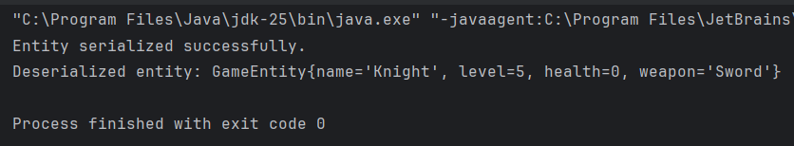
Рис.1 Результат Main.java
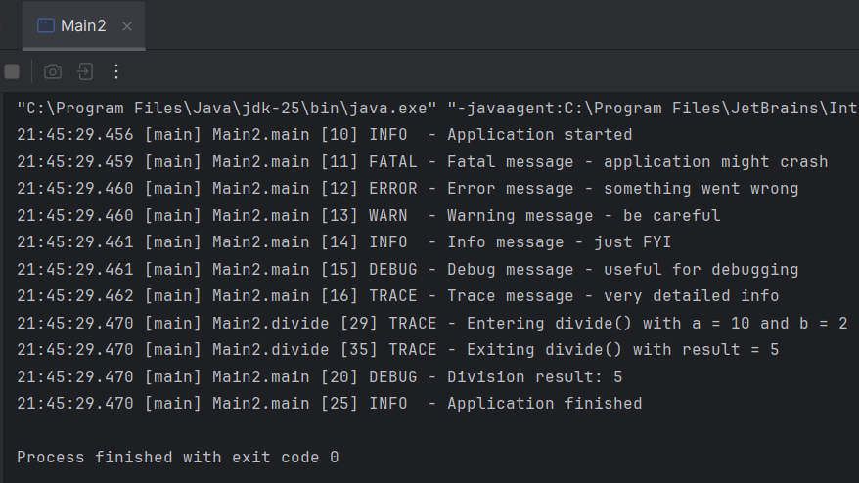
Рис.2 Результат Main2.java
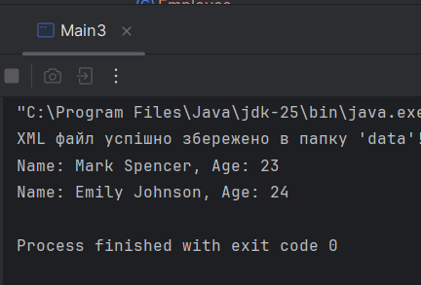
Рис.3 Результат Main3.java
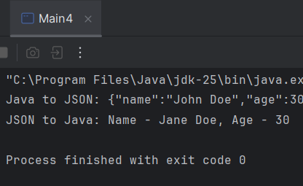
Рис.4 Результат Main4.java
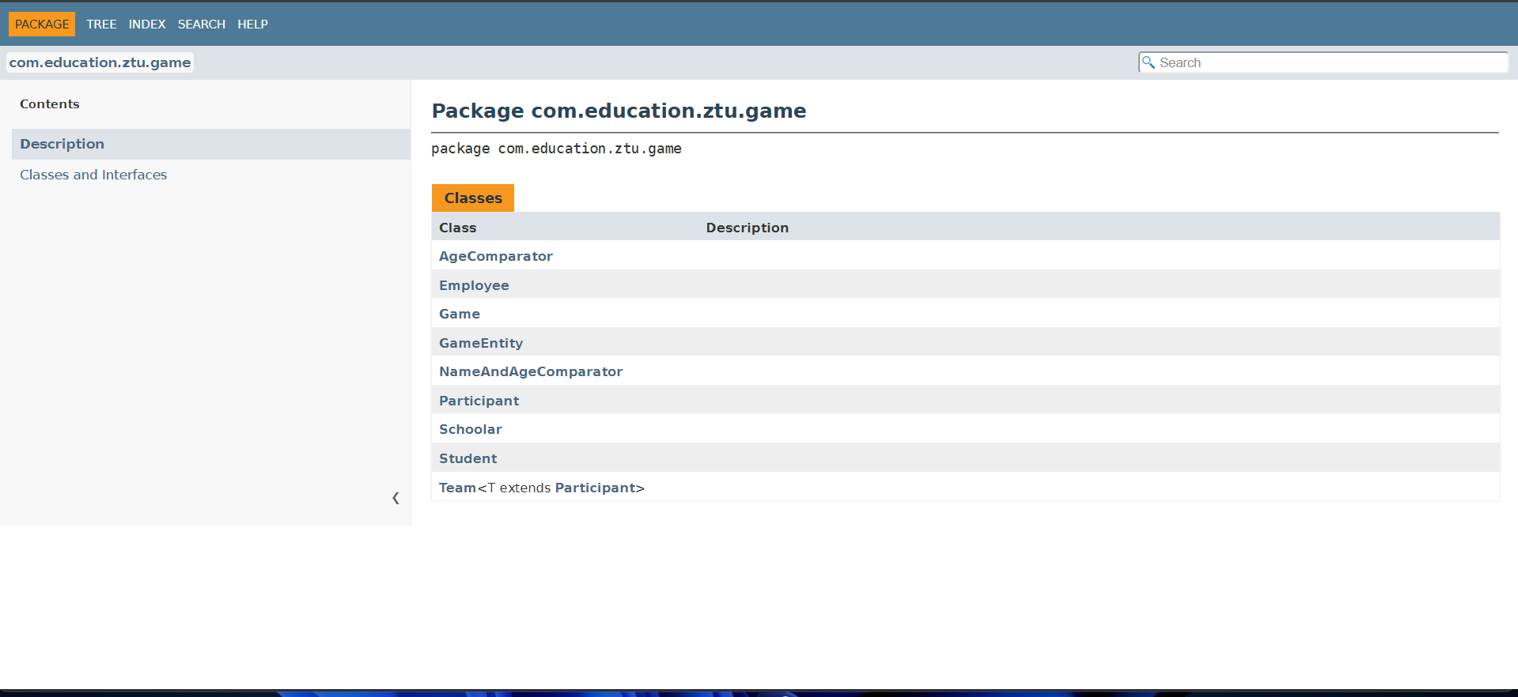
Рис.5 Документація з класами
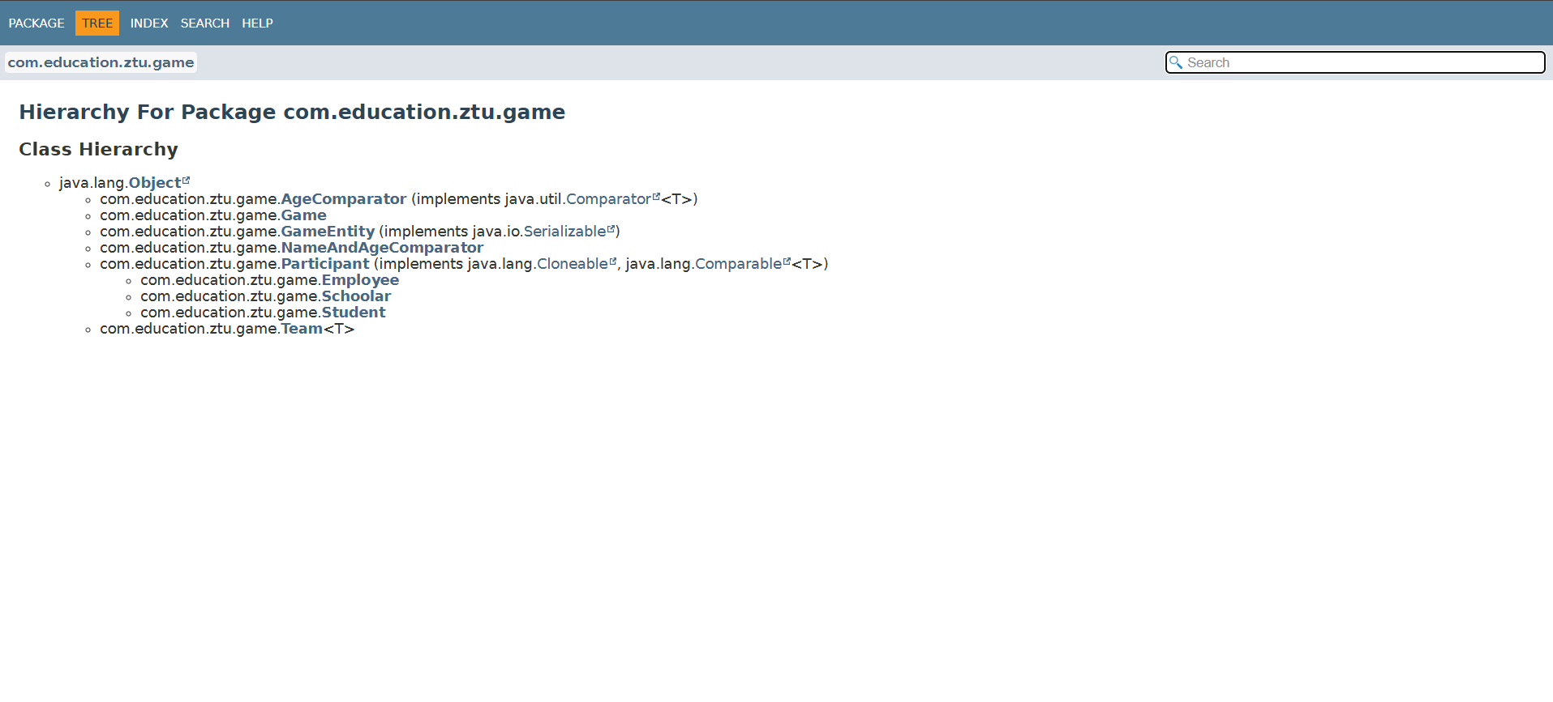
Рис.6 Документація класу Hierarchy
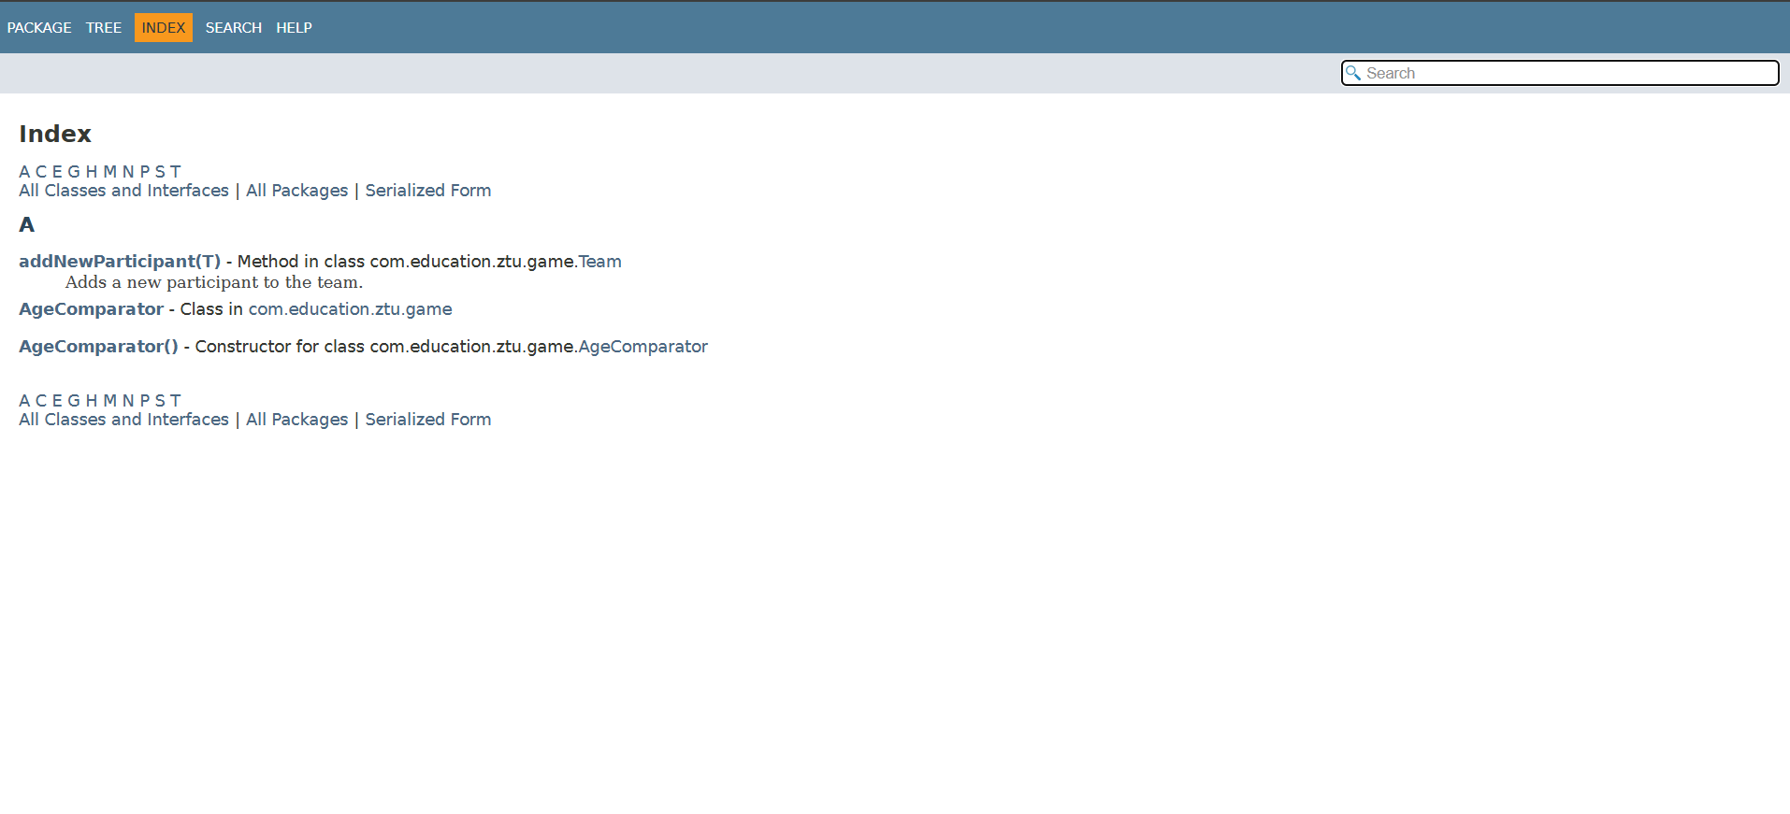
Рис.7 Документація Index
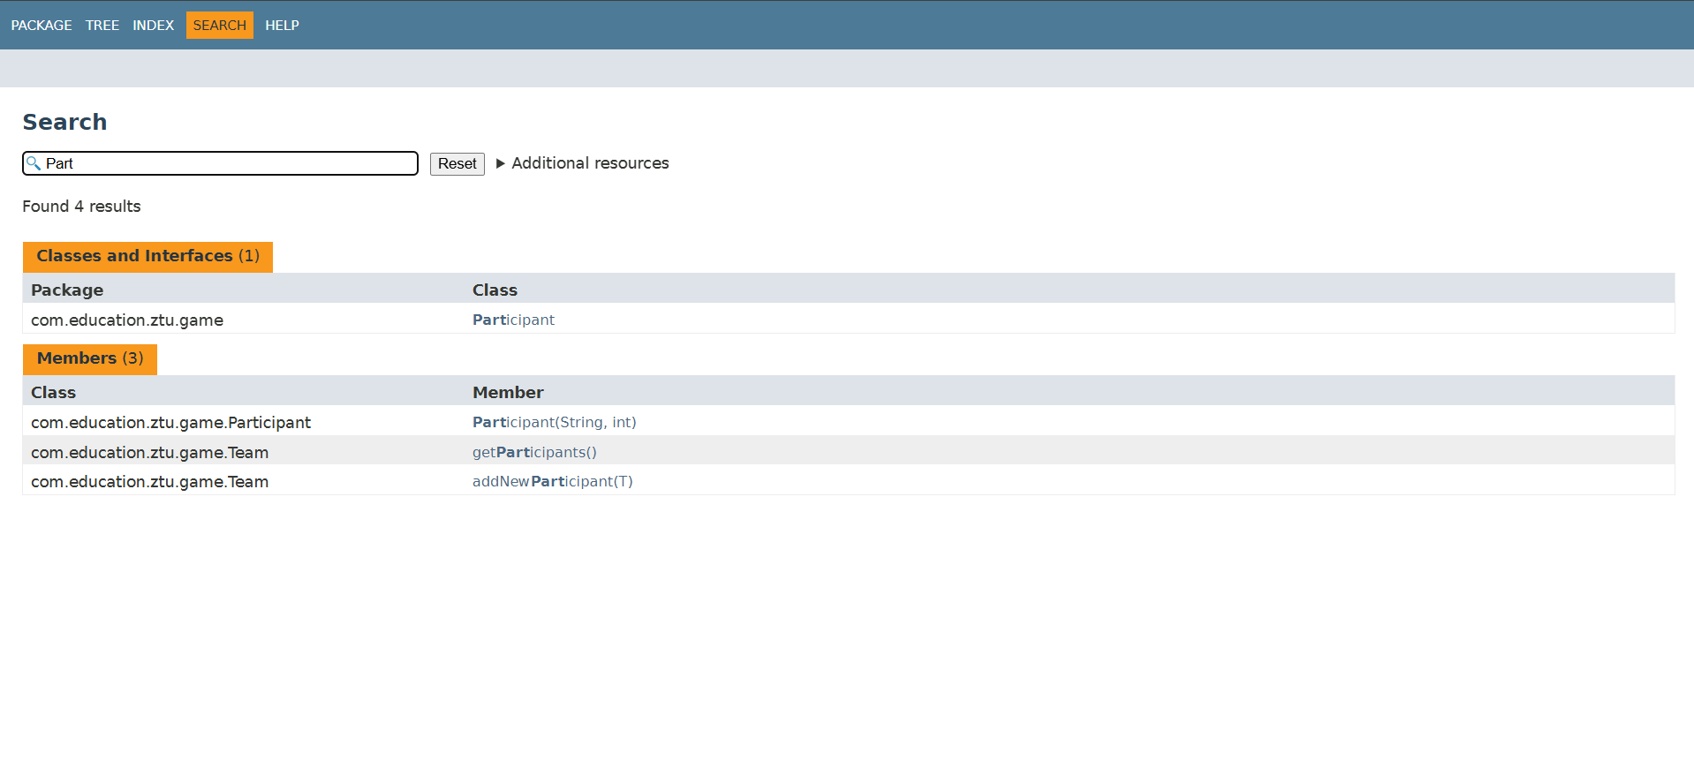
Рис.8 Документація з Search
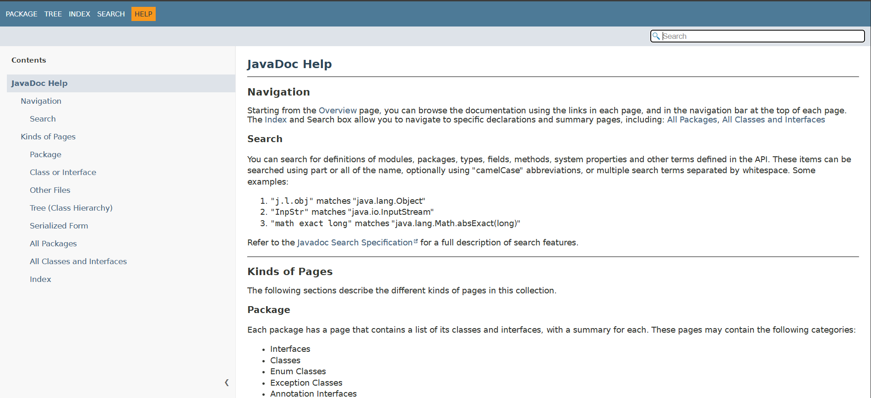
Рис.9 Документація з Help
Посилання на репозиторій: https://github.com/Sasha1845/Java
Висновок: Я навчився роботи з XML та JSON парсерами, використання серіалізації, логування та докусентування коду.

