APPROVED
Head of the Department of Software Engineering
Professor
____________ L. P. Bedratiuk
“____” ____________ 2026
PRELIMINARY DESIGN
for the development of “Bookshelf: a web application for tracking reading and book notes”
Khmelnytskyi, 2026

1 Introduction
This document is the preliminary design for the development of the web application Bookshelf, a personal reading tracker. The list of organizations that take part in the development, the terms and phases of the work, and the goals and purpose of the system are stated in the technical specification for Bookshelf (theme code BS-2026), which was developed and approved at the previous stage.
The preliminary design refines the requirements of the technical specification into formal models: data flow diagrams, functional diagrams, a state transition diagram, an entity-relationship diagram, specifications of the processes and a glossary of terms. It also fixes the main technical decisions: the structure of the system, the solution method, the programming languages and the structure of the database. The network schedule of the works is given in the report on the laboratory work.

2 List of documents
Table 1. Documents of the preliminary design
No. | Document | Content
1 | Technical specification | Requirements for the product; the basis of the preliminary design.
2 | Explanatory note (this document) | Main technical decisions and the structure of the system.
3 | Data flow diagrams | Context diagram and the diagram of level 1 (Section 4).
4 | Functional diagrams | SADT diagrams A-0 and A0 (Section 5).
5 | State transition diagram | Statuses of a book in the library (Section 6).
6 | Entity-relationship diagram | Structure of the database (Section 3.3).
7 | Process specifications | Descriptions, a flowchart and pseudocode (Section 7).
8 | Glossary | Definitions of the terms of the subject area (Section 8).
9 | Network schedule of works | Given in the report on the laboratory work.

3 Main technical decisions

3.1 Structure of the system
Bookshelf is built as a client-server web application with a separate client. The client is a single-page application written in Vue 3, which is installed on the phone as a progressive web application (PWA). The server part is a REST API written in Laravel. The API stores data in a MySQL database and, on behalf of the client, calls the external catalog Open Library. A web server (nginx) serves the static files of the client and passes requests to the API. The whole system is packaged in Docker containers. The structure is shown in Figure 1.
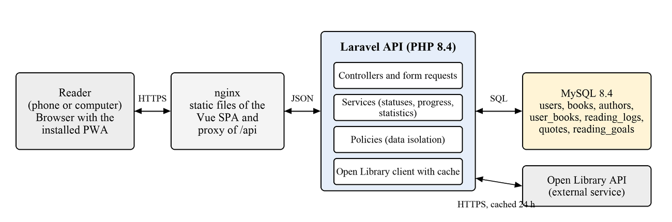
Figure 1. Structure of the system
The server part is divided into layers: a controller receives a request, a form request validates it, a service performs the domain logic (statuses, progress, statistics), a policy checks that the data belongs to the user, and a model reads and writes the database. The client never calls Open Library directly, so the server can cache the answers and limit the request rate.

3.2 Choice of the solution method and programming languages
The specification of the system is built by the structured approach: the functions, the data and the flows of data are described by separate, mutually consistent models (DFD, SADT, state transition diagram, entity-relationship diagram) with process specifications and a glossary. The system is implemented in a layered architecture and developed incrementally, in the phases of the network schedule, so that every phase ends with a working version.
Table 2. Programming languages and tools
Part | Language and tools | Reason
Server part | PHP 8.4, Laravel | Required by the team; mature tools for APIs, authentication, migrations and tests.
Client part | TypeScript, Vue 3, Vite, Tailwind CSS | Typed code, fast component development, ready support of PWA.
Data | SQL, MySQL 8.4 | A relational model fits the data; the team knows MySQL.
Tests | Pest, Vitest | Automated checking of the rules of the system.
Delivery | Git, Docker, GitHub Actions | Repeatable builds, automatic checks and deployment.

3.3 Structure of the database
The database is relational. A book in the catalog is shared by all users, and all personal data belongs to a user book, which links a user to a book. The structure is shown in Figure 2.
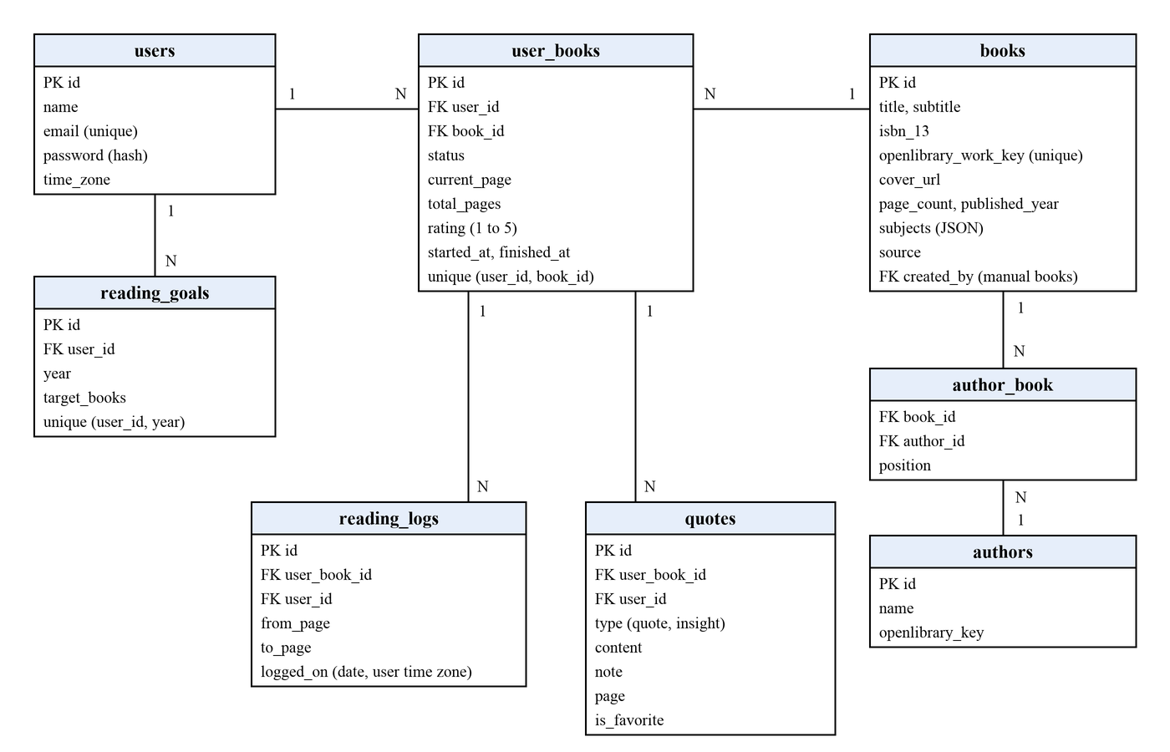
Figure 2. Entity-relationship diagram
- users: accounts of the readers, with the time zone used for all date calculations;
- books and authors: the shared catalog (books come from Open Library or are added manually), linked by author_book;
- user_books: a book in the library of a user, with the status, the current page, the page count of the user’s edition and the rating;
- reading_logs: one record for every progress update (from page, to page, date);
- quotes: quotes and insights linked to a user book;
- reading_goals: the annual goal of a user (one record per user and year).
The user_id column is repeated in reading_logs and quotes to simplify access checks and the statistics queries. Unique indexes protect the pairs “user and book” and “user and year”. Deleting a user book deletes its log and quotes.

3.4 Functions of the system
The system must perform the functions of the technical specification, which are grouped in Table 3.
Table 3. Groups of functions
Group | Functions
Account | Register, sign in and out, recover a password, edit the profile and the time zone.
Library | Search a book in Open Library, add a book manually, list books by status, edit the status, the rating and the page count, delete a book.
Progress | Update the current page, keep the reading log, show progress bars, suggest finishing a book.
Quotes | Add, edit and delete quotes and insights, mark favorites, show the quote of the day, generate a quote card image.
Statistics | Pages per day, reading streak, reading pace, completion forecast, annual goal.
PWA | Install the application on the home screen, cache the application shell, show a message when there is no connection.

4 Data flow diagrams

4.1 Context diagram
The context diagram Figure 3 shows the system as one process that exchanges data with two external entities: the Reader and the external service Open Library.
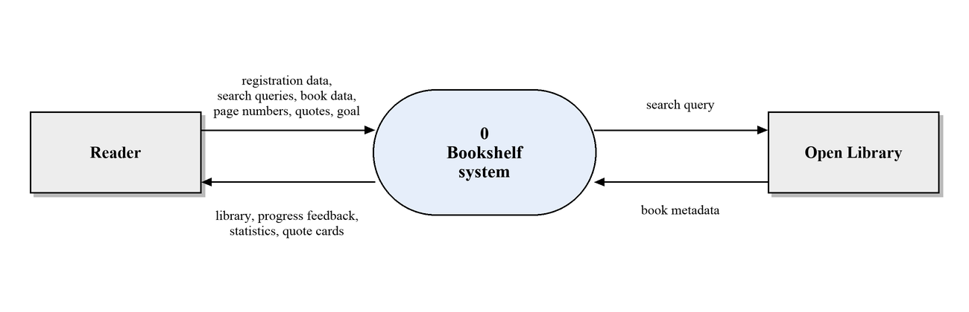
Figure 3. Context data flow diagram

4.2 Diagram of level 1
The system is decomposed into five processes that work with six data stores (Figure 4). A store marked with a vertical bar is shown twice to keep the diagram readable.
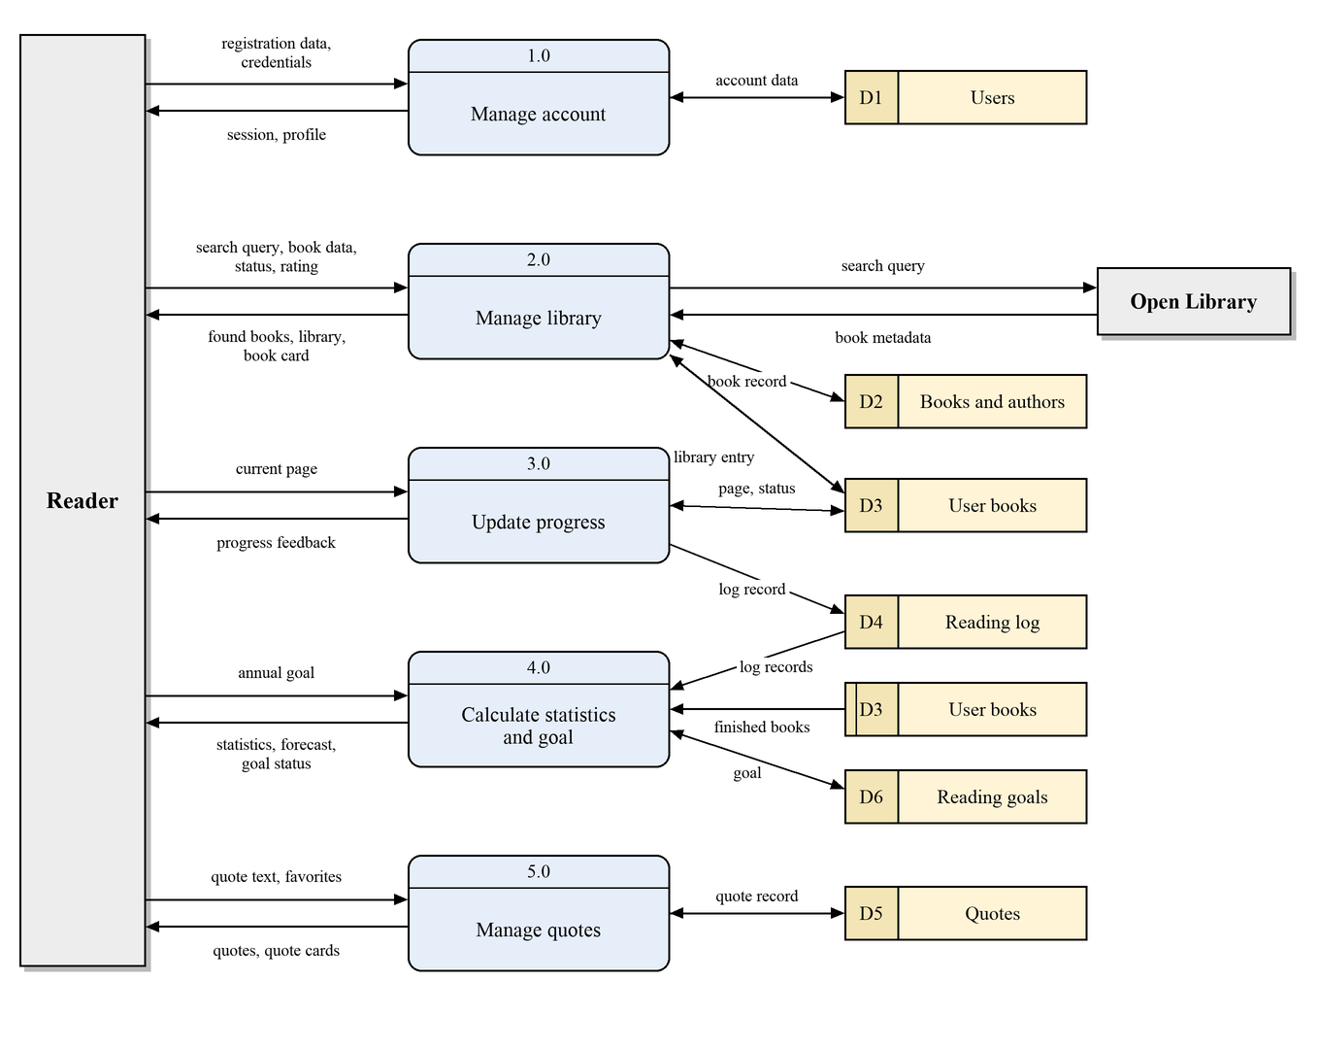
Figure 4. Data flow diagram of level 1
Table 4. Processes of the diagram of level 1
ID | Process | Input data | Output data
1.0 | Manage account | Registration data, credentials | Session, profile
2.0 | Manage library | Search query, book data, status, rating, Open Library metadata | Found books, library, book card
3.0 | Update progress | Current page | Progress feedback, log record
4.0 | Calculate statistics and goal | Annual goal, log records, finished books | Statistics, forecast, goal status
5.0 | Manage quotes | Quote text, favorite flag | Quotes, quote cards

Table 5. Data stores
ID | Store | Content | Database tables
D1 | Users | Accounts and profiles | users
D2 | Books and authors | The shared catalog | books, authors, author_book
D3 | User books | Library entries with status and progress | user_books
D4 | Reading log | Progress updates | reading_logs
D5 | Quotes | Quotes and insights | quotes
D6 | Reading goals | Annual goals | reading_goals

5 Functional diagrams
Functional diagrams are built by the SADT methodology. Every function is shown as a box, and its interfaces are arrows: an input enters from the left, a control from the top, an output leaves to the right, and a mechanism enters from the bottom. The context diagram A-0 (Figure 5) shows the whole system as the function “Track personal reading”.
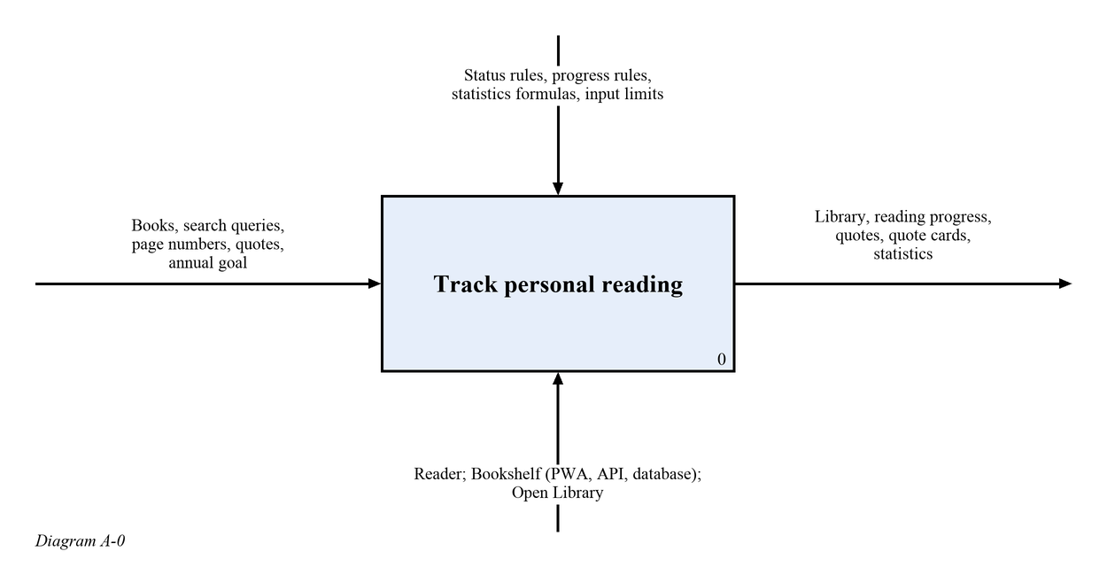
Figure 5. SADT diagram A-0
The diagram A0 (Figure 6) decomposes it into five functions. The session produced by the account function lets the user work with the library, the user books flow to the functions of progress and quotes, and the reading log together with the finished books flow to the function that calculates statistics. The interfaces are described in Table 6.
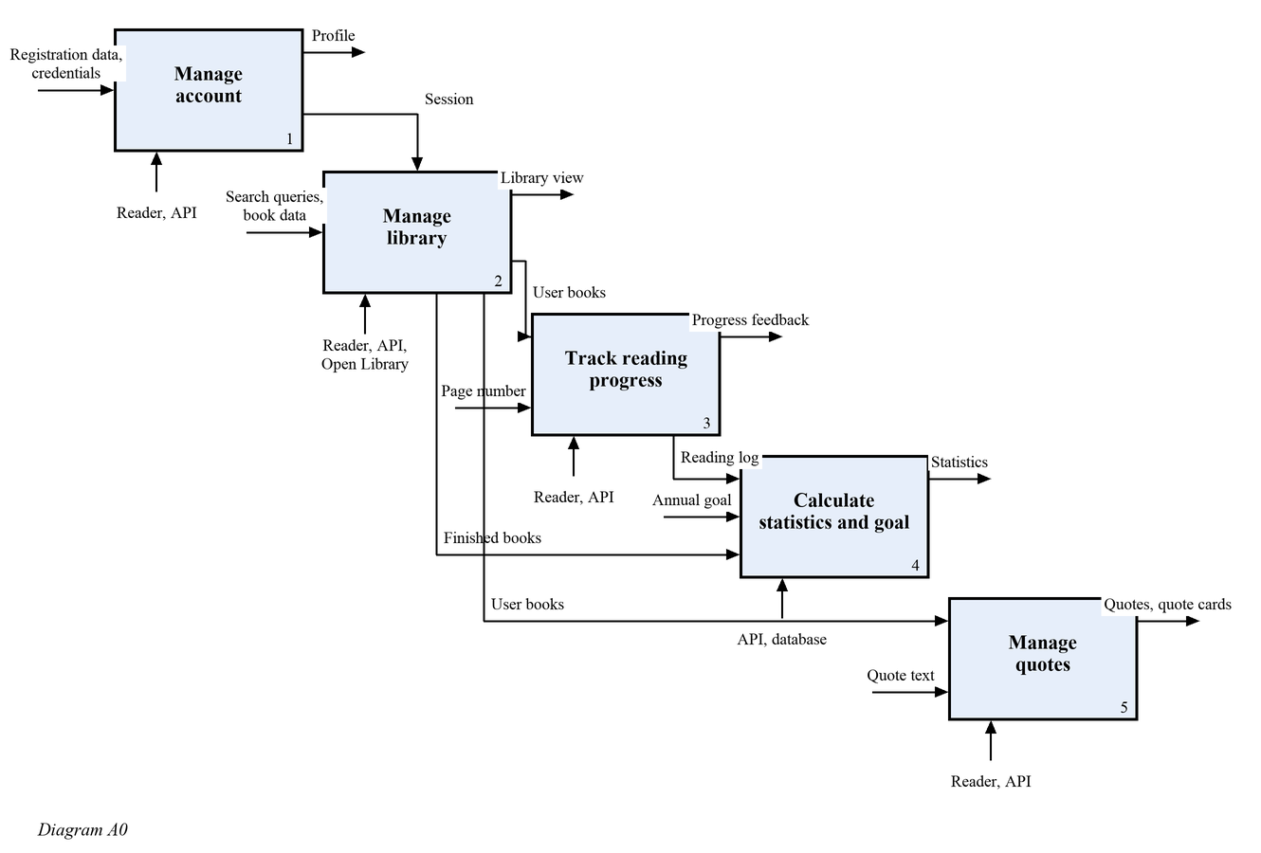
Figure 6. SADT diagram A0
Table 6. Interfaces of the functions of the diagram A0
Function | Input | Control | Output | Mechanism
1 Manage account | Registration data, credentials | Password and email rules | Session, profile | Reader, API
2 Manage library | Search queries, book data | Status rules, input limits | Library view, user books | Reader, API, Open Library
3 Track reading progress | Page number, user books | Progress rules | Progress feedback, reading log | Reader, API
4 Calculate statistics and goal | Annual goal, reading log, finished books | Statistics formulas | Statistics, goal status | API, database
5 Manage quotes | Quote text, user books | Input limits | Quotes, quote cards | Reader, API

6 State transition diagram
A book in the library of a user is always in one of four states. The transitions and their conditions are shown in Figure 7 and described in Table 7.
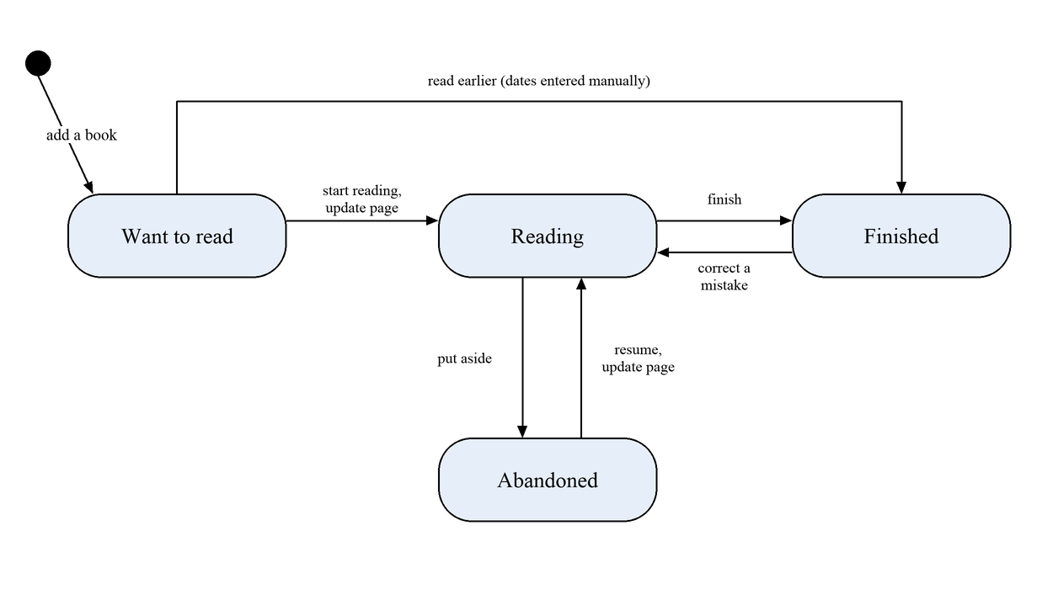
Figure 7. State transition diagram of a book
Table 7. Transitions between the states of a book
Transition | Condition and consequence
Want to read to reading | The reader starts reading or updates the page. The start date is recorded; the page count of the book must be known.
Reading to finished | The reader finishes the book. The finish date is recorded, the current page equals the page count.
Reading to abandoned | The reader puts the book aside. The progress is kept.
Abandoned to reading | The reader resumes or updates the page. Reading continues from the same page.
Want to read to finished | The book was read earlier. The dates are entered manually, no log records are created.
Finished to reading | Correction of a mistake. The finish date is cleared.

7 Specifications of the processes

7.1 Update of reading progress (process 3.0)
Purpose: to save the page on which the reader stopped and to keep the history of reading. The process receives the user book b and the new page p. It rejects an update of a finished book and a page outside the range from 0 to the page count. A book that is not being read yet moves to the status “reading”. The log record and the new page are saved in one transaction. The algorithm is shown in Figure 8 and written in pseudocode below.
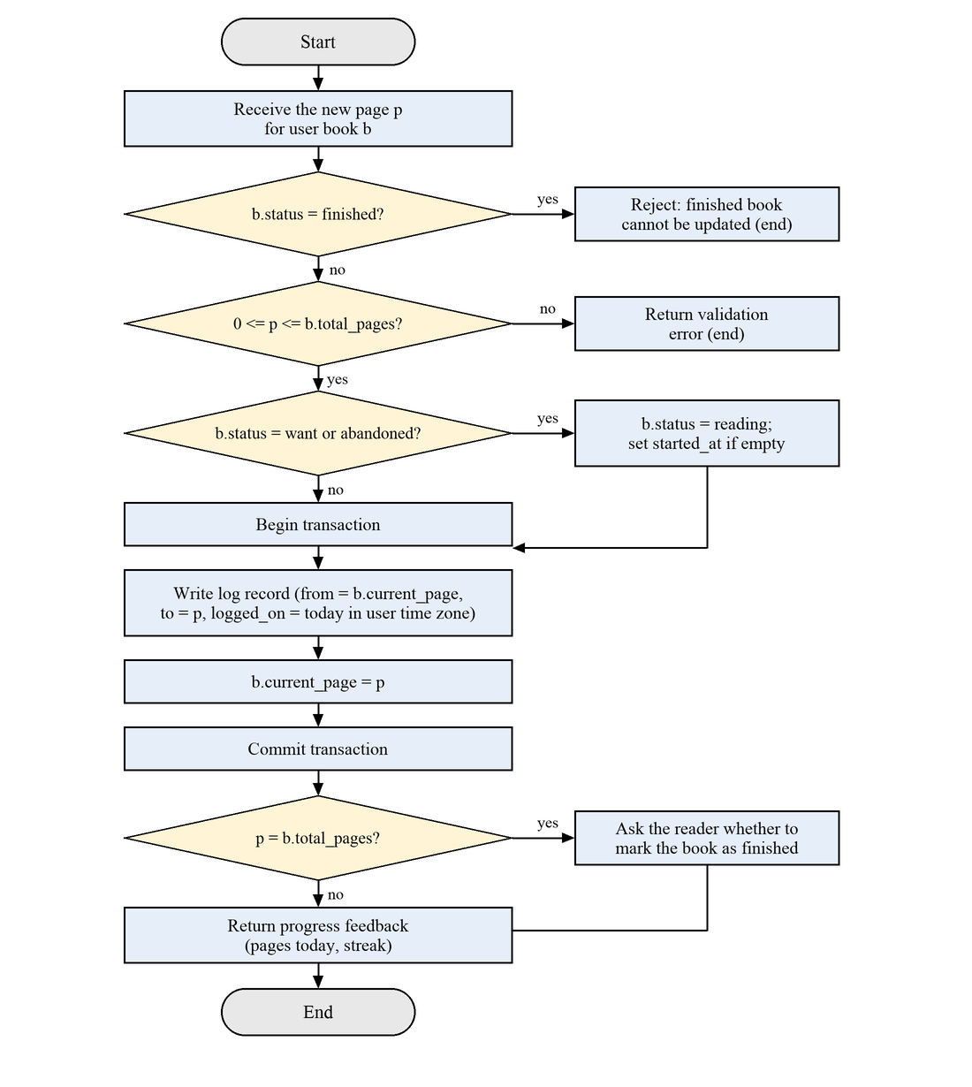
Figure 8. Flowchart of the progress update
FUNCTION update_progress(user, b, p)
IF b.status = finished THEN RETURN error(“finished book cannot be updated”)
IF p < 0 OR p > b.total_pages THEN RETURN error(“page is out of range”)
IF b.status IN (want, abandoned) THEN
b.status <- reading (saved with the transaction below)
IF b.started_at IS EMPTY THEN b.started_at <- now()
BEGIN TRANSACTION
CREATE reading_log(user_book = b, from_page = b.current_page, to_page = p,
logged_on = today(user.time_zone))
b.current_page <- p
SAVE b
COMMIT
RETURN feedback(pages_today(user), streak(user), offer_finish = (p = b.total_pages))
END

7.2 Reading streak (process 4.0)
Purpose: to show how many days in a row the reader read. A day counts if the net number of pages read on that day, in the time zone of the user, is greater than zero. The streak is active if the last such day is today or yesterday, so in the morning it is not reset yet.
FUNCTION streak(user)
today <- today(user.time_zone)
days <- SET OF dates d WHERE net_pages(user, d) > 0
IF today IN days THEN d <- today
ELSE IF (today - 1 day) IN days THEN d <- today - 1 day
ELSE RETURN 0
n <- 0
WHILE d IN days DO
n <- n + 1
d <- d - 1 day
RETURN n
END

net_pages(user, d) = MAX(0, SUM(to_page - from_page) over the log records of the user on the day d)

7.3 Reading pace and completion forecast (process 4.0)
Purpose: to estimate when the current book will be finished. The pace is the average number of pages per day over the last 14 days; days without reading are counted. If a book has no recent reading, the overall pace of the user is used.
FUNCTION pace(user, scope)
total <- SUM of net_pages over the last 14 days (today included), for the book or for all books
RETURN total / 14
END

FUNCTION forecast(b, user)
remaining <- b.total_pages - b.current_page
v <- pace(user, b)
IF v = 0 THEN v <- pace(user, all)
IF v = 0 THEN RETURN unknown
RETURN today(user.time_zone) + CEIL(remaining / v) days
END

7.4 Annual goal (process 4.0)
Purpose: to tell the reader whether the pace of reading is enough to reach the annual goal. The number of books finished in the year is compared with the part of the goal that corresponds to the part of the year that has passed.
FUNCTION on_track(user, year)
goal <- reading_goal(user, year)
IF goal IS EMPTY THEN RETURN unknown
finished <- COUNT user_books of the user WHERE finished_at is in year
expected <- goal.target_books * day_of_year(today) / days_in_year(year)
RETURN finished >= expected
END

8 Glossary
Table 8. Terms of the subject area
Term | Definition
Reader (user) | A person who keeps a personal library in the application.
Catalog | The shared set of books known to the system.
User book | A book in the library of a reader, with a status, a progress and quotes.
Status | One of four states of a user book: want to read, reading, finished, abandoned.
Progress | The current page of a user book and the percentage read.
Reading log | The list of progress updates: from page, to page, date.
Net pages | The sum of the changes of the page on a day, not less than zero.
Streak | The number of consecutive days with more than zero net pages.
Pace | The average number of pages per day over the last 14 days.
Quote | A fragment of a book saved by the reader.
Insight | A personal thought of the reader saved separately from a quote.
Quote card | An image with a quote that can be shared.
Annual goal | The number of books that the reader plans to finish in a year.
PWA | A web application that can be installed on a device and launched as a standalone application.
API | The interface through which the client exchanges data with the server.
Open Library | An open free catalog of books used for search.
Data flow | A movement of data between an entity, a process and a data store.
Data store | A place where data is kept between the operations of processes.

