Ministry of Education and Science of Ukraine
KHMELNYTSKYI NATIONAL UNIVERSITY
Faculty of Information Technologies
Department of Software Engineering

LABORATORY WORK No. 2

Discipline: “Software Construction”
Topic: “Structured Approach to Programming. The Preliminary Design Stage.
Network Schedule of Works”

Completed by: 3rd-year students of group SE-23-1 Oleksandr Cheshun
(name, surname)
Teammate 2
(name, surname)
Teammate 3
(name, surname)
Checked by: Teacher name
(name, surname)

Khmelnytskyi, 2026

Objective
To acquire the skills of building formal models and using them to define the specification of the software to be developed, and to learn to use a network schedule of works to estimate the duration of a project.

Tasks for the laboratory work
1. Study the theoretical material on the stages of software development, the analysis of requirements and the definition of software specifications.
2. Develop the preliminary design for the software product from laboratory work No. 1 and build the network schedule of works for its further development.
3. Prepare the report and answer the control questions.

Theoretical background
Before the software is developed, the requirements for it are analyzed, and on the basis of the results the specifications are written. In the structured approach the models built at this stage are of three types: models of functions, models of data and models of data flows. Because each model describes the software from one side, several models are used together. They are diagrams accompanied by text descriptions and a glossary.
A data flow diagram (DFD) shows how data moves between external entities, processes and data stores. A functional diagram of the SADT methodology shows functions with their inputs, controls, outputs and mechanisms. A state transition diagram shows the states of an object and the transitions between them. An entity-relationship diagram describes the structure of the data. A process specification describes the algorithm of a process by a short text, a flowchart or pseudocode. A glossary defines the terms of the subject area.
A network schedule shows the works of a project as a graph. In the critical path method the nodes are works and the arrows are the dependencies between them. The schedule is built in the following order: the goal and the constraints of planning are defined; the works are listed, for example with a tree diagram, and the duration of each work is estimated in the same unit; the order of the works is determined and the dependencies are drawn; a forward pass finds the early start and the early finish of each work (a work cannot start until all its predecessors have finished); a backward pass finds the late start and the late finish; the slack of each work is the difference between its late and early start; the works with zero slack form the critical path, which determines the duration of the whole project.

Performing the laboratory work
The problem statement: to develop the preliminary design for the web application Bookshelf according to the technical specification from laboratory work No. 1, and to build the network schedule of the works for its development. The following steps were performed.
- The theoretical material on the models of the structured analysis and on the critical path method was studied.
- The data flow diagrams were built: the context diagram and the diagram of level 1 with five processes and six data stores.
- The functional diagrams in the SADT notation were built: the diagram A-0 and its decomposition A0.
- The state transition diagram of a book was built; it shows four states and six transitions.
- The entity-relationship diagram of the database was built from the data model of the technical specification.
- The processes were specified: a flowchart and pseudocode for the progress update, pseudocode for the streak, the pace with the completion forecast, and the annual goal.
- The glossary of the subject area was compiled, and the solution method and the programming languages were chosen.
- The network schedule of works was built and calculated by the critical path method.
The preliminary design is given in Appendix A, and Table 1 shows its contents. The network schedule is described below.
Table 1. Contents of the preliminary design
No. | Section | Content
1 | Introduction | Purpose of the document and its link with the technical specification.
2 | List of documents | The documents of the preliminary design.
3 | Main technical decisions | Structure of the system, solution method, programming languages, structure of the database, functions.
4 | Data flow diagrams | Context diagram, diagram of level 1, processes and data stores.
5 | Functional diagrams | SADT diagrams A-0 and A0, interfaces of the functions.
6 | State transition diagram | Four states of a book and six transitions.
7 | Specifications of the processes | Flowchart and pseudocode of four processes.
8 | Glossary | Eighteen terms of the subject area.

Network schedule of works

Goal and constraints
The goal of planning is a Bookshelf MVP that is ready for acceptance in nine weeks, which is the total term of the phases in the technical specification. The constraints are the team of three people, the order of work imposed by the technology (for example, the client screens need the skeleton of the project and authentication) and the unit of time. All durations are given in working days, five days make a week.

Tree diagram of works
The works were found with a tree diagram (Figure 1). The top-level works of the tree are the works of the network schedule.
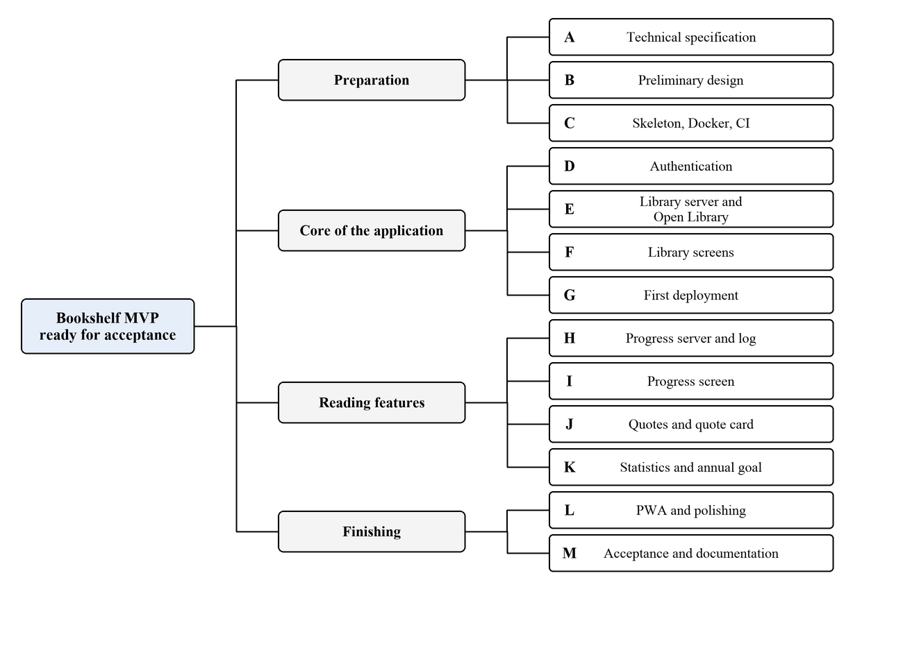
Figure 1. Tree diagram of works

Works, durations and dependencies
Table 2. Works of the project
Code | Work | Duration, days | Predecessors
A | Technical specification | 5 | none
B | Preliminary design | 5 | A
C | Skeleton, Docker, CI | 5 | B
D | Authentication | 4 | C
E | Library server and Open Library | 6 | D
F | Library screens | 6 | D
G | First deployment | 3 | E, F
H | Progress server and log | 4 | E
I | Progress screen | 5 | F, H
J | Quotes and quote card | 7 | E, F
K | Statistics and annual goal | 7 | H
L | PWA and polishing | 4 | I, J, K
M | Acceptance and documentation | 5 | G, L

Network graph
The network graph (Figure 2) is built with the works as nodes and the dependencies as arrows. Every node shows the early start, the duration and the early finish in the top row, and the late start, the slack and the late finish in the bottom row.
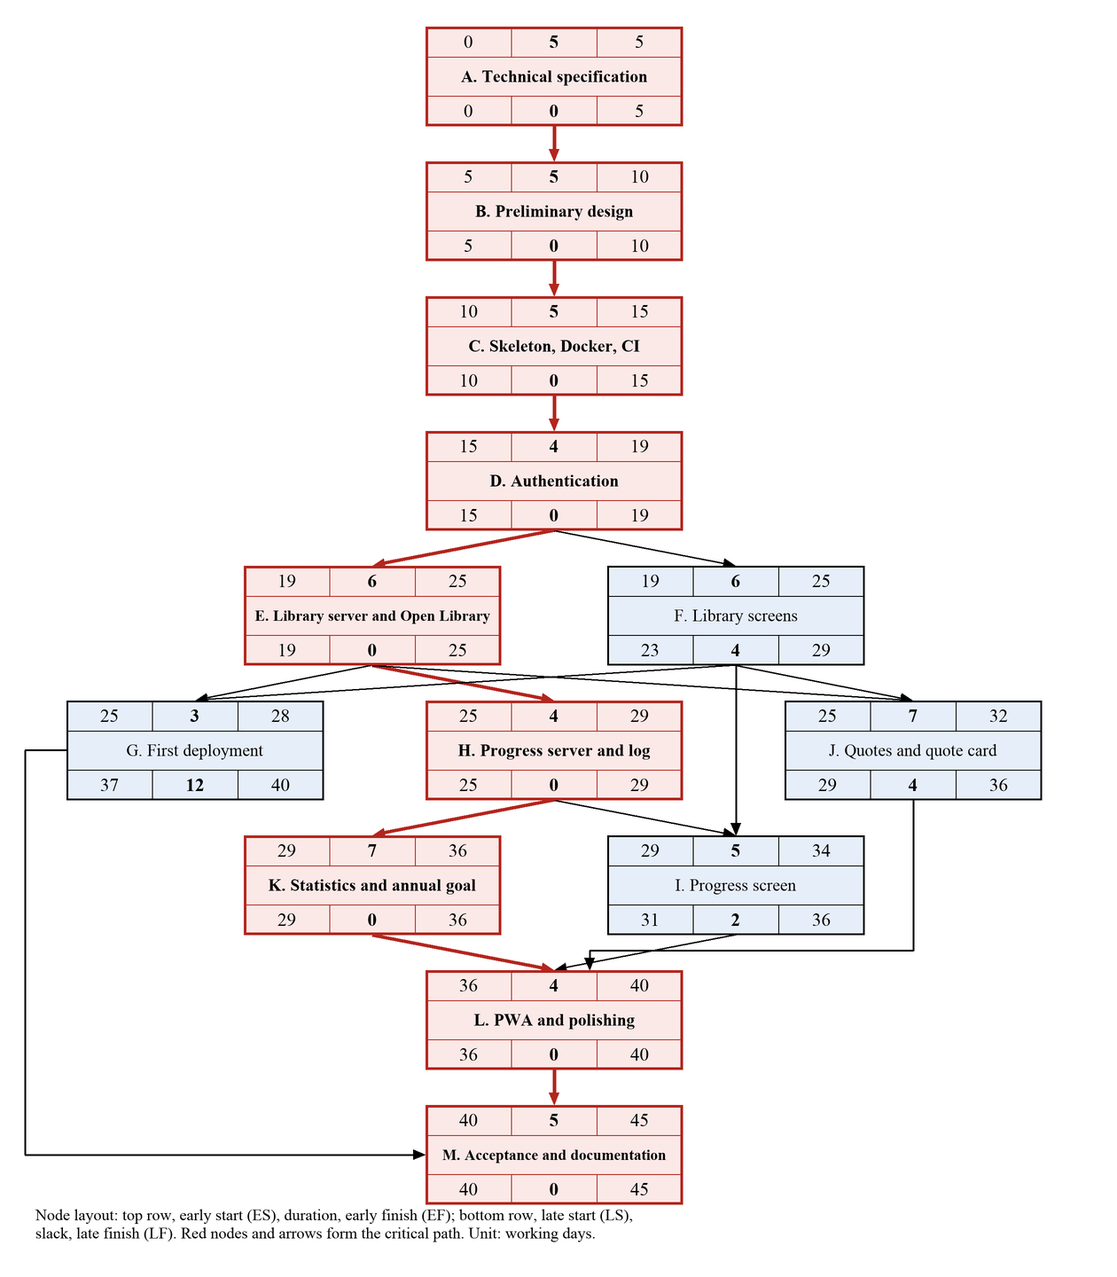
Figure 2. Network graph of the project

Calculation of the schedule
The forward pass gives the early start (ES) and the early finish (EF) of each work: the early start is the largest early finish of its predecessors, and the early finish is the early start plus the duration. The backward pass gives the late finish (LF) and the late start (LS): the late finish is the smallest late start of the successors, and for the last work it equals the duration of the project. The slack equals LS minus ES. The results are in Table 3.
Table 3. Calculation of the network schedule
Work | Duration | ES | EF | LS | LF | Slack | Critical
A | 5 | 0 | 5 | 0 | 5 | 0 | yes
B | 5 | 5 | 10 | 5 | 10 | 0 | yes
C | 5 | 10 | 15 | 10 | 15 | 0 | yes
D | 4 | 15 | 19 | 15 | 19 | 0 | yes
E | 6 | 19 | 25 | 19 | 25 | 0 | yes
F | 6 | 19 | 25 | 23 | 29 | 4 | no
G | 3 | 25 | 28 | 37 | 40 | 12 | no
H | 4 | 25 | 29 | 25 | 29 | 0 | yes
I | 5 | 29 | 34 | 31 | 36 | 2 | no
J | 7 | 25 | 32 | 29 | 36 | 4 | no
K | 7 | 29 | 36 | 29 | 36 | 0 | yes
L | 4 | 36 | 40 | 36 | 40 | 0 | yes
M | 5 | 40 | 45 | 40 | 45 | 0 | yes

Critical path
The works with zero slack form the critical path: A → B → C → D → E → H → K → L → M. Its length is 45 working days, that is nine weeks, so the project fits the term set in the technical specification. The other works have a reserve: the library screens (F) and the quotes (J) can be delayed by four days, the progress screen (I) by two days, and the first deployment (G) by twelve days without moving the end of the project.
To shorten the project, the works of the critical path must be shortened first. The gain is limited by the nearest non-critical path, which goes through the progress screen (I) and has a reserve of two days: after a shortening by two days a second critical path appears, and further gains require shortening both paths.

Conclusion
In this laboratory work the preliminary design of the web application Bookshelf was developed and the network schedule of the works was built. The structured approach was used: data flow diagrams, SADT diagrams, a state transition diagram, an entity-relationship diagram, specifications of the processes and a glossary were built, and the structure of the system, the solution method and the programming languages were chosen. The network schedule of thirteen works was calculated by the critical path method. The project duration is 45 working days, and the critical path goes through nine works, from the technical specification to the acceptance. The models are consistent with each other and with the technical specification, so they can be used as the basis for the technical design and for the implementation.

Answers to the control questions
1. List the stages of software development.
The main stages are: the technical specification, the preliminary design, the technical design, the working design and the implementation. In terms of the life cycle these are the analysis of requirements, design, implementation, testing, deployment and maintenance.
2. What is the software life cycle?
The life cycle is the period from the moment the idea of a software product appears to the moment it is withdrawn from use. It includes the analysis of requirements, design, coding, testing, deployment, operation and maintenance, and the modernization of the product. Models of the life cycle (waterfall, incremental, spiral) differ in the order and the repetition of these stages.
3. What do the problem statement and the pre-design research consist of?
The problem statement defines the goal of the development, the object of automation and the expected result. The pre-design research includes the analysis of the subject area and the analogues, the collection of the requirements of the customer, the choice of functions, data and the environment, and the assessment of feasibility and resources.
4. List the functional and operational requirements for a software product.
Functional requirements describe what the product does, for example registration, the update of progress and the calculation of statistics. Operational requirements describe the conditions of its use: the response time, reliability, security, the hardware and the software environment, and the qualification of the personnel.
5. List the components of the preliminary design.
The preliminary design consists of the explanatory note with the main technical decisions (the structure of the system, the structure of the database, the functions, the choice of the method and the programming language), the process specifications, all the diagrams that were built, and the glossary of terms. The network schedule is prepared together with it.
6. Characterize specifications and models.
A specification is a description of what the software must do, without the details of how it is implemented. A model is a formal representation of the software from one side: a model of functions (SADT), a model of data (entity-relationship diagram) or a model of data flows (DFD). The state transition diagram describes behavior. The models are used together because each of them shows only one aspect.
7. Why is a network schedule used?
The network schedule is used to plan and control the works of a project. It shows the dependencies between the works, allows calculating the duration of the project and the reserves of the works, identifies the critical path, whose works determine the end date, and helps to find ways to shorten the project and to monitor its progress.

Appendix A. Preliminary design
The full text of the preliminary design follows.
APPROVED
Head of the Department of Software Engineering
Professor
____________ L. P. Bedratiuk
“____” ____________ 2026
PRELIMINARY DESIGN
for the development of “Bookshelf: a web application for tracking reading and book notes”
Khmelnytskyi, 2026

1 Introduction
This document is the preliminary design for the development of the web application Bookshelf, a personal reading tracker. The list of organizations that take part in the development, the terms and phases of the work, and the goals and purpose of the system are stated in the technical specification for Bookshelf (theme code BS-2026), which was developed and approved at the previous stage.
The preliminary design refines the requirements of the technical specification into formal models: data flow diagrams, functional diagrams, a state transition diagram, an entity-relationship diagram, specifications of the processes and a glossary of terms. It also fixes the main technical decisions: the structure of the system, the solution method, the programming languages and the structure of the database. The network schedule of the works is given in the report on the laboratory work.

2 List of documents
Table A.1. Documents of the preliminary design
No. | Document | Content
1 | Technical specification | Requirements for the product; the basis of the preliminary design.
2 | Explanatory note (this document) | Main technical decisions and the structure of the system.
3 | Data flow diagrams | Context diagram and the diagram of level 1 (Section 4).
4 | Functional diagrams | SADT diagrams A-0 and A0 (Section 5).
5 | State transition diagram | Statuses of a book in the library (Section 6).
6 | Entity-relationship diagram | Structure of the database (Section 3.3).
7 | Process specifications | Descriptions, a flowchart and pseudocode (Section 7).
8 | Glossary | Definitions of the terms of the subject area (Section 8).
9 | Network schedule of works | Given in the report on the laboratory work.

3 Main technical decisions

3.1 Structure of the system
Bookshelf is built as a client-server web application with a separate client. The client is a single-page application written in Vue 3, which is installed on the phone as a progressive web application (PWA). The server part is a REST API written in Laravel. The API stores data in a MySQL database and, on behalf of the client, calls the external catalog Open Library. A web server (nginx) serves the static files of the client and passes requests to the API. The whole system is packaged in Docker containers. The structure is shown in Figure A.1.
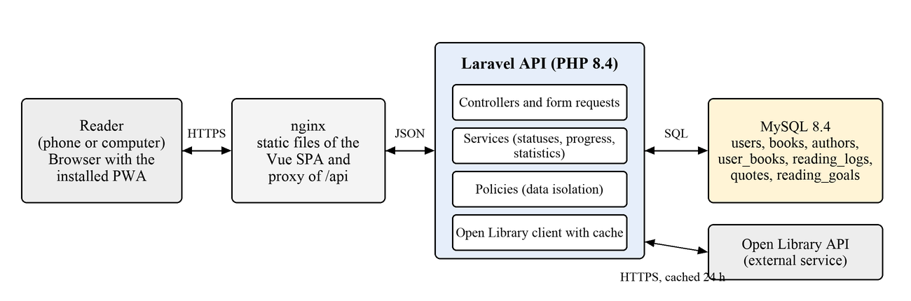
Figure A.1. Structure of the system
The server part is divided into layers: a controller receives a request, a form request validates it, a service performs the domain logic (statuses, progress, statistics), a policy checks that the data belongs to the user, and a model reads and writes the database. The client never calls Open Library directly, so the server can cache the answers and limit the request rate.

3.2 Choice of the solution method and programming languages
The specification of the system is built by the structured approach: the functions, the data and the flows of data are described by separate, mutually consistent models (DFD, SADT, state transition diagram, entity-relationship diagram) with process specifications and a glossary. The system is implemented in a layered architecture and developed incrementally, in the phases of the network schedule, so that every phase ends with a working version.
Table A.2. Programming languages and tools
Part | Language and tools | Reason
Server part | PHP 8.4, Laravel | Required by the team; mature tools for APIs, authentication, migrations and tests.
Client part | TypeScript, Vue 3, Vite, Tailwind CSS | Typed code, fast component development, ready support of PWA.
Data | SQL, MySQL 8.4 | A relational model fits the data; the team knows MySQL.
Tests | Pest, Vitest | Automated checking of the rules of the system.
Delivery | Git, Docker, GitHub Actions | Repeatable builds, automatic checks and deployment.

3.3 Structure of the database
The database is relational. A book in the catalog is shared by all users, and all personal data belongs to a user book, which links a user to a book. The structure is shown in Figure A.2.
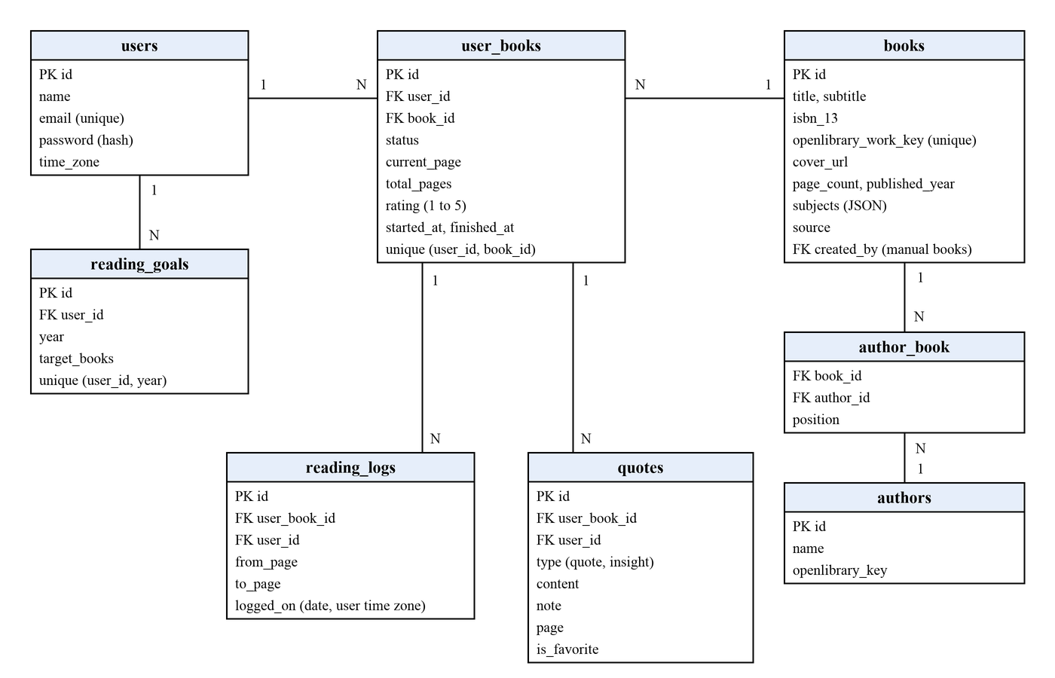
Figure A.2. Entity-relationship diagram
- users: accounts of the readers, with the time zone used for all date calculations;
- books and authors: the shared catalog (books come from Open Library or are added manually), linked by author_book;
- user_books: a book in the library of a user, with the status, the current page, the page count of the user’s edition and the rating;
- reading_logs: one record for every progress update (from page, to page, date);
- quotes: quotes and insights linked to a user book;
- reading_goals: the annual goal of a user (one record per user and year).
The user_id column is repeated in reading_logs and quotes to simplify access checks and the statistics queries. Unique indexes protect the pairs “user and book” and “user and year”. Deleting a user book deletes its log and quotes.

3.4 Functions of the system
The system must perform the functions of the technical specification, which are grouped in Table A.3.
Table A.3. Groups of functions
Group | Functions
Account | Register, sign in and out, recover a password, edit the profile and the time zone.
Library | Search a book in Open Library, add a book manually, list books by status, edit the status, the rating and the page count, delete a book.
Progress | Update the current page, keep the reading log, show progress bars, suggest finishing a book.
Quotes | Add, edit and delete quotes and insights, mark favorites, show the quote of the day, generate a quote card image.
Statistics | Pages per day, reading streak, reading pace, completion forecast, annual goal.
PWA | Install the application on the home screen, cache the application shell, show a message when there is no connection.

4 Data flow diagrams

4.1 Context diagram
The context diagram Figure A.3 shows the system as one process that exchanges data with two external entities: the Reader and the external service Open Library.
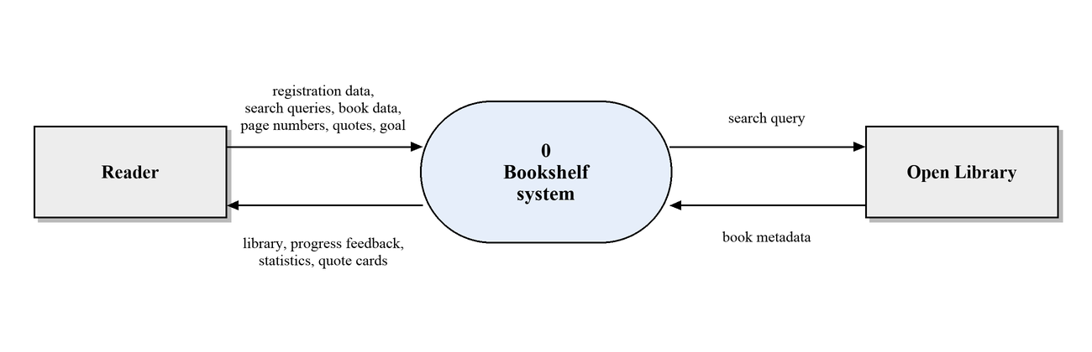
Figure A.3. Context data flow diagram

4.2 Diagram of level 1
The system is decomposed into five processes that work with six data stores (Figure A.4). A store marked with a vertical bar is shown twice to keep the diagram readable.
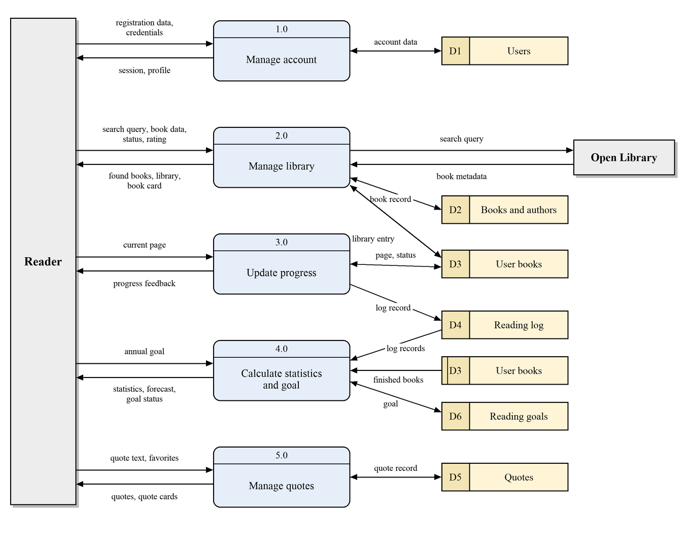
Figure A.4. Data flow diagram of level 1
Table A.4. Processes of the diagram of level 1
ID | Process | Input data | Output data
1.0 | Manage account | Registration data, credentials | Session, profile
2.0 | Manage library | Search query, book data, status, rating, Open Library metadata | Found books, library, book card
3.0 | Update progress | Current page | Progress feedback, log record
4.0 | Calculate statistics and goal | Annual goal, log records, finished books | Statistics, forecast, goal status
5.0 | Manage quotes | Quote text, favorite flag | Quotes, quote cards

Table A.5. Data stores
ID | Store | Content | Database tables
D1 | Users | Accounts and profiles | users
D2 | Books and authors | The shared catalog | books, authors, author_book
D3 | User books | Library entries with status and progress | user_books
D4 | Reading log | Progress updates | reading_logs
D5 | Quotes | Quotes and insights | quotes
D6 | Reading goals | Annual goals | reading_goals

5 Functional diagrams
Functional diagrams are built by the SADT methodology. Every function is shown as a box, and its interfaces are arrows: an input enters from the left, a control from the top, an output leaves to the right, and a mechanism enters from the bottom. The context diagram A-0 (Figure A.5) shows the whole system as the function “Track personal reading”.
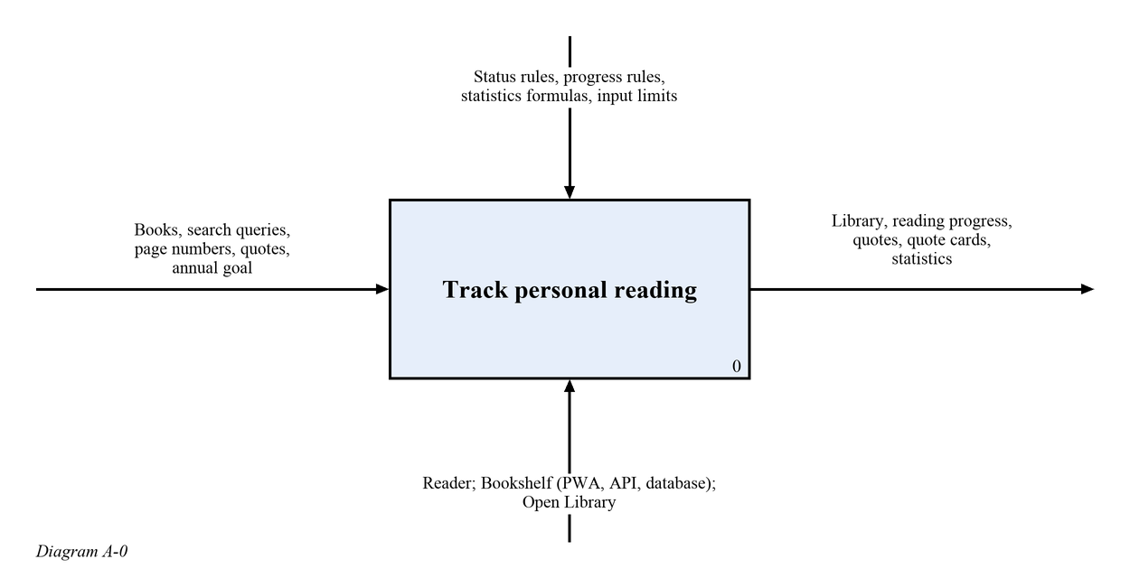
Figure A.5. SADT diagram A-0
The diagram A0 (Figure A.6) decomposes it into five functions. The session produced by the account function lets the user work with the library, the user books flow to the functions of progress and quotes, and the reading log together with the finished books flow to the function that calculates statistics. The interfaces are described in Table A.6.
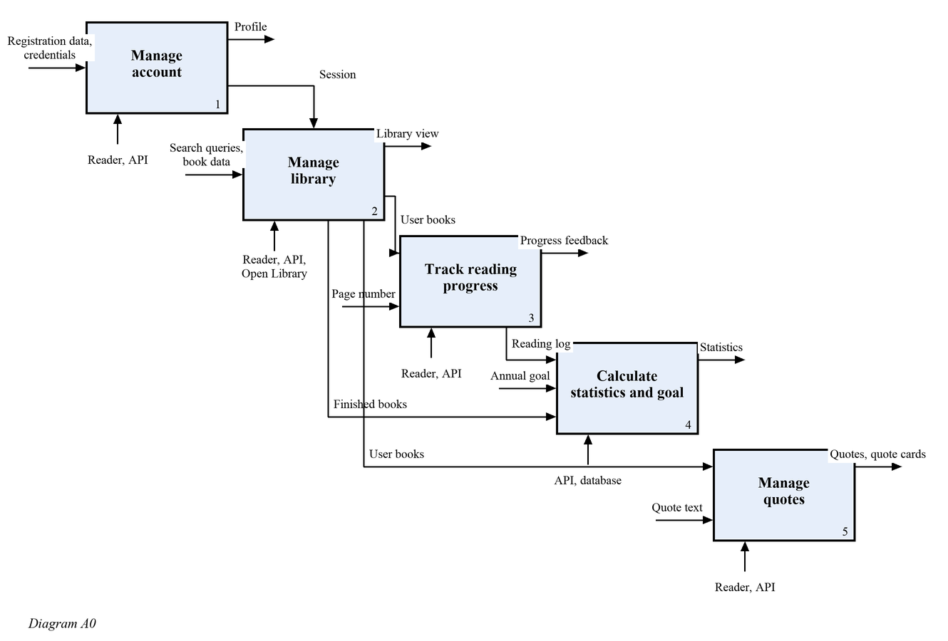
Figure A.6. SADT diagram A0
Table A.6. Interfaces of the functions of the diagram A0
Function | Input | Control | Output | Mechanism
1 Manage account | Registration data, credentials | Password and email rules | Session, profile | Reader, API
2 Manage library | Search queries, book data | Status rules, input limits | Library view, user books | Reader, API, Open Library
3 Track reading progress | Page number, user books | Progress rules | Progress feedback, reading log | Reader, API
4 Calculate statistics and goal | Annual goal, reading log, finished books | Statistics formulas | Statistics, goal status | API, database
5 Manage quotes | Quote text, user books | Input limits | Quotes, quote cards | Reader, API

6 State transition diagram
A book in the library of a user is always in one of four states. The transitions and their conditions are shown in Figure A.7 and described in Table A.7.
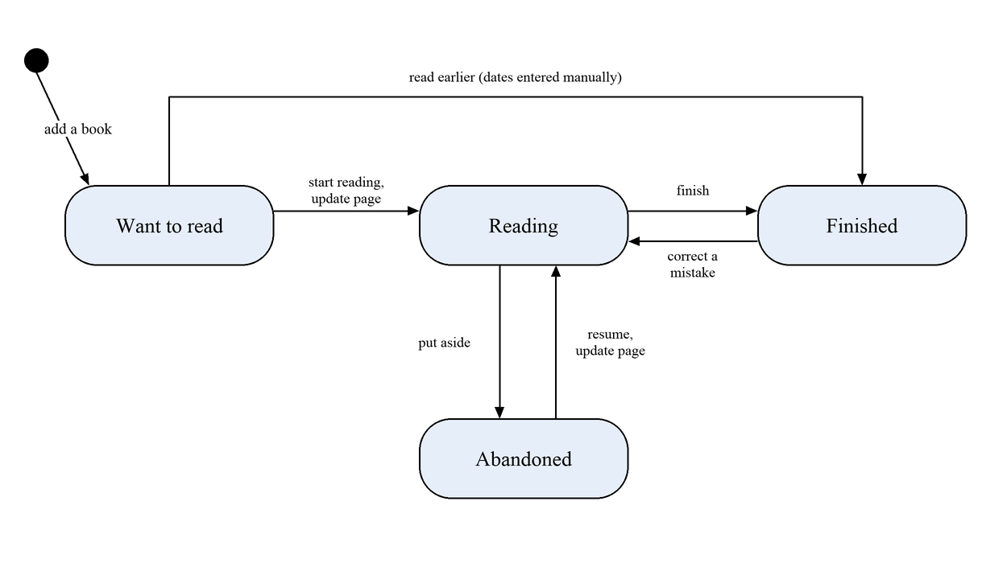
Figure A.7. State transition diagram of a book
Table A.7. Transitions between the states of a book
Transition | Condition and consequence
Want to read to reading | The reader starts reading or updates the page. The start date is recorded; the page count of the book must be known.
Reading to finished | The reader finishes the book. The finish date is recorded, the current page equals the page count.
Reading to abandoned | The reader puts the book aside. The progress is kept.
Abandoned to reading | The reader resumes or updates the page. Reading continues from the same page.
Want to read to finished | The book was read earlier. The dates are entered manually, no log records are created.
Finished to reading | Correction of a mistake. The finish date is cleared.

7 Specifications of the processes

7.1 Update of reading progress (process 3.0)
Purpose: to save the page on which the reader stopped and to keep the history of reading. The process receives the user book b and the new page p. It rejects an update of a finished book and a page outside the range from 0 to the page count. A book that is not being read yet moves to the status “reading”. The log record and the new page are saved in one transaction. The algorithm is shown in Figure A.8 and written in pseudocode below.
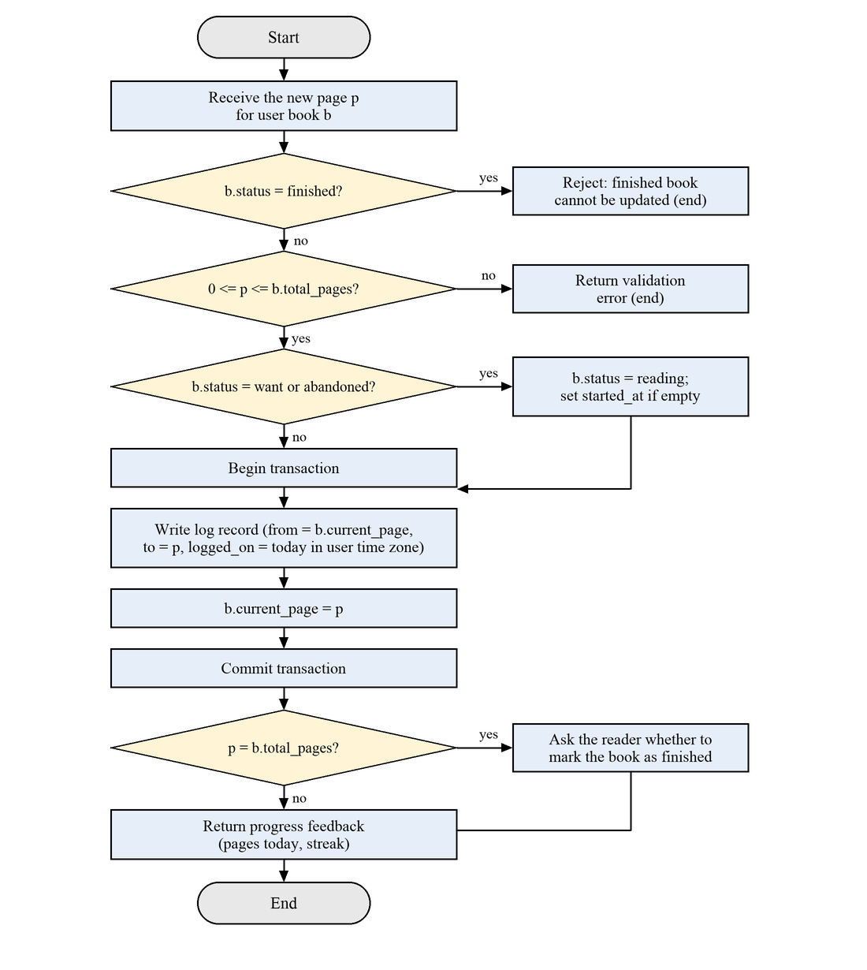
Figure A.8. Flowchart of the progress update
FUNCTION update_progress(user, b, p)
IF b.status = finished THEN RETURN error(“finished book cannot be updated”)
IF p < 0 OR p > b.total_pages THEN RETURN error(“page is out of range”)
IF b.status IN (want, abandoned) THEN
b.status <- reading (saved with the transaction below)
IF b.started_at IS EMPTY THEN b.started_at <- now()
BEGIN TRANSACTION
CREATE reading_log(user_book = b, from_page = b.current_page, to_page = p,
logged_on = today(user.time_zone))
b.current_page <- p
SAVE b
COMMIT
RETURN feedback(pages_today(user), streak(user), offer_finish = (p = b.total_pages))
END

7.2 Reading streak (process 4.0)
Purpose: to show how many days in a row the reader read. A day counts if the net number of pages read on that day, in the time zone of the user, is greater than zero. The streak is active if the last such day is today or yesterday, so in the morning it is not reset yet.
FUNCTION streak(user)
today <- today(user.time_zone)
days <- SET OF dates d WHERE net_pages(user, d) > 0
IF today IN days THEN d <- today
ELSE IF (today - 1 day) IN days THEN d <- today - 1 day
ELSE RETURN 0
n <- 0
WHILE d IN days DO
n <- n + 1
d <- d - 1 day
RETURN n
END

net_pages(user, d) = MAX(0, SUM(to_page - from_page) over the log records of the user on the day d)

7.3 Reading pace and completion forecast (process 4.0)
Purpose: to estimate when the current book will be finished. The pace is the average number of pages per day over the last 14 days; days without reading are counted. If a book has no recent reading, the overall pace of the user is used.
FUNCTION pace(user, scope)
total <- SUM of net_pages over the last 14 days (today included), for the book or for all books
RETURN total / 14
END

FUNCTION forecast(b, user)
remaining <- b.total_pages - b.current_page
v <- pace(user, b)
IF v = 0 THEN v <- pace(user, all)
IF v = 0 THEN RETURN unknown
RETURN today(user.time_zone) + CEIL(remaining / v) days
END

7.4 Annual goal (process 4.0)
Purpose: to tell the reader whether the pace of reading is enough to reach the annual goal. The number of books finished in the year is compared with the part of the goal that corresponds to the part of the year that has passed.
FUNCTION on_track(user, year)
goal <- reading_goal(user, year)
IF goal IS EMPTY THEN RETURN unknown
finished <- COUNT user_books of the user WHERE finished_at is in year
expected <- goal.target_books * day_of_year(today) / days_in_year(year)
RETURN finished >= expected
END

8 Glossary
Table A.8. Terms of the subject area
Term | Definition
Reader (user) | A person who keeps a personal library in the application.
Catalog | The shared set of books known to the system.
User book | A book in the library of a reader, with a status, a progress and quotes.
Status | One of four states of a user book: want to read, reading, finished, abandoned.
Progress | The current page of a user book and the percentage read.
Reading log | The list of progress updates: from page, to page, date.
Net pages | The sum of the changes of the page on a day, not less than zero.
Streak | The number of consecutive days with more than zero net pages.
Pace | The average number of pages per day over the last 14 days.
Quote | A fragment of a book saved by the reader.
Insight | A personal thought of the reader saved separately from a quote.
Quote card | An image with a quote that can be shared.
Annual goal | The number of books that the reader plans to finish in a year.
PWA | A web application that can be installed on a device and launched as a standalone application.
API | The interface through which the client exchanges data with the server.
Open Library | An open free catalog of books used for search.
Data flow | A movement of data between an entity, a process and a data store.
Data store | A place where data is kept between the operations of processes.

