[Ange företagets namn]

Digital Clock
2025-10-16

Table of Contents
1 Introduction 3
2 RTL Level of the Project 4
3 Simulation in ModelSim 4
4 Test Bench 6
5 Test Protocol 7

1 Introduction
This report describes the design and implementation of a digital timer on the Deli MAX10 using VHDL. The system consists of several components: a clock divider that generates a 1-second signal from the 50 MHz system clock, a timer counter that counts seconds, minutes, and hours, a BCD splitter that breaks the values into tens and units, and 7-segment displays used to show the time, see Figure 1.
The goal of the project is to demonstrate how different digital components work together in a complete system, to verify its functionality through simulation in ModelSim, and to validate the behavior on physical hardware, see Figure 2.

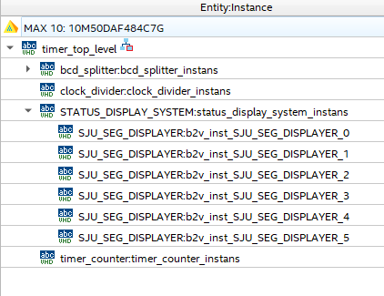
Figure 1 Component hierarchy of the timer
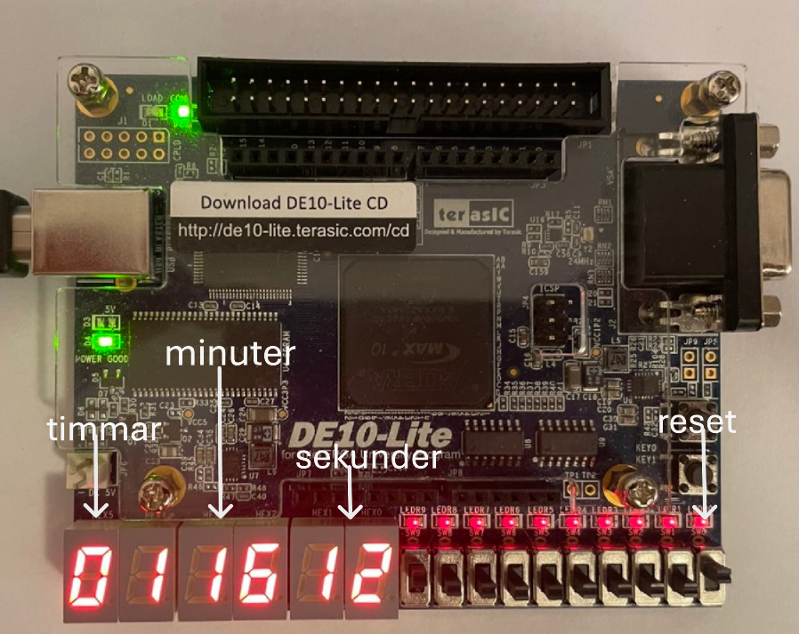
Figure 2 Digital clock architecture

2 RTL Level of the Project
Figure 3 shows the RTL level of the design.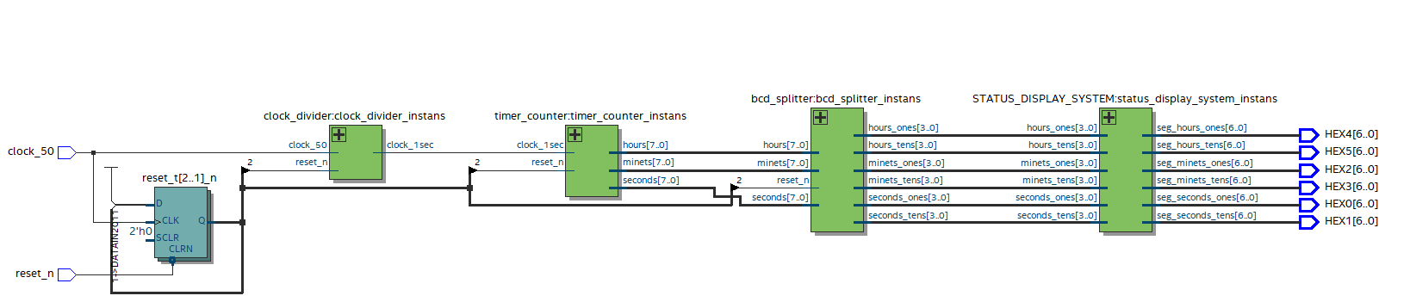
Figure 3 RTL level

3 Simulation in ModelSim
The following parts were verified in ModelSim. During development, each component was tested separately, starting with the clock divider.
The purpose of this component is to convert the 50 MHz system clock into a 1 Hz signal, which corresponds to a pulse generated once per second. A pulse is created every time the internal counter reaches 50 million cycles.
For verification, the counter value was changed to 10, so the output pulse toggles every tenth clock cycle, which is clearly visible in the simulation, see Figure 4.
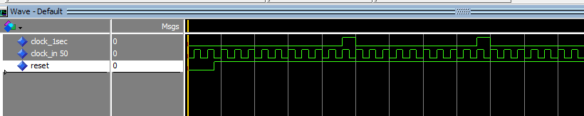
Figure 4 Clock divider verification
The next component verified was the timer counter. Its task is to receive the 1 Hz signal from the clock divider and count seconds, minutes, and hours. Each time a second pulse is received, the seconds counter increases, and when it reaches 60 it resets to zero and the minutes counter increments. Minutes reset at 60 in the same way, and the hours counter increases. Figure 5 shows how seconds and minutes change.
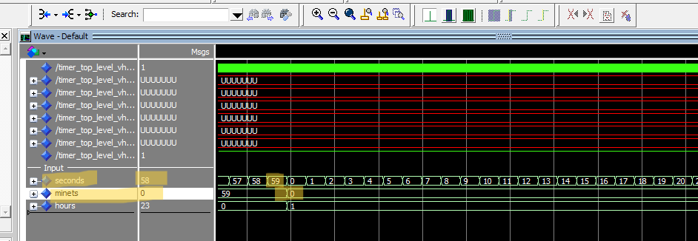
Figure 5 Simulation of seconds and minutes

IAt the beginning of the simulation, the reset signal is tested. It is kept active for five clock periods. After that, ten pulses are generated for counting, and at the eleventh pulse the signal toggles, see Figure 6.

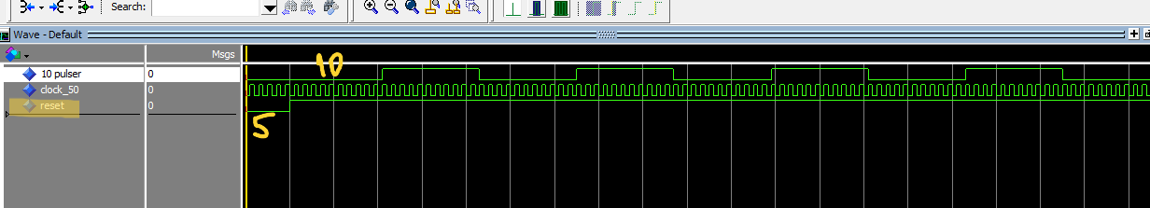
Figure 6 Reset simulation

4 Test Bench
In the test bench, only the reset signal and the 50 MHz clock signal are simulated.
The test bench looks as follows:

ENTITY timer_top_level_vhd_tst IS
END timer_top_level_vhd_tst;
ARCHITECTURE timer_top_level_arch OF timer_top_level_vhd_tst IS
-- constants
-- signals
SIGNAL clock_50 : STD_LOGIC;
SIGNAL HEX0 : STD_LOGIC_VECTOR(6 DOWNTO 0);
SIGNAL HEX1 : STD_LOGIC_VECTOR(6 DOWNTO 0);
SIGNAL HEX2 : STD_LOGIC_VECTOR(6 DOWNTO 0);
SIGNAL HEX3 : STD_LOGIC_VECTOR(6 DOWNTO 0);
SIGNAL HEX4 : STD_LOGIC_VECTOR(6 DOWNTO 0);
SIGNAL HEX5 : STD_LOGIC_VECTOR(6 DOWNTO 0);
SIGNAL reset_n : STD_LOGIC;
CONSTANT clock_period :TIME :=20 ns;
COMPONENT timer_top_level
PORT (
clock_50 : IN STD_LOGIC;
HEX0 : out STD_LOGIC_VECTOR(6 DOWNTO 0);
HEX1 : out STD_LOGIC_VECTOR(6 DOWNTO 0);
HEX2 : out STD_LOGIC_VECTOR(6 DOWNTO 0);
HEX3 : out STD_LOGIC_VECTOR(6 DOWNTO 0);
HEX4 : out STD_LOGIC_VECTOR(6 DOWNTO 0);
HEX5 : out STD_LOGIC_VECTOR(6 DOWNTO 0);
reset_n : IN STD_LOGIC
);
END COMPONENT;
BEGIN
i1 : timer_top_level
PORT MAP (
-- list connections between master ports and signals
clock_50 => clock_50,
HEX0 => HEX0,
HEX1 => HEX1,
HEX2 => HEX2,
HEX3 => HEX3,
HEX4 => HEX4,
HEX5 => HEX5,
reset_n => reset_n
);
clock : PROCESS
begin
clock_50 <= '0';
WAIT FOR clock_period / 2;
clock_50 <= '1';
WAIT FOR clock_period /2;
end process;
reset_p :PROCESS
begin
reset_n <= '0';
WAIt FOR 2 *clock_period;
reset_n <= '1';
WAIT;
end process;
END timer_top_level_arch;

5 Test Protocol
The test protocol contains three tests: two verified in ModelSim and one validated on hardware, see Table 1.
The validation is demonstrated in a video attached to the report.

Tabell 1: Testprotokoll
Case | Description | OK | Verifiering (Simulator) | Validering (DE10)
Test 1 | Reset_n = ’0’ | 7 seg display = ”000 000” | OK | OK
Test 2 | Divider delar 50 MHZ till 1 HZ* | signal toggles every 10 clock cycles | OK | x
Test 3 | 7-segment display shows seconds, minutes, hours | time counts correctly | X | OK
* During simulation, only 10 clock cycles were used instead of the full 50 MHz.

