**Client Server Auth0 SQL Db**

**General:**

U don’t must to create the same topic I’m using in the website such like products pages u can add any topic u want, also please make sure that you are adding page for inserting data.

**Project** **requirements**:

1. Implement React website with the flowing functionality:
   1. Authentication based on Auth0
   2. One page for unauthorized users
   3. Dashboard with several pages
   4. Make sure that you are using the following packages:
      1. React-router-dom
      2. auth0-react
      3. bootstrap
      4. icon-material (for popup when adding or validation)
      5. axios (for sending HTTP requests)
2. Jira Scrum managed (stories, tasks, epics)
3. Server side ( 4 tiers model) with Azure functions (all the below endpoint should effect the database (SQL)),:
   1. Get all products
   2. Get one product with all its details
   3. Delete endpoint when u delete a row
4. SQL Db:
   1. Use Northwind DB, use Products table

**Project** **example:**

Once u access the website and you’re not authorized user (didn’t pass login flow)

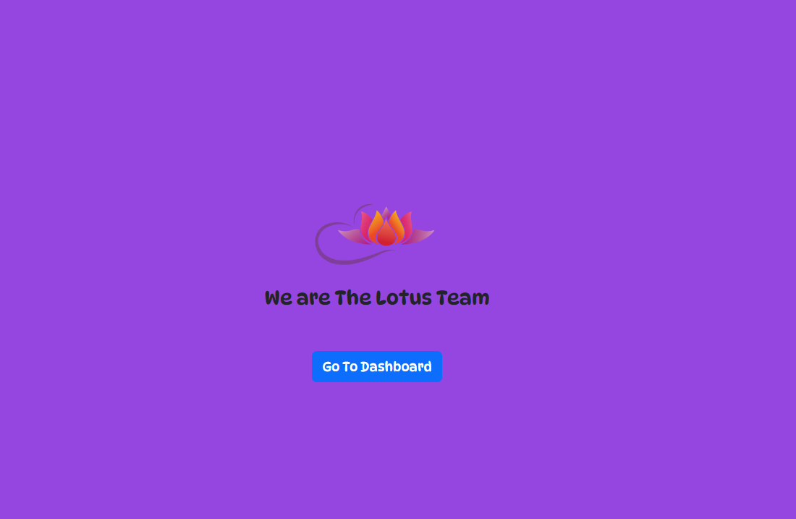

After clicking on button (Go To Dashboard) user will redirected to Auth0:

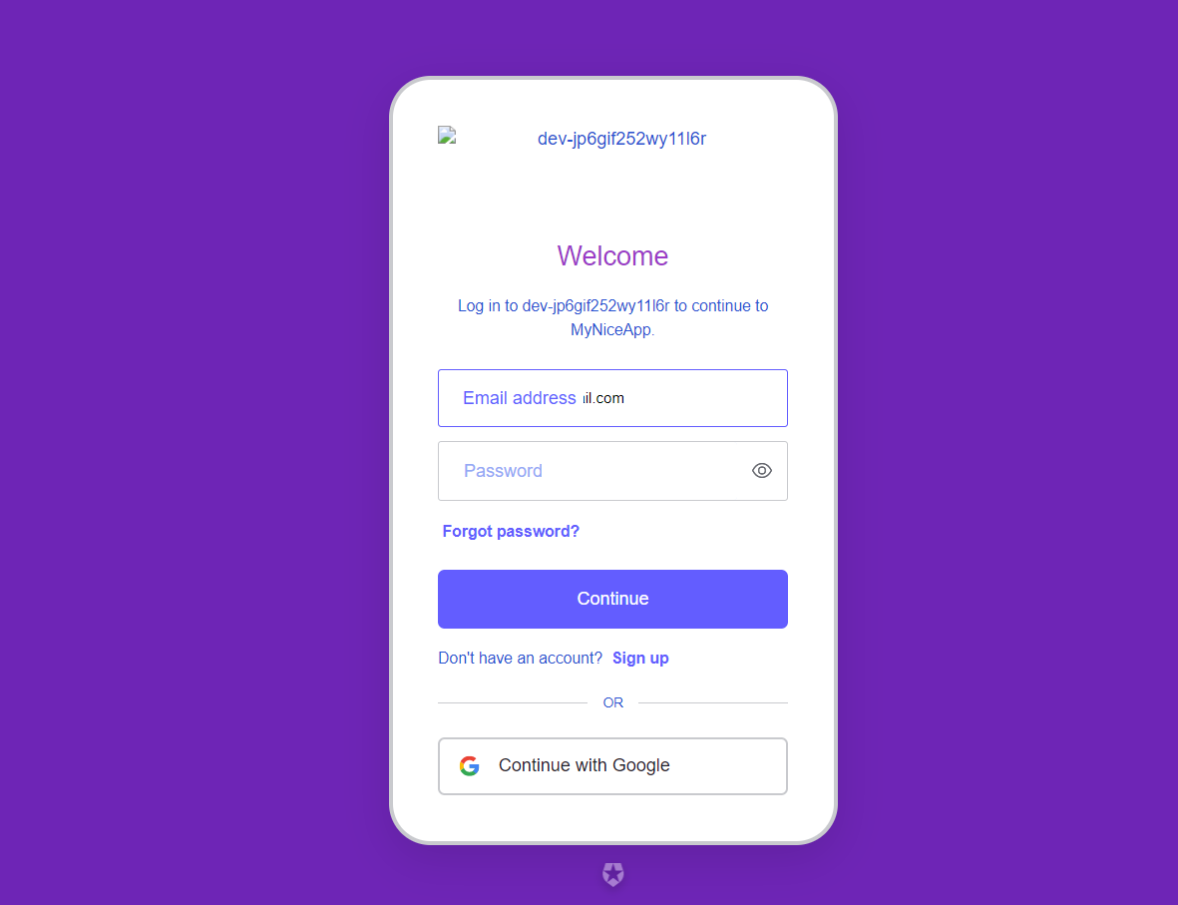

After successfully logged in Auth0 will redirect the user to the dashboard:

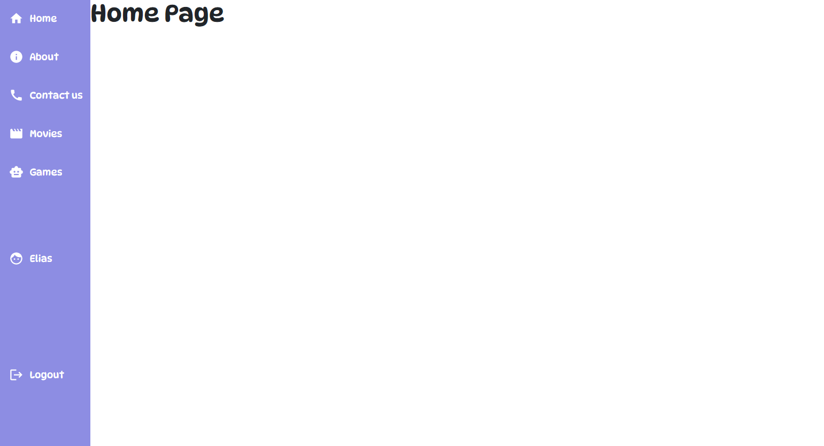

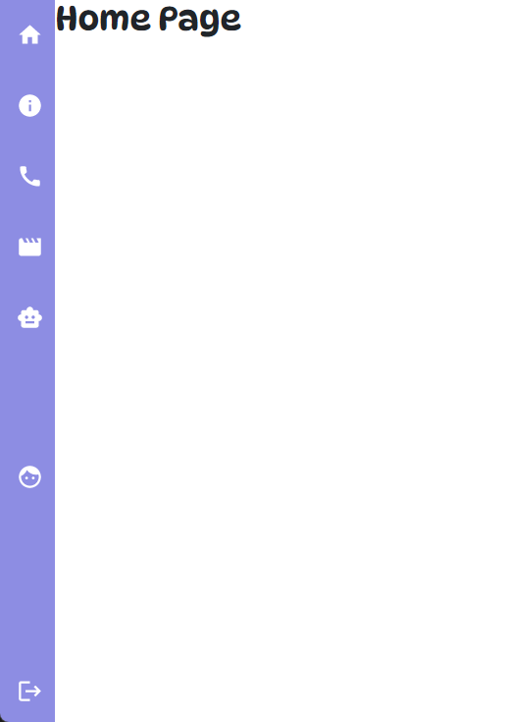

As u can see u have the following web sections:

1. Home
2. About
3. Contact Us
4. All Products (in table view), each line is clickable that opens Extended One Product
5. Extended One product with all product information
6. Logout button

**Pages instructions:**

1. Home page feel free to add any general info about your website
2. About page: should be about your services what you offer in this dashboard
3. Contact Us: make sure that u have input fields and can take contact us request and save it into the database for example page that user add any questions or asking for help
4. Movies list all the movies that u have in database (u don’t must to use movies u can add any data u want)
5. The same as point (4) but choose different entity such like games
6. Logout should exist from the dashboard and redirect the user outside to the main page