Version 0.7.5 – Alpha

INTRA**LATTICE**

CORE MODULES

User Documentation

**SYSTEM REQUIREMENTS**

**Operating System:** Windows 7 or 8 (64-bit recommended) **RAM:** 8GB or more  
**Video Card:** OpenGL 2.0 capable video card  
**CPU:** No more than 63 CPU cores

**INSTALLATION INSTRUCTIONS**

The following **required software** should be installed on your system.

- [**Rhinoceros 5**](http://www.rhino3d.com/)- [**Grasshopper**](http://www.grasshopper3d.com/page/download-1)

Next, if you haven’t yet, download the latest version of INTRA**LATTICE**

- [**Intralattice**](http://intralattice.com/download/form)

To install, simply drag the ‘IntraLattice.gha’ file into your Grasshopper viewport. A new toolbar will appear.

**SUPPORT**

If you have any issues, or want to report a bug, please contact [**support@intralattice.com**](mailto:support@intralattice.com)

**1 - BACKGROUND**

The freedom of form enabled by 3D printing has allowed engineers to integrate new orders of complexity into their designs. The goal of this research was to develop a set of CAD tools for generating solid lattice structures within a design space. The software would be used to:

* Reduce volume/weight while maintaining structural integrity.
* Increase surface area as a means of maximizing heat transfer.
* Generate porosity in bone scaffolds and implants
* Serve as a platform for structural optimization.

In doing so, it should always output a watertight mesh suited for 3D printing. The lack of flexibility of current software solutions was the motivation behind this research. We wanted to develop a flexible platform more conducive to research, which would allow us to explore and experiment with lattice design at a deeper level. The obvious first step was to decide in which environment we would develop our system. Rhinoceros is known to be very open ended, having its own engine for interpreting scripts (Python, C# and VB), and a powerful plugin SDK ([Rhinocommon](http://wiki.mcneel.com/developer/rhinocommon)). Rhinoceros’ Grasshopper addon is an algorithmic modeling tool widely used in architecture which provides an ideal interface for systematic design. In this visual interface, parameters and function components are combined sequentially to carry out the design of 3D models. By developing a set of custom components for Grasshopper, we established a modular workflow for lattice design.

Developing custom components for Grasshopper was deemed a great approach to designing lattices.

That being said, if you are not familiar with Grasshopper, you are highly encouraged to have a look at the latest [Grasshopper Primer](http://modelab.is/grasshopper-primer/), to bring you up to speed.

**2 - MODULAR WORKFLOW**

As discussed previously, the algorithm is split into a set of Grasshopper components, which can be categorized into three main modules:

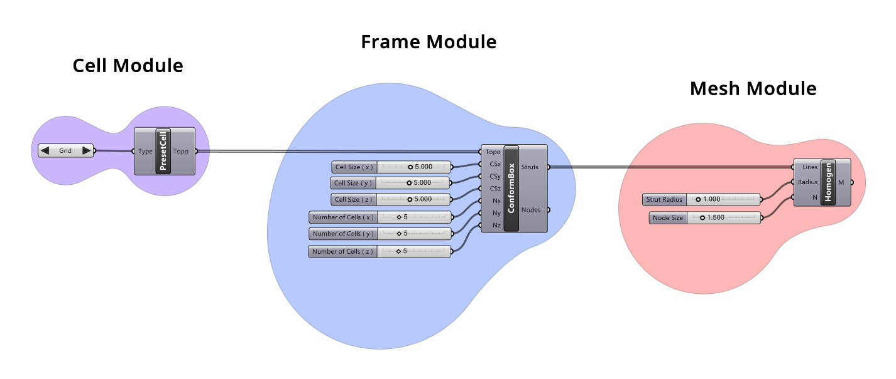

This

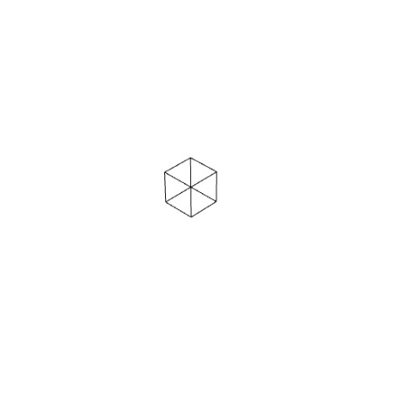 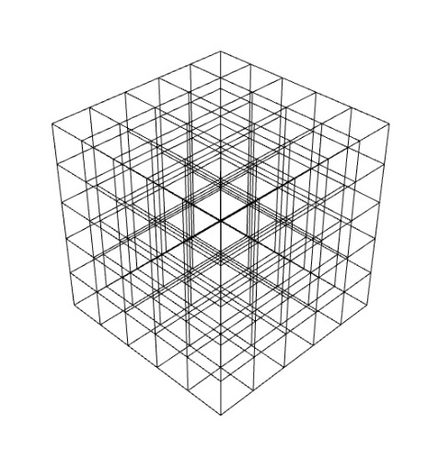 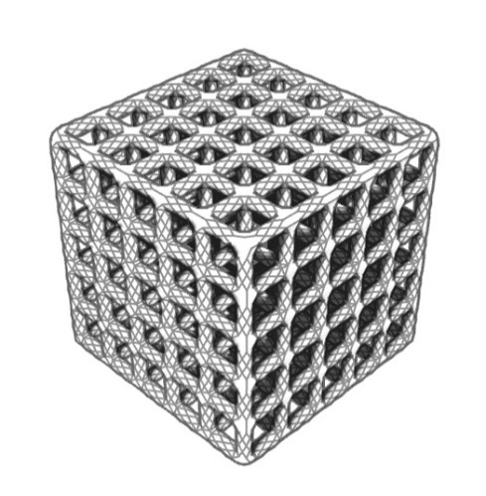

**3 - COMPONENTS**

**Preset Cell**

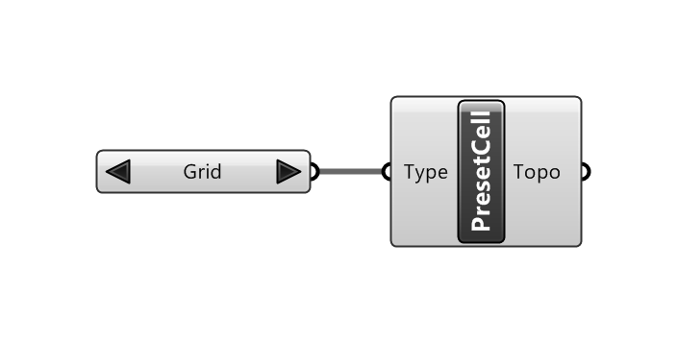

Inputs

**Type :**

Outputs

**Topo :**

Example

**Custom Cell**

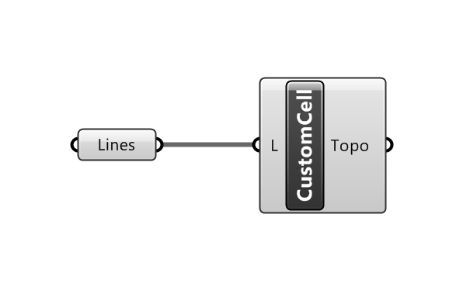

**Conform Box**

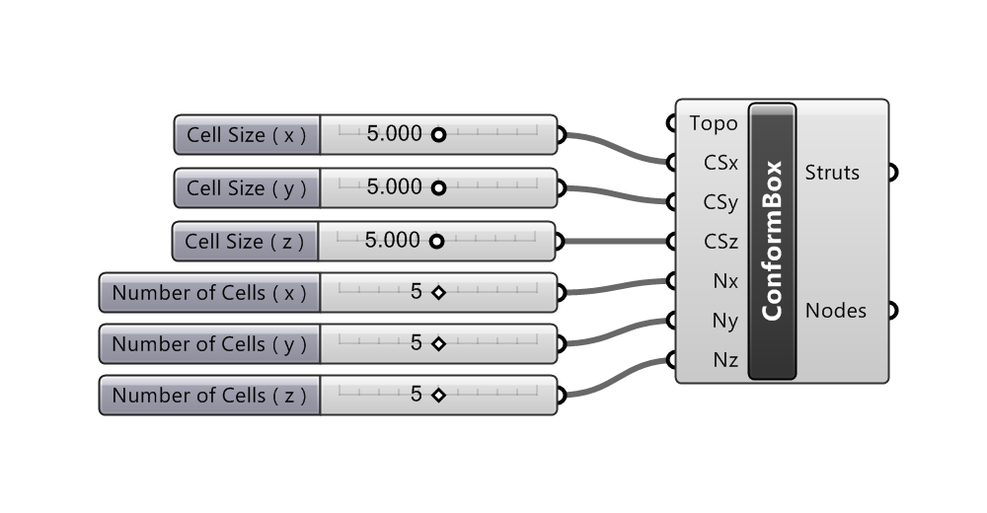

**Conform Cylinder**

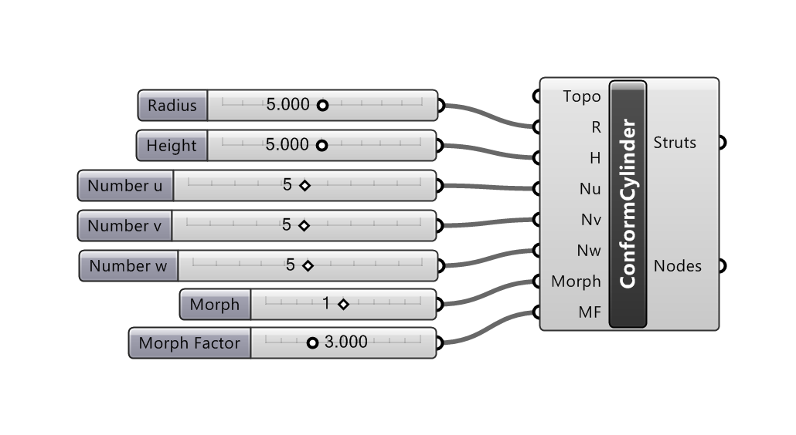

**Conform Surface-Surface**

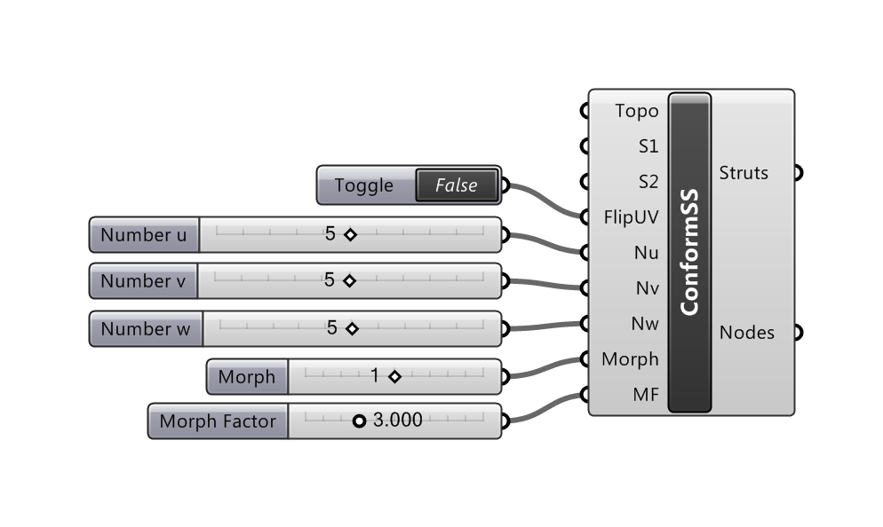

**Conform Surface-Axis**

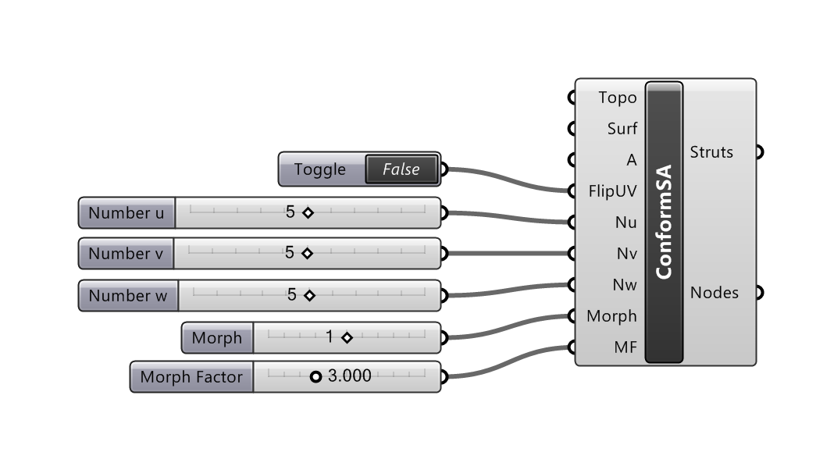

**Conform Surface-Point**

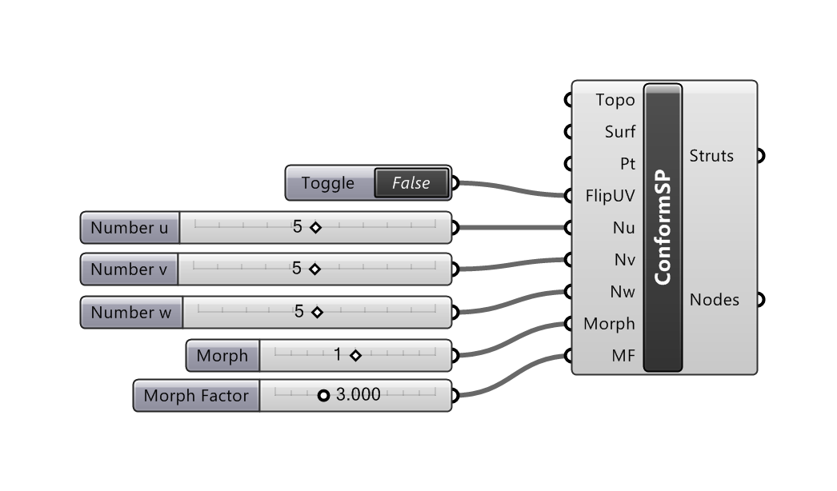

**Uniform in Design Space**

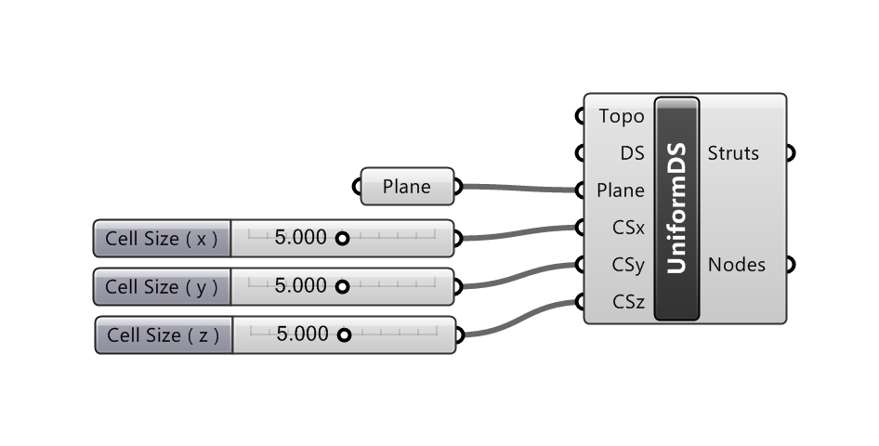

**Homogeneous**

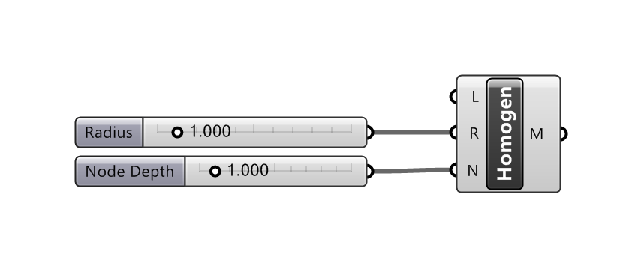

**Heterogeneous Gradient**

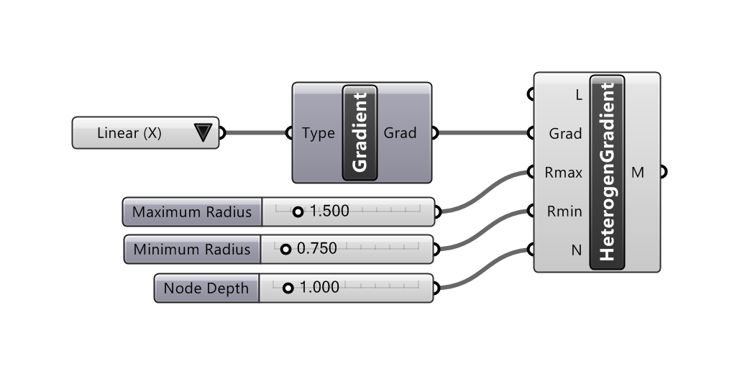

**Heterogeneous Custom**

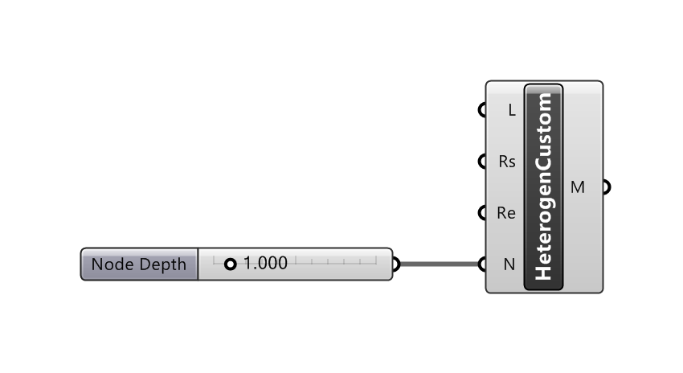

**View Report**

