Suffolk County Carceral Budgeting

# Introduction

The goal of this project was to find how much is spent on incarceration in Suffolk County MA from 2016-2019 using only publicly available data and to use this sum to calculate a cost per case tried by the Suffolk County District Attorney’s office.

The incarceration system in Suffolk County consists of 17 different government agencies: 13 within the state government and 4 municipal police departments. The state agencies are the State Police, Suffolk County Sheriff’s Department, Department of Correction, Trial Court, Public Counsel Services, Suffolk County District Attorney, Massachusetts Bay Transit Authority Police, District Attorney Association, Sheriff’s Association, Parole Board, Municipal State Police Training Committee, Appeals Court, and Supreme Judicial Court. The municipal police departments are the Boston Police, Chelsea Police, Revere Police, and Winthrop Police.

Finding the full spending on incarceration is more complex than just adding the stated yearly spending on each agency as there are several “hidden costs” that show up in other parts of the budget. The stated yearly spending for each agency that goes towards things like payroll, office rentals, technology costs are just part of the total cost of running each agency. There are 3 hidden costs that are calculated for each agency and added to the total: pension costs, fringe benefit costs, and capital costs. Additionally, for the Boston and Chelsea police departments there are spending datasets that include additional payroll paid out to employees, which constitutes another hidden cost. A breakdown of all these costs is detailed in the “Cost Types Section.”

Once the full cost of the system is calculated, finding the cost per case per year is quite simple.

Because this project looks exclusively at Suffolk County, the total cost of the statewide agencies isn’t used. Instead, a calculation is used to estimate the % of total statewide spending that is spent within Suffolk County. The methodology to develop these calculations is detailed in the “Statewide to Suffolk Correction” section.

This project doesn’t count federal money spent on incarceration, the methodology to remove those dollars is detailed in the “Removing Federal Money” section.

The final section details the various instances of missing data and how they were addressed if possible.

# 

# Data Sources

### cthru

cthru is a site run by the MA comptroller’s oﬀice that hosts datasets related to the state budget. It has a functioning API and good documentation for each dataset. The three datasets used from cthru are [yearly expenditures](https://cthru.data.socrata.com/dataset/Comptroller-of-the-Commonwealth-Spending/pegc-naaa), [yearly payroll](http://cthrupayroll.mass.gov/#!/year/2020/), and [retirement benefits](https://www.macomptroller.org/cthru-msers). Expenditures are by fiscal year, payroll and retirement benefits are by calendar year. Data was collected using the API.

### Budget PDFs

Each municipality in Suffolk County publishes its yearly budget as a pdf on its website. These budgets generally have the planned spending the current year and actual expenditures for previous years. These budgets are all by fiscal year. Most data from these budget pdfs was scraped using optical character recognition with the textract library in python with some data filled in manually.

* [Boston Budget PDFs](https://www.boston.gov/departments/budget)
* [Chelsea Budget PDFs](https://www.chelseama.gov/city-auditor/pages/financial-documents-reports)
* [Revere Budget PDFs](https://www.revere.org/departments/auditor)
* [Winthrop's Budget PDFs](https://www.town.winthrop.ma.us/town-managers-office/pages/previous-years-budgets)

### Employee Earnings Datasets

Both [Boston](https://data.boston.gov/dataset/employee-earnings-report) and [Chelsea](https://chelseama.payroll.socrata.com/#!/year/2021/full_time_employees,others/pay1,pay2,pay3/explore/1-0/segment2?x-return-url=https:%2F%2Fchelseama.finance.socrata.com%2F%23!%2Fdashboard&x-return-description=Return%20to%20Open%20Finance) publish earnings datasets on their websites. These are downloaded as .csv files. They are organized by calendar year.

### MBTA Payroll Data

The [MBTA’s site](https://www.mbta.com/financials/mbta-budget) has yearly payroll data which fills in some gaps where payroll data for MBTA is missing from cthru.

### mass.gov

This site has [trial court statistics](https://www.mass.gov/court-data-metrics-reports) used to calculate % of total resources trial court spends on Suffolk County. It also has data on [DOC admissions](https://www.mass.gov/lists/admissions-and-releases) used to calculate the % of total resources that the statewide DOC spends on Suffolk County.

### American Community Survey

The American Community Survey was used to find the population per year of Suffolk County and the state of Massachusetts for the population correction.

# Results

### Costs by Agency

Of the 17 agencies analyzed, the Boston PD is by far the most costly in the county.

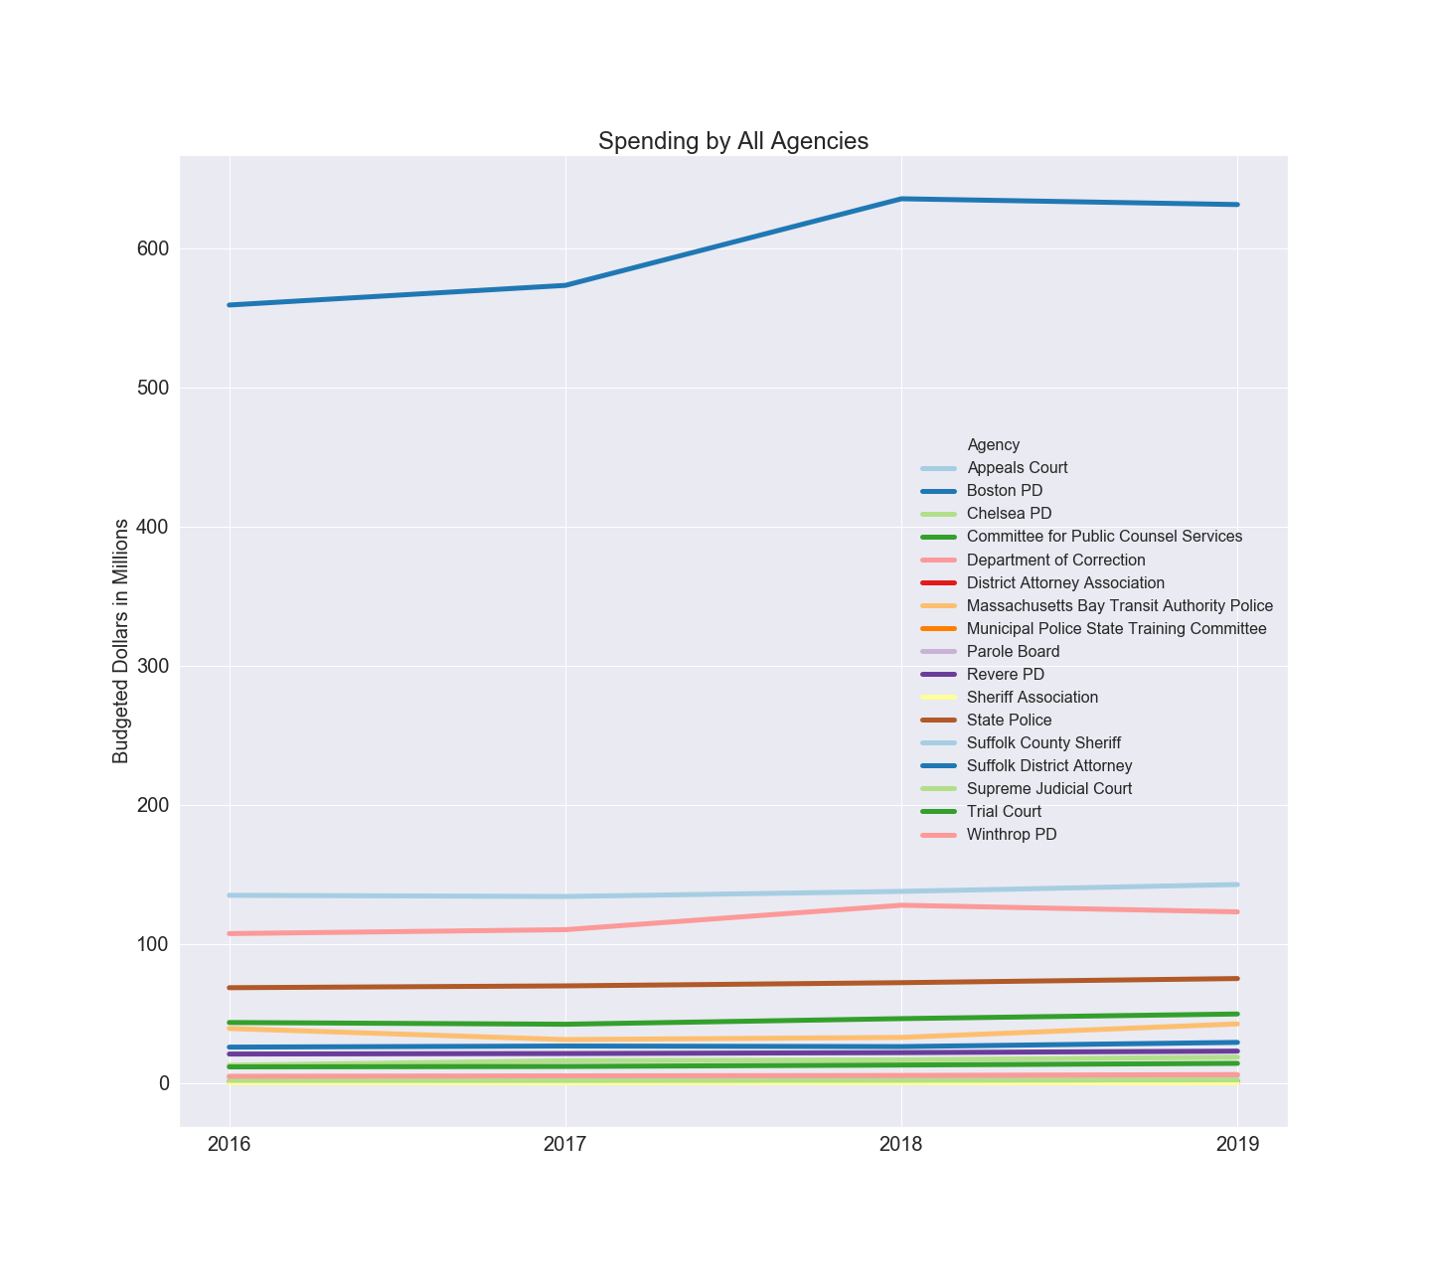

Overall Spending by Year

|  |  |  |  |
| --- | --- | --- | --- |
| 2016 | 2017 | 2018 | 2019 |
| 1036342355 | 1049105052 | 1143981015 | 1164300327 |

### 

### Costs by Cost Type

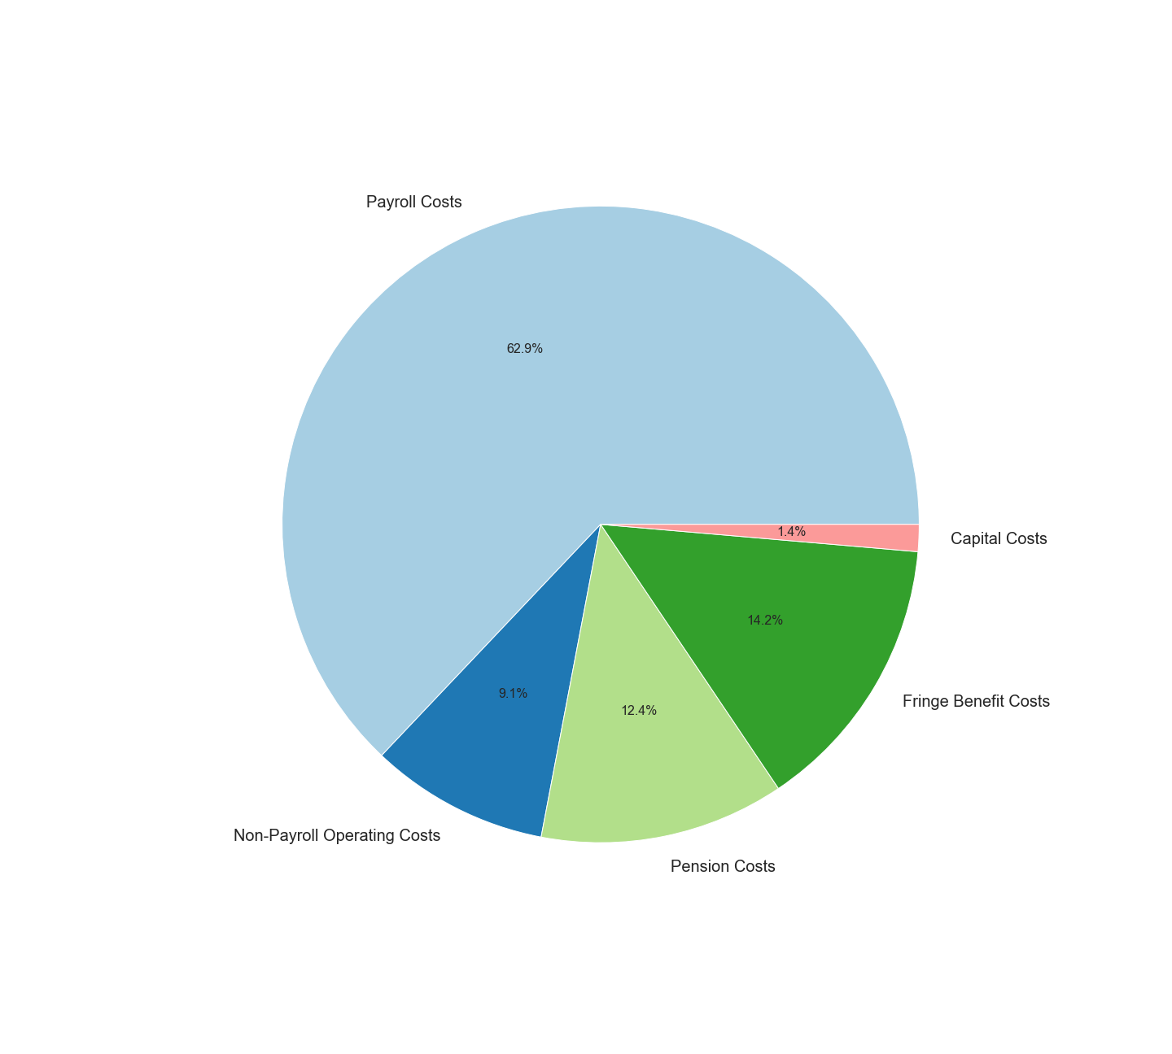

### 

### 

### Cost per Case

This plot is created using SCDAO internal data on number of prosecutions per year.

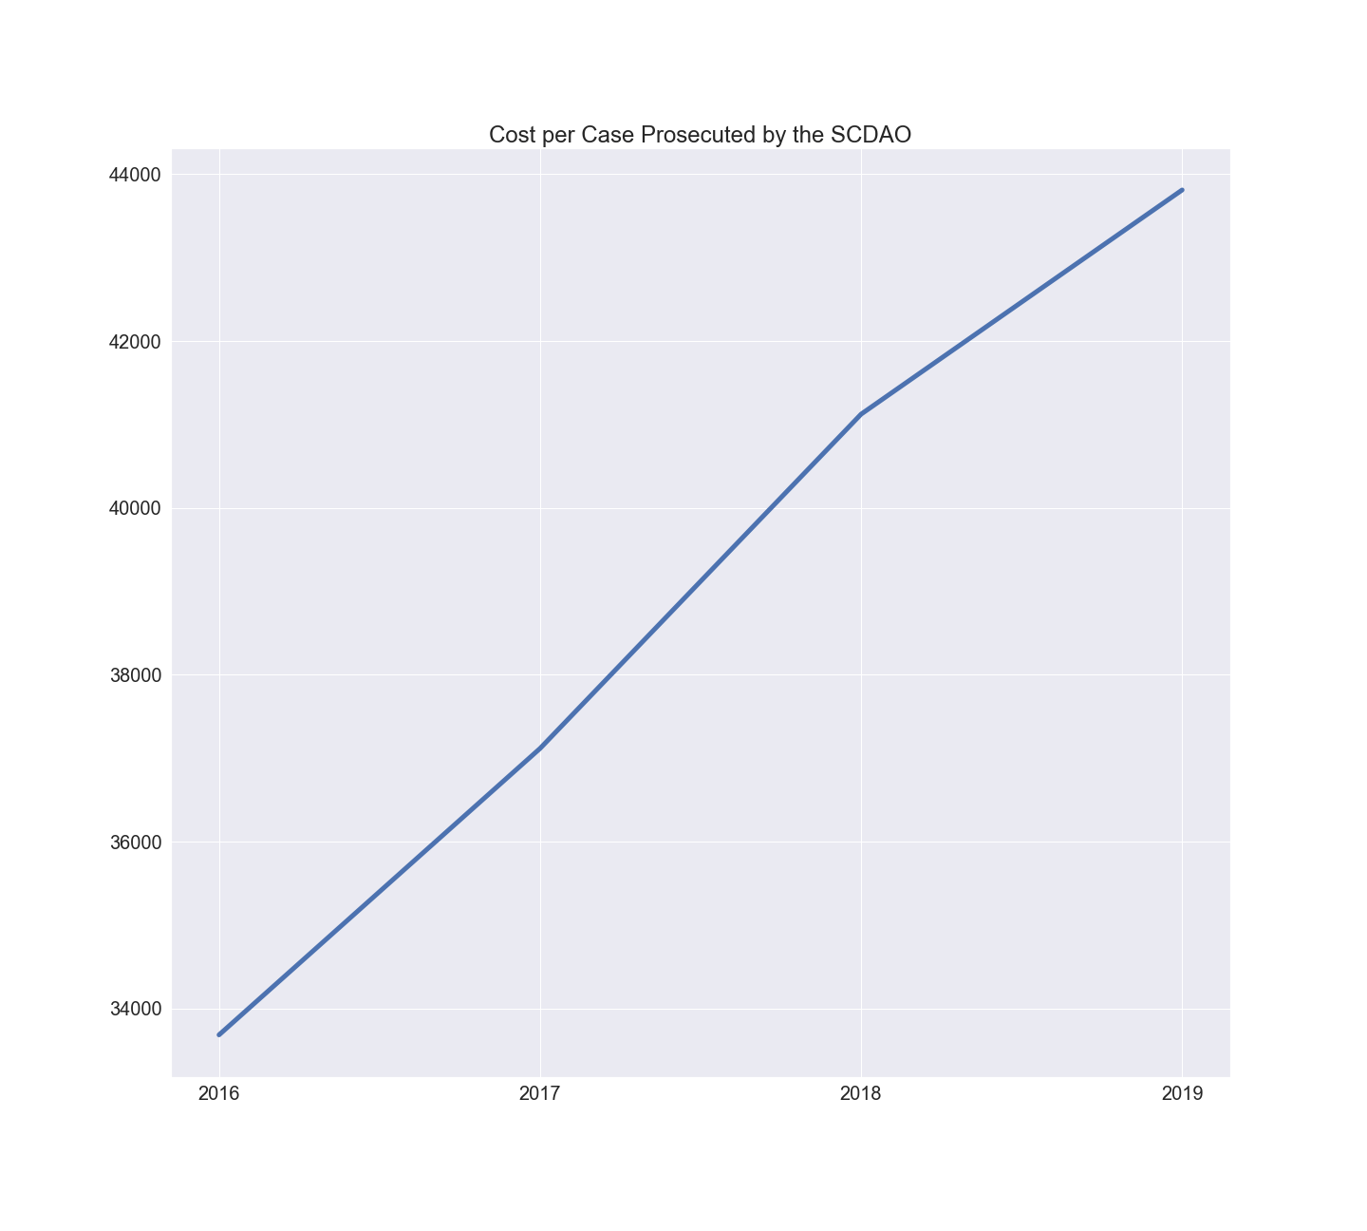

Cost Per Case

|  |  |  |  |
| --- | --- | --- | --- |
| **2016** | **2017** | **2018** | **2019** |
| 33686 | 37118 | 41124 | 43810 |

# Methodology

## Cost Types

### Yearly Operating Costs (Payroll and Non-Payroll Operating)

For the state agencies, the [cthru dataset on yearly expenditures](https://cthru.data.socrata.com/dataset/Comptroller-of-the-Commonwealth-Spending/pegc-naaa) is used. These numbers are organized by fiscal year. The payroll costs are all line-items whose object code begins with “A”, and the non-payroll costs are everything else.

For the Boston PD, yearly payroll is found from <https://data.boston.gov/dataset/employee-earnings-report>. The non-payroll yearly operating costs are found in the public safety documents from <https://www.boston.gov/departments/budget>. The total non-payroll operating costs are calculated as the total operating costs (“Actual” number under the “Grand Total” line-item on the “Department History” page) minus the total payroll (“Total Personnel Services” line-item on the “Department History” page).

For the Chelsea PD, yearly payroll is found from the [Open Finances Page](https://chelseama.payroll.socrata.com/#!/year/2021/full_time_employees,others/pay1,pay2,pay3/explore/1-0/segment2?x-return-url=https:%2F%2Fchelseama.finance.socrata.com%2F%23!%2Fdashboard&x-return-description=Return%20to%20Open%20Finance), except for 2016 where it is taken from the 2020 yearly budget pdf found on [Chelsea Financial Reports](https://www.chelseama.gov/city-auditor/pages/financial-documents-reports) page. Total non-payroll operating costs taken from “Budget” columns the “Operations and Maintenance” line-items in the 2020 and 2021 budget pdf’s.

For the Revere PD, all data is from budget pdf’s found at <https://www.revere.org/departments/auditor>. The section titled “Total Department Expenses” has an “Adopted” column which is used as spending on payroll and non-payroll.

For the Winthrop PD, all data is from budget pdf’s found on [Winthrop's Site](https://www.town.winthrop.ma.us/town-managers-office/pages/previous-years-budgets). For each year the payroll expenditures are found on the “Sub-Total Personnel Services” line item under the “Actual” column, and yearly non-payroll operating expenses are calculated as the total department expenditures minus the payroll expenditures.

### Pension Costs

Calculating pension costs for a particular agency involves several steps. In a given year the government is responsible for making contributions to each pension fund it manages, and the goal is the estimate the % of those contributions that are “due to” employees in the relevant agency. The methodology to achieve this is slightly different at the state and municipal levels

At the state level, the Office of the State Treasurer is responsible for paying the yearly employer contributions under the appropriation name “State Retirement BD Commonwealth Pension.” To find the % of this yearly contribution that is attributed to each agency a second dataset of [yearly pension payouts](http://cthrupensions.mass.gov/) is used. The % of the total contribution that is assigned to each agency as “pension costs” is the % of the total pension payouts that go to former employees of that agency.

At the municipal level, the budget documents linked above have the city’s yearly contribution to the citywide pension funds. However, there is no publicly available data on where the retirement payouts go, so instead the % of total city payroll is used. But teachers statewide participate in a state-run pension system, so the calculation is done as the police payroll as a % of *non-teacher* payroll.

### Fringe Benefit Costs

This cost type includes all spending on the following employee benefits: health insurance, life insurance, worker’s comp, and unemployment insurance. None of the agencies analyzed list these costs under their own spending. These benefits are not broken by employee either, so the % of total spending on fringe benefits that is associated with each agency is estimated as % of total payroll that is dedicated to each agency.

For all state agencies, fringe benefits consist of health insurance premium spending from an agency called '[GROUP INSURANCE COMMISSION](https://www.mass.gov/orgs/group-insurance-commission).’ Because spending on health/life insurance from this agency is not broken down by department or employee, an estimation is used. The % of total payroll for each agency is calculated using total yearly payroll from the cthru payroll dataset.

For the Boston PD, the [2019 citywide summary budget](https://www.boston.gov/sites/default/files/embed/file/2019-04/v1_02-_19_a_summary-budget.pdf) and [2021 citywide operating budget](https://www.boston.gov/sites/default/files/file/2020/04/2-Volume%201%20-%20Operating%20Budget%20%281%29.pdf) have line-items for health insurance and a worker’s compensation fund. There is a line-item for unemployment insurance too but it doesn’t include any spending 2016-2019.

For the Chelsea PD, there is a single line-item for “Salaries, Wages and Benefits.” This entire line-item is categorized as “payroll” and fringe benefits are set to 0.

For the Revere PD, there is an “Unclassified” section under departments that has a single line-item for “Employee Benefits, Insurance.”

For the Winthrop PD, the following line-items are counted as fringe benefits: “Workers Comp”, “Unemployment”, “Group Insurance - Retirees”, “Group Insurance - Town”, “Police Fire Medical.”

### Capital Costs

This cost type refers to spending on longer-term capital projects.

At the state level, some of these costs are “hidden” in that they are paid through the ‘[CAPITAL ASSET MANAGEMENT AND MAINTENANCE DIVISION (DCP)](https://www.mass.gov/orgs/division-of-capital-asset-management-and-maintenance).’ Some of the capital costs are also paid through each individual agency’s spending with object code ‘(2CN) CAPITAL.’

Within the DCP, there are payments for “Court Facilities” that are assigned as Trial Court Spending, payments for “Jail” and “Correctional Facilities” spending that are assigned to Department of Correction, and “State Police” spending that is assigned to the State Police.

For Boston, Chelsea, and Winthrop, the yearly capital costs associated with the police departments are clearly laid out in the budget documents. For Revere there is only capital costs for a “Public Safety” division that includes police as well as other departments. The % of public safety capital costs that go to police is estimated as the % of the total public safety budget that goes to police.

## Statewide to Suffolk Correction

These corrections cover all statewide agencies included in the analysis.

### Trial Court Correction

This correction uses data from the [trial court metrics on mass.gov](https://www.mass.gov/info-details/trial-court-statistical-reports-and-dashboards#statistics-2014-2019-). There are two overlapping corrections that are applied here. The first is to estimate the % of trial court money that goes to prosecuting criminal cases, and the second is to estimate % of that money that goes to cases in Suffolk County.

Within the “Year End Summary of All Court Activity” documents there is a breakdown of how many of the total case filings are due to criminal matters. The fraction of case filings that are criminal are used as the fraction of total dollars that go to running criminal court. This document also provides the total criminal *cases* statewide under the sub-header “Criminal.” The number of these cases that occured within Suffolk is the sum of the total criminal cases in the Boston Municipal Court document, the total criminal defendants in Chelsea in the Total Filings by Court Location document, the Criminal Case Entries in Suffolk in the Civil and Criminal Cases Entered document under the “Superior Court Department” header, and the Adult Criminal, Delinquency, and Youthful Offender Juvenile Cases within Suffolk in the Total Filings by Court Location document under the Juvenile Court Department header. The fraction of criminal cases that occur in Suffolk County is used as the fraction of total dollars that go towards Suffolk County. The final correction is these two fractions multiplied together.

This correction is used for Trial Court, Public Counsel Services, and Supreme Judicial Court as these agencies operate within the court system and participate in both criminal and non-criminal cases.

### Appeals Court

The Appeals Court is the only agency within the court system that has seperate records on how many cases each year criminal. Data on the number of criminal panel decisions on the [Appeals Court Cases](https://www.mass.gov/service-details/appeals-court-case-statistics) on mass.gov was used to calculate the % of money spent on criminal cases out of total spending. There are no numbers on location specific enough to know if cases are in Suffolk County or not, so % of total cases in Suffolk County is estimated to be the same as Trial Court correction.

### DOC Correction

This correction uses [Department of Correction records on admissions and releases from mass.gov](https://www.mass.gov/lists/admissions-and-releases). Similarly to the trial court correction, there are two overlapping corrections for the % of population that is in on criminal cases and the % of new admits that are in on cases from Suffolk County.

Data on % of cases that are criminally sentenced is found in figure 1.2. Data on % of new “court commitments” (ie admits) that are booked on Suffolk County cases is found in figure 2.7.

This correction is used for the Department of Correction and Parole Board.

### Population

For the remaining statewide agencies there isn’t rigorous publicly available information on where within the state of Massachusetts they use their resources. So the estimation is used that the % of money spent in Suffolk County each year is equal to the % of the statewide population that lives in Suffolk County that year. Data is from the American Community Survey.

## Removing Federal Money

For statewide agencies, removing federal money is simple. All expenditures with an appropriations code that contains the term “FEDERAL” is excluded.

The Boston PD is the only municipal police department that explicitly states which of it’s dollars come from federal grants. Within the external funds section, it breaks down the money paid out yearly from each “external” source which are federal grants, private foundation money, and state/municipal dollars from funds earmarked for specific purposes. Along with federal money, a small amount of dollars from private foundations are also excluded.

## Missing Data

### Debt Service

Along with Capital Costs, “Debt Service” is where spending on expensive long-term projects like construction/renovations shows up with the budget records. Unfortunately at no level of government is the debt service broken down by agency or project well enough to determine how much of those dollars go towards the agencies examined here.

### 

### Missing Numbers from Municipal Budget Documents

There are missing expenditures for the Chelsea, Revere, and Winthrop police departments at various years:

1. Chelsea Total Expenditures 2016 not found, use Total Budget instead (less than 1% difference on net between the two the years we have data for 2017-2019)
2. Revere Total Expenditures 2019 not found, use total Budget instead (less than 1% on difference on net between the two years we have the data for 2016-2018
3. Winthrop Total Expenditures 2018 not found, use total budget instead (less than 1% difference between total budget and total expenditures for the one year we have both)

### DOC Pension Dollars Error

The data says there are 160 million dollars in pension costs paid out in 2020 but 6 through 11 million was paid out in the previous 9 years. This is assumed to be a book keeping error and the 2020 dollars were meant to spread out over some larger number of years. The dataset went back to 2011, so it seems most likely that the 160 million dollar 2020 payout was supposed to be spread out over 2011-2020. So for each year 2011-2020 the fraction of total money paid in that year is calculated, and the lump sum is distributed according to that fraction. Even with this correction, the DOC pensions are surprisingly low. The DOC is an agency with a 130% larger budget than the state police but about 30% lower total retirement payouts.

### Lack of Transparency for MBTA Police

There is a great deal of missing data for MBTA Police due to it being the only agency in the analysis that is not a separate agency as defined within the state/municipal government. The MBTA police is technically a department within the MBTA, and so it’s yearly expenditures aren’t clearly laid out in cthru (it’s lumped in with the entire MBTA). Cthru has a separate dataset of payroll expenditures that include employee title, so the payroll for the police within the MBTA can be separated from the total payroll. This data doesn’t cover all years, so for data on payroll from the [MBTA’s site](https://www.mbta.com/financials/mbta-budget) is used to calculate total payroll for 2016 and 2017. For 2016 the 2015 numbers are used as data for 2016 is missing.

### Settlements/Payouts

Data on settlements and judgement paid out for Boston police misconduct could not be found. Cthru has data on settlements/judgements paid out due to lawsuits but without the Boston Police Department settlements numbers this section is incomplete so it isn’t included in the final report.