**19BCE2484**

**Sashank Rijal**

**DSA**

1. **Convert the following infix expression to postfix:**

**CODE:**

#include<stdio.h>

#include<ctype.h>

#include<stdlib.h>

#include<string.h>

#define SIZE 100

char stack[SIZE];

int top = -1;

void push(char item)

{

if (top >= SIZE - 1)

{

printf("\nStack Overflow.");

}

else

{

top = top + 1;

stack[top] = item;

}

}

char pop()

{

char item;

if (top < 0)

{

printf("stack under flow: invalid infix expression");

getchar();

exit(1);

}

else

{

item = stack[top];

top = top - 1;

return(item);

}

int is_operator(char symbol)

{

if (symbol == '^' || symbol == '*' || symbol == '/' || symbol == '+' || symbol == '-')

{

return 1;

}

else

{

return 0;

}

int precedence(char symbol)

{

if (symbol == '^')

{

return(3);

}

else if (symbol == '*' || symbol == '/')

{

return(2);

}

else if (symbol == '+' || symbol == '-')

{

return(1);

}

else

{

return(0);

}

}

void InfixToPostfix(char infix_exp[], char postfix_exp[])

{

int i, j;

char item;

char x;

push('(');

strcat(infix_exp, ")");

i = 0;

j = 0;

item = infix_exp[i];

while (item != '\0')

{

if (item == '(')

{

push(item);

}

else if (isdigit(item) || isalpha(item))

{

postfix_exp[j] = item;

j++;

}

else if (is_operator(item) == 1)

{

x = pop();

while (is_operator(x) == 1 && precedence(x) >= precedence(item))

{

postfix_exp[j] = x;

j++;

x = pop();

}

push(x);

push(item);

}

else if (item == ')')

{

x = pop();

while (x != '(')

{

postfix_exp[j] = x;

j++;

x = pop();

}

}

else

{

printf("\nInvalid infix Expression.\n");

getchar();

exit(1);

}

i++;

item = infix_exp[i];

}

if (top > 0)

{

printf("\nInvalid infix Expression.\n");

getchar();

exit(1);

}

if (top > 0)

{

printf("\nInvalid infix Expression.\n");

getchar();

exit(1);

}

postfix_exp[j] = '\0';

}

int main()

{

char infix[SIZE], postfix[SIZE];

printf("\nEnter Infix expression : ");

gets(infix);

InfixToPostfix(infix, postfix);

printf("Postfix Expression: ");

puts(postfix);

return 0;

}

1. **(X/Y + U * (V-W)):**

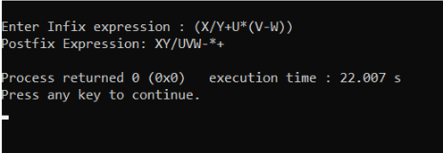

1. **((A + B ^ C) * D + E ^ F):**

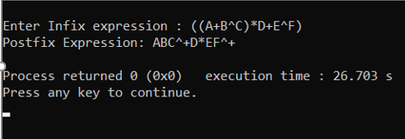

1. **Evaluate the following postfix expression:**

**CODE:**

#include<stdio.h>

int stack[20];

int top = -1;

void push(int x)

{

stack[++top] = x;

}

int pop()

{

return stack[top--];

}

int main()

{

char exp[20];

char *e;

int n1,n2,n3,num;

printf("Enter the expression :: ");

scanf("%s",exp);

e = exp;

while(*e != '\0')

{

if(isdigit(*e))

{

num = *e - 48;

push(num);

}

else

{

n1 = pop();

n2 = pop();

switch(*e)

{

case '+':

{

n3 = n1 + n2;

break;

}

case '-':

{

n3 = n2 - n1;

break;

}

case '*':

{

n3 = n1 * n2;

break;

}

case '/':

{

n3 = n2 / n1;

break;

}

}

push(n3);

}

e++;

}

printf("\nThe result of expression %s = %d\n\n",exp,pop());

return 0;

}

Expression : 15 2 3 / 4 3 2 ^ * - 15 + 10 * +

**OUTPUT:**

