**LAB ASSESSMENT-1**

**SLOT: L33-L34**

**CSE 2003: Data Structures and Algorithms**

*Submitted By: Submitted to:*

*Sashank Rijal Annapurna Jonnalagadda*

*19BCE2484*

Q1

Algorithm:

Pseudo code:

Code:

#include <stdio.h>

#include <string.h>

void main()

{

char str[1000];

int flag=0;

printf("Enter the string: ");

scanf("%s",&str);

int len = strlen(str);

int i;

if(len%2!=0)

{

printf("This string does not satisfy the given pattern");

exit(0);

}

for(i=0;i<len;i++)

{

if(i<len/2)

{if (str[i]!='a')

flag++;

}

else

{if (str[i]!='b')

flag++;

}

}

if(flag==0)

{

printf("This string satisfies the given pattern");

}

else

printf("This string does not satisfy the given pattern");

}

Output:

Test case 1:

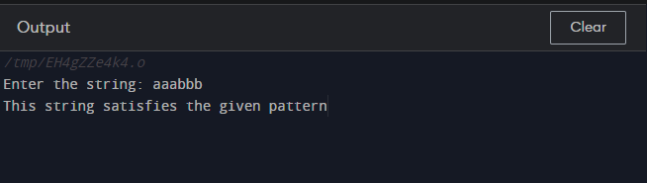

Test case 2:

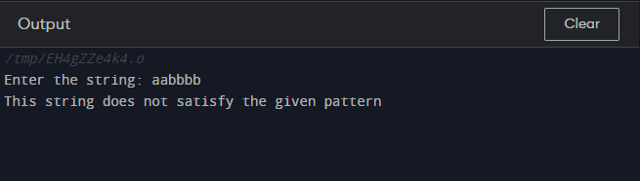

Test case 3:

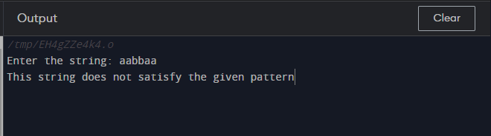

Test case 4:

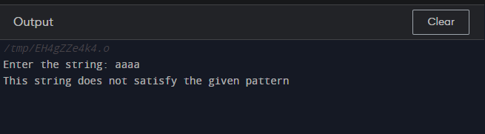

Q2:

Code: