**19BCE2484**

**Sashank Rijal**

**Matrix Multiplication**

**Code:**

#include <stdio.h>

int main()

{

int m, n, p, q, a, b, z, sum = 0;

int first[10][10], second[10][10], multiply[10][10];

printf("Enter number of rows and columns of first matrix\n");

scanf("%d%d", &m, &n);

printf("Enter elements of first matrix\n");

for (a = 0; a < m; a++)

for (b = 0; b < n; b++)

scanf("%d", &first[a][b]);

printf("Enter number of rows and columns of second matrix\n");

scanf("%d%d", &p, &q);

if (n != p)

printf("The multiplication isn't possible.\n");

else

{

printf("Enter elements of second matrix\n");

for (a = 0; a < p; a++)

for (b = 0; b < q; b++)

scanf("%d", &second[a][b]);

for (a = 0; a < m; a++) {

for (b = 0; b < q; b++) {

for (z = 0; z < p; z++) {

sum = sum + first[a][z] * second[z][b];

}

multiply[a][b] = sum;

sum = 0;

}

}

printf("Product of the matrices:\n");

for (a = 0; a < m; a++) {

for (b = 0; b < q; b++)

printf("%d\t", multiply[a][b]);

printf("\n");

}

}

return 0;

}

**Output:**

Testcase 1:

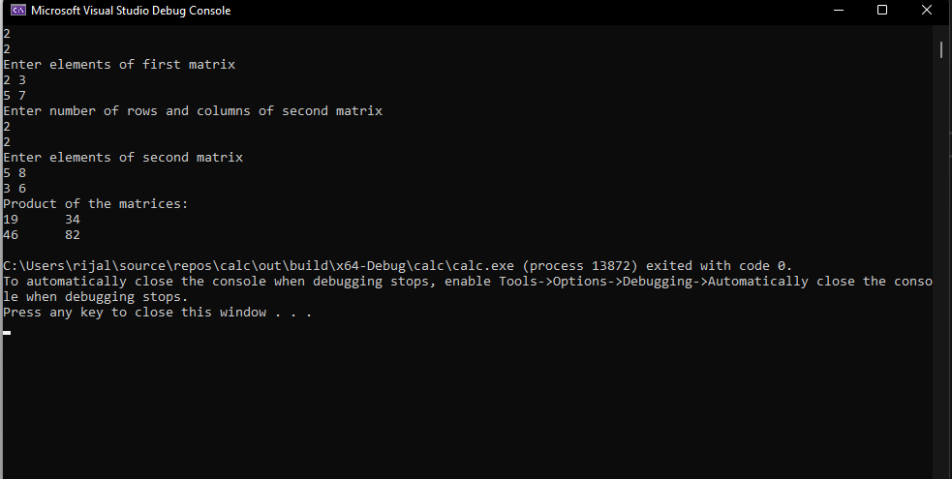

Test case 2:

