**19BCE2484**

**Sashank Rijal**

**Code:**

#include <iostream>

using namespace std;

int stack[100], x = 100, top = -1;

void push(int val) {

if (top >= x - 1)

cout << "Stack Overflow" << endl;

else {

top++;

stack[top] = val;

}

}

void pop() {

if (top <= -1)

cout << "Stack Underflow" << endl;

else {

cout << "The popped element is " << stack[top] << endl;

top--;

}

}

void display() {

if (top >= 0) {

cout << "The Stack elements are:";

for (int i = top; i >= 0; i--)

cout << stack[i] << " ";

cout << endl;

}

else

cout << "The Stack is empty";

}

int main() {

int n, val;

cout << "1. Push to stack" << endl;

cout << "2. Pop from stack" << endl;

cout << "3. Display stack" << endl;

cout << "4. Exit" << endl;

do {

cout << "Enter choice: " << endl;

cin >> n;

switch (n) {

case 1: {

cout << "Enter value to push:" << endl;

cin >> val;

push(val);

break;

}

case 2: {

pop();

break;

}

case 3: {

display();

break;

}

case 4: {

cout << "Exit" << endl;

break;

}

default: {

cout << "Invalid Input" << endl;

}

}

} while (n != 4);

return 0;

}

**Output:**

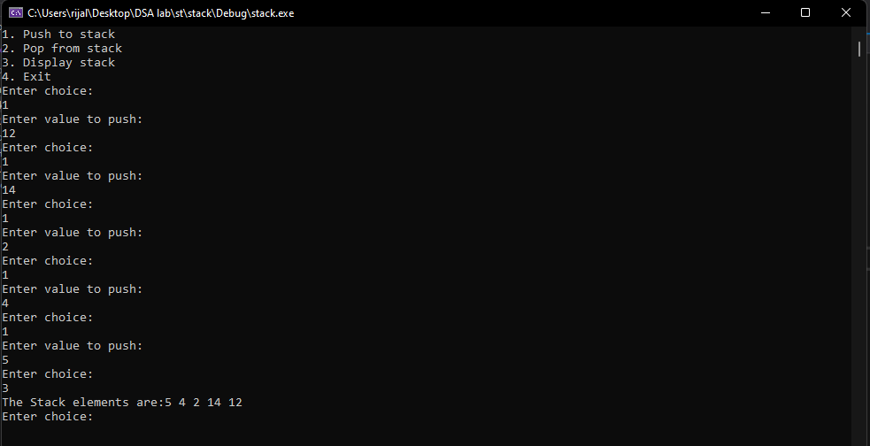**Push to and Display Stack:**

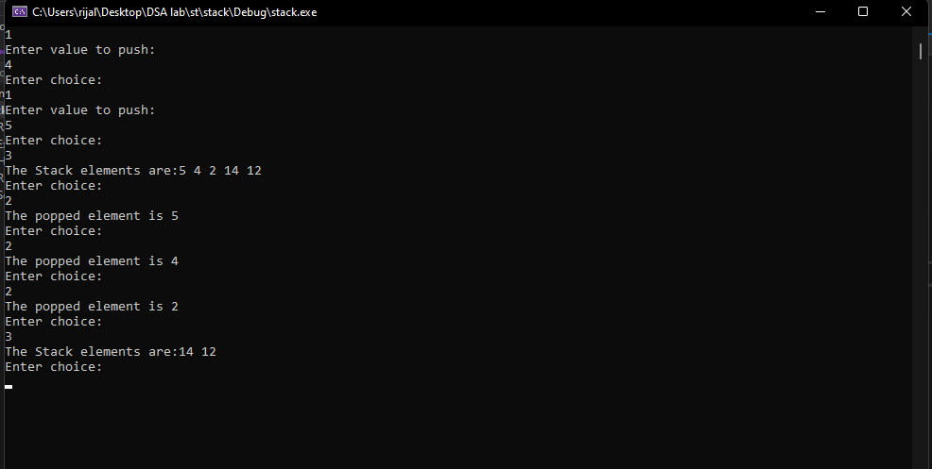**Pop and Display Stack:**