**LAB ASSESSMENT-1**

**SLOT: L49-L50**

**CSE 3502: INFORMATION SECURITY MANAGEMENT**

*Submitted By: Submitted to:*

*Sashank Rijal Vimala Devi K.*

*19BCE2484*

**Experiment1: CONNECTING TWO VLANS BY SWITCHES**

**Aim:**

The goal of this project is to use switches to join two LANS.

**Procedure:**

**STEP 1: PC/ Computer Configuration:**

PC1 : 192.168.1.1

PC2 : 192.168.1.2

PC3 : 192.168.1.3

PC4 : 192.168.1.4

**STEP 2: Switch 1 Configuration:**

switch>en

switch>conf t

switch (config)# interfce vlan1

switch (config-if)# ip address 10.0.0.1 255.0.0.0

switch (config-if)# no shut

#exit

**STEP 3: Switch 2 configuration:**

switch>en

switch>conf t

switch (config)# interfce vlan2

switch (config-if) # ip address 10.0.0.2 255.0.0.0

switch (config-if)# no shut

#exit

**CLI:**

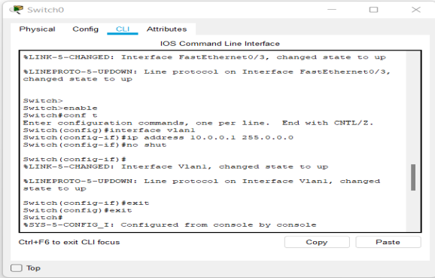

**Design:**

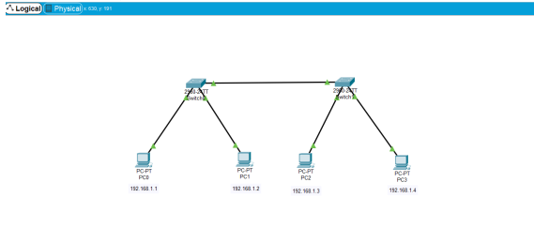

**Simulation and Result:**

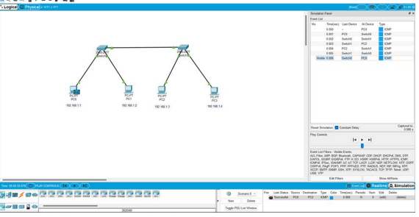

**Conclusion:**

We may deduce from the above simulation and outcome that there is a switch connection between two LANs.

**Experiment 2: CONNECTING TWO NETWORKS USING A ROUTER.**

**Aim:**

The goal of the experiment is to use a Router to link two networks.

**Procedure:**

**STEP 1: Router Configuration:**

Router>en

Router>enable

Router>conf

Router (config) #interface gigabitEthernet 0/0

Router (config-if) #ip address 192.168.1.1 255.255.255.0

Router (config-if) #no shutdown

Router (config-if) #exit

Router (config) #interface gigabitEthernet 0/1

Router (config-if) #ip address 192.168.2.1 255.255.255.0

Router (config-if) #no shutdown

**STEP 2: PC Configuration:**

Give addresses for Pcs in Network1 as: 192.168.1.11 to 192.168.1.13

Give addresses for Pcs in Network2 as: 192.168.2.11 to 192.168.2.13

Set default gateway for the leftside network as 192.168.1.1

Set default gateway for the leftside network as 192.168.2.1 edure:

**CLI:**

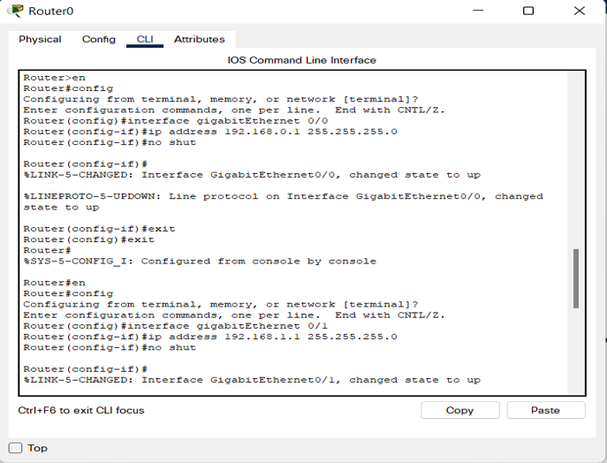

**Design:**

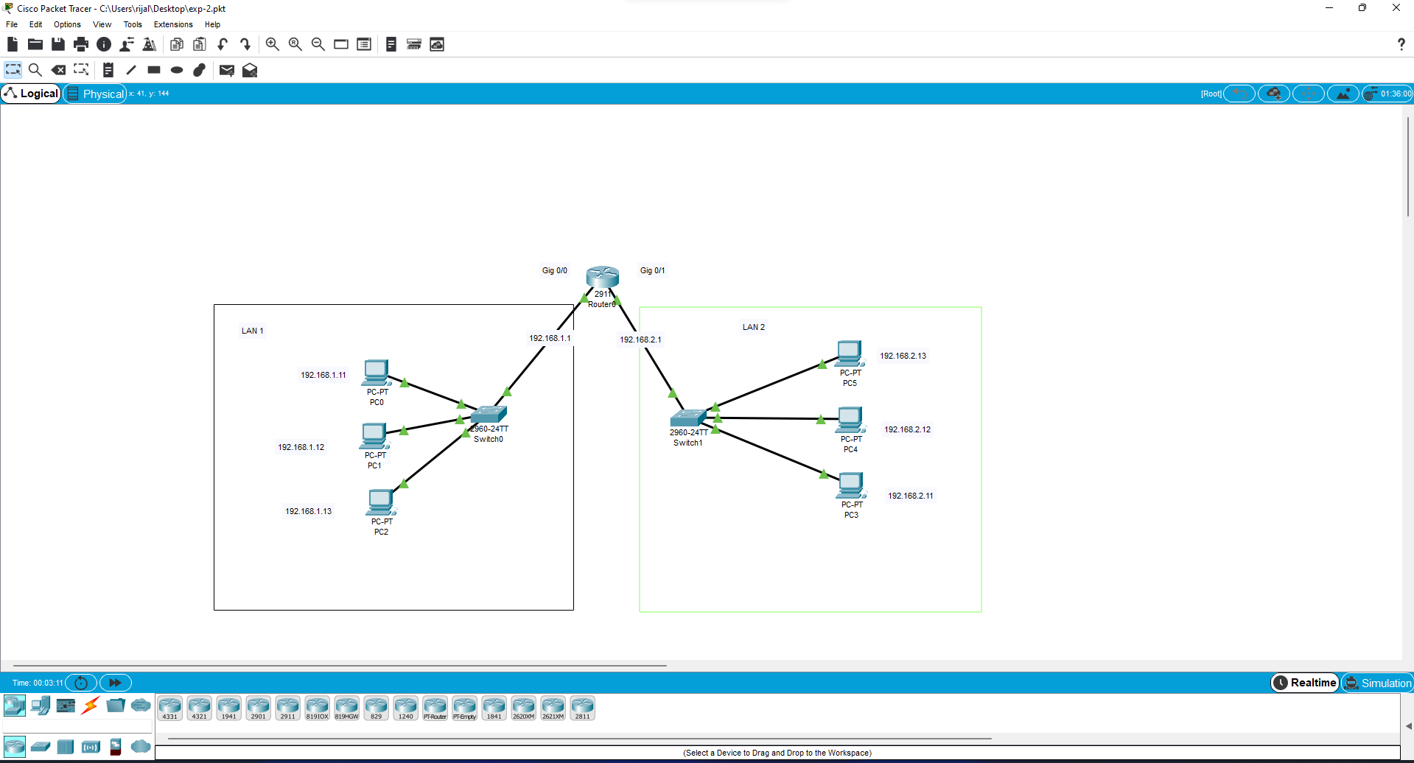

**Simulation and Result:**

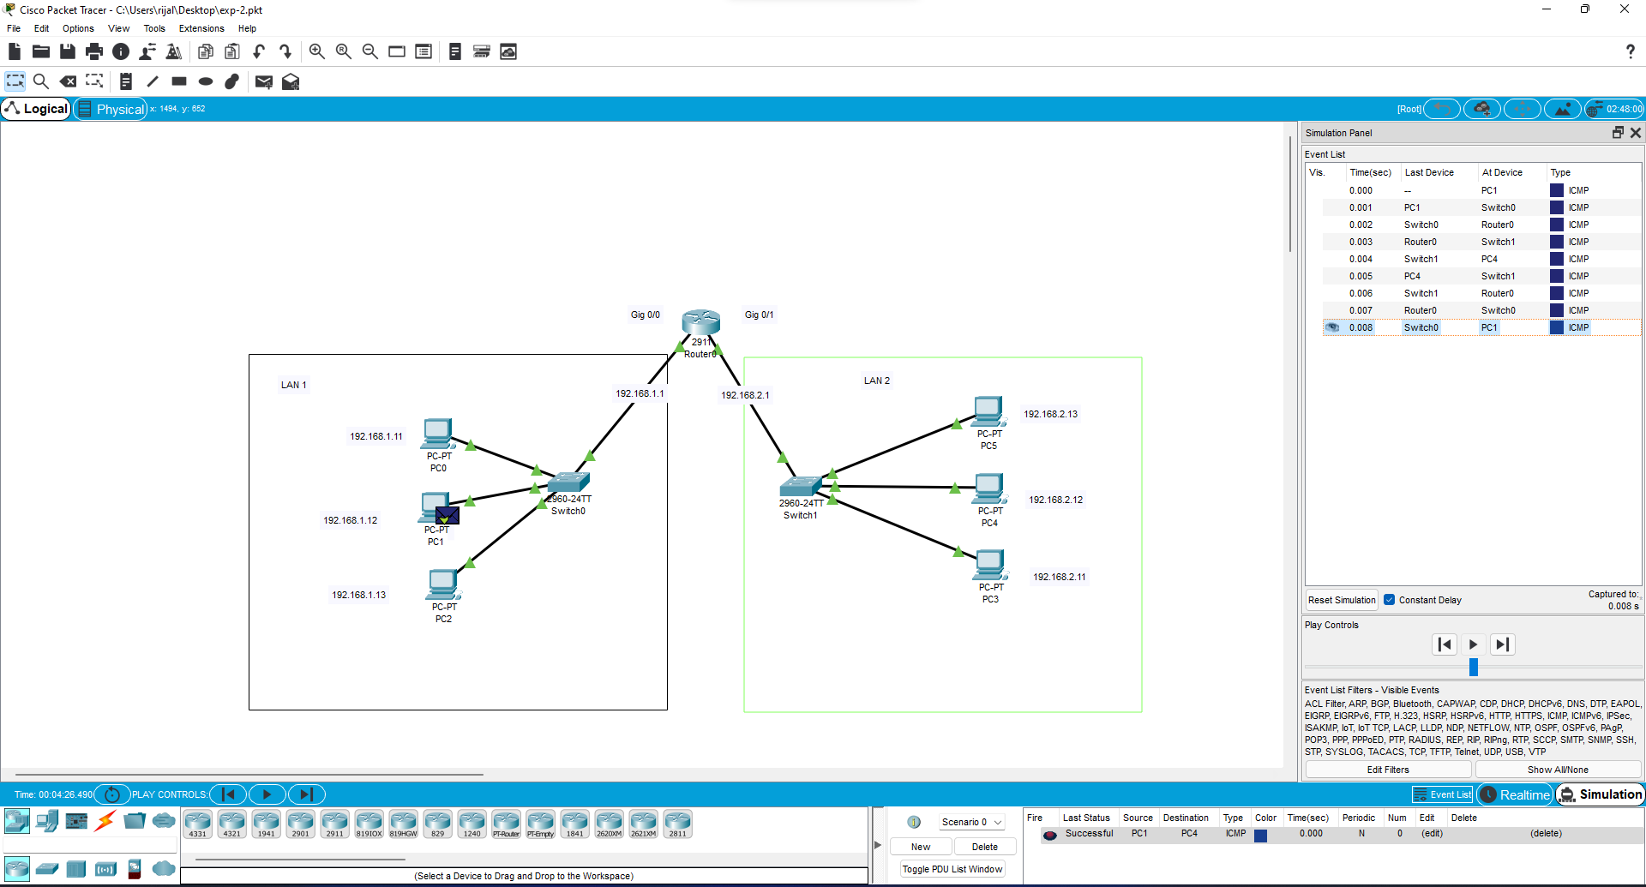

**Conclusion:**

We may deduce from the above simulation and result that there is a Router link between two networks.