**LAB ASSESSMENT-2**

**SLOT: L49-L50**

**CSE 3502: INFORMATION SECURITY MANAGEMENT**

*Submitted By: Submitted to:*

*Sashank Rijal Vimala Devi K.*

*19BCE2484*

**Experiment 1 Firewall Configuration:**

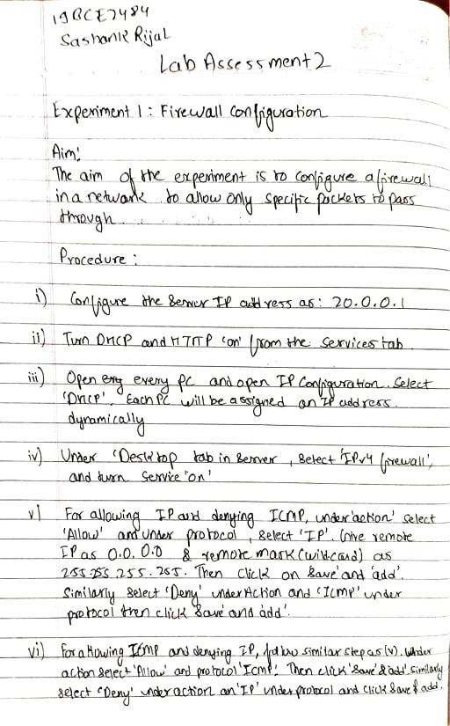

**Network Design:**

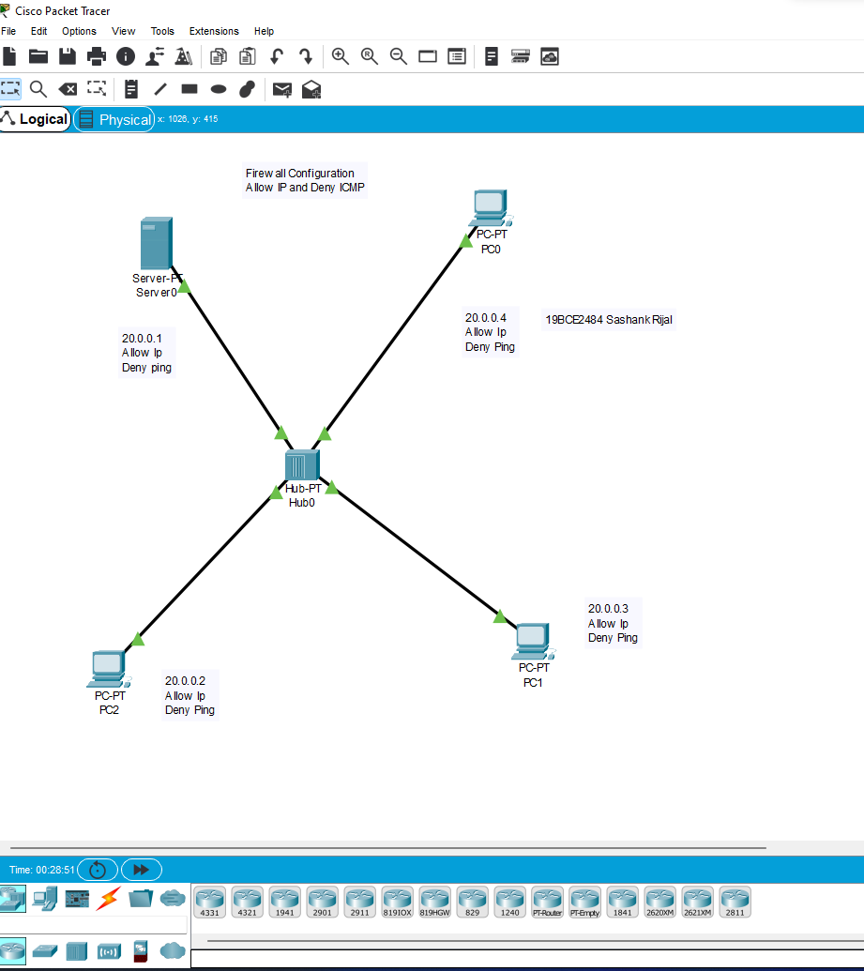

**Configuring Server:**

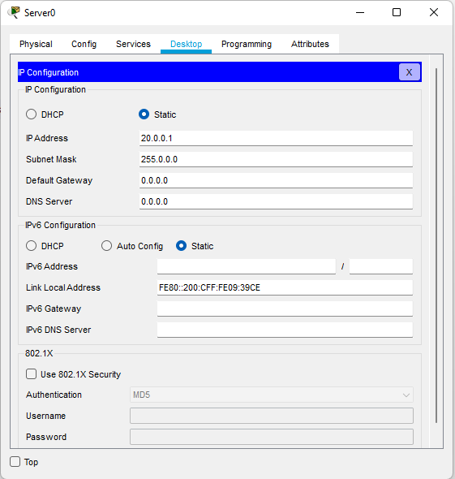

**Enabling DHCP and HTTP:**

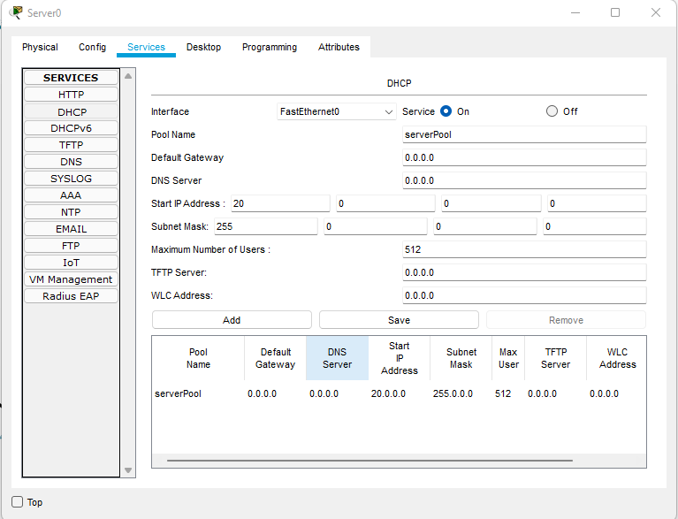

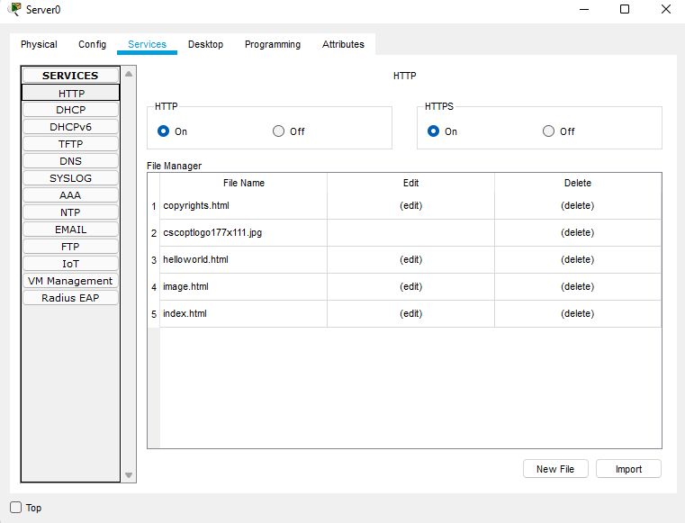

**Allowing IP and Denying ICMP:**

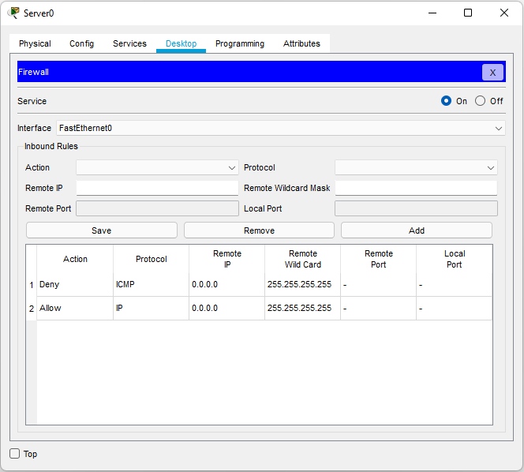

**Ip configuration using DHCP:**

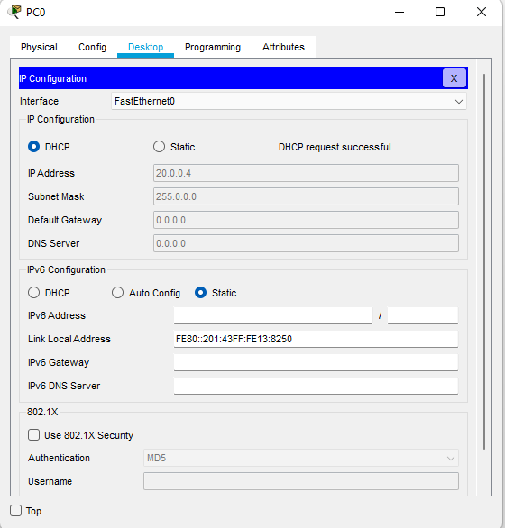

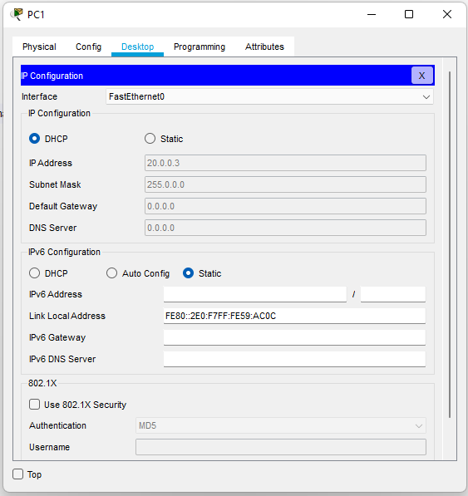

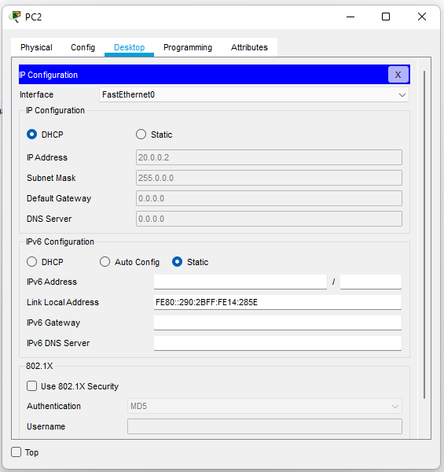

**Denying ICMP:**

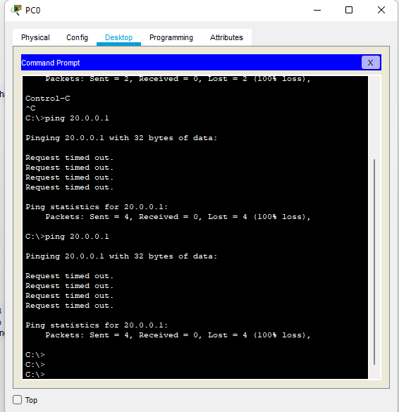

**Allowing IP:**

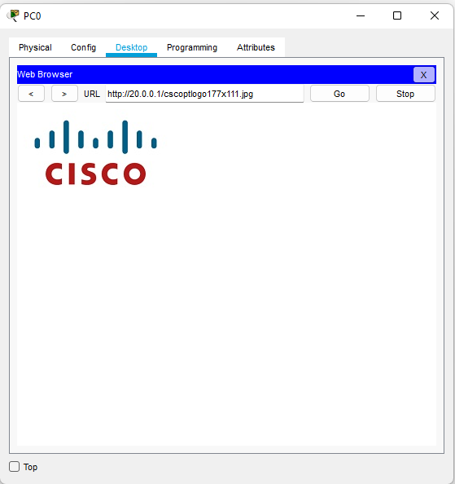

**Allowing ICMP and Denying IP:**

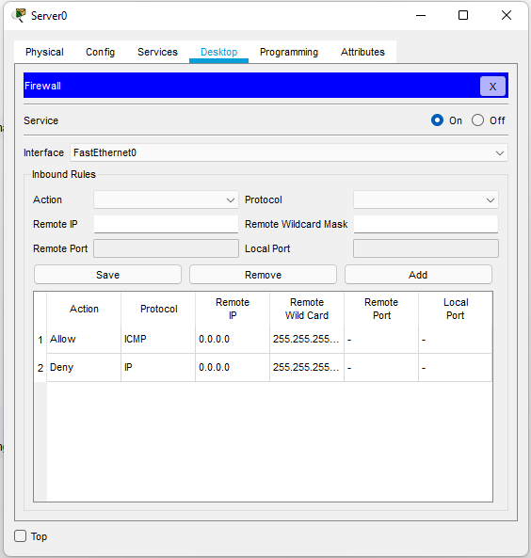

**Allowing ICMP:**

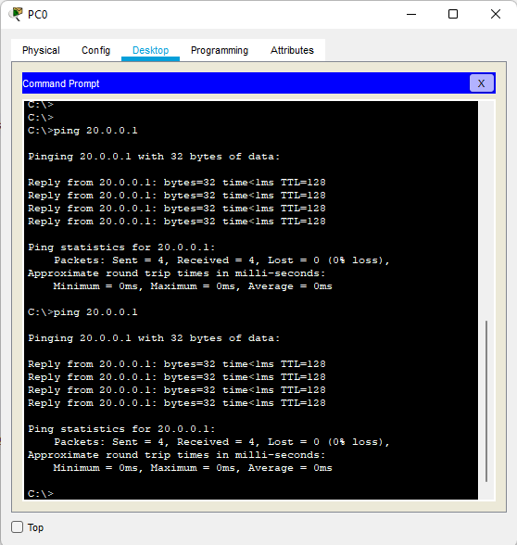

**Denying IP:**

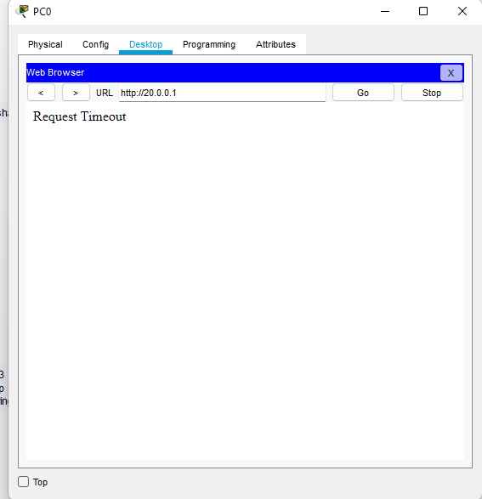

**Experiment 2 Implementing Access Control lists:**

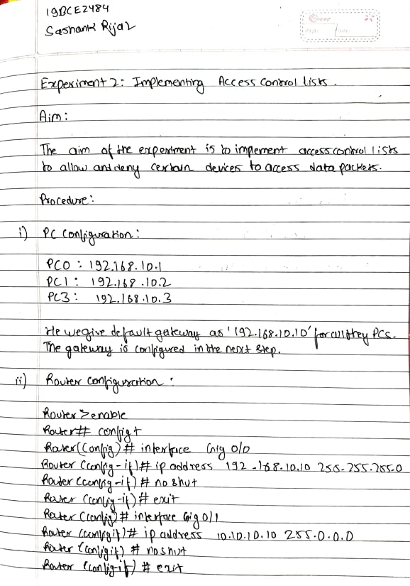

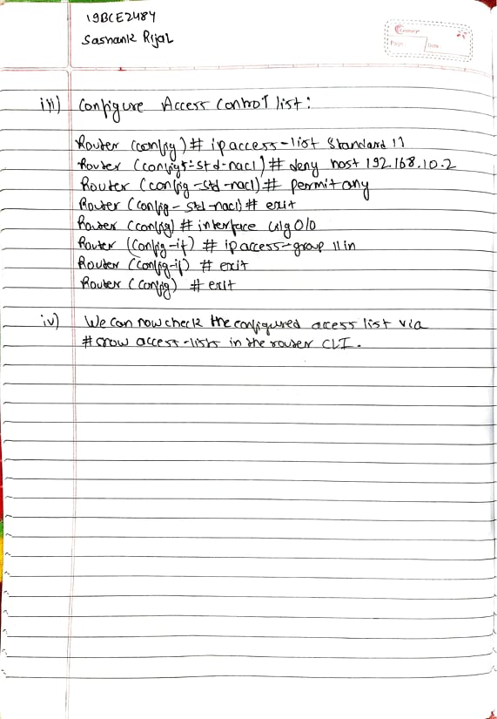

**Network Design:**

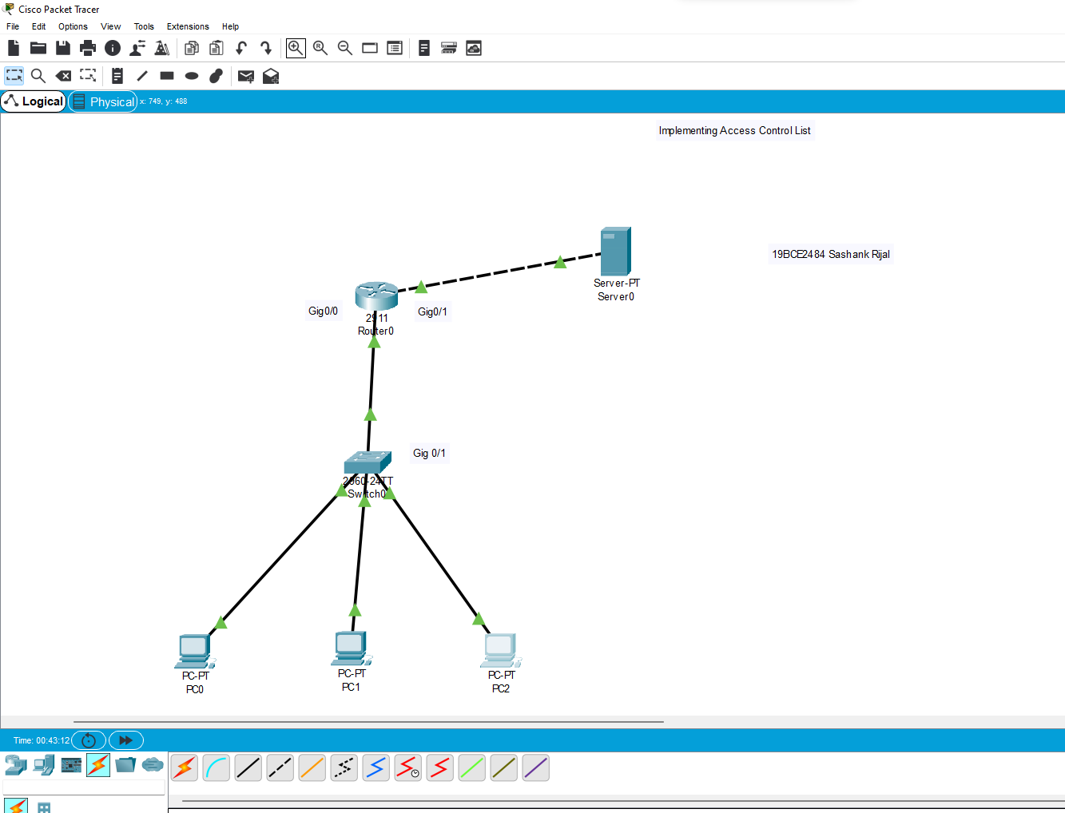

**Configuring the Router:**

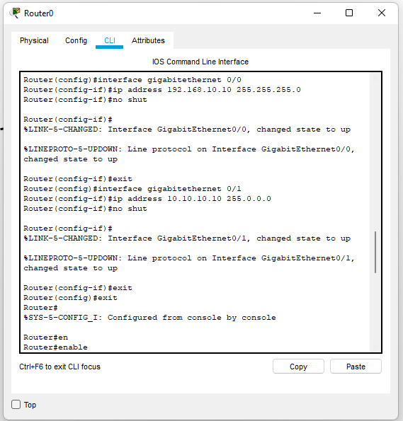

**Pinging PC0 PC1 AND PC2:**

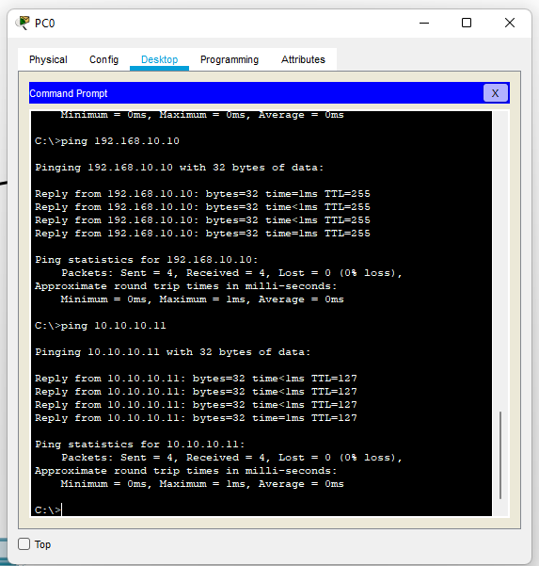

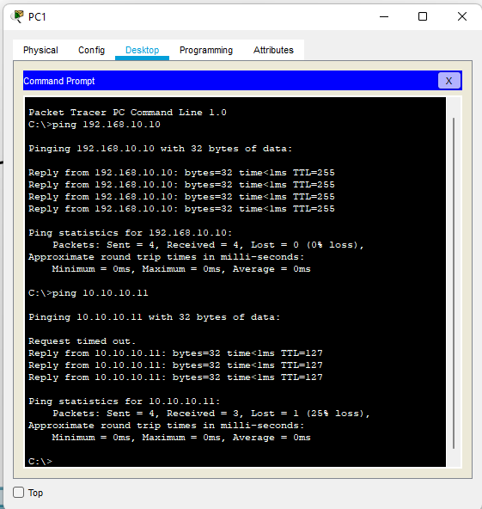

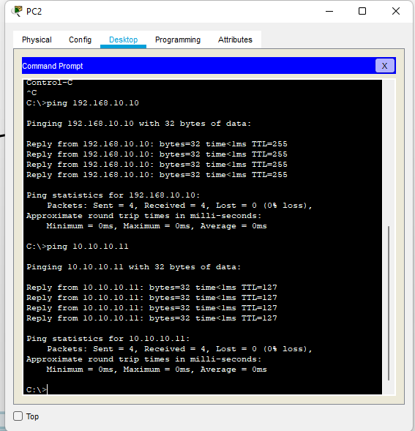

**Configuring Access control list (Standard 11)**

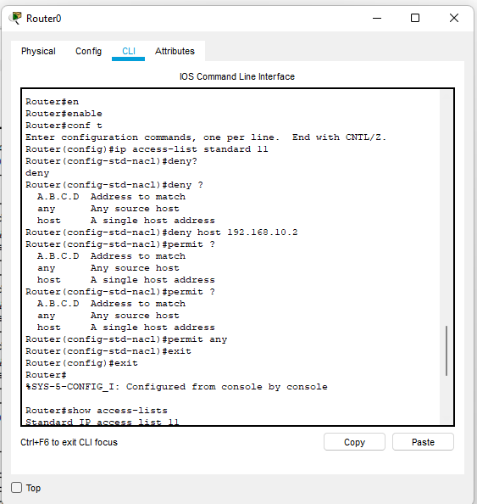

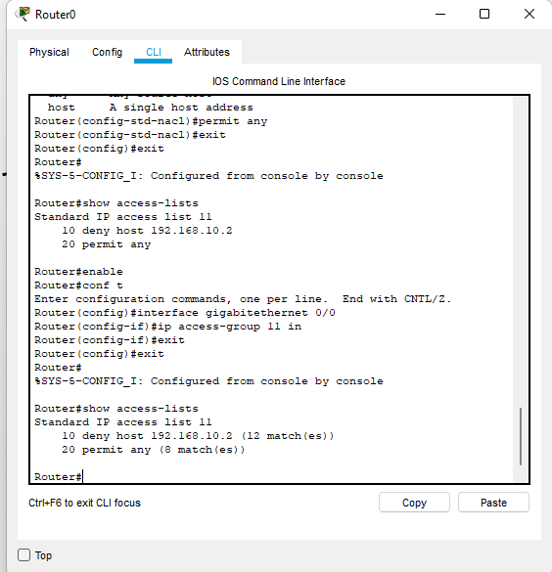

**Pinging PC after setting access control list:**



**This PC (PC1) was denied therefore does not receive any reply:**

