Q1.Write a concurrent program (using fork()) that starts three processes. Arrange for each process to print a few lines of output and then halt.
Ans. Sample Screen shot of execution

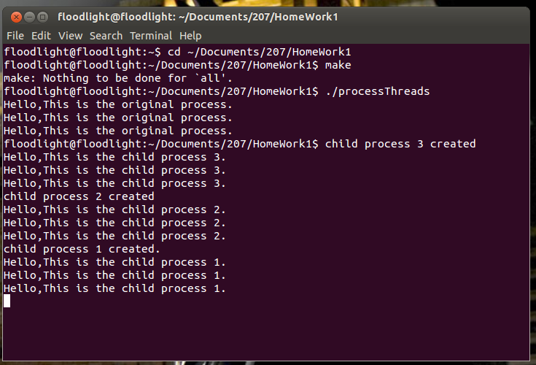

Q2. Write a program that uses “execve” to change the code a process executes. Write and compile the summation procedure (like the slide) as a separate program and use execve() to call it in the child process.
Ans. Sample Screen shot of execution

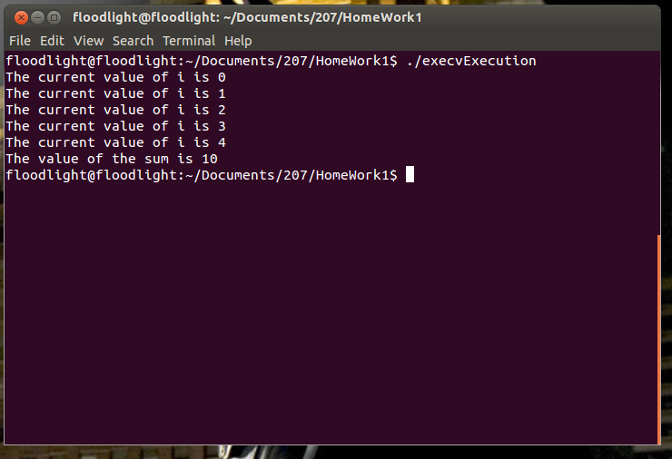

Q3. Explain the following questions.
- What is Network Byte Order?
Ans. Broadly computers can be categorized in to following two ways based on their way of storing multi byte values.
- Big Endian: Higher order byte is stored in starting location.
- Little Endian: Lower order byte is stored in starting location.
But to establish proper communication channel between differently categorized machines, Internet protocol standardized the Byte order convention for data transmitted through network. This is known as Network Byte Order. In most cases Big Endian terminology is followed for Network Byte Order.
There are few routines implemented which can help in converting a host’s internal representation to the IP standardized Byte Order.
- htonl (uint32_t hostlong): It converts unsigned 32bit long integer from host byte order to network byte order.

- htons (uint16_t hostshort): It converts unsigned 16bit short integer from host byte order to network byte order.

- ntohl (uint32_t netlong): It converts unsigned 32bit long integer from network byte order to host byte order.

- ntohs (uint16_t netshort): It converts unsigned 16bit short integer from network byte order to host byte order.

These functions are all macros and so are inserted in to calling program during implementation. In case of Little Endian machines they help to change values to Network Byte Order. On Big Endian machines, the functions are defined as null as they don’t have significance.
The header file <netinet/in.h> should be included for utilizing above routines.

- What is the difference between processes and threads?
Ans. Processes can be considered as running instances of a program. In Linux system process are represented by task_struct data structure.
A flow of execution of a process can be considered a thread. A process with multiple execution flows can be considered a multi-threaded process.

Some of the major differences that can be observed between processes and threads are as follows
- Processes do not share their address space while threads executing under same process share address space.
- Process synchronization should be taken care by kernel whereas thread synchronization should be taken care by process under which it is being executed.
- Context switching is very fast and light in case of threads compared to processes.
- Processes usually form a tree hierarchy. While all the threads of a process are peers.
- Threads carry less state information thus forms to be less overhead compared to processes.
- Changes in main thread may affect other concurrent threads but changes in a process have minimal effect on its peers.

Q4. Write your server and client programs by using TCP as well as UDP. Just follow the socket programming flow like socket()->bind()-> and so on. No concurrency, blocking I/O, Simple message prints.
- TCP-based server/client
Ans. Sample Screen shot of execution
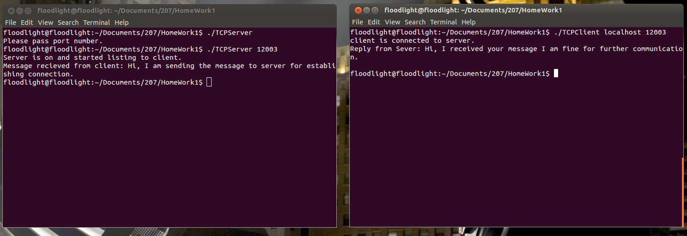

- UDP-based server/client
Ans. Sample Screen shot of execution

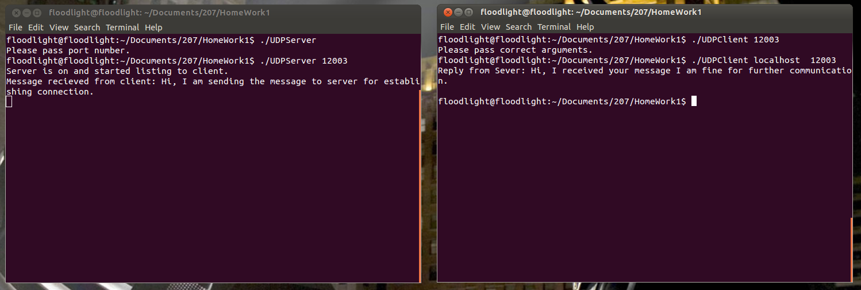

- Explain main socket APIs in detail like socket()->bind()->.
Ans. Following are the routines used in socket API
- Socket(): It is combination of IP and port. Socket can be considered as end point for communication.
Parameters Passed:
    - family , type- integer, eg: AF_INET(IPV4)
    - type, type- integer, eg: SOCK_STREAM (TCP), SOCK_DGRAM (UDP)
    - socket descriptor , type – integer
- Bind(): binds created a socket address of type sockaddr_in structure with socket created above
Parameters Passed:
    - socket, type- integer, eg: socket created using Socket routine
    - socket address, type- sockaddr_in
    - length of the socket address, type – socklen_t

- Listen(): This routine is implemented on the server, helps in listening to the client. It is utilized in connection oriented communication.
Parameters Passed:
    - socket, type- integer, eg: socket created using Socket routine
    - backlog, type- integer, eg: 5 (for listening to 5 clients simultaneously)

- Connect(): It establishes connection through 3- way handshake. This routine is used by the client. It is utilized in connection oriented communication.
Parameters Passed:
    - socket, type- integer, eg: socket created using Socket routine
    - server address, type- sockaddr_in
    - length of the socket address, type – socklen_t

- Accept():This routine implemented on the server, accepts the client with established connection in to a new socket. It is utilized in connection oriented communication.
Parameters Passed:
    - socket, type- integer, eg: socket created using Socket routine
    - client address, type- sockaddr_in
    - length of the socket address, type – socklen_t

- read(): once connection is established , data can be received using this routine both in client and server. It is utilized in connection oriented communication.
Parameters Passed:
    - socket, type- integer, eg: socket created using Accept routine
    - buffer, type- char array
    - length of the buffer, type – integer

- write(): Once connection is established , data can be sent using this routine both in client and server. It is utilized in connection oriented communication.
Parameters Passed:
    - socket, type- integer,
    - message , type- char string
    - length of the message, type – integer
- recvfrom(): Once connection is established , data can be received using this routine both in client and server. It is utilized in connectionless oriented communication (UDP).
Parameters Passed:
    - socket, type- integer
    - buffer, type- char array
    - length, type – integer
    - flag, type- integer
    - sock address, type- sockaddr_in
    - address length

- sendto(): Once connection is established , data can be sent using this routine both in client and server. It is utilized in connectionless oriented communication (UDP).
Parameters Passed:
    - socket, type- integer
    - message, type- char string
    - length, type – integer
    - flag, type- integer
    - sock address, type- sockaddr_in
    - address length
- Close(): closing the connection established
Parameters Passed:
    - socket, type- integer, eg: socket created using Socket routine

Q5. Install Mininet to explore Software Defined Networking(SDN) based on the manual on Canvas. Create a simple topology and print out the flow rules for your topology. Explain the flow rules that you capture.
Ans. I have installed the Mininet and created a simple topology with three hosts, a switch and a controller. Please find following screen shot.

Simple topology is created by command- sudo mn –topo=single,3
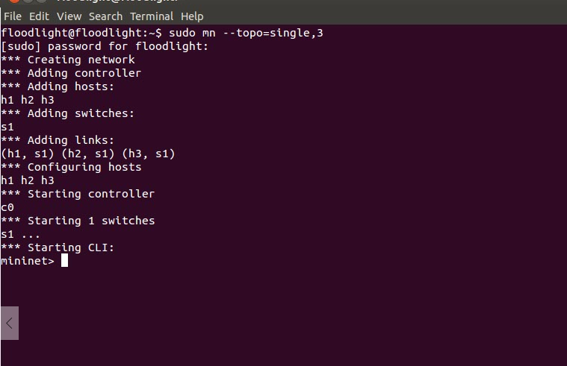

The following screen shot shows links established on the topology
dump command shows all the hosts with their configurations.
net command shows how the network is built

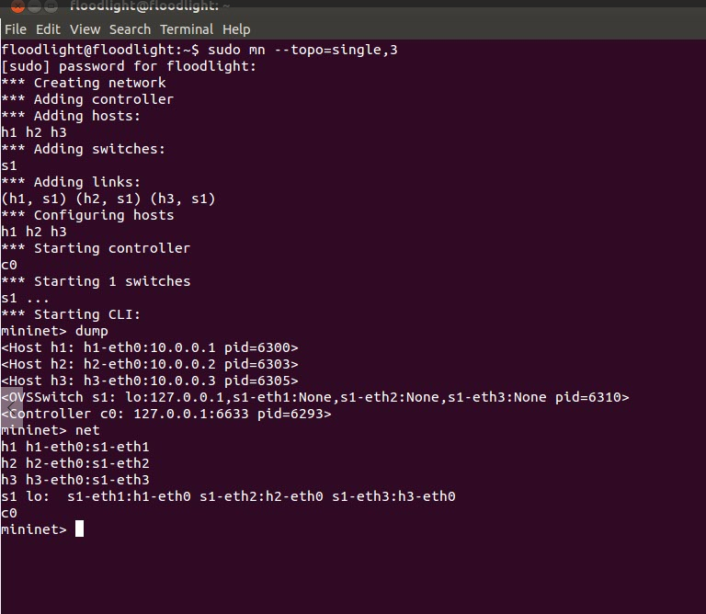

The following screenshot shows flow statistics captured on terminal
ovs-ofctl dump-flows s1 command is used to print out all the flow entries utilized in the packet transfer in the switch 1.

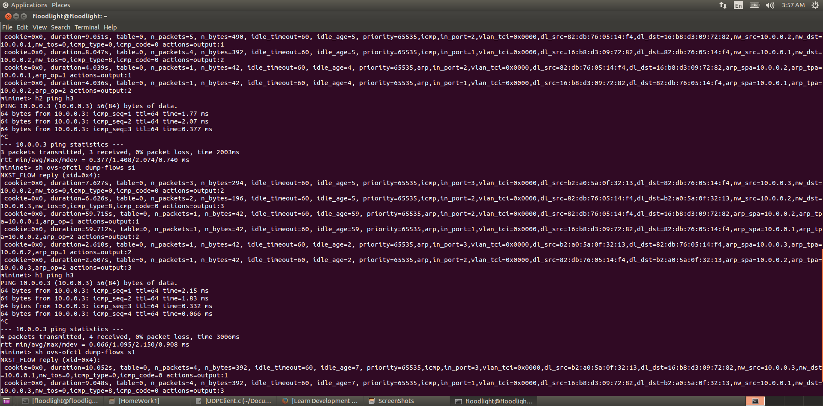

Capture Inspection: In the above capture, ping command flows can be observed between the three hosts created. Let us take a flow of h2 is trying to ping h3 and observe its entries.
One of the entry shows following statics.
n_packets: 2 (Describes number of packets through this entry in the flow table)
n_bytes:196 (Describes number of packets through this entry in the flow table)
idle_timeout:60 (Number of idle seconds before the flow entry is removed)
idle_age:5(Describes how long it’s been since this row is hit in seconds)
priority:65535
in_port:2 (Describes the incoming port of packets which in our case is 2 for host 2)
actions=output:3 (Describes the outgoing port of packets which in our case is 3 for host 3)
duration :6.6266 ( it describes the duration this entry is in the flow table)
cookie:0x0
nw_dst:10.0.0.3 (destination IP for the transfer of packets)

The Following screen shot shows exiting the Mininet
exit command is utilized for exiting out of Mininet.
