SquadUp Screenshots
Screenshots in presentation order, with slide numbers.

Slide 4 – Project structure
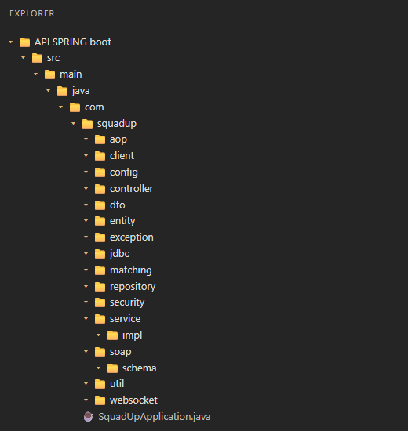

Slide 6 – Login screen
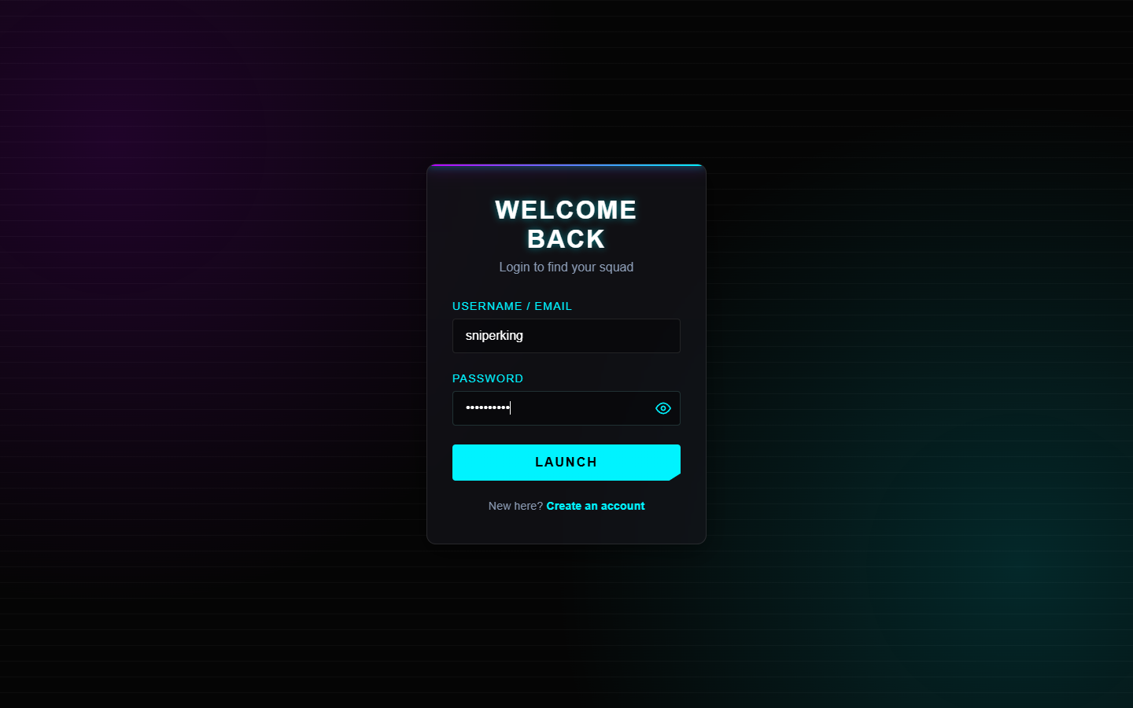

Slide 6 – Token response (login API)
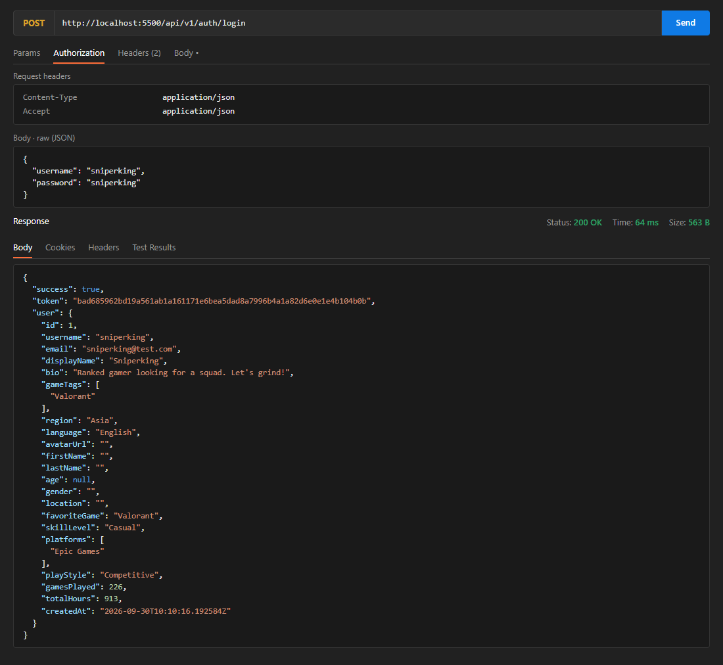

Slide 6 – 401 JSON error
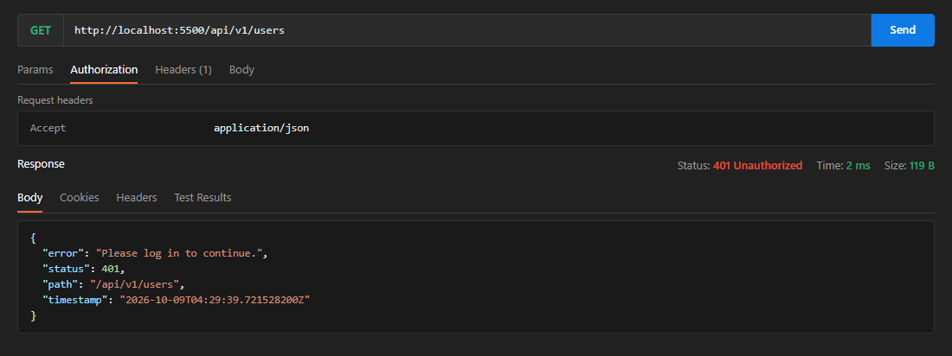

Slide 6 – 403 JSON error
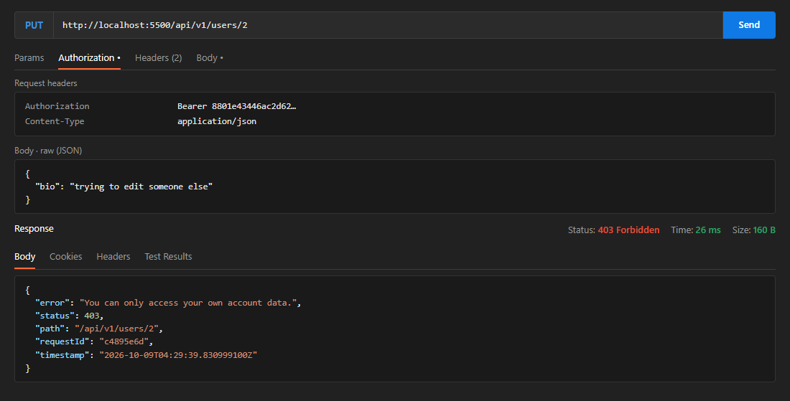

Slide 7 – Player profile page
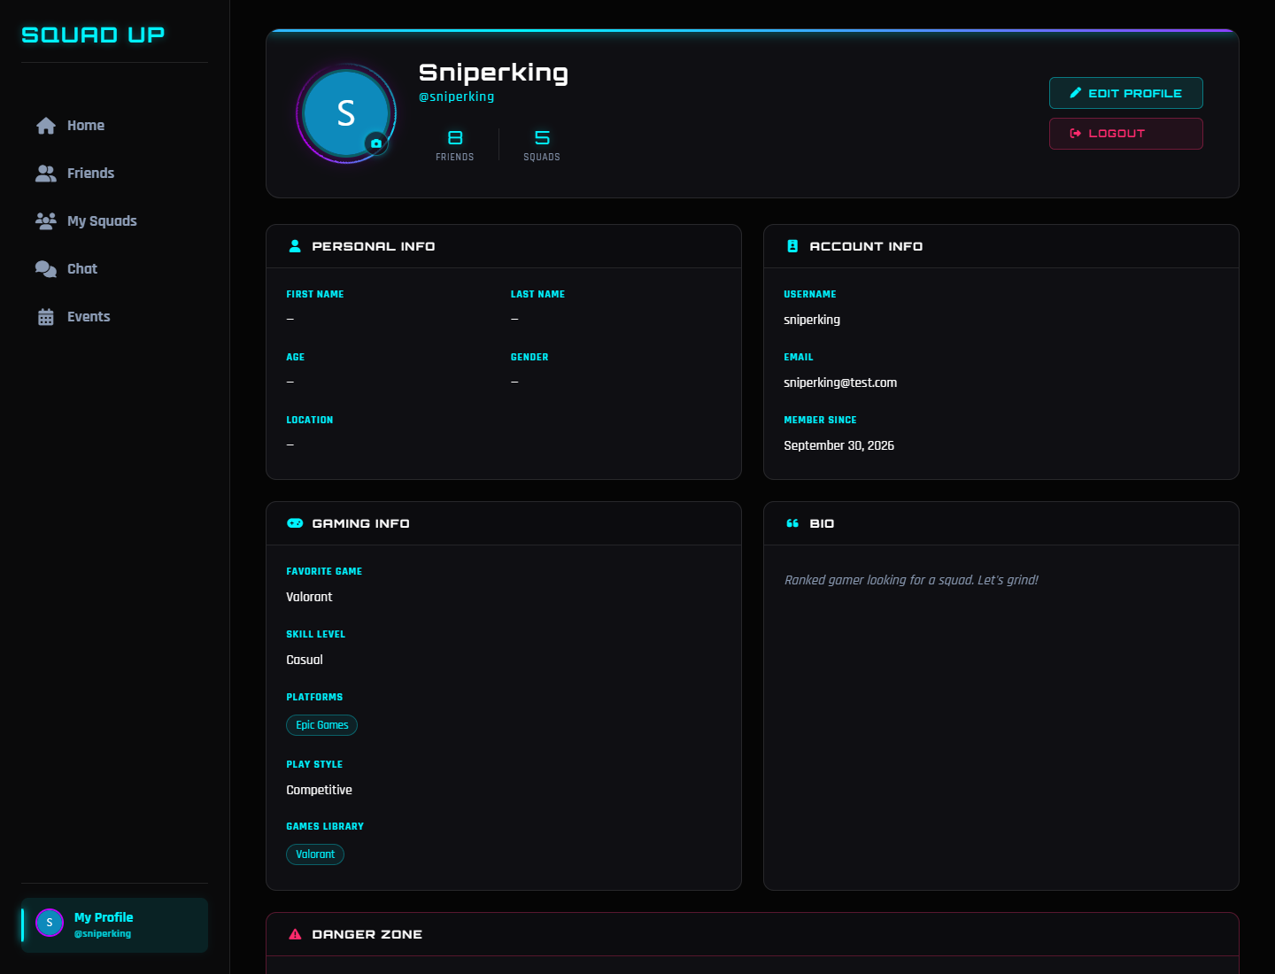

Slide 7 – Paged player search
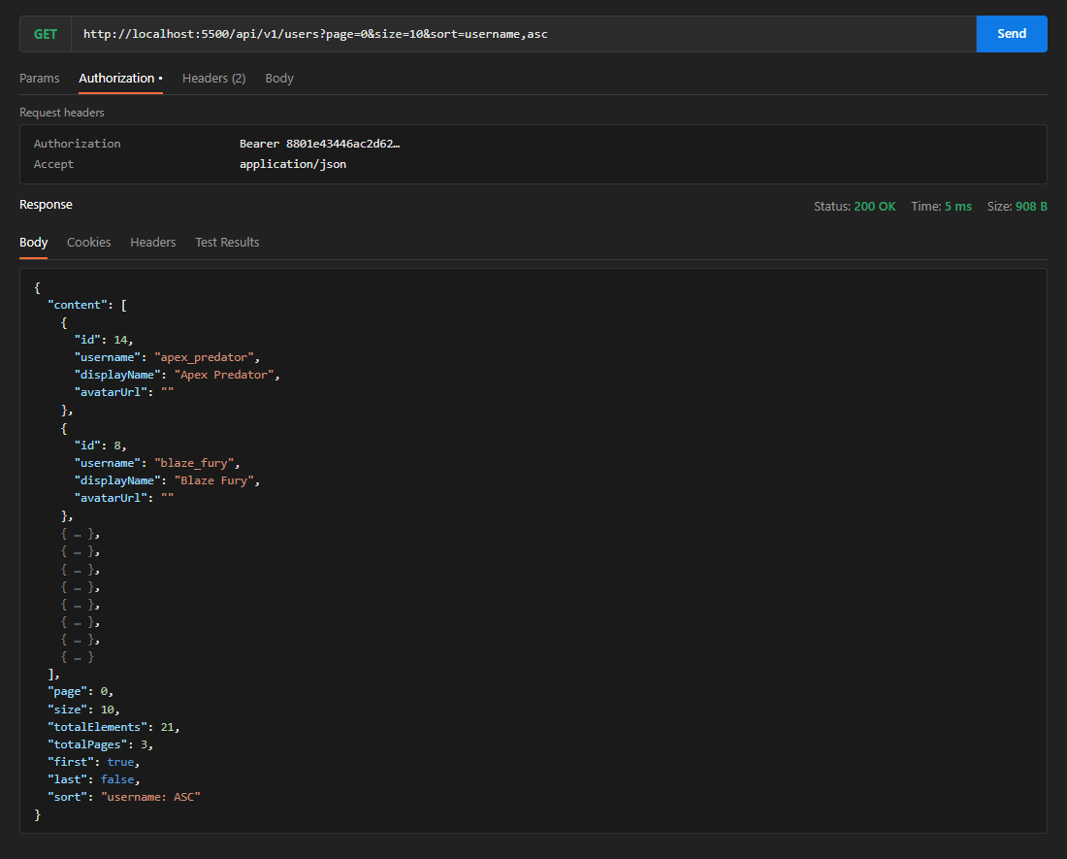

Slide 8 – Filtered squad lobby
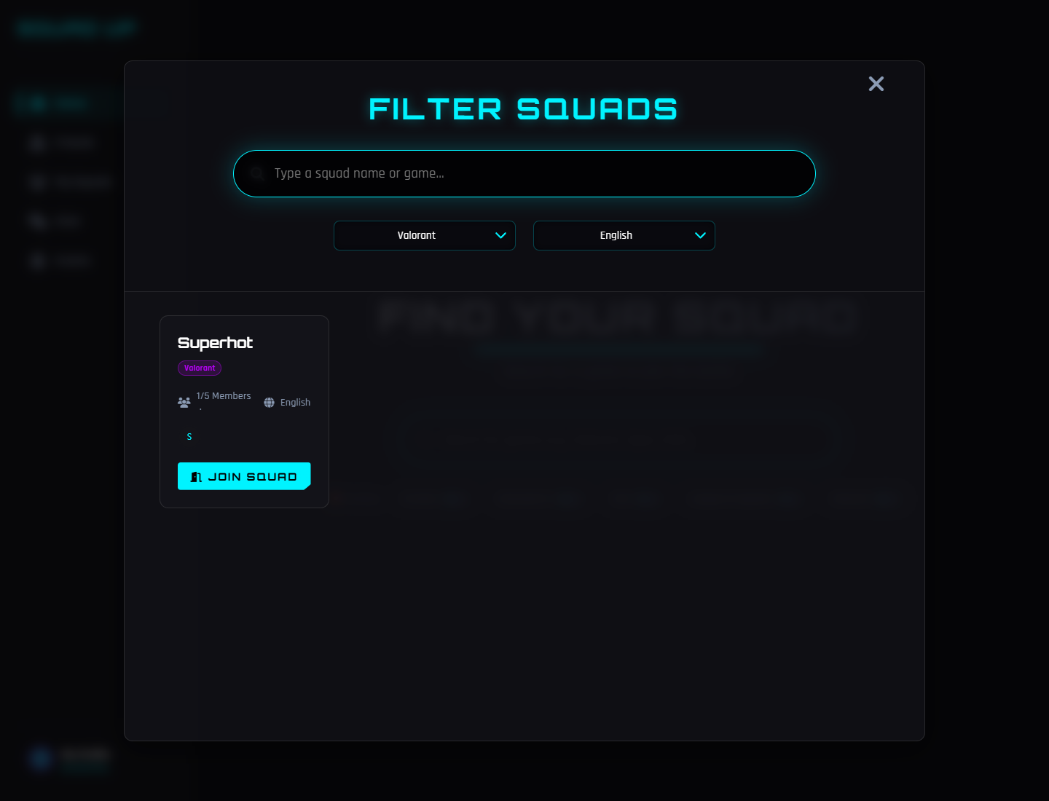

Slide 8 – Matrix-variable request / response
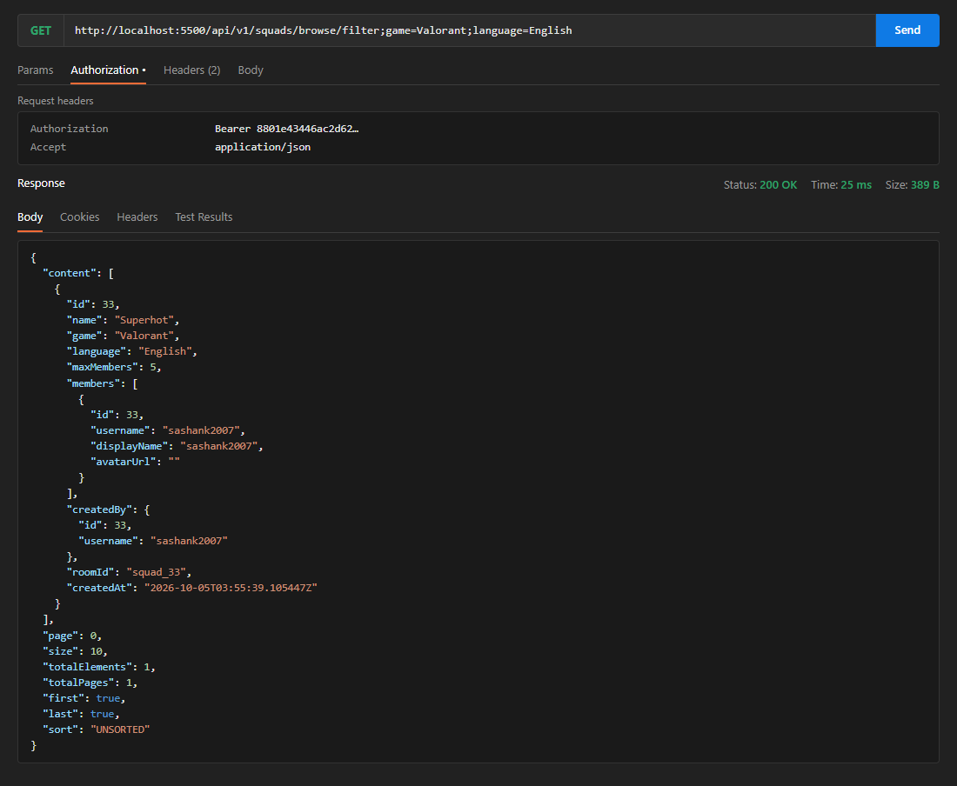

Slide 9 – Recommended squads with match percentage
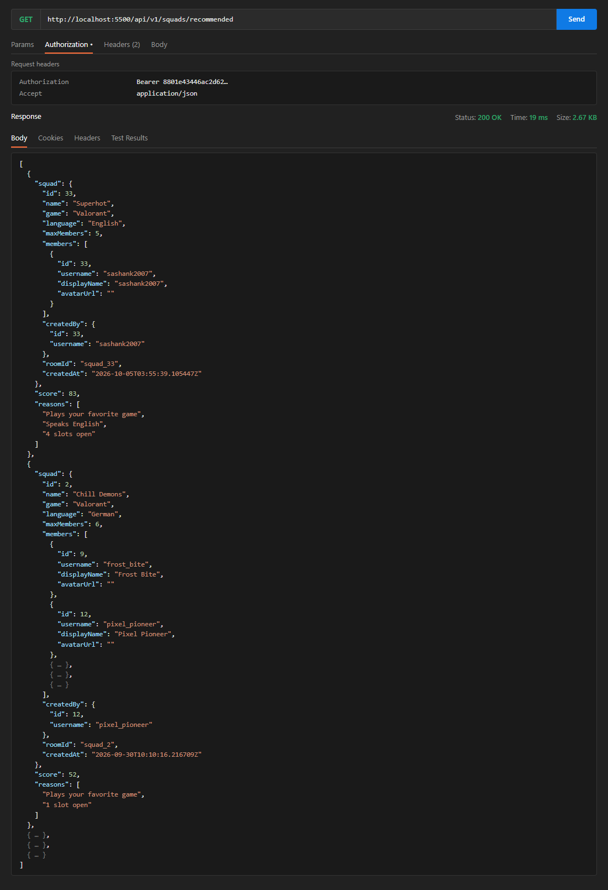

Slide 10 – Friends list
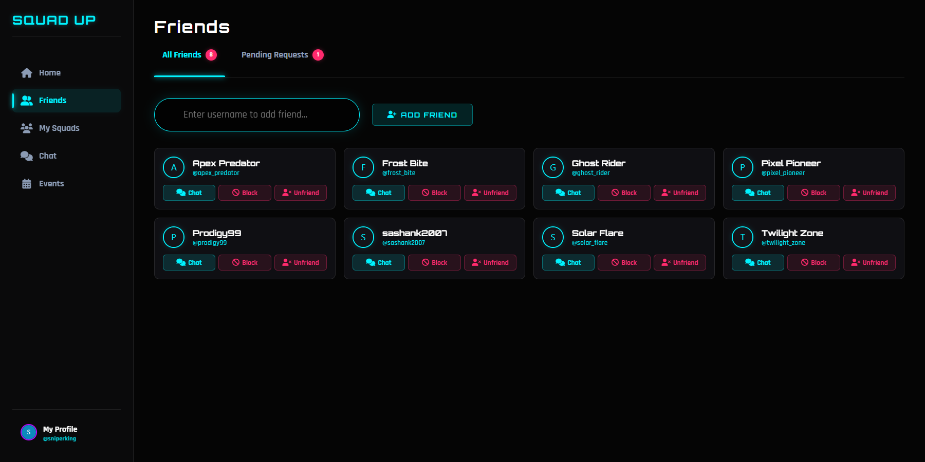

Slide 10 – Pending friend requests
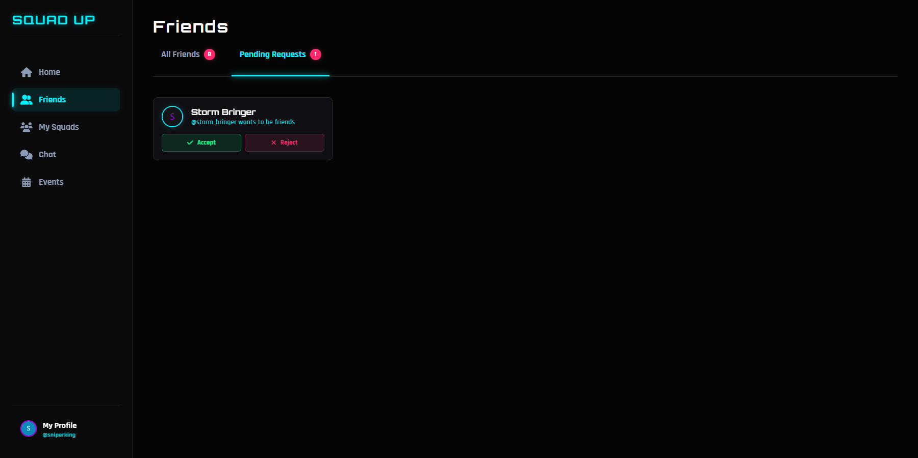

Slide 10 – Real-time notification: request received (receiver screen)
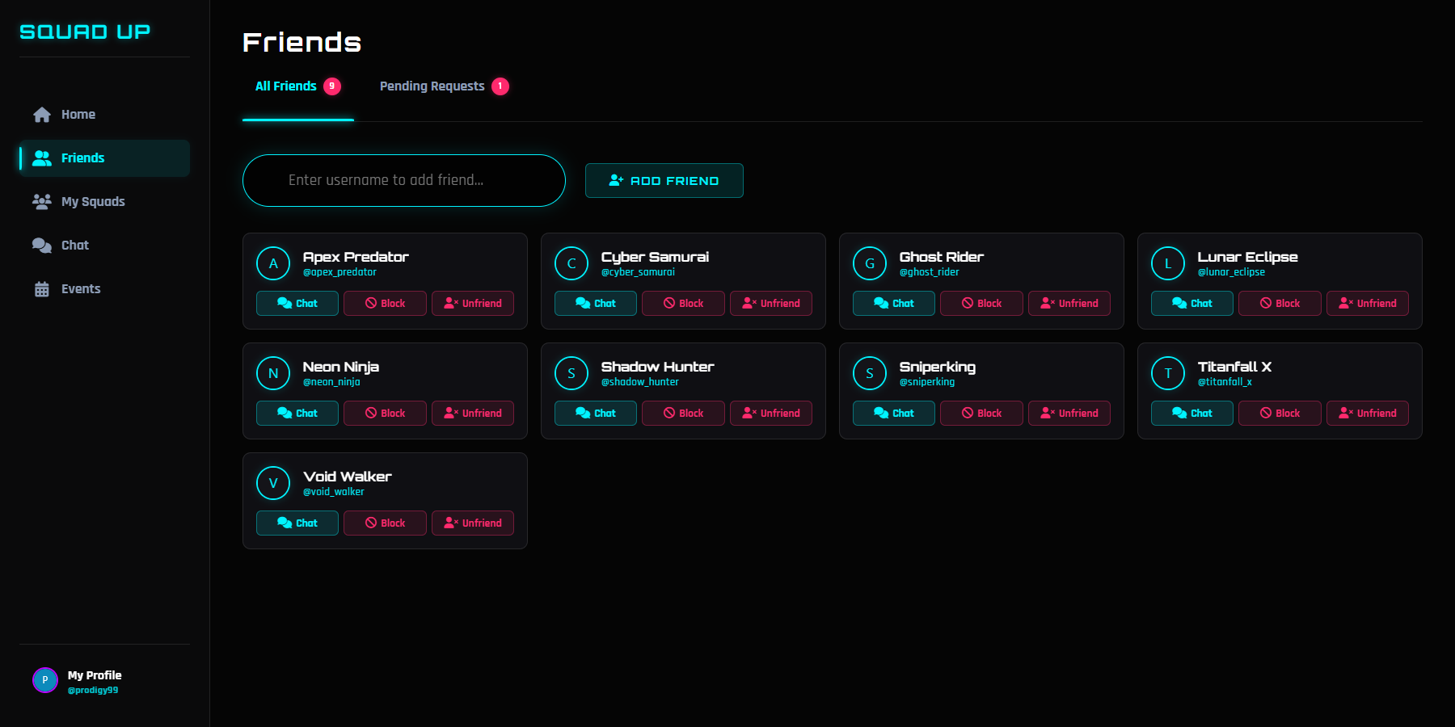

Slide 10 – Real-time notification: request accepted (sender screen)
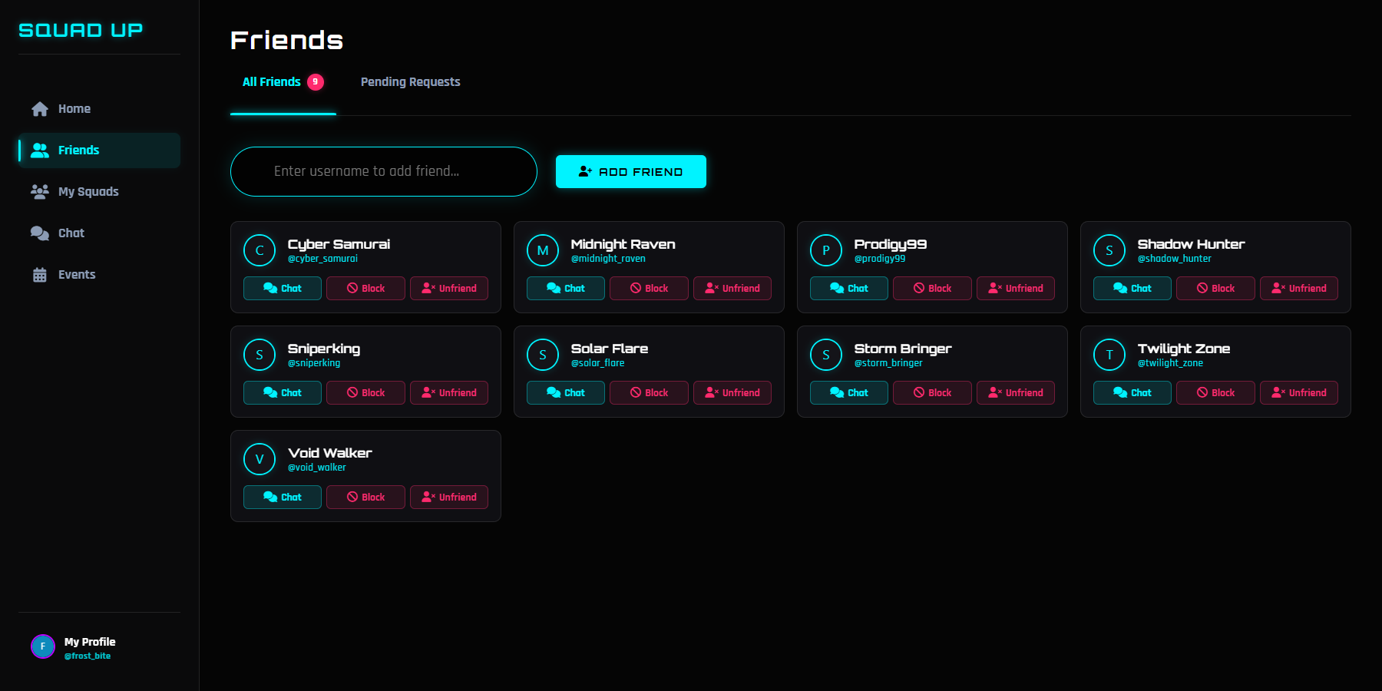

Slide 11 – Squad lobby chat and censored message
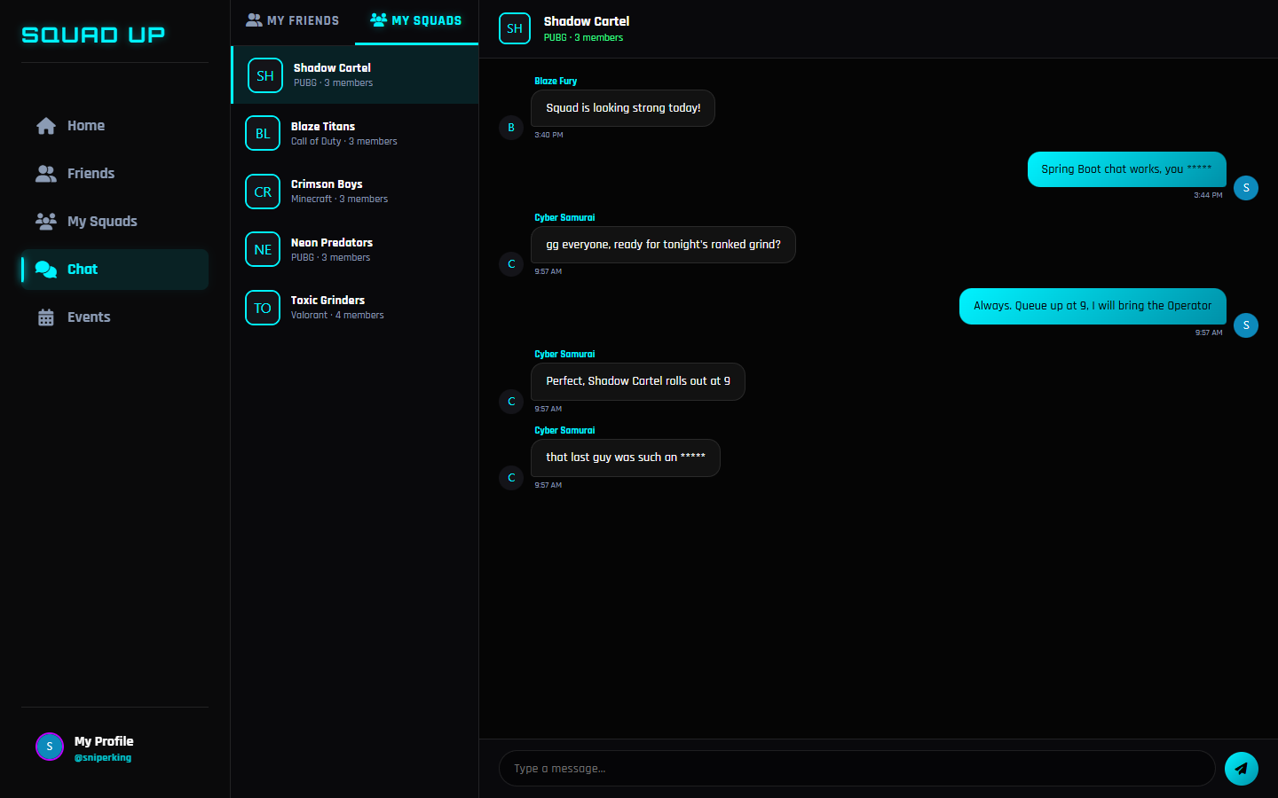

Slide 11 – Typing indicator
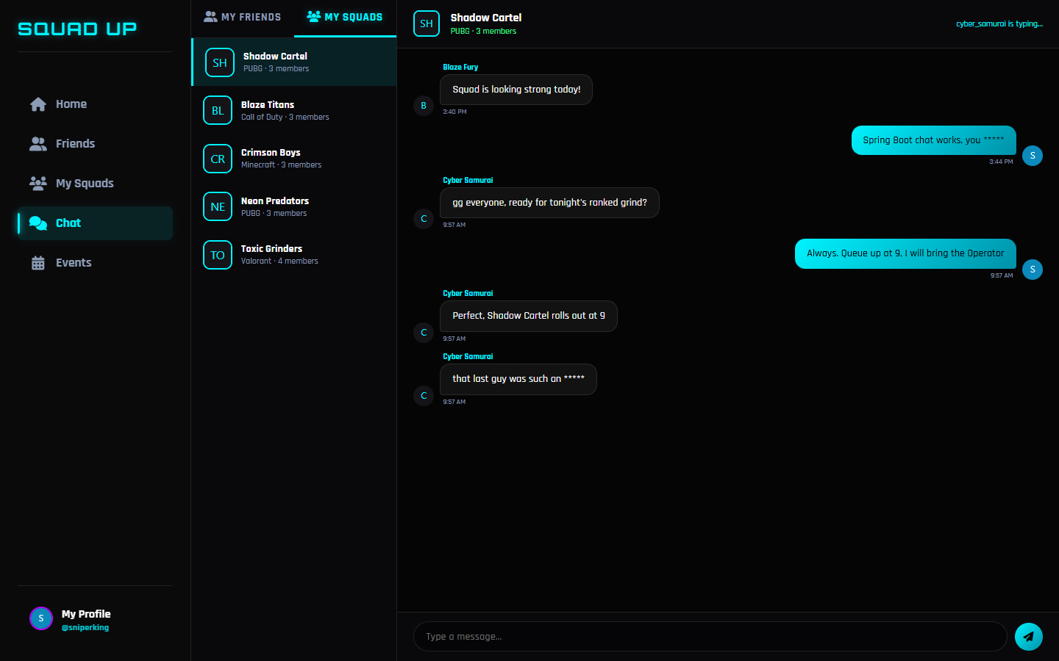

Slide 12 – WSDL in browser
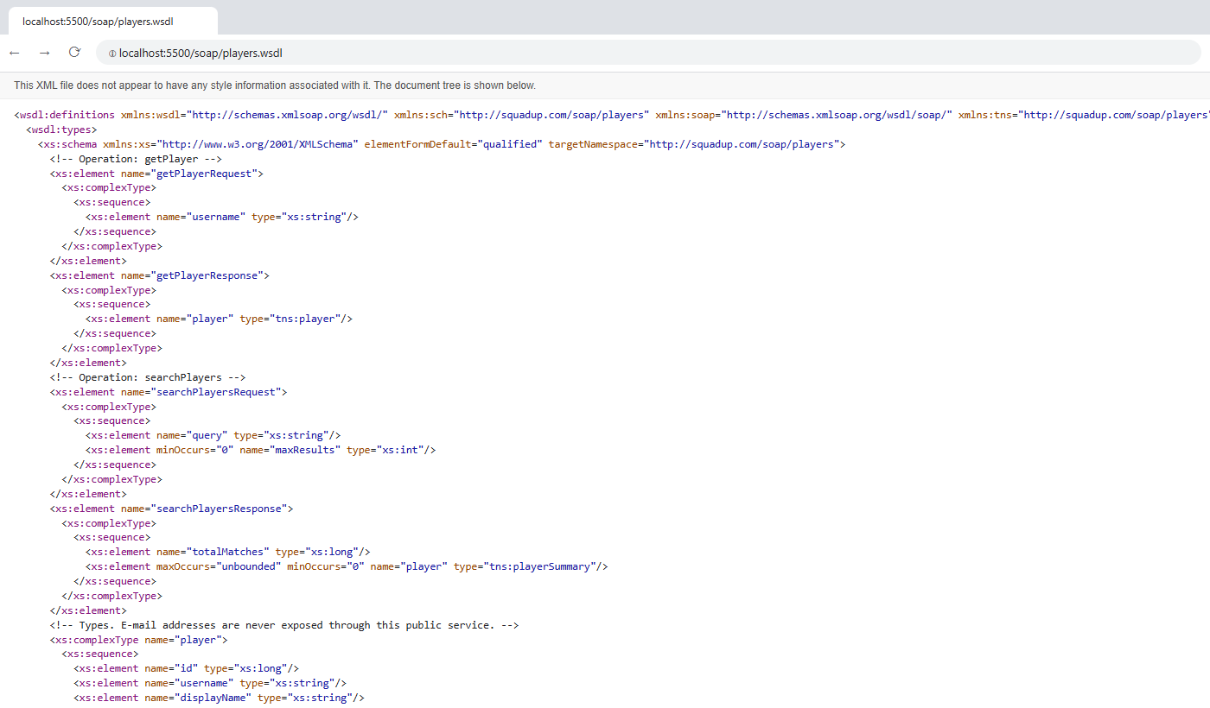

Slide 12 – SOAP request and response
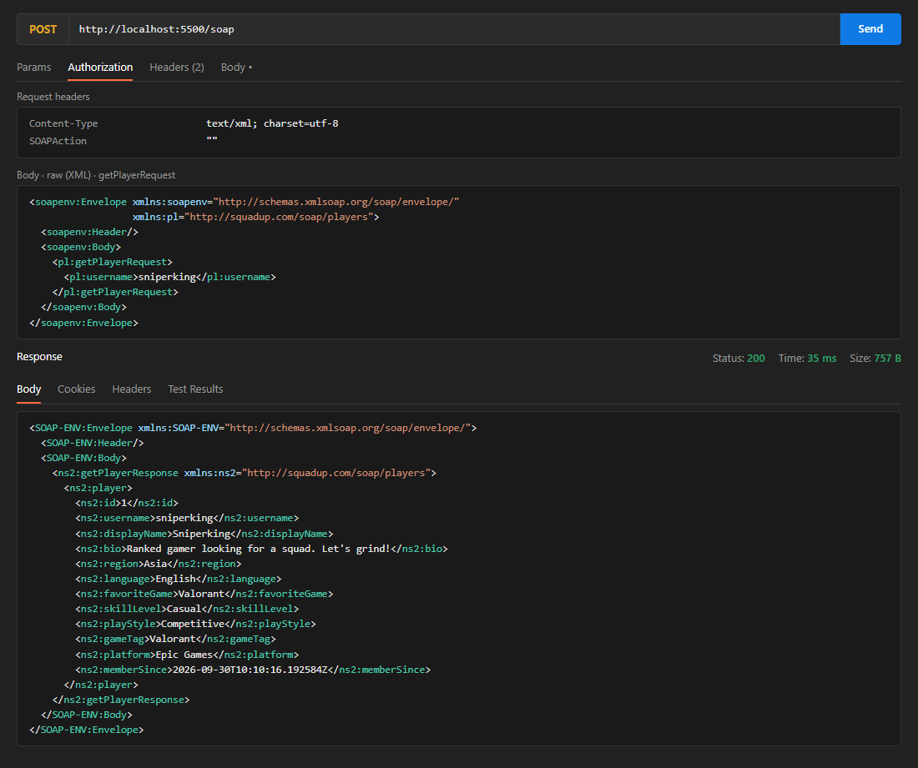

Slide 12 – Platform stats JSON
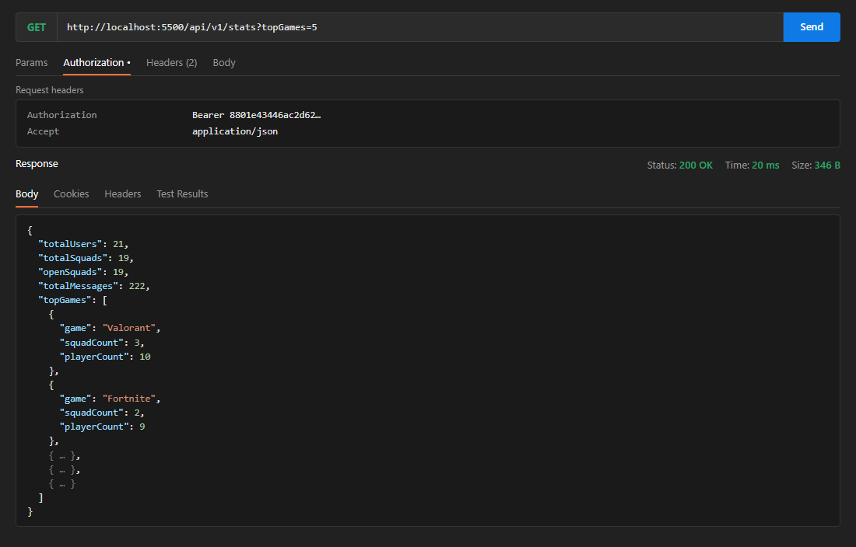

Slide 13 – Audit and performance logs
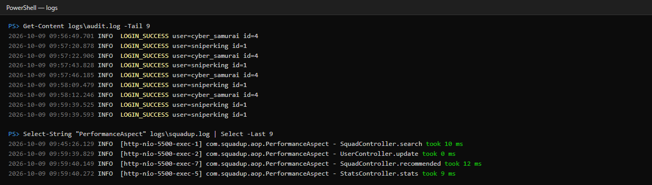

Slide 14 – Maven test result
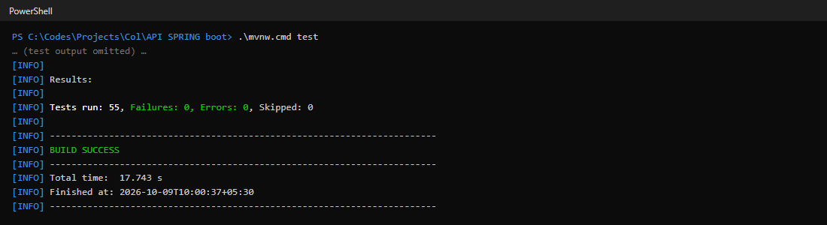

Slide 14 – Seeded data in H2 console
