# Specification of Computer:

o The brand of CPU (Intel or AMD): **AMD**

o The model of CPU (e.g. Intel i7-9700K Coffee Lake): **AMD Ryzen 5 5500U with Radeon Graphics**

o The number of cores on CPU: **6 cores**

o The clock rate of CPU in GHz: **2.10 GHz**

o The amount of memory in GB: **8.00 GB**

o The speed of memory: **DDR4 3200**

o The capacity of hard drive: **256 GB**

o The type of hard drive: magnetic or SSD: **SSD**

# SSD

* Max sequential read speed: 2100 Mb/s
* Max sequential write speed: 1400 Mb/s
* Max random read speed: 250000 IOPS
* Max random write speed: 180000 IOPS

# Screenshots of Benchmarks

Caption: Output of integer operations benchmark

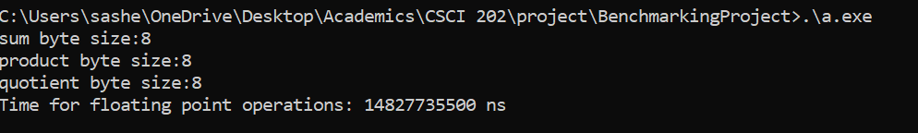

Caption: Output of floating-point operations benchmark



Caption: Output of memory operations benchmark



Caption: Output of Hard Drive benchmark 2



Caption: Output of Hard Drive benchmark 2

# Table recording the results of all the benchmarks

|  |  |  |  |  |  |
| --- | --- | --- | --- | --- | --- |
| Name | Description | Execution time (ns) | Execution time (s) | Reference time (s) | Ratio |
| Integer Operations | o 1010 additions (of integer constants)  o 5 × 109 multiplication (of integer constants)  o 2 × 109 division (of integer constants) | 14765120900 | 14.765120900 | 100 | 6.7727179938 |
| Floating Point Operations | o Same as integer, use *double precision* floating point numbers instead of integer. | 14827735500 | 14.827735500 | 100 | 6.7441181427 |
| Memory Operations | o Read from 5 × 109 different array elements, 4 bytes each time  o Write to 5 × 109 different array elements, 4 bytes each time | 20064810300 | 20.064810300 | 100 | 4.9838497600 |
| Hard drive benchmark 1 | o Read a whole file of 109 bytes, 100 bytes each time  o Write 109 bytes to a file, 100 bytes each time | 4271242200 | 4.271242200 | 250 | 58.530981923 |
| Hard drive benchmark 2 | o Read a whole file of 109 bytes, 10000 bytes each time  o Write 109 bytes to a file, 10000 bytes each time | 2748607200 | 2.748607200 | 10 | 3.6382062886 |
| Geometric mean |  |  |  |  | 8.651775603 |

# Summary of Results of Benchmarks using Geometric Mean

Summary of results using a single number (geometric mean): 8.651775603