

ICT3722

Assignment 4



September 5, 2022

64482790

Table of Contents

Question 1 2

Question 2 9

Question 3 10

Question 4 11

Question 5 12

Question 6 13

Question 7 14

Question 8 16

# Question 1

* 1. CREATE SEQUENCE invoices_invoiceID_seq

INCREMENT BY 1

START WITH 1

CACHE 20

NOCYCLE;

CREATE TABLE Invoices

(Invoice_ID NUMBER(4) NOT NULL,

Vendor_ID NUMBER(5) NOT NULL,

Invoice_NUMBER VARCHAR(10),

Invoice_Date DATE,

Invoice_Total NUMBER(10,2),

Payment_Total NUMBER(10,2),

Credit_Total NUMBER(10,2),

Terms_ID NUMBER(2) NOT NULL,

Invoice_Due_Date DATE,

Payment_Date DATE,

CONSTRAINT Invoices_InvoiceID_PK PRIMARY KEY(Invoice_ID),

CONSTRAINT Invoices_invoicedate_ck CHECK (Invoice_Date < Invoice_Due_Date));

1.2 CREATE TABLE Vendors

(Vendor_ID NUMBER(5) NOT NULL,

Name VARCHAR(30),

Location VARCHAR(15),

Cell VARCHAR(10),

Email VARCHAR(20),

CONSTRAINT Vendors_VendorID_PK PRIMARY KEY(Vendor_ID));

1.3 INSERT INTO Invoices

VALUES (invoices_invoiceID_seq.NEXTVAL,

34,

'QP58872',

TO_DATE('25-FEB-14', 'DD-MON-YY'),

116.54,

116.54,

0,

4,

NULL,

NULL);

INSERT INTO Invoices

VALUES (invoices_invoiceID_seq.NEXTVAL,

34,

'Q545443',

TO_DATE('14-MAR-14', 'DD-MON-YY'),

1083.58,

1083.58,

0,

4,

NULL,

NULL);

INSERT INTO Invoices

VALUES (invoices_invoiceID_seq.NEXTVAL,

110,

'P-0608',

TO_DATE('16-APR-14', 'DD-MON-YY'),

20551.13,

0,

1200,

5,

NULL,

NULL);

INSERT INTO Invoices

VALUES (invoices_invoiceID_seq.NEXTVAL,

110,

'P-0259',

TO_DATE('16-APR-14', 'DD-MON-YY'),

26881.4,

26881.4,

0,

3,

NULL,

NULL);

INSERT INTO Invoices

VALUES (invoices_invoiceID_seq.NEXTVAL,

122,

'MAB01489',

TO_DATE('16-APR-14', 'DD-MON-YY'),

936.93,

936.93,

0,

3,

NULL,

NULL);

INSERT INTO Invoices

VALUES (invoices_invoiceID_seq.NEXTVAL,

112,

'989319-497',

TO_DATE('17-APR-14', 'DD-MON-YY'),

2312.2,

0,

0,

4,

NULL,

NULL);

INSERT INTO Invoices

VALUES (invoices_invoiceID_seq.NEXTVAL,

82,

'C73-24',

TO_DATE('17-APR-14', 'DD-MON-YY'),

600,

600,

0,

2,

NULL,

NULL);

INSERT INTO Invoices

VALUES (invoices_invoiceID_seq.NEXTVAL,

112,

'989319-487',

TO_DATE('18-APR-14', 'DD-MON-YY'),

1927.54,

0,

0,

4,

NULL,

NULL);

INSERT INTO Invoices

VALUES (invoices_invoiceID_seq.NEXTVAL,

112,

'989319-477',

TO_DATE('19-APR-14', 'DD-MON-YY'),

2184.11,

0,

0,

4,

NULL,

NULL);

INSERT INTO Invoices

VALUES (invoices_invoiceID_seq.NEXTVAL,

112,

'989319-467',

TO_DATE('24-APR-14', 'DD-MON-YY'),

2318.03,

2318.03,

0,

4,

NULL,

NULL);

INSERT INTO Invoices

VALUES (invoices_invoiceID_seq.NEXTVAL,

112,

'989319-457',

TO_DATE('24-APR-14', 'DD-MON-YY'),

3813.33,

3813.33,

0,

3,

NULL,

NULL);

INSERT INTO Invoices

VALUES (invoices_invoiceID_seq.NEXTVAL,

112,

'989319-447',

TO_DATE('24-APR-14', 'DD-MON-YY'),

3689.99,

3689.99,

0,

3,

NULL,

NULL);

INSERT INTO Invoices

VALUES (invoices_invoiceID_seq.NEXTVAL,

112,

'989319-437',

TO_DATE('24-APR-14', 'DD-MON-YY'),

2765.36,

2765.36,

0,

2,

NULL,

NULL);

INSERT INTO Invoices

VALUES (invoices_invoiceID_seq.NEXTVAL,

112,

'989319-427',

TO_DATE('25-APR-14', 'DD-MON-YY'),

2115.81,

2115.81,

0,

1,

NULL,

NULL);

INSERT INTO Invoices

VALUES (invoices_invoiceID_seq.NEXTVAL,

112,

'97/553B',

TO_DATE('26-APR-14', 'DD-MON-YY'),

313.55,

0,

0,

4,

NULL,

NULL);

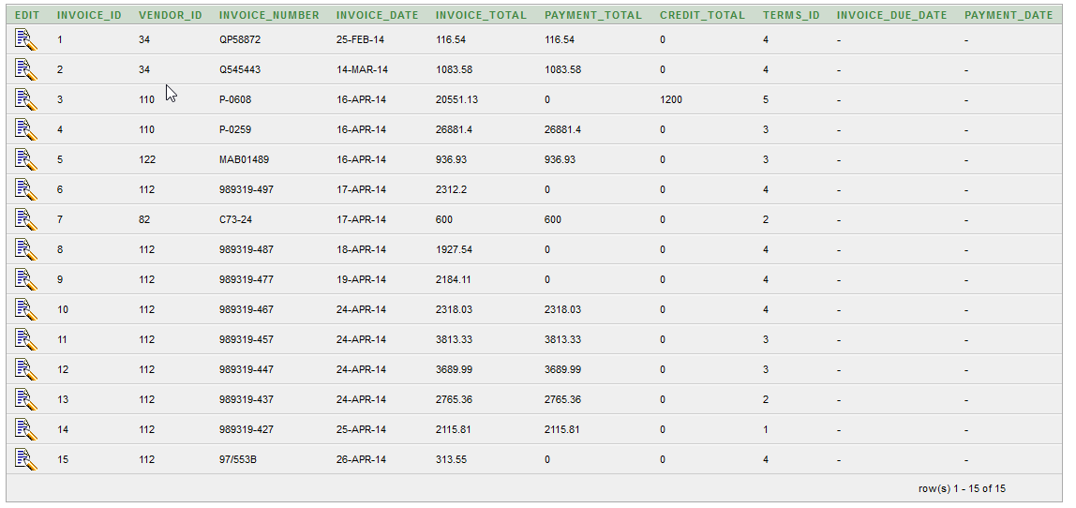

# Question 2

2.1 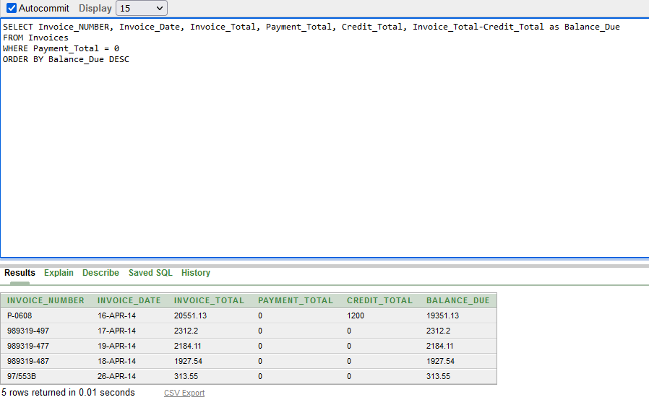

SELECT Invoice_NUMBER, Invoice_Date, Invoice_Total, Payment_Total, Credit_Total, Invoice_Total-Credit_Total as Balance_Due

FROM Invoices

WHERE Payment_Total = 0

ORDER BY Balance_Due DESC

# Question 3

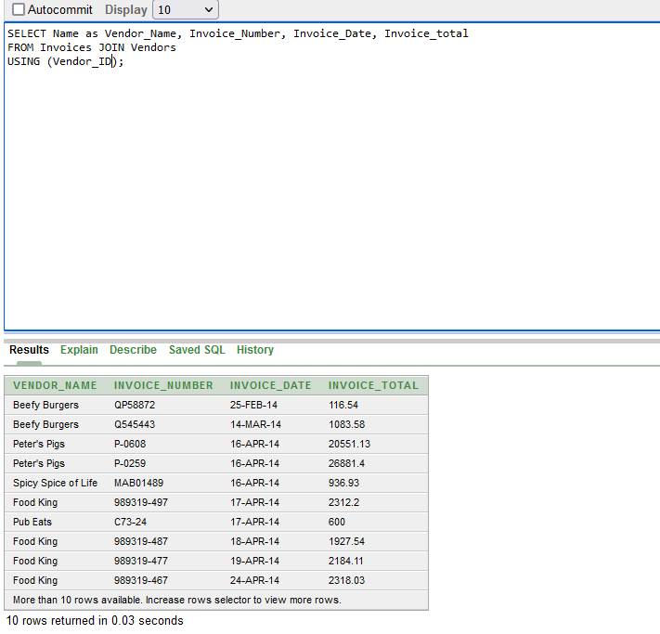

# Question 4

INSERT INTO Invoices

VALUES (invoices_invoiceID_seq.NEXTVAL, 12, '3289178', TO_DATE('18-JUL-14', 'DD-MON-YY'), 165, 0, 0, 3, TO_DATE('17-AUG-14', 'DD-MON-YY'), NULL);

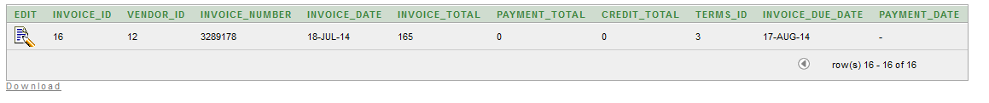

# Question 5

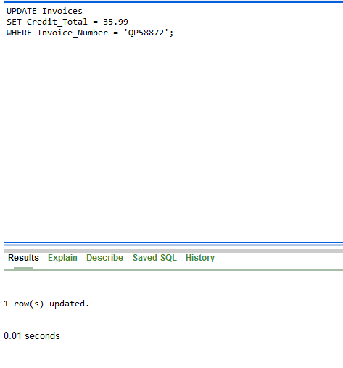

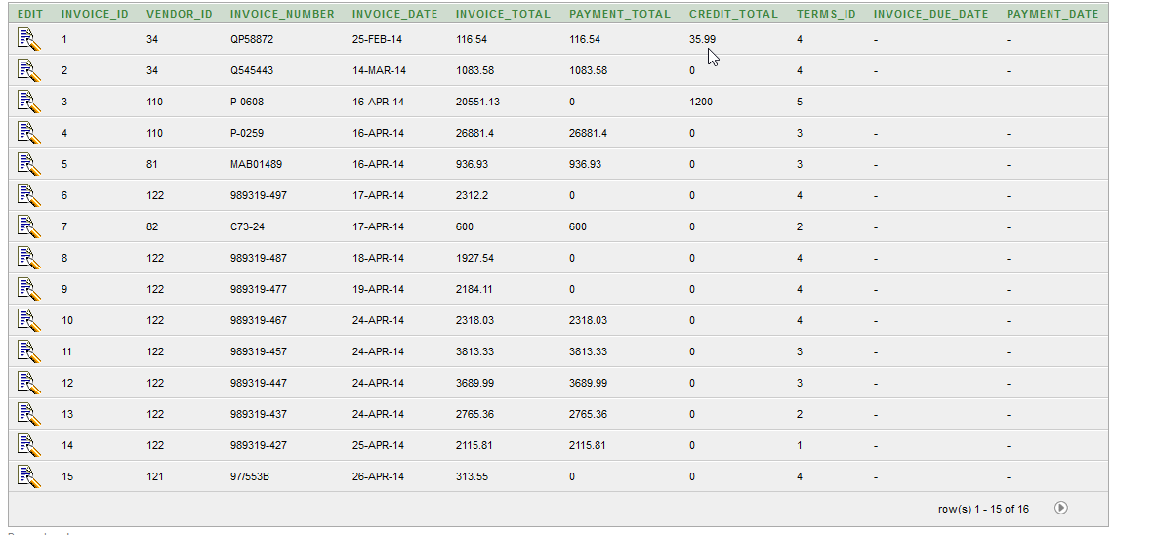

# Question 6

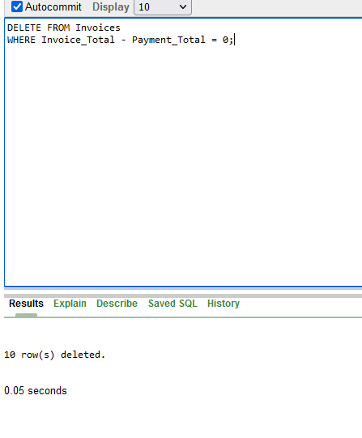

# Question 7

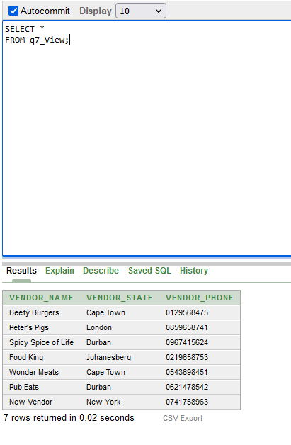

# Question 8

CREATE TABLE Avg_Invoice_Total

AS (SELECT Vendor_ID, AVG(Invoice_Total) AS Average FROM Invoices GROUP BY Vendor_ID);

SELECT Vendor_ID, Invoice_Total, ROUND(Average,2)

FROM Invoices JOIN Avg_Invoice_Total

Using (Vendor_ID);