ICT3611

Assignment 5

64482790

2022

Contents

Project 4- Airplane Seating Chart 2

Screenshots 2

Code 3

Project 2-Gradebook 10

Screenshots 10

Code 12

Project 1-Bank Account 15

Screenshots 15

Code 24

# Project 4- Airplane Seating Chart

## Screenshots

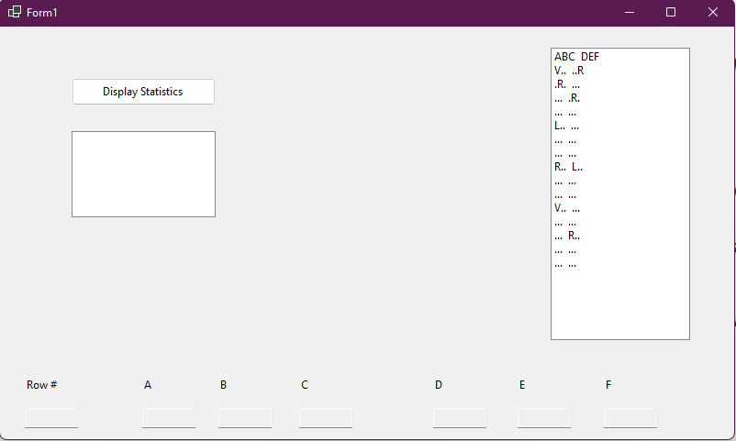

## Code

Public Class Form1

'Public 3d array that is used to store data from the text file

Public arrSeats(,) = New String(14, 5) {}

'shared variables between form1 and form2 to track index

Public Property rowIndex As Integer

Public Property columIndex As Intege

Private Sub lsbRows_SelectedIndexChanged(sender As Object, e As EventArgs) Handles lsbRows.SelectedIndexChanged

'displays the selected row in the edit boxes

Dim rowNum = lsbRows.SelectedIndex.ToString()

txbRow.Text = rowNum

'changes to correct value as array indexes from 0

rowNum -= 1

txbA.Text = arrSeats(rowNum, 0)

txbB.Text = arrSeats(rowNum, 1)

txbC.Text = arrSeats(rowNum, 2)

txbD.Text = arrSeats(rowNum, 3)

txbE.Text = arrSeats(rowNum, 4)

txbF.Text = arrSeats(rowNum, 5)

'sets shared variable

rowIndex = rowNum

End Sub

Private Sub Form1_Load(sender As Object, e As EventArgs) Handles MyBase.Load

'onloads opens text file to be read into the 3d array

Dim splitLine As String()

Dim myline As String

Dim count As Integer = 0

Dim rows() As String = IO.File.ReadAllLines("C:\Users\Sashin\Documents\Unisa 2022\Assignments\ICT3611_A4\ICT3611_A5_Project\AirplaneSeats\seats.txt")

Do Until count = 15

myline = rows(count)

splitLine = Split(myline, ",")

For i As Integer = 0 To 5

arrSeats(count, i) = splitLine(i)

Next

count += 1

Loop

'procedure to populate text field with the array

Seats()

End Sub

Sub Seats()

lsbRows.Items.Clear()

lsbRows.Items.Add("ABC DEF")

For i As Integer = 0 To 14

'adds line to the edit field

lsbRows.Items.Add(arrSeats(i, 0) + arrSeats(i, 1) + arrSeats(i, 2) + " " + arrSeats(i, 3) + arrSeats(i, 4) + arrSeats(i, 5))

Next

End Sub

Private Sub btnStats_Click(sender As Object, e As EventArgs) Handles btnStats.Click

'sets counter variables for the statistics button

Dim filSeats, avaWind, regM, lowM, vegM As Integer

regM = 0

vegM = 0

filSeats = 0

lowM = 0

avaWind = 0

'checks every element in the array

For i As Integer = 0 To 14

For k As Integer = 0 To 5

If arrSeats(i, k) <> "." Then

'adds to filled seats if not a "."

filSeats += 1

'case statement to count meal types

Select Case arrSeats(i, k)

Case "R"

regM += 1

Case "V"

vegM += 1

Case "L"

lowM += 1

End Select

Else

'checks if the free seat is a window seat

If k = 0 Or k = 5 Then

avaWind += 1

End If

End If

Next

Next

'adds the data to the edit

lstStats.Items.Add("Seats filled: " + filSeats.ToString)

lstStats.Items.Add("Windows avail: " + avaWind.ToString)

lstStats.Items.Add("Regular meals: " + regM.ToString)

lstStats.Items.Add("LowCal meals: " + lowM.ToString)

lstStats.Items.Add("Veggie meals: " + vegM.ToString)

End Sub

'hides form1 and shows form2 as well as sets the correct colum index based on choice

Private Sub txbA_Click(sender As Object, e As EventArgs) Handles txbA.Click

columIndex = 0

Me.Hide()

Form2.Show()

End Sub

Private Sub txbB_Click(sender As Object, e As EventArgs) Handles txbB.Click

columIndex = 1

Me.Hide()

Form2.Show()

End Sub

Private Sub txbC_Click(sender As Object, e As EventArgs) Handles txbC.Click

columIndex = 2

Me.Hide()

Form2.Show()

End Sub

Private Sub txbD_Click(sender As Object, e As EventArgs) Handles txbD.Click

columIndex = 3

Me.Hide()

Form2.Show()

End Sub

Private Sub txbE_Click(sender As Object, e As EventArgs) Handles txbE.Click

columIndex = 4

Me.Hide()

Form2.Show()

End Sub

Private Sub txbF_Click(sender As Object, e As EventArgs) Handles txbF.Click

columIndex = 5

Me.Hide()

Form2.Show()

End Sub

End Class

Public Class Form2

'public variables

Public arrSeats(,) = New String(14, 5) {}

Dim col As Integer

Dim row As Integer

'adds textfile into array

Private Sub Form2_Load(sender As Object, e As EventArgs) Handles MyBase.Load

Dim splitLine As String()

Dim myline As String

Dim count As Integer = 0

Dim rows() As String = IO.File.ReadAllLines("C:\Users\Sashin\Documents\Unisa 2022\Assignments\ICT3611_A4\ICT3611_A5_Project\AirplaneSeats\seats.txt")

Do Until count = 15

myline = rows(count)

splitLine = Split(myline, ",")

For i As Integer = 0 To 5

arrSeats(count, i) = splitLine(i)

Next

count += 1

Loop

'sets varaibles as the public varaible in form1

col = Form1.columIndex

row = Form1.rowIndex

End Sub

'updates the textfile to the changed information

Sub UpdateTxt()

'clears textfile

Dim lineTemp As String

lineTemp = ""

System.IO.File.WriteAllText("C:\Users\Sashin\Documents\Unisa 2022\Assignments\ICT3611_A4\ICT3611_A5_Project\AirplaneSeats\seats.txt", "")

Dim myFile As IO.StreamWriter

'allows file to be appended

myFile = New IO.StreamWriter("C:\Users\Sashin\Documents\Unisa 2022\Assignments\ICT3611_A4\ICT3611_A5_Project\AirplaneSeats\seats.txt", True)

'writes from array to textfile

For i As Integer = 0 To 14

For k As Integer = 0 To 5

lineTemp += arrSeats(i, k) + ","

Next

myFile.WriteLine(lineTemp)

lineTemp = ""

Next

myFile.Close()

Me.Hide()

'restarts application to update information in edit field on form1

Application.Restart()

End Sub

'onchecked it will change to the appropriate data and then run the updateTxt procedure

Private Sub rbFree_CheckedChanged(sender As Object, e As EventArgs) Handles rbFree.CheckedChanged

arrSeats(row, col) = "."

UpdateTxt()

End Sub

Private Sub rbReg_CheckedChanged(sender As Object, e As EventArgs) Handles rbReg.CheckedChanged

arrSeats(row, col) = "R"

UpdateTxt()

End Sub

Private Sub rbLow_CheckedChanged(sender As Object, e As EventArgs) Handles rbLow.CheckedChanged

arrSeats(row, col) = "L"

UpdateTxt()

End Sub

Private Sub rbVeg_CheckedChanged(sender As Object, e As EventArgs) Handles rbVeg.CheckedChanged

arrSeats(row, col) = "V"

UpdateTxt()

End Sub

End Class

# Project 2-Gradebook

## Screenshots

## Code

Public Class Form1

Private Sub Form1_Load(sender As Object, e As EventArgs) Handles MyBase.Load

'TODO: This line of code loads data into the 'GradebookDataSet.Students' table. You can move, or remove it, as needed.

' Me.StudentsTableAdapter.Fill(Me.GradebookDataSet.Students)

'TODO: This line of code loads data into the 'GradebookDataSet.Grades' table. You can move, or remove it, as needed.

Me.GradesTableAdapter.Fill(Me.GradebookDataSet.Grades)

End Sub

Private Sub btnUpdate_Click(sender As Object, e As EventArgs) Handles btnUpdate.Click

'updates database

GradesBindingSource.EndEdit()

GradesTableAdapter.Update(GradebookDataSet.Grades)

End Sub

Private Sub btnGrades_Click(sender As Object, e As EventArgs) Handles btnGrades.Click

'Gets an array of the lastnames

Dim mySQl = "SELECT lastName FROM Students"

Dim dbt As New DataTable

Using con As New OleDbConnection("Provider=Microsoft.ACE.OLEDB.12.0;Data Source=|DataDirectory|\Gradebook.accdb;Persist Security Info=True"), cmd As New OleDbCommand(mySQl, con)

con.Open()

Using reader = cmd.ExecuteReader

dbt.Load(reader)

End Using

End Using

Dim lastName = dbt.AsEnumerable.Select(Function(r) r.Field(Of String)(0)).ToArray

'Gets an array of the first names

mySQl = "SELECT firstName FROM Students"

Using con As New OleDbConnection("Provider=Microsoft.ACE.OLEDB.12.0;Data Source=|DataDirectory|\Gradebook.accdb;Persist Security Info=True"), cmd As New OleDbCommand(mySQl, con)

con.Open()

Using reader = cmd.ExecuteReader

dbt.Load(reader)

End Using

End Using

Dim firstName = dbt.AsEnumerable.Select(Function(r) r.Field(Of String)(0)).ToArray

'Gets an array of the first exam results

Dim dbtG As New DataTable

mySQl = "SELECT firstExam FROM Grades"

Using con As New OleDbConnection("Provider=Microsoft.ACE.OLEDB.12.0;Data Source=|DataDirectory|\Gradebook.accdb;Persist Security Info=True"), cmd As New OleDbCommand(mySQl, con)

con.Open()

Using reader = cmd.ExecuteReader

dbtG.Load(reader)

End Using

End Using

Dim exam1 = dbtG.AsEnumerable.Select(Function(r) r.Field(Of Integer)(0)).ToArray

'Gets an array of the second exam results

mySQl = "SELECT secondExam FROM Grades"

Using con As New OleDbConnection("Provider=Microsoft.ACE.OLEDB.12.0;Data Source=|DataDirectory|\Gradebook.accdb;Persist Security Info=True"), cmd As New OleDbCommand(mySQl, con)

con.Open()

Using reader = cmd.ExecuteReader

dbtG.Load(reader)

End Using

End Using

Dim exam2 = dbtG.AsEnumerable.Select(selector:=Function(r) r.Field(Of Integer)(0)).ToArray

'Gets an array of the final exam results

mySQl = "SELECT finalExam FROM Grades"

Using con As New OleDbConnection("Provider=Microsoft.ACE.OLEDB.12.0;Data Source=|DataDirectory|\Gradebook.accdb;Persist Security Info=True"), cmd As New OleDbCommand(mySQl, con)

con.Open()

Using reader = cmd.ExecuteReader

dbtG.Load(reader)

End Using

End Using

Dim examF = dbtG.AsEnumerable.Select(Function(r) r.Field(Of Integer)(0)).ToArray

Dim row As String()

Dim fullName As String

Dim grade As Integer

'combines first and last name then calculates grade

For i = 0 To firstName.Length

fullName = firstName(i) + " " + lastName(i)

grade = (exam1(i) + exam2(i) + examF(i) * 2) / 4

'sets the string row to be added into the grid

row = New String() {fullName, grade.ToString()}

'adds row to grid

dgvFinalGrade.Rows.Add(row)

Next

End Sub

End Class

# Project 1-Bank Account

## Screenshots

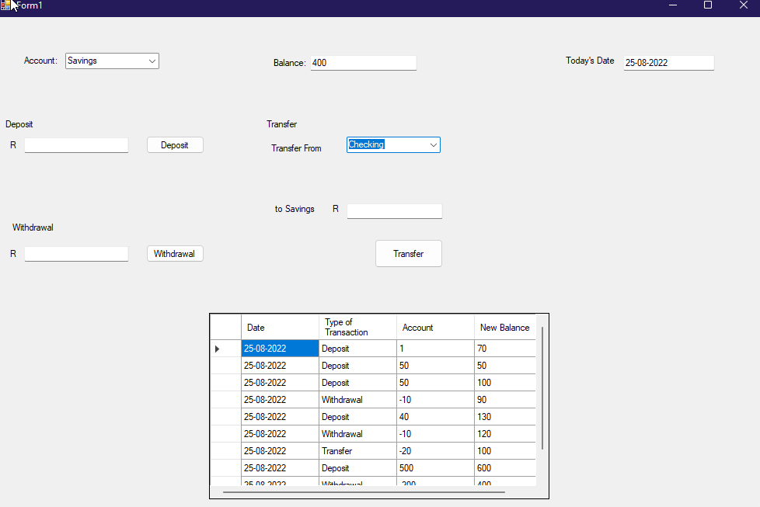

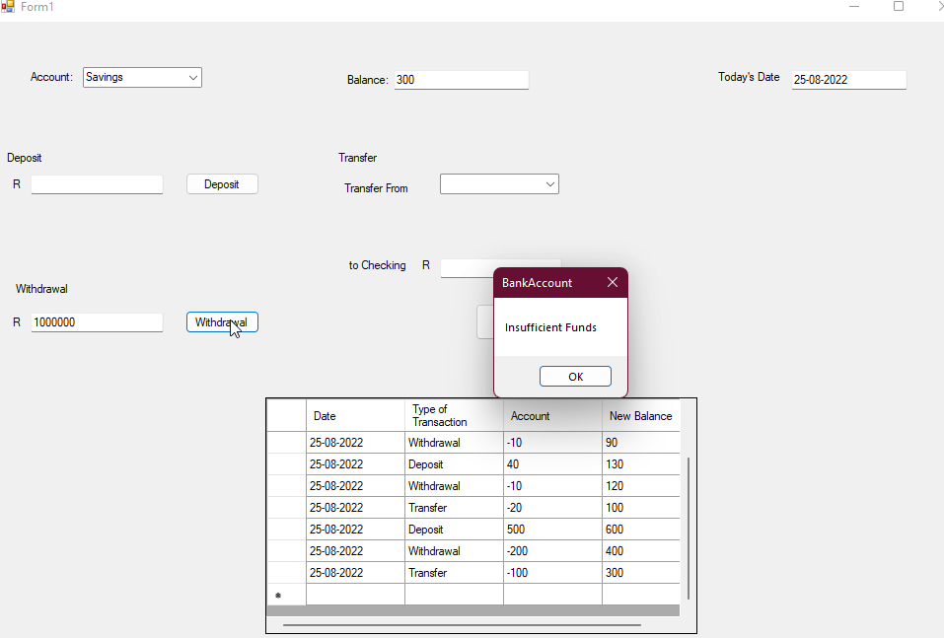

## Code

Public Class Form1

'arrays to be edited

Dim arrCheck(,) = New String(3, 0) {}

Dim arrSave(,) = New String(3, 0) {}

'date string to hold date and put into textfile

Dim myDateStr As String

Dim lenSave As Integer

Dim lenCheck As Integer

Private Sub Form1_Load(sender As Object, e As EventArgs) Handles MyBase.Load

'loads the data into grid

loadData()

'sets date

Dim todayDate As Date

todayDate = Today

myDateStr = todayDate.ToString("dd-MM-yyyy")

txtDate.Text = myDateStr

'hides check panel

pnlCheck.Hide()

End Sub

Sub loadData()

'gets the text file and adds it to the array

Dim splitLine As String()

Dim myline As String

Dim rows() As String = IO.File.ReadAllLines("C:\Users\Sashin\Documents\Unisa 2022\Assignments\ICT3611_A4\ICT3611_A5_Project\BankAccount\checking.txt")

Dim count As Integer = 0

ReDim arrCheck(3, rows.Length)

Do Until count = rows.Length

myline = rows(count)

splitLine = Split(myline, ",")

For i As Integer = 0 To 3

arrCheck(i, count) = splitLine(i)

Next

count += 1

Loop

Dim splitLine1 As String()

Dim rows1 As String() = IO.File.ReadAllLines("C:\Users\Sashin\Documents\Unisa 2022\Assignments\ICT3611_A4\ICT3611_A5_Project\BankAccount\savings.txt")

count = 0

ReDim arrSave(3, rows1.Length)

Do Until count = rows1.Length

myline = rows1(count)

splitLine1 = Split(myline, ",")

For i As Integer = 0 To 3

arrSave(i, count) = splitLine1(i)

Next

count += 1

Loop

End Sub

Private Sub chbAcc_SelectedIndexChanged(sender As Object, e As EventArgs) Handles chbAcc.SelectedIndexChanged

'hides the check panel when savings is selected and shows check panel when check is selected

If chbAcc.SelectedIndex = 0 Then

pnlCheck.Hide()

Else

pnlCheck.Show()

End If

tableMaker()

End Sub

Private Sub btnDeposit_Click(sender As Object, e As EventArgs) Handles btnDeposit.Click

Dim myBalance As Integer

'deposits the account that is selected

If chbAcc.SelectedIndex = 0 Then

myBalance = Val(arrSave(3, lenSave - 1)) + Val(txtDeposit.Text)

lenSave += 1

'increases size of the array while keeping the data

ReDim Preserve arrSave(3, lenSave)

'adds new data

arrSave(0, lenSave - 1) = myDateStr

arrSave(1, lenSave - 1) = "Deposit"

arrSave(2, lenSave - 1) = txtDeposit.Text

arrSave(3, lenSave - 1) = myBalance.ToString

MsgBox("Balance for Savings has been Updated With Deposit")

ElseIf chbAcc.SelectedIndex = 1 Then

myBalance = Val(arrCheck(3, lenCheck - 1)) + Val(txtDeposit.Text)

lenCheck += 1

'increases size of the array while keeping the data

ReDim Preserve arrCheck(3, lenCheck)

'adds new data

arrCheck(0, lenCheck - 1) = myDateStr

arrCheck(1, lenCheck - 1) = "Deposit"

arrCheck(2, lenCheck - 1) = txtDeposit.Text

arrCheck(3, lenCheck - 1) = myBalance.ToString

MsgBox("Balance for Checking has been Updated With Deposit")

End If

writeTxt()

End Sub

'writes data into text files

Sub writeTxt()

'clears textfile

Dim lineTemp As String

lineTemp = ""

System.IO.File.WriteAllText("C:\Users\Sashin\Documents\Unisa 2022\Assignments\ICT3611_A4\ICT3611_A5_Project\BankAccount\savings.txt", "")

Dim myFile As IO.StreamWriter

'allows file to be appended

myFile = New IO.StreamWriter("C:\Users\Sashin\Documents\Unisa 2022\Assignments\ICT3611_A4\ICT3611_A5_Project\BankAccount\savings.txt", True)

'writes from array to textfile

For i As Integer = 0 To lenSave - 1

For k As Integer = 0 To 3

lineTemp += arrSave(k, i)

lineTemp += ","

Next

myFile.WriteLine(lineTemp)

lineTemp = ""

Next

myFile.Close()

'clears textfile

lineTemp = ""

System.IO.File.WriteAllText("C:\Users\Sashin\Documents\Unisa 2022\Assignments\ICT3611_A4\ICT3611_A5_Project\BankAccount\checking.txt", "")

'allows file to be appended

myFile = New IO.StreamWriter("C:\Users\Sashin\Documents\Unisa 2022\Assignments\ICT3611_A4\ICT3611_A5_Project\BankAccount\checking.txt", True)

'writes from array to textfile

For i As Integer = 0 To lenCheck - 1

For k As Integer = 0 To 3

lineTemp += arrCheck(k, i)

lineTemp += ","

Next

myFile.WriteLine(lineTemp)

lineTemp = ""

Next

myFile.Close()

tableMaker()

End Sub

'creates the table/grid for details viewing

Sub tableMaker()

Dim row As String() = New String() {}

dgvTrans.Rows.Clear()

'sets column amount

dgvTrans.ColumnCount = 4

'sets column headings

dgvTrans.Columns(0).Name = "Date"

dgvTrans.Columns(1).Name = "Type of Transaction"

dgvTrans.Columns(2).Name = "Account"

dgvTrans.Columns(3).Name = "New Balance"

lenSave = arrSave.GetLength(1) - 1

lenCheck = arrCheck.GetLength(1) - 1

'writes to selected account for grid

If chbAcc.SelectedIndex = 0 Then

For i As Integer = 0 To lenSave - 1

'adds line to the grid

row = New String() {arrSave(0, i), arrSave(1, i), arrSave(2, i), arrSave(3, i)}

dgvTrans.Rows.Add(row)

Next

txtBalance.Text = arrSave(3, lenSave - 1)

ElseIf chbAcc.SelectedIndex = 1 Then

For i As Integer = 0 To lenCheck - 1

'adds line to the grid

row = New String() {arrCheck(0, i), arrCheck(1, i), arrCheck(2, i), arrCheck(3, i)}

dgvTrans.Rows.Add(row)

Next

txtBalance.Text = arrCheck(3, lenCheck - 1)

End If

End Sub

'withdrawal code

Private Sub btnDraw_Click(sender As Object, e As EventArgs) Handles btnDraw.Click

Dim myBalance As Integer

'gets correct account

If chbAcc.SelectedIndex = 0 Then

myBalance = Val(arrSave(3, lenSave - 1))

'checks if balance is big enough

If myBalance > Val(txtDraw.Text) Then

myBalance -= Val(txtDraw.Text)

lenSave += 1

ReDim Preserve arrSave(3, lenSave)

arrSave(0, lenSave - 1) = myDateStr

arrSave(1, lenSave - 1) = "Withdrawal"

arrSave(2, lenSave - 1) = "-" + txtDraw.Text

arrSave(3, lenSave - 1) = myBalance.ToString

MsgBox("Withdrawal Successful")

Else

MsgBox("Insufficient Funds")

End If

ElseIf chbAcc.SelectedIndex = 1 Then

myBalance = Val(arrCheck(3, lenCheck - 1))

If myBalance > Val(txtDraw.Text) Then

myBalance -= Val(txtDraw.Text)

lenCheck += 1

ReDim Preserve arrSave(3, lenSave)

arrCheck(0, lenCheck - 1) = myDateStr

arrCheck(1, lenCheck - 1) = "Withdrawal"

arrCheck(2, lenCheck - 1) = "-" + txtDraw.Text

arrCheck(3, lenCheck - 1) = myBalance.ToString

MsgBox("Withdrawal Successful")

Else

MsgBox("Insufficient Funds")

End If

End If

writeTxt()

End Sub

Private Sub cmbTransAcc_SelectedIndexChanged(sender As Object, e As EventArgs)

'changes label based on section

If cmbTransAcc.SelectedIndex = 0 Then

lblAcc.Text = "to Checking"

Else

lblAcc.Text = "to Savings"

End If

End Sub

Private Sub btnTrans_Click(sender As Object, e As EventArgs) Handles btnTrans.Click

Dim myBalance As Integer

'checks which account is being used

If cmbTransAcc.SelectedIndex = 0 Then

myBalance = Val(arrSave(3, lenSave - 1))

If myBalance > Val(txtTrans.Text) Then

myBalance = Val(arrSave(3, lenSave - 1)) - Val(txtTrans.Text)

lenSave += 1

'updates the amount to be subtracted

ReDim Preserve arrSave(3, lenSave)

arrSave(0, lenSave - 1) = myDateStr

arrSave(1, lenSave - 1) = "Transfer"

arrSave(2, lenSave - 1) = "-" + txtTrans.Text

arrSave(3, lenSave - 1) = myBalance.ToString

'updates amount to be added

myBalance = Val(arrCheck(3, lenCheck - 1)) + Val(txtTrans.Text)

lenCheck += 1

ReDim Preserve arrCheck(3, lenCheck)

arrCheck(0, lenCheck - 1) = myDateStr

arrCheck(1, lenCheck - 1) = "Transfer"

arrCheck(2, lenCheck - 1) = txtTrans.Text

arrCheck(3, lenCheck - 1) = myBalance.ToString

MsgBox("Balances Updated")

End If

ElseIf cmbTransAcc.SelectedIndex = 1 Then

myBalance = Val(arrCheck(3, lenCheck - 1))

If myBalance > Val(txtTrans.Text) Then

'updates the amount to be subtracted

myBalance = Val(arrCheck(3, lenCheck - 1)) - Val(txtTrans.Text)

lenCheck += 1

ReDim Preserve arrCheck(3, lenCheck)

arrCheck(0, lenCheck - 1) = myDateStr

arrCheck(1, lenCheck - 1) = "Transfer"

arrCheck(2, lenCheck - 1) = "-" + txtTrans.Text

arrCheck(3, lenCheck - 1) = myBalance.ToString

'updates amount to be added

myBalance = Val(arrSave(3, lenSave - 1)) + Val(txtTrans.Text)

lenSave += 1

ReDim Preserve arrSave(3, lenSave)

arrSave(0, lenSave - 1) = myDateStr

arrSave(1, lenSave - 1) = "Transfer"

arrSave(2, lenSave - 1) = txtTrans.Text

arrSave(3, lenSave - 1) = myBalance.ToString

MsgBox("Balances Updated")

End If

End If

writeTxt()

End Sub

Private Sub btnCheck_Click(sender As Object, e As EventArgs) Handles btnCheck.Click

'checks if amount is enough for order

Dim myBalance As Integer

myBalance = Val(arrCheck(3, lenCheck - 1))

MsgBox(myBalance)

If myBalance > Val(txtPayAmount.Text) Then

myBalance -= Val(txtPayAmount.Text)

lenCheck += 1

ReDim Preserve arrSave(3, lenSave)

arrCheck(0, lenCheck - 1) = myDateStr

arrCheck(1, lenCheck - 1) = txtOrder.Text

arrCheck(2, lenCheck - 1) = "-" + txtPayAmount.Text

arrCheck(3, lenCheck - 1) = myBalance.ToString

MsgBox("Order Successful")

Else

MsgBox("Insufficient Funds")

End If

writeTxt()

End Sub

Private Sub cmbTransAcc_SelectedIndexChanged_1(sender As Object, e As EventArgs) Handles cmbTransAcc.SelectedIndexChanged

'changes label

If cmbTransAcc.SelectedIndex = 1 Then

lblAcc.Text = "to Savings"

Else

lblAcc.Text = "to Checking"

End If

End Sub

End Class