Alexander Atanasov PCO website

1. Compliments

* Design and creativity, “wow” factors and good layout
* Good colour palette
* Very good and structured motivation
* Images are downloaded to prevent problems
* Functional
* Good code editor and clean, understandable code

1. Improvements

* Suggestion to change one image in the index “Home” page
* Possible change in the “hover” in the Dashboard page

1. Code Review Feedback

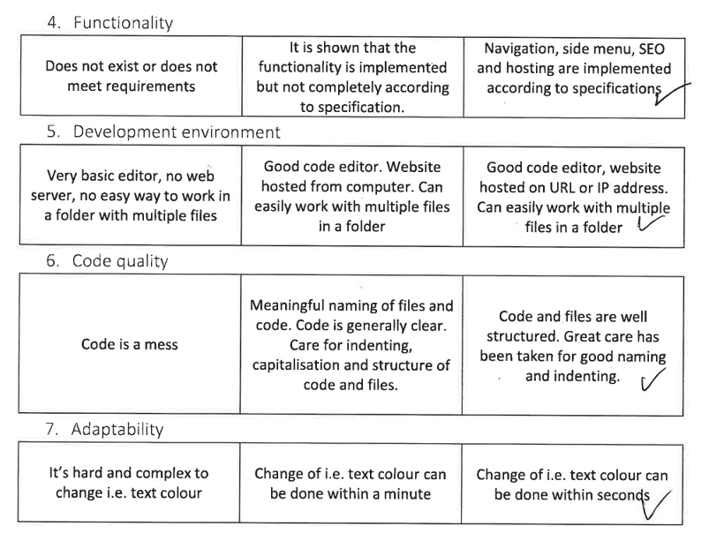 From Maria

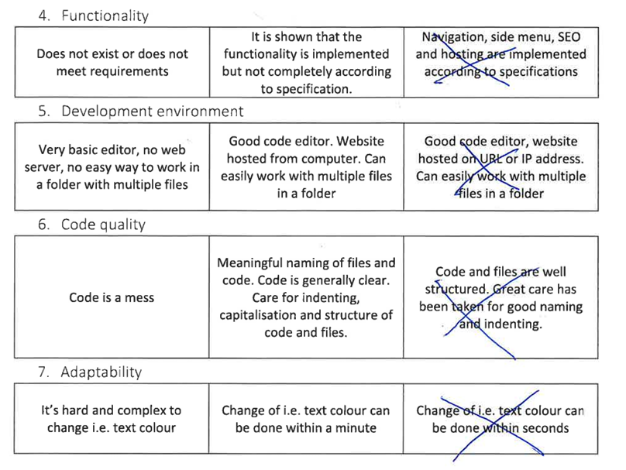From Dimitar

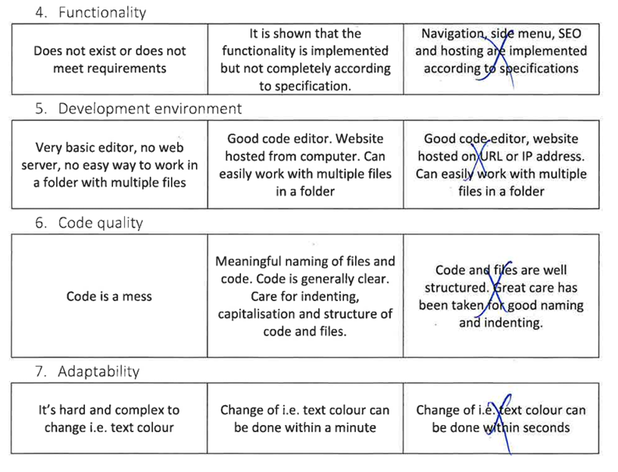From Kiril

I believe that the code review is sufficient enough and I don’t consider major code changes in the near future.

1. Tasks

* To change the Dashboard page hover animation colour
* To fix misspelled words
* To justify the blog posts
* To change one of the home page images
* To fix Blog page dates
  1. Change the Dashboard page hover animation colour
* Dashboard table colour changed to cyan for better overall look
  1. Fix misspelled words
* Minor spelling issues fixed
  1. Justify blog post content
* Text content in the blog posts justified, achieving better readability
  1. Change the home page image
* Changing both images to being blue makes the content a little less visible and a too similar look wouldn’t benefit the readability
  1. Fix Blog page dates
* Publication dates of posts arranged chronologically